January 12, 2009

**Steve Stauffer**

**SEAHO Awards and Recognition Committee Chair**

537 Patterson Office Tower

Lexington, KY 40506

Dear Steve,

I take great professional pleasure in writing in support of Megan Horan, a second-year graduate student at North Carolina State University, for the 2009 SEAHO Graduate Student of the Year Award. I have known Megan since she joined the University Housing staff in 2007 and she is a tremendous individual that will be a great student affairs professional in the near future.

Megan started interning in our office shortly after arriving on campus, first with Panhellenic recruitment and later working with our Interfraternity Council leadership. She brought a wealth of fresh ideas from her undergraduate experience and a willingness to learn more about fraternity/sorority life. This fall she took the leadership role in an effort to reenvision our traditional Greek Week activities. So far, she has successfully enlisted the participation and support from a broad range of fraternity and sorority members, many of whom represent organizations that have never participated nor felt included in these events. She has cultivated a growing culture of leadership, service, and inclusivity among our students and has pushed the planning of this annual event in an entirely new direction for our campus. In short, she is a tremendous asset to our staff and community.

There is a bright future in student affairs for Megan, one not limited to housing or fraternity/sorority affairs. She understands that we are student affairs professionals first and specialists in our areas second, a perspective often lost on most graduate assistants immersed in their functional areas. I look forward to working and collaborating with Megan in the future.

Sincerely,

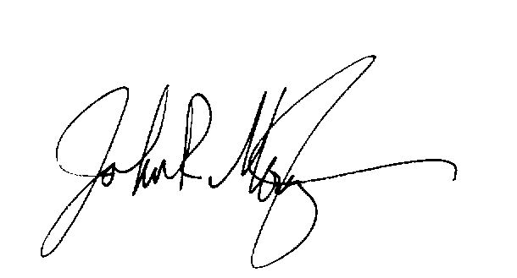

John R. Mountz, M.Ed.

Director of Greek Life