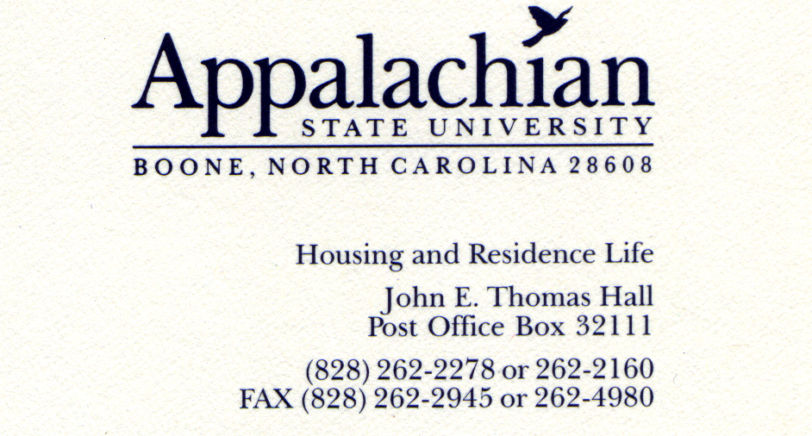

SEAHO Awards Selection Committee,

I would like to nominate someone I know is an extremely strong candidate for Outstanding Mid-Level Professional award. In the summer of 2005 Alicia Chandler arrived at Appalachian State University and began her service as Assistant Director of Residence Life. Alicia had previously served in Housing and Residence Life at Drake University, Iowa State University, and U. of Minnesota at Mankato. Immediately after Alicia’s arrival in Boone she began to make an impact. Because of her many accomplishments in several primary areas of her job I will write this letter in a list format to allow for inclusion of as much content as possible.

Residential Learning Communities (RLCs): Alicia accomplished the following…
- Developed two new RLCs, Sophomore Year Experience and Black and Gold, which included establishing Leadership Teams, marketing materials, and establishing funding
- Served on the Learning Communities Council, a committee of faculty, academic support staff, and student affairs staff for the past two years. This fall, Alicia was elected the first chair from Student Development for this council.
- As a member of the Marketing subcommittee for the Learning Communities Council, developed campus-wide publicity materials for learning communities.
- Developed a separate brochure for marketing RLCs, in addition to making significant improvements to RLC websites.
- Was one of five Appalachian State University representatives at the annual week-long Summer Institute for Learning Communities, sponsored by the Washington Center for Improving Undergraduate Education.
- Supervised a master’s level intern for RLCs and co-wrote a 25-page handbook for faculty and staff members on RLC Leadership Teams. Disseminated and trained Leadership Teams on the content in this handbook.
- Created a graduate assistant position for learning communities. Selected, trained, and supervised the first Graduate Assistant for Learning Communities.
- Worked with computer coders to design a database for RLC application and enrollment. Monitored and used this database to finalize placement of over 200 students in RLCs.
- Currently developing new RLCs for Entrepreneurship and Education, in addition to theme housing for substance free living.
- Held RLC Leadership Teams accountable for maintaining success in Consistent Elements of all RLCs, including mission statement, learning and program goals, early move-in, pre-school activities, regular events, linked academic class, and annual evaluation.

Campus Resident Student Association (CRSA) Alicia accomplished the following…
- Started leading annual summer retreat for CRSA Executive Council, in which Executive team came to Boone for a weekend in the summer and developed a plan for the year.
- Added a new September training day for Resident Student Association (RSA) executive officers.
- Improved October CRSA/RSA Leadership Retreat held a Friday and Saturday off-site. Added additional training and fun activities to increase community and stimulate service to Appalachian.
- Transformed CRSA from a student activity planning group to a governing body that offered input on departmental policy and advocated for additional student voice and leadership.
- Advised CRSA in offering input and recommendations for smoking perimeter distance, common area painting, alcohol limit in the residence halls, and other policies.
- Significantly improved CRSA website by adding as much content as possible and increasing visibility and transparency of CRSA.
- Guided CRSA in writing and presenting 30-page bid to host annual North Carolina Association of Residence Halls in February 2008. Won bid!
- Assisted CRSA leadership in developing new executive position to focus on diversity.
- Proposed and led extensive multi-hour training for RSA advisors.
- Served on and became a leading voice on Appalachian Homecoming Committee and the role of RSAs in Homecoming.

Community Development Alicia accomplished the following…
- Oversaw major improvements in programming resource room; including addition of new equipment such as a laminator, button making machine, and new block letters.
- Facilitated new website for programming resource room and addition of large amounts of helpful content on this website
- Initiated staffing of programming resource room from 8 a.m. to 7 p.m. every weekday.
- Developed database for collecting and monitoring all programs led by RAs on campus.
- Led development of a new programming model which closely aligns to student learning goals.
- Stimulated workshops on programming led by Graduate Assistant for Community Development.
- Coordinated recognition for RAs in their achievement of programming.
- Advised monthly publication of programming newsletter for residence life staff.
- Met with 17 Residence Directors at least twice a year to assist them in programming in their residence halls.
- Serve on late night programming task force that resulted in a residence life programming model that required regular late night programs.

Other Alicia accomplished the following…
- Coordinated Residence Life’s involvement in presenting to parents and incoming students during June Orientation
- Participated in university-wide leadership training for mid-managers
- Completed ART Training to earn certification as a ART training for other
- Served on Placement Committee for ACPA Annual Conference Placement
- Chaired Search Committee for Assistant Director of Residence Life for Staff Selection and Education

I hope the above accomplishments provide you with an overview of some of the many successes Alicia had led, coordinated, advised, or overseen during her time at Appalachian State. In addition to accomplishing much, Alicia is a pleasure to work alongside. She is has the ability to get along with many people and handles conflict constructively. Alicia brings an optimistic attitude to work and encourages students and staff on a daily basis. Alicia is very intelligent and masters complex concepts quickly and teaches others. One of her strengths is developing leaders and this has been clearly evident in the staff she has guided through significant professional hurdles.

I hope will consider rewarding her efforts with the SEAHO Outstanding Mid-Level Professional award. Should you have any questions about Alicia’s candidacy for this award please do not hesitate to contact me at 828.262.7637 or doyleja@appstate.edu. Thank you.

Sincerely,

Jeff Doyle, Ph.D., Director of Residence Life, Appalachian State University

