
Residence Life
P. O. Box 8795
Campus Center 212
Williamsburg, Virginia 23187-8795
757/221-4314, Fax 757/221-1240
living@wm.edu

January 20, 2010

NOMINATION OF DAVID JONES FOR SEAHO FOUNDERS AWARD

It is a sincere pleasure for me to support the nomination of David Jones for the 2010 SEAHO Founders Award. As his former supervisor I worked closely with David when he served as Area Director here at the College of William & Mary from 1995 to 2000. During his time on our staff, David grew personally and professionally and was viewed as a leader among his colleagues. David was first assigned to the residential area housing our fraternities and sororities and was faced with unique challenges and problems. He consistently maintained a truly professional manner, strong ethical standards, and a positive attitude toward his work. To broaden his experiences and influence, David moved to a different residential area of our campus where he was able to work closely with non-Greek students and staff and where he embraced the opportunity to supervise and mentor graduate student staff members. David made valuable contributions to Residence Life, the Division of Student Affairs, and the College of William and Mary.

Capable and determined, David's skills and abilities are diverse and strong. He combines a warm and caring attitude toward students with a broad understanding of student development and a solid commitment to Student Affairs. Respected and admired by his colleagues, he provides insightful ideas, a supportive attitude, a variety of experiences, and a balanced perspective. His involvement in committees and projects beyond those required of his position reflects not only his wide range of interests but his aspiration to learn and contribute as much as he can. Throughout his career he has actively seized opportunities for professional development both on campus and through involvement in state, regional and national associations. David is willing, cooperative, and open minded. He is level headed and while he approaches his work in a serious and rational manner he maintains a healthy combination of humor and sincerity.

As a past SEAHO Committee Chair and President David is very deserving of the SEAHO Founders Award. It is with confidence and enthusiasm that I support his nomination. If you have questions regarding his qualifications and potential, please feel free to contact me.

Sincerely,
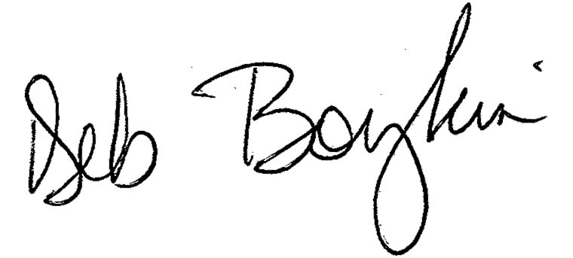
Deb Boykin
Assistant Vice President for Student Affairs
and Director of Residence Life

