January 12, 2009

Dear Selection Committee,

Please consider this my letter of support for Holly Hallmann for the SEAHO Outstanding Mid-Level Professional Award. During my first year and half as a new professional in housing, I was able to learn so much from having Holly as my supervisor.

On my fist day of work at the University of Alabama, Holly asked me about my professional goals. She then spent the next year finding every opportunity she could to help me accomplish my goals. For example, I wanted to present at a regional, national, and international conference in the same year. Thanks to Holly’s support and willingness to put her self in the uncomfortable role of presenting with me, together we presented at a regional and national conference. Our program for the international conference was not accepted.

Holly was quick to recognize my struggle of life balance. She worked with me to develop better habbits of work-life balance so as to avoid a three year burn out. She provided me with the idea of the end-of-the-day summary list. It was difficult at first but as I slowly began to take time at the end of each day and write down what needed to be done the following day, I began to think less about work while at home.

Holly has worked extensively with living learning communities and the first year experience. She was able to bring her knowledge and experience from other institutions to the University of Alabama and lead the creation of the UA FYE program. She developed booklets for every first year student on campus. The RA would take these booklets and have three timely conversations with each first year student on their floor. The conversations focused on adjusting to college and getting involved, academic support on campus, and plans for internships over the summer and/or their sophomore year.

Holly has also worked intensively with at least five academic departments on campus to education the faculty on the purpose and function of living learning communities, the importance of faculty investment and support, the development/refinement of living learning communities.

Because of Holly’s investment in me as a new professional, I have been able to obtain employment in a midlevel position a year earlier than anticipated. Her investment to the first year experience and the living learning communities at the University of Alabama have only helped increase the student retention and satisfaction rates over the last four years.

Please consider Holly Hallmann for the SEAHO Outstanding Mid-Level Professional Award. With her knowledge, experience, and commitment to field, I would not be where I am today.

Sincerely,
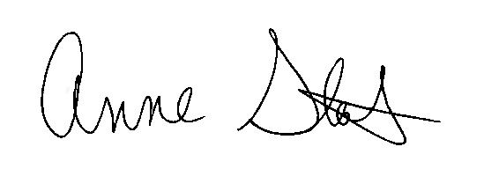
Anne Stark
Residential Life Manager, Windsor Halls

