NC STATE UNIVERSITY

North Carolina State University is a land-grant University Honors Program
university and a constituent institution of The 219 Clark Hall
University of North Carolina Campus Box 8610
Raleigh, NC 27695-8610

January 12, 2009

Dear SEAHO Selection Committee,

It is with great pride that I provide this letter of support for Jordan Luzader for James C. Grimm Outstanding New Professional Award. I have had the pleasure of observing, supervising and working in collaboration with Jordan for the last two and a half years in a variety of areas, and I have seen Jordan transform from a great Graduate Resident Director to an exceptional first year professional.

Jordan has emerged as one of the leaders among the housing staff at North Carolina State University. He never fails to volunteer for assignments to help the organization. Jordan has the drive to constantly seek out opportunity for growth, while continually exceeding job expectations. This trait is particularly impressive in that he is currently working in a newly created position. He is the first full time staff member to serve as the Community Director for the Quad and Honors Village at North Carolina State University. As the first person, he has been pivotal in shaping the position responsibilities and is working to bridge the gap between Student Affairs and Academic Affairs at the University.

My respect for Jordan comes from his ability to do whatever is necessary to get the job done, while at the same time maintaining the highest level of integrity when working with his staff and residents. He challenges them to identify their interests and passions and supports them to achieve their goals. He is always eager to offer spend time with students to assist in their individual development, either as a student staff member, residence hall leader or as a student. He is also always open to any advice that the staff can offer him about his role as a supervisor and how the staff can work together to make his residential area a stronger community. This type of openness towards his staff shows that he is willing to reflect upon himself and that he is open to any information that can help him become a stronger professional.

I also admire Jordan’s ability to make short-term and long-term goals for him and with the staffs he works. Although he is already strong in so many areas, he challenges himself to become a better leader and a better asset to the North Carolina State University community. He carries this ambition with him by also challenging the staff to become better leaders, better students, and better assets to the North Carolina State University community. He is an exceptional role model for both his peers and undergraduate students. He has maintained a balance of high professional development, outstanding job performance, and personal accomplishments…all qualities that any individual would admire.

Jordan is truly an outstanding new professional. He understands what it takes to be a leader that leads by example. His strength lies in the way he connects with others and his ability to motivate them to meet their full potential. I believe that Jordan Luzader represents all that is good and right in the field of Student Affairs. I also believe that as long as he continues on his present path, he is headed for greatness in student affairs.

Sincerely yours,
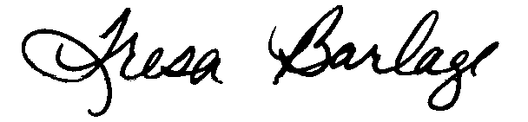
Tresa Barlage, Assistant Director
University Honors Program
North Carolina State University
221 Jensen Dr, Campus Box 8610
Raleigh, NC 27695

