
2000 North Parkway
Memphis TN, 38112

21 December 2007

Dear Graduate Student Award Committee Members,

I am pleased to serve as a nominator for KHOREY BAKER as Outstanding Graduate Student. Khorey is a full-time second year graduate student at the University of Memphis, and his graduate assistantship is through Rhodes College.

When I think about the past two years, Khorey has been as active and visible as our full-time staff! Several specifics of his involvement –
- Last year, as we were short-staffed, Khorey volunteered to co-chair coordination of the Homecoming halftime activities.
- Khorey served on the planning committee to bring national speaker, Jane Elliott, to campus.
- Khorey is active member of bi-weekly Student Affairs staff meetings, and he is comfortable interacting as a full member of this team.
- Khorey was an ACUHO-I Summer Intern in 2007.
- Students have asked Khorey to serve as a judge for several events, including our annual Kappa Delta All-Sing and Homecoming spirit contests.

Not only is Khorey willing to help in a variety of activities, he exhibits a maturity and confidence rarely observed in this level of professional staff member. Khorey serves as an on-call staff member. We worked through several crises, and I was impressed with Khorey’s first response, his ability to remain calm and share information in a concise manner, and his initiative in problem solving. On several occasions, Khorey has asked to meet with me for feedback on ways he could improve responses to specific situations.

Khorey will graduate this May, and some lucky institution will have an opportunity to employ him. Unfortunately, I do not anticipate an opening at Rhodes, as we would welcome the chance to keep his talents here.

Good luck in your difficult job of selecting the award winner.

Sincerely,
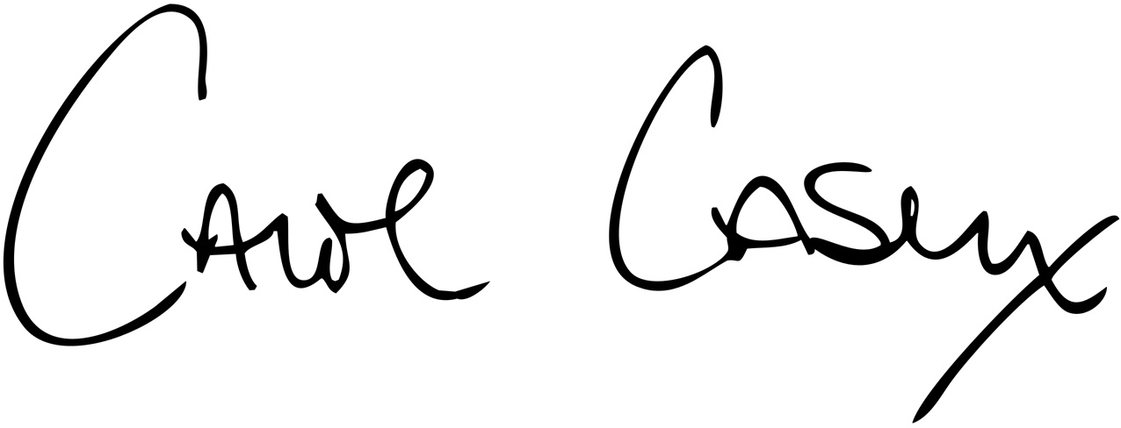
Carol Casey, Dean of Students

