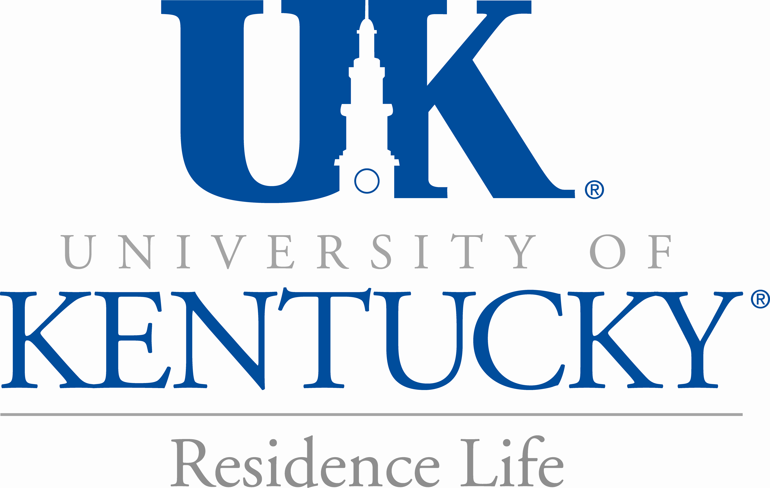
Leslie N. Woltenberg
Living Learning Communities Coordinator
Office of Residence Life
University of Kentucky
January 6, 2009
Steve Stauffer, Committee Chair
Awards and Recognition Committee:
The Southeastern Association of Housing Officers
537 Patterson Office Tower
Lexington, KY 40506

To Mr. Stauffer and Members of the SEAHO Awards & Recognition Committee:

There is no better program to recognize than the New Economy Incubator Living Learning Community for the SEAHO Housing & Academic Collaboration Award. This Living Learning Community (LLC) embodies the spirit of collaboration in multiple ways. The New Economy community is comprised of twenty-five first-year business and engineering students who desire to live and study together in an environment where the spirit of entrepreneurship and collaboration is valued. These students live together in Ingels Hall on the south side of the University of Kentucky’s campus and take a course together. As one of UK’s strongest communities, New Economy has set a high standard of excellence for what LLCs can achieve both on UK’s campus and beyond.

This community serves as an example of a strong partnership between academic and student affairs. The Office of Residence Life is responsible for the selection of members, offers regular programs, events, tutoring, support, and assistance to the students throughout the year. Under the leadership of Resident Director Chris Miller, six highly trained and qualified resident advisors plan numerous programs throughout the year. The College of Engineering and the College of Business & Economics are the academic anchors to this experience. LLC students major in business or engineering and are afforded special opportunities to meet esteemed guest speakers, attend internship fairs, and even take courses together to continue the sense of community that is established through the LLC experience.

The New Economy Community provides an opportunity for first-year students unlike any other on campus. These students live together in one of the newest residence halls on campus and are offered amazing amenities. Tutoring takes place within the residence hall, in the first floor classroom space, by the engineer-in-residence. The engineer-in-residence, Noah, lives in Ingels and is available to the students any time. The College of Engineering fully funds this position as well as providing a programming stipend; meanwhile, the Office of Residence Life provides an in-hall apartment for this position. Noah has done an exemplary job of offering field trip opportunities to local businesses related to engineering and entrepreneurship. This position is a huge draw particularly for engineering students who know they will face extremely challenging courses. To have a professional in the residence hall to help tutor and relate is of great value to these residents.

Noah and Chris have worked together for several years to create the weekly program “Dr. Pepper Hour”. Every Wednesday at 4pm, Dr. Pepper and rootbeer float ingredients are set out in the lobby. Students are invited to make a smoothie and listen to special guest speakers, discuss current events, or even watch an episode of “Myth Busters” (a favorite among the students). This is but one example of the special environment created by the New Economy Community. Other programs have included “The Great Boat Float”- constructing boats out of recycled materials and racing them at UK’s aquatic center, “Tower of Power” – structures created from edible materials and tested for structural variables, “Women in Engineering and Business Dinner” – an etiquette lesson and meal with local professionals, & more. The creativity of the Residence Life staff is nothing short of astounding, they truly set the bar of quality programming & service.

Without the financial support of the College of Engineering, the specialized programs, field trips, guest speakers, dinners, and more would not be possible to such a grand extent. It is the partnership that has been built between the Office of Residence Life and the Colleges of Engineering and Business that has made New Economy such a success. The phenomenal student recruitment done by Engineering and Business fills the community effortlessly year after year. In fact, there is almost always a waiting list to get in to Ingels Hall. Students love the experience in the LLC so much that requests flood in each year to return. There is no doubt that the New Economy Community has greatly contributed to retention efforts and has become quite a draw for prospective students.

In closing, I give my highest recommendation for the New Economy Incubator Living Learning Community to be the recipient of the SEAHO Housing & Academic Collaboration Award. I am fortunate in that my office is located in Ingels Hall, so I see the impact this community has on students on a daily basis. In my seven years in Residence Life, I have never observed such a strong sense of community and a true connection that these residents have for this community. They are thriving and learning together both inside and outside the classroom, the primary goal of any institution of higher education. New Economy is a great model of Living Learning Communities and an exemplary collaboration between Residence Life (Housing) and Academic Affairs. Please do not hesitate to contact me if you wish to speak further about the New Economy LLC, have questions, etc.

Sincerely,

Leslie N. Woltenberg Office: (859)-323-0799
Office of Residence Life: University of KY Fax: (859)-323-4941
Ingels Hall: Faculty Office Email: leslie.woltenberg@uky.edu
Lexington, KY
40526-0567

