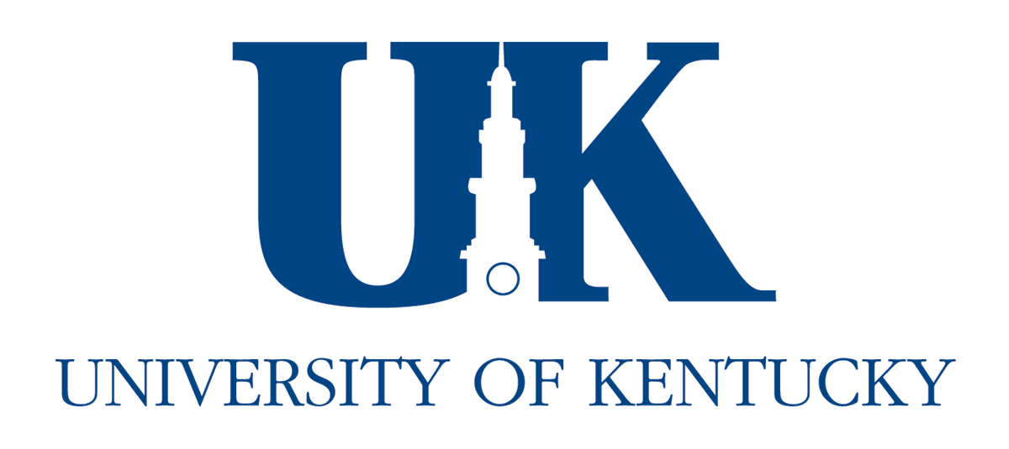

Office of Residence Life
Student Affairs
537 Patterson Office Tower
Lexington, KY 40506-0027
Phone: (859) 257-4784
Fax: (859) 323-4941
www.uky.edu

January 5, 2009

To Mr. Stauffer and the SEAHO Awards and Recognition Committee:

I am writing this letter of nomination on behalf of the New Economy Incubator Living Learning Community for the 2009 SEAHO Housing and Academic Collaboration Award. Since its inception in the fall of 2004, the New Economy has established itself as one of the most successful living learning communities at the University of Kentucky. Consisting of twenty-five freshmen students drawn from the College of Engineering and the Gatton College of Business and Economics, this program stresses the importance of partnership between those with engineering and business backgrounds. There are many reasons why this community represents such a noteworthy and successful collaboration between housing and partnering colleges.

The first of these reasons is the successful collaboration on the part of both colleges involved and the Office of Residence Life. The College of Engineering is directly represented through, Noah Meeks, our Engineer-in-Residence. Noah is a full-time doctoral student in chemical engineering who lives in the building and serves as a mentor and academic resource to students in the community. The College of Business and Economics is represented by Dr. Gordon Holbine who teaches the seminar course on management and leadership which all New Economy students must take. From the Office of Residence Life the six Resident Advisors and Resident Director of Ingels Hall work closely together to meet the academic and social needs of the community. In this they are assisted by our Learning Communities Coordinator, Leslie Woltenberg, and our Assistant Director of Academic Initiatives, Marianne Lorensen. Rather than “too many cooks spoiling the stew,” the collaboration between everyone involved in the colleges and the Office of Residence Life has been seamless and effective in providing a unique living learning experience for students.

Part of the reason that this experience is so unique is the strong variety of programming opportunities for students. The Residence Life staff strives to create innovative programs that stress critical thinking skills, problem solving, communication, and teamwork. Some of our annual events include:

- “Tower of Power” – A bridge building contest between teams of students to build the highest and most efficient free-standing tower using pasta, marshmallows, and gumdrops.
- “Bridge Building Contest” – The spring counterpart to the tower building contest. Students use plastic tinker-toys to build the most efficient bridge to span a two-foot gap which is then tested for the amount of weight it can hold.
- “Great Boat Float” – A competition held during the spring in which teams of residents construct boats using only cardboard and duct tape. Each boat must be able to hold one person and is tested in a competition at the campus aquatic center. Prizes are awarded for the fastest boat to cross the coal, the boat judged to be the most stable/seaworthy, and the boat with the most creative design.
- “Edible Architecture” – A design contest in which teams of students were asked to create representations of famous buildings and landmarks using food materials such as graham crackers, pretzel sticks, assorted candies, and cake frosting.
- “Women in Business and Engineering Dinner” – This program involves a catered sit-down dinner held in the hall. All female engineering and business students in the building receive personal invitations to attend. Female faculty and staff from both the College of Engineering and the College of Business and Economics are invited to the dinner to speak, network, and dine with the students.

Another program that draws wide appeal among New Economy students is our weekly “Dr. Pepper Hour.” This program was inspired by staff at Baylor University and consists of a weekly social in the main hall lobby where students are invited to have root beer or Dr. Pepper ice cream floats. Besides functioning as a regular social event geared toward our learning community students, faculty and staff are invited to attend to socialize with the students. Our students have been able to meet faculty, deans, advisors, and other support staff at this weekly event. This has also been an effective way to inform New Economy of opportunities such as approaching job fairs or study-abroad programs.

In addition to these regular events, Engineer-in-Residence arranges and leads regular plant tours each semester. These are meant to expose New Economy students to various businesses and types of manufacturing in the area and are ideal for engineering and business students alike. Some of the tours in the past have included a local Toyota plant, the local JIF peanut butter plant, and Ceredyne, a company that manufactures ceramic body armor for the U.S. military. New Economy students also receive business themed programming through regular “Coffee Talks” hosted by the Gatton College. This ongoing series involves successful business leaders being invited to speak to students in a comfortable and catered “coffee talk” setting. For the first three years of the New Economy these events were hosted within Ingels Hall but the number of participants has now exceeded the space we have in the building. Although this series has recently moved to another location, the Gatton College is very intentional in recruiting New Economy students to participate.

The collaboration between the Office of Residence Life and the two colleges is also evident in the enhanced academic support and amenities provided to students in the New Economy. Besides serving as a mentor and programming resource, our Engineer-in-Residence conducts regular tutoring sessions every Monday night in the hall classroom. The College of Engineering supplies additional peer tutors and pizza as well. This is a tremendous resource to students in the community as they can receive assistance with any level of math and get a bite to eat all without having to leave the hall. Both colleges have also realized that their students require access to various licensed software programs typically only found in campus computer labs. To increase the ease of access to these programs for New Economy students, the colleges have installed and regularly monitor twenty computer stations throughout Ingels hall. This allows New Economy students ready access to several software programs essential to their coursework. In addition to these amenities, the Engineer-in-Residence is allotted a programming budget to fund additional New Economy programming. Where our regular hall programming budget could only take us so far, the extra funds allotted to the Engineer-in-Residence mean that our staff is able to facilitate more programs of a better quality than we would otherwise be able to. The weekly tutoring, computer stations, and additional program funding are all representative of the support and assistance that the colleges offer to the New Economy program.

In conclusion, the New Economy Incubator Living Learning Community is an exceptional program that represents the best of what can be achieved through successful collaboration between housing and academics. The commitment on the part of the colleges and Office of Residence Life, the programming facilitated by the staff, and the additional financial assistance and amenities provided by the colleges all contribute to this great success. It is a partnership between housing and academics that we look to as an ideal model in shaping our other living learning communities. If I can be of further assistance in any way, please do not hesitate to contact me directly.

Sincerely,

Christopher Miller
University of Kentucky
Office of Residence Life
Resident Director
Ingels Hall
859-323-0700
clmilla@uky.edu

