NC STATE UNIVERSITY

North Carolina State University is a land- University Housing and Greek Life
grant university and a constituent institution 1112 Pullen Hall
of The University of North Carolina Campus Box 7315
Raleigh, NC 27695-7315
Antoinette Bonnie Candia
Assistant Director, East Campus
919.515.8736 (phone)
919.513-3430 (fax)
bonnie_candia@ncsu.edu (e-mail)

1/9/08

Dear SEAHO Conference Scholarship Committee:

I am writing this recommendation letter on behalf of Ms. Paris Kee. I have known Ms. Kee for seven months. Our affiliation is through University Housing at North Carolina State University. Paris currently serves as the Residence Director on southeast campus and I supervise Paris.

Paris displays strong character, diversity awareness, citizenship, and civility throughout her daily practices. Paris is dependable and overall displays an outstanding sense of confidence and ability to be successful in her administrative duties, personal, and professional practices. Paris works with a diverse community, which serve approximately 650 students and staff in the Avent Ferry Complex. Paris serves on various East campus and University Housing committee’s:
- University Housing RA Selection Graduate Liaison
- East Campus RA Training Facilitator
- East Campus Diversity Committee
- Advisor, PPGD (Personal, Professional, Growth and Development) Southeast campus.

Paris is committed to the field of Student Affairs and has a desire to further her career opportunities, post graduation. Paris is in good standing with the University Housing and will greatly appreciate the scholarship assistance SEAHO may offer. If you have further questions, please don’t hesitate to contact me at (919) 515-8736.

Sincerely,

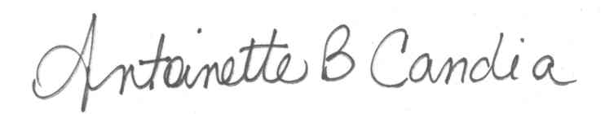
Antoinette Bonnie Candia
Assistant Director, East Campus

“Students Affairs
Division of Student Affairs”

