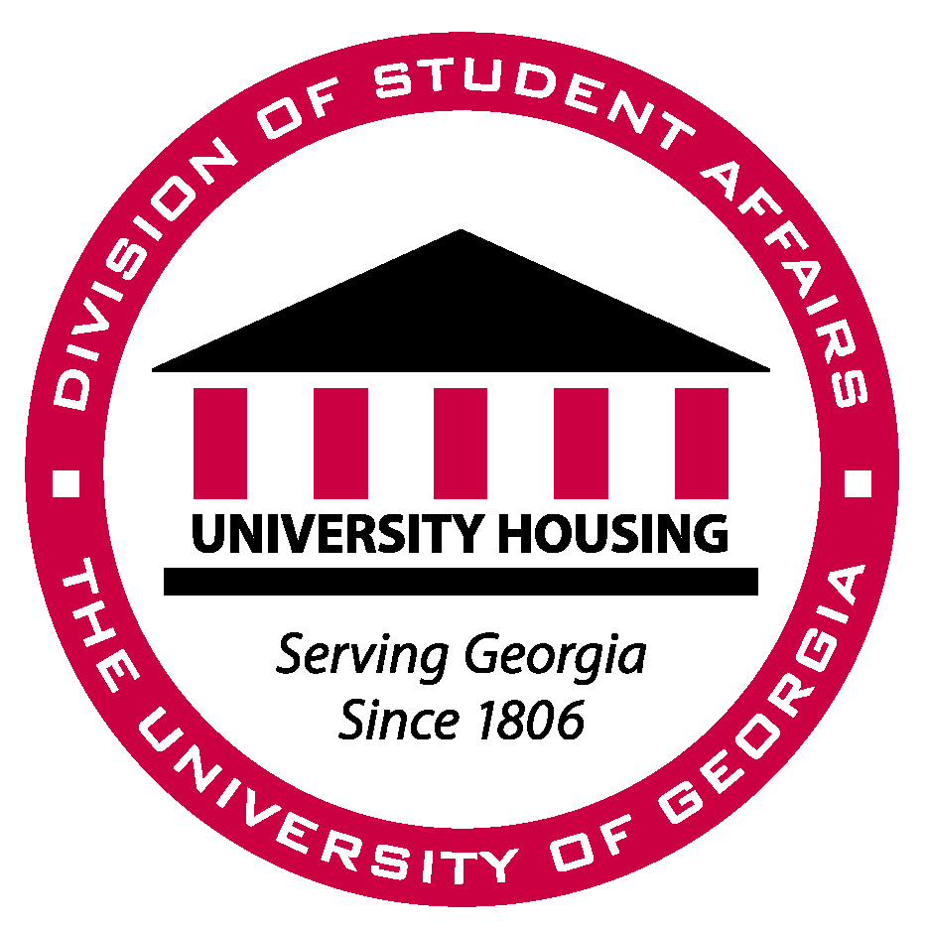
December 12, 2007

Southeastern Association of Housing Officers
Awards Committee

To Whom It May Concern:

The purpose of this letter is to nominate Ricky Boggs for the The James C. Grimm Outstanding New Professional Award. Ricky has worked in the Myers Community as a Residence Hall Director since the summer of 2006. This is his first professional position after graduating with his MA in Counseling from Marshall University in West Virginia. Ricky has demonstrated outstanding performance in his position at The University of Georgia while being actively involved in the Georgia Housing Officer’s state organization and SEAHO.

Ricky has a passion for his work and realizes how everything he does in his position supports the mission of the university and department. He understands his role helping students succeed and has had a great impact on our residents and staff. He is always willing to step up and take on responsibilities outside of his job description. He is the Chair of the Staff Representative Group for the Division of Student Affairs and Co-Advises the Residence Hall Association which is the governing body for residential students.

Ricky respects the importance of involvement with professional organizations and gives back by serving in a volunteer capacity. He serves as the webmaster for Georgia Housing Officers state organization and is on the SEAHO Report editorial staff. Ricky is dedicated to the housing profession and actively shows this through professional organization involvement

This past fall Ricky began another part of his professional and personal journey entering into the College and Student Personnel Services PhD program at The University of Georgia. He is enrolled part-time in the program and has taken on this challenge to further his learning to become a better professional. Ricky has done an excellent job balancing his priorities with work, education, and family.

Beyond all of the things Ricky does professionally, he is a great person and someone who cares deeply for people. Ricky has reached out to many of our new staff members this past year and has become a leader amongst his peers. I believe he is able to do this because of his caring personality and openness. There are many great new professionals throughout our profession and I believe Ricky Boggs stands out amongst his peers as an “Outstanding New Professional”.

Sincerely,

Mark A. Whitesel
Area Coordinator
The University of Georgia

