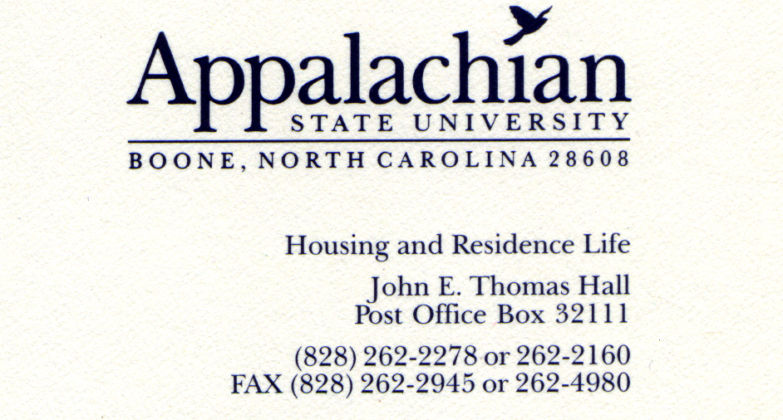

SEAHO Award Selection Committee,

What follows below are comments from Appalachian State University staff who wanted to contribute to Sarah Chapman’s nomination for the SEAHO Outstanding Mid-Level Professional Award.

“Sarah has been a phenomenal asset to the Yosef Hollow community. She has guided new RA's to standards in which they should be performing at, or even to points to where they will excel. Her administrative abilities have been phenomenal while working with the area. For instance, I once had a rough experience in the residence hall and completed an incident report that was promptly sent to Sarah. She personally thanked me for the outstanding follow-up with the situation, and for writing an outstanding IR. It is little moments like these that helps the RA today develop into the RA of tomorrow. The words of gratefulness, encouragement, "good jobs!," and her personal thoughtfulness are all things that makes Sarah what she is...a great supervisor.”
Davonté McKenith, Resident Assistant

“Sarah is energetic, full of enthusiasm and encouragement for her staff and co-workers. Sarah is the ultimate description of personality working in Student Development, always looking out for the students and the under -represented population, both two legged and four legged. Sarah has a LARGE caring heart full of ways to recognize and thank people. It doesn’t matter what the event or task, Sarah is helping in some way. She was so excited this past holiday season to be selected to ring the bell for the Salvation Army and spent several cold nights at her assigned posts. Sarah organizes blood donation drives, even in locations off campus for the community. If you looked up the word “giving” it would have a photo of Sarah, because she is always giving of herself and puts others needs before her own.”
Janice Smith, Administrative Assistant

"To not choose a person of the character and quality of Sarah Chapman for this award would be folly. SEAHO defines this 'Outstanding Mid-Level Professional' firstly as a person who supports and mentors staffers, which is the same definition that could be used to describe how Sarah Chapman approaches her work. In addition to doing a great job with her own area, Sarah has helped me as a first-year staff member transition into the role of a professional. Understanding that at times new professionals struggle but may be reluctant to ask for help, Sarah reaches out with her support and her resources at the onset of projects. She does this in a way that is caring without encroaching. When I needed to complete several presentations for RA training, it was Sarah who gave me activities on 'confrontation' or presentations on 'supervision,' so that I would know what had been done in the past and could build from that rather than starting from scratch. Additionally, Sarah has a keen sense of creativity and innovation to get staff excited about working in Residence Life. For instance, she completely redesigned our training for mid-year hires this year, changing it from a cram session of policies to a retreat-style training that the staff really responded to and could better connect to their new roles as Resident Assistants."
Aaron Voyles, Residence Life Coordinator
“I have learned a lot working for Sarah this year. She has been patient and kind teacher, helping me put both staff and resident issues into perspectives. She encourages each of her residence directors to be independent, while always giving us her support. Sarah consistently goes out of her way to help anyone on staff when they need something, and keeps her office open whether you have a question or just need someone to talk to. One of the most important thing she does for me is ask questions, whether discussing programs or RA evaluations she makes sure things are thought through. Working with her has made me better in my role, and I look forward to learning more from her.”
Rebecca Driesen, Residence Director

“I just wanted to say that it has been a pleasure to work with Sarah Chapman. She has been a very organized area coordinator that is always full of enthusiasm and support for all of the staff members in our area. She always has a smile and a good joke to share with everyone and I have truly enjoyed getting to know her over the past few years. She does a great job at generating and developing program ideas which is very helpful as one of her staff.”
Heath Towson, Resident Assistant

“Sarah is one of our biggest ‘campus citizens.’ She is generous with her time, her belongings, and her money. I work with the volunteer service & service-learning office on campus, and Sarah is one of our biggest champions and most frequent volunteers. She routinely volunteers to serve as a project site leader, Alternative Spring Break staff guide, blood drive donor & volunteer, volunteer committee projects, and more. The thing that most impresses me is the attitude with which she does everything, and I do mean everything. In a high-paced, potentially stressful job, Sarah keeps her calm & cheerful attitude with everyone she encounters. Simply put, she is one of the most positive people I have ever met. Plus, she's an angel just when you need it: at the height of my hunger, in the middle of our 1000-pint blood drive, Sarah appeared with food for me and other committee members that she had personally purchased at the restaurant next door. That food made the difference and the organizers rejoiced! It is a thoughtful gesture like this that is so typical of Sarah.”
Jenny Koehn, Associate Director for Student Programs

“Sarah's commitment to students and her staff are beyond comparison. She seems to have an unlimited source of energy, enthusiasm, and compassion than anyone I have ever worked with.”
Tom Kane, Ed.D., Director of Housing and Residence Life
“Sarah Chapman is always smiling and always takes the extra step in making Yosef Hollow Staff feeling comfortable. She puts littles notes in our boxes during special events. For example, she gave us treat bags after the first week of training and she gave each person a cute Christmas goodie. Also, she is energetic at our times and does random acts of kindness such as baking cookies and dropping them at our staff meetings.”
Jeanne-Claire White, Resident Assistant

“I have worked with Sarah approximately one year. I chose to move to Sarah's area because of her outstanding leadership. Sarah is the most positive person I have ever worked for in the profession. She does an outstanding job recognizing the 30 RAs and 4 GAs in her area. She continuously writes personalized notes to RAs that are doing great things, as well as to the RAs that could use a thinking of you message. She pushes me to be a better professional. I am a more organized, dedicated, and much more creative professional because of Sarah. No one works harder than her! I can speak from experience, Sarah positively impacts her students and staff on a daily basis.”
Brandon Nelson, Residence Director
"Sarah Chapman is not only a great mid-level housing employee, but she is also a great friend to everyone within our community. Personally she has helped me in so many ways as I prepare a future in higher education and I know that anytime I have a question or need advice I can go to her. She definitely deserves this award!”
Samuel Byrd, Resident Assistant

“Sarah Chapman is a servant leader - she leads by example. There are many, many projects that we have worked on together in the past. The one that stands out for me is the Don't Throw It Away Program. Sarah is right there working away with all of us as we sort, carry, and load items that students have left in the residence halls and in the dumpsters. She is energetic, committed, enthusiastic, and fun for all who are working with her.”
Susie Greene, Associate Vice-Chancellor for Student Development and Dean of Students

“It is my honor to write regarding Sarah Chapman’s nomination for the SEAHO Outstanding Mid-Level Professional Award. Sarah is always going above and beyond to help her graduates that work for her and the Resident Assistants that work in her area of supervision. She is a fun and happy person who will always make you feel good about yourself. Sarah truly cares about how you are doing-whether it is the latest program that your staff was planning for the building or a research paper that she knew you had been working on. Her positive attitude helps her staff work hard and Sarah is always willing to help you out. I consider Sarah to know anything and everything about our housing and residence life policies. My RA staff knows that they can go to Sarah about anything because they have told me plenty of times that she is very approachable. Students who live in our building love Sarah and know who she is because Sarah has that presence in the area. Sarah has a program that she holds every Tuesday night which is called “Tollhouse Tuesdays.” Sarah will make cookies and bring them out, despite what the weather may be, to the area where students will hang out and smoke cigarettes. Sarah does this program to remind residents that they need to stay in this specific area because it is 50 feet away from the building. Sarah has even worked on bringing in peer educators to inform the students on how they can stop smoking. Students look forward to this program on Tuesday nights and respond well to Sarah when she reminds them of the policies. Sarah is respectful and trustworthy. I can always go to her and know that she will listen to me and provide feedback. Sarah responds to emails and phone calls in a timely manner which makes her reliable to her graduate and student staff. One thing that I appreciate about Sarah is that she challenges and supports, but she understands that her graduate students need to learn from experience. Sarah allows me to have control over my building and express my ideas freely for what I think would be good for my staff. I have learned so much from Sarah about being a professional and making that transition from an undergraduate student to a graduate student. Sarah was very intentional with conversations that we had and allowed me to work through the process on my own. Sarah does so much for so many people here at Appalachian State University that she deserves this award to remind her that people think she is amazing and wonderful.“
Kristan Cardinali, Residence Director

“After working with Sarah for nearly three years, I am always amazed by her dedication to the job. She models the core values of the department every day and I have often been inspired by her ability to find the best in any situation. When the staff is given more work to do Sarah's response is always, ‘What a super-nifty, new challenge; I can't wait to get started.’
The truth is, Sarah craves new challenges, as evidenced by the improvements she has made to every committee she has served on at the university. Her efforts on the training committee, retention services committee, diversity committee and many others have resulted in creative solutions that have been re-used by committee members long after Sarah is no longer with the group. I have lost track of the number of times that I have heard an administrator say, ‘Our plan for the committee this year is based off of what Sarah created last year.’
Sarah is the person I call whenever I have a question about the best way to carry out a task or if I have a procedural question. I have noticed that other staff use Sarah as a resource, too, and I have even heard out director refer to her as, ‘the go to person for Residence Life information.’ I appreciate that Sarah rarely seems frustrated by everyone interrupting her work to ask questions. She makes me feel glad that I asked for her help. I have genuinely enjoyed working with Sarah these last few years and I thought it was time that other professionals in the region knew how wonderful she was to work with, too. “
Cathy Roberts-Cooper, Coordinator of the Living Learning Center
“I have had the privilege of working with Sarah Chapman for the past three years in my capacity as co-chair of the Diversity Celebration Planning Committee at Appalachian. Sarah is currently the co-director off the Unity Festival, the family-friendly hub of this university/community festival. Sarah is an individual absolutely lit from within, and whatever her sphere of activity, the brightness translates. Spokes to other avenues of action radiate from the central element of her mission - whatever it is. If it's designing decorations for ten different venues for the Celebration, the translation is engaging the Diversity Committee in HRL to participate. If the request for her involvement is tangential for another ASU program, like Open Door, the circle of concern widens with her every effort on its behalf, and into arenas where the program directors would otherwise not have easy access. More times than I can count I have recommended her for other committees, almost immediately biting my tongue at the prospect of losing her on ours. Somehow - and I am not sure how this has happened - we have managed to keep her.

Sarah inspires, galvanized, includes and challenges her constituents – and herself - and produces results, whatever her task. I have never seen her beautiful face not lit with a smile. I have never heard her say no to any request for her help, though surely she has done so once or twice, or there'd be nothing left of her. She always takes time to talk. She never seems to be in a hurry. When people participate in an effort under her leadership her thanks are swift and tangible. There's so much more I could say, but there's probably not room on whatever form these words will occupy. So in conclusion: Sarah Chapman
is a creative and skillful manager, a compassionate human being, and a primary contributor to the success of every endeavor of which she is a part. I cannot recommend her highly enough for this award.
Susan King, Co-Chair, Diversity Celebration Planning Committee, Office of Equity, Diversity & Compliance

“I have worked under Sarah Chapman now for two academic years, and she has served as a wonderful resource and support for me. As a senior applying to graduate programs, she has worked hard to give me potential application questions and excellent recommendation letters so I can be the best applicant for the positions. She also has always encouraged me. At every winter break she hand-makes small ornaments for the entire staff. After large milestones, like opening day, end of the semester, etc., she has also written sweet cards to both me and my entire staff. She has always done an excellent job recognizing staff members who go beyond their call of duty to help with major incidents with residents and with herself. One member of my staff this year helped her extensively with some issue with her car. She recognized him with a card of the deepest appreciation.
I have also served on the RA Development and Training Committee under Sarah Chapman. Her leadership style is more relaxed compared to some full-time staff and I appreciate her willingness to listen to every idea presented by any committee member. Never in my years of working with Sarah have I ever felt that my ideas are unvalued or unwanted, even if they are silly. When selecting a theme for January training, our list of potential themes increased to approximately thirty so we could accommodate everyone's ideas. With so many potential themes, Sarah Chapman also helped us all to select one out of those thirty themes in an organized manner to use at training. She never appeared frazzled or discouraged, but thoroughly enjoyed working with us to put together a great January training.
These simple characteristics are found in most ACs across campus. What helps make Sarah stand out is her constant positive attitude. I have never seen her not perky and happy, even at late night calls or the next day when I know she did not get a lot of sleep. I don't know exactly how to explain this, but she is always smiling and happy. Every time I see her in the office, she greets everyone with a smile and knows most of the names of every RA on campus. She loves students as well. Many Tuesdays during the semester she has "Tollhouse Tuesday" where she bakes cookies for the smokers. Many smokers feel uncared for simply because the 50 foot smoking rule has forced them away from campus buildings. Her caring cookies remind these students that someone does care for them.
In essence, Sarah Chapman is an excellent employee. She supports the staff and encourages them constantly. She takes everyone's opinion into account and keeps her composure even in difficult circumstances. And finally, she loves students and does her best to make all students feel welcomed and cared for.”
Courtney Bell, Resident Assistant

