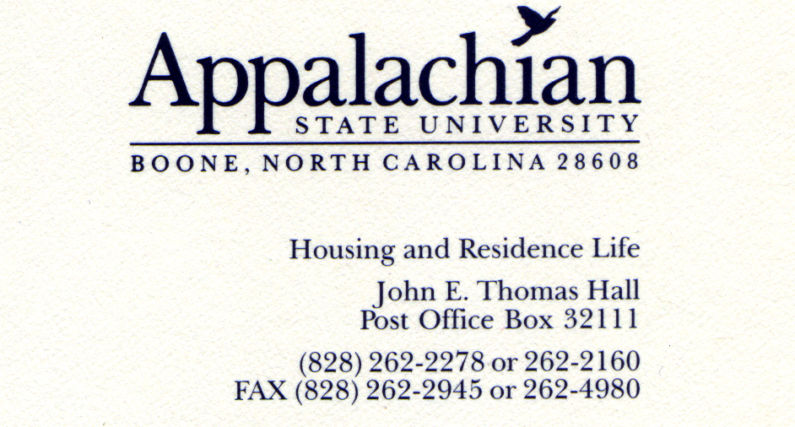

To Whom It May Concern:

As I reviewed the criteria for SEAHO Outstanding Mid-Level Professional Award, I am certain that Sarah Chapman is well-deserving and also know that my colleagues will tell you about Sarah’s impact on our department. I’d like to take this opportunity to tell you about another aspect of Sarah Chapman’s character that supports her nomination for this prestigious award, which is her willingness and dedication to serve others.

Three years ago, Housing and Residence Life at Appalachian State University hired a Residence Director from Bulgaria. When this student arrived, it would be her first time in the United States: she would know no one, would only have her luggage from the plane, would have to learn customs and traditions of a new culture, and find a way to make Boone, NC, her home for two years. Sarah immediately recognized that this would be difficult and made it her mission to help our new RD with whatever she needed, whenever she needed that assistance. As two years of assistance amounts to quite a bit, I’ll limit this to a few examples.

The first thing Sarah did was contact the coordinator for our Appalachian and the Community Together office to determine if we could use donated items to provide some household furnishings like a lamp, trashcans, fan, bedding, and small appliances to our Residence Director, so that the she would not have to purchase these items her first night in the United States. Sarah also helped this student acclimate to our community by taking her to the grocery store, showing her how to get to the farmer’s market, spending an entire Saturday sitting in a Verizon store while this student worked out the details of selecting a cell phone and plan that would provide her with the best rates to call home and keep in touch with family.

Sarah is also involved within the Boone Community and makes sure that she is giving back in whatever way she can. “I decided that the only reason I wasn’t donating blood was because I was afraid of needles, once I thought about this I realized that there was not a logical reason to let my fear stand in the way of possibly saving a life” and it is with this thought that Sarah Chapman became a committed volunteer and donor with the American Red Cross. Sarah gives blood at every opportunity she has and makes multiple trips during the year to a platelet donation center located two hours from Boone so that she can help someone in this way as well. When a blood drive is in need of volunteers to help organize, set-up, advertise, and run logistics of the registration process, Sarah is always willing to step in and give a few hours, which has made her someone that is called regularly to step in at the last minute and assist.

As a live-in staff member, Sarah is not allowed to have a pet, so she spends time at the Watauga County Humane Society volunteering and getting in what she refers to as “puppy time.” She spent a Saturday painting one of the rooms at the Humane Society because she saw a need and asked how she could assist. Because of her relationship with the staff at the humane society, Sarah has been able to arrange special activities that not just anyone can, for example she has organized numerous “puppy play dates” in our halls so that students can de-stress at exam time and relax by playing with a puppy. This process involves Sarah checking the website to find new litters of puppies, calling the humane society and arranging a pick up time, transporting the puppies to the hall, and working with our housekeeping staff to make sure that the area is cleaned after use without requiring extra work of the housekeepers. Sarah also recognizes that students may be allergic to animals, so she posts information well in advance of the program and helps the students find routes within the building that avoid the puppy play date location.

While her generosity extends to our graduate and undergraduate staff, her colleagues, and the Boone community, it also extends to our campus community. During her first year at Appalachian State University, Sarah learned of a need to enhance the campus and community-wide Diversity Celebration. Sarah eagerly stepped in and offered to arrange all the decorations that were needed, which included decorating every room with a different theme in our student union. That first year, Sarah spent most of the day and night by herself hanging pictures, blowing up balloons, and decorating these rooms. The next year, she recruited some student helpers and during her third year was able to organize the logistical aspects of which decorations went where, but left the actual decorating to students. Now, Sarah has stepped up to chair one aspect of this day which is geared toward educating and entertaining children who attend the celebration.

Mentoring, recruiting and supporting colleagues at any level is an essential element for this award and Sarah Chapman is dedicated to all three of these areas; however, it is her selfless nature and genuine willingness to help out others that sets her apart from other nominees. As a friend and colleague, I enthusiastically support Sarah Chapman’s nomination for SEAHO Outstanding Mid-Level professional.

Sincerely,

Julie Lassalle
Coordinator for Sorority Life and Living
Appalachian State University

