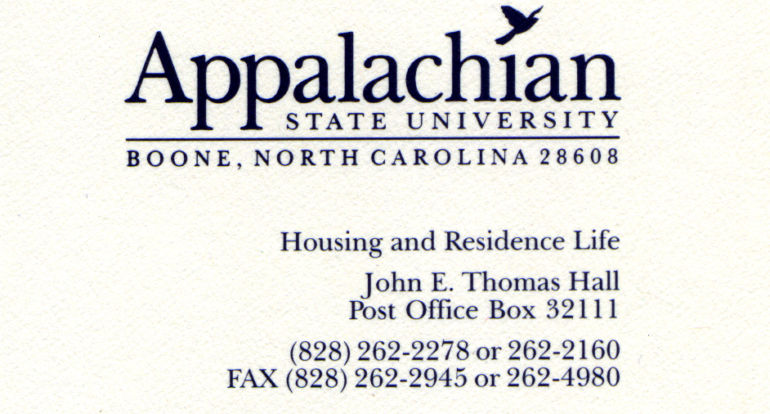
01/12/10

Dear SEAHO Awards Selection Committee,
It is with great pleasure that I nominate Sarah Chapman for the SEAHO Outstanding Mid-Level Professional Award. I met Sarah when I began working at Appalachian State University in July 2008. During that time, Sarah has demonstrated exceptional characteristics that make her very deserving of this award.
During my first months as an Area Coordinator, Sarah taught me the ropes of the position and the department. She always sacrificed her time to answer my questions and help me with my work. As a person who does not like to ask for help, it was a big deal that I felt very comfortable going to Sarah for help. During my time here, I have labeled Sarah the “Welcome Wagon.” Anytime there is a new staff person – desk assistant, RA, graduate student, or full-time employee – Sarah is the first to make welcome signs, greet the person, provide information, and offer help.
Sarah does a remarkable job keeping policies and processes organized. It became a trend that during certain times of year (i.e., opening, closing) full time staff would gather to remember how we did something the previous year. Sarah is the person who collects our data and recollections to create documents containing our processes and policies. This benefits our entire campus as she is able to ensure everyone is clear about our responsibilities as we welcome and serve our on campus residents.
Finally, Sarah not only commits an exceptional amount of her life to Housing and Residence Life, but she is also dedicated to service. She supports nearly every cause on campus. She sets up many of the blood drives on campus and volunteers for campus wide service events. She also initiates service projects in her own buildings; usually bringing dogs in from the Humane Society to raise money for them. What she cannot participate in, she donates to the cause. Sarah’s goal is to have a $0 balance in her checking account at the end of the month, meaning that whatever money she does not need to live on, she donates to other causes.
Sarah is one of the most giving individuals I have ever met. She has been integral in my transition to Appalachian State, as she has been to many others. There is no one I can think of more deserving of the Outstanding Mid-Level Professional Award than Sarah Chapman.
Sincerely,
Shari Williamson

