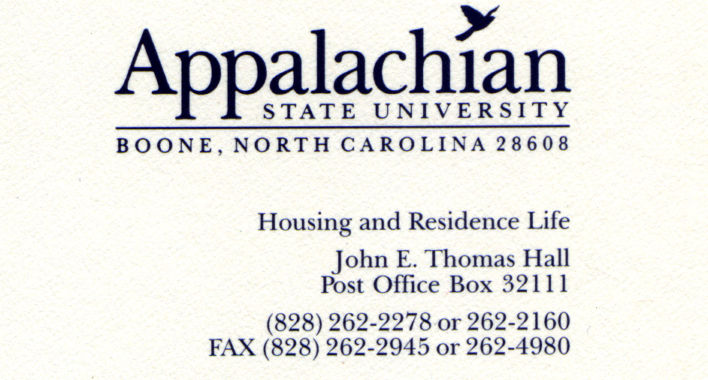

1/13/10

SEAHO Award Selection Committee,

It is with great excitement and pride that I write this letter for Sarah Chapman to win the SEAHO Outstanding Mid-Level Professional Award. My hope is that this letter, in addition to the other letters and supporting quotes, convey a real sense of the impact Sarah has had on Appalachian. It would not do justice to Sarah’s candidacy to begin with Sarah’s accomplishments in her time at Appalachian. These achievements are numerous and will be mentioned, but they pale in comparison to the impeccably positive attitude, exceedingly hard work, and extraordinary caring nature that Sarah demonstrates on a daily basis.

I look forward to my initial greeting with Sarah every day, as she undoubtedly smiles and greets me as if I am her favorite person. The fact is, everyone is greeted this way by Sarah. The emotional energy it would take me to do this would leave me exhausted by 9 a.m. It seems as if each day Sarah is alive is her favorite day of the year. She can describe the joy of completing conduct letters, cleaning her office, and sitting in a boring meeting with the same enthusiasm reserved for our many more engaging responsibilities. But she would rather talk about you than her and displays this interest in remembering many details about everyone’s lives and gently asking us about ourselves with this interpersonal insight. Sarah’s day begins early and ends late. She works fast and hard and accomplishes in one day what would take many people an entire week. She reads voraciously and is well-informed of the changing trends in housing, student affairs, and the world. She balances her time in the office and in the halls in a manner most hall supervisors struggle to do. She gives feedback and mentors staff with a kindness rooted in an empathy of having been there before. She reaches out to students with diverse backgrounds in a manner that leaves them feeling included and welcomed. In short, Sarah is the consummate professional and ideal Mid-Level Professional.

In her 7.5 years as a full-time residence life professional, Sarah has established a legacy for service to students and the profession that is going to ultimately result in an award in her honor someday. As a member of the Appalachian State residence life staff the past 3.5 years Sarah has been instrumental in the following departmental achievements above and beyond her existing job responsibilities as an Area Coordinator;

- Volunteered to chaired the Recognition Committee and coordinate 6 different recognition days for various staff roles during the year in addition to an end-of-year departmental banquet based on an award nomination process that required significant work
- Volunteered to lead a series of job search workshops for graduate assistants that involved multiple outside speakers and prepared cards and gift boxes for 2nd year graduate students that resulted in some of the best equipped and supported graduate students at placement conferences.
- Volunteered to serve on a student conduct process task force that fundamentally improved the process for residence life staff in hearing cases
- Created a program called Tollhouse Tuesdays to reach out to students who are forced to smoke 50 feet from all halls (Boone winters are harsh), in which she takes these students free cookies and basically shares her support for them (and offers them handouts on how to quit smoking).
- Volunteered as the only full-time staff member to ask to work alongside Residence Hall Association members in planning and helping support Appalachian’s hosting of the NCARH Conference.
- Volunteered to lead annual workshops, in collaboration with facilities staff, for residence life staff on end-of-semester and end-of-year closing procedures.
- Volunteered to serve on the University Staff Council in addition to leading subcommittees within this group.
- Volunteered to serve on the Greening Committee for the Union in addition to helping recycle after football games.
- Volunteered to serve on the Diversity Celebration Committee and ended up being in charge of decorations for this huge campus-wide event for several years.
- Volunteers to work with the Don’t Throw It Away program twice a day for a week multiple years in driving a truck and picking up student belongings left behind at the end of the year which are then sold to raise money for charities.
- Volunteers to take any leftover food from staff training events to the local homeless shelter so that it can be wisely used.

I could go on but I hope you are getting the picture that Sarah is not content with simply doing her job; she brings a personality that makes her one of the most outstanding employees of the university. I am regularly at university or divisional meetings where people who when they hear the department I work in, thank me for hiring Sarah Chapman because of something she has done to make their jobs or lives easier.

Knowing part of criteria for this job includes professional involvement, you should know that Sarah has served for years in leadership roles in both SEAHO and NCHO. She has been on the programming committee for NCHO and is the current chair of this committee. She also was an editor for the NCHO newsletter and has assisted in reviewing programs for ACPA. She chaired the Human Relations committee within SEAHO for over 2 years and has continued to serve on that committee since stepping down as chair.

I am confident that Sarah is one of the most outstanding mid-level professionals in SEAHO region. Not only myself and our department would rejoice in this honor for her, but most of the student affairs division and many university partners would be excited to see Sarah win this award. I really hope Sarah can get the recognition she deserves from an organization she care so much about and has invested so much in. If you have any questions about her candidacy please let me know. Thank you.

Jeff Doyle, Ph.D., Director of Residence Life and Adjunct Graduate Faculty
Appalachian State University, 828.262.2160, doyleja@appstate.edu

