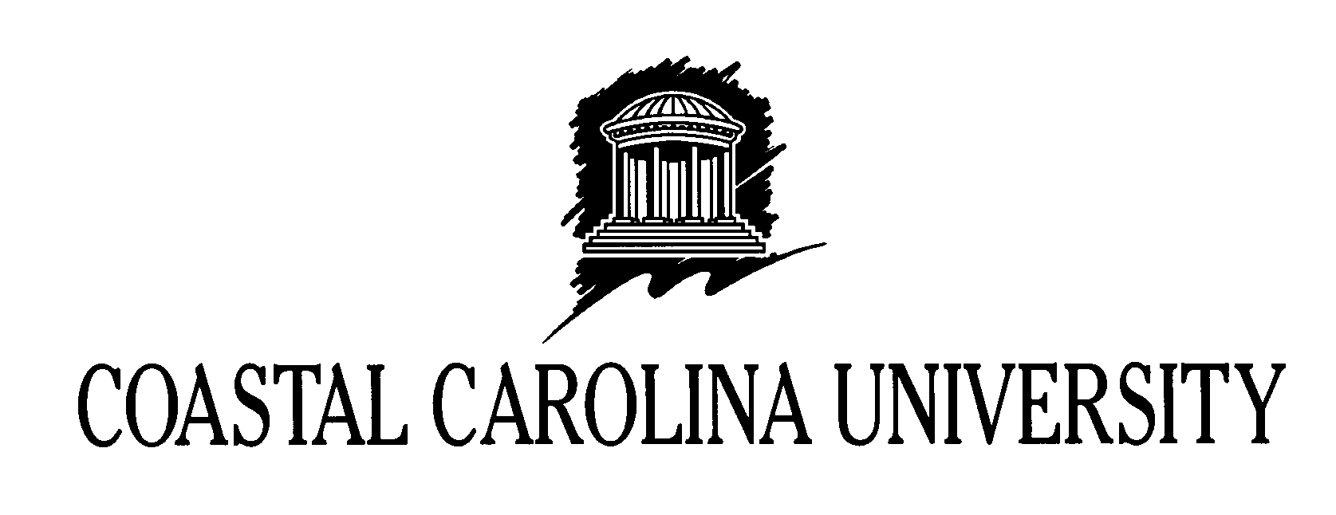
The Vice President for Student Affairs

Date: January 11, 2008

To: Whom It May Concern

From: Lynn Willett, PhD
Vice President for Student Affairs

Re: Nicole Svonavec

I am writing to recommend Nicole Svonavec for the James C. Grimm Outstanding New Professional Award. I have known Nicole since July 2006, while she has served as a Resident Director at Coastal Carolina University. During that time, I have had the opportunity to observe her work and her personal characteristics and can comment on her qualities with confidence. Nicole has many outstanding skills and characteristics, but I will highlight several that have made her an excellent employee.

First of all, Nicole has a solid work ethic that she applies to her duties and to the additional work for which she volunteers. She is eager for new experiences and is quick to identify what needs to be done and then does it.

Secondly, Nicole has a naturally collaborative work style and as a result, is a successful and productive team member. She is personally secure and willingly shares credit with others – even if that means having her own accomplishments overshadowed.

Thirdly, Nicole is an excellent role model for students (and her colleagues) and understands how to work in a professionally-friendly manner with students. She acts according to what is in the best interest of the students and makes her personal and professional decisions with integrity.

Nicole is serious and committed about her career and those qualities make her a valuable colleague. During my years in ACUHO-I, I worked with Jim Grimm and always had a great admiration and respect for him. I am so pleased to be able to nominate a young professional who I also admire and respect for this award that honors him and his contributions to our profession.

