NC STATE UNIVERSITY

North Carolina State University is a land- University Housing and Greek Life
grant university and a constituent institution 1112 Pullen Hall
of The University of North Carolina Campus Box 7315
Raleigh, NC 27695-7315
Lisa LaBarbera
Associate Director, East Campus
919.515.3706 (phone)
919.515-9656 (fax)
Lisa_labarbera@ncsu.edu

January 12, 2009

Steve Stauffer
University of Kentucky
SEAHO Awards and Recognition Committee

Dear Mr. Stauffer;

It is my pleasure to write a letter of support for Paris Kee in her efforts to secure a SEAHO Conference Fee Waiver Scholarship. Paris is in her first year as a Graduate student in Higher Education at North Carolina State University and also serves as a Residence Director with University Housing on East Campus. As the Associate Director for the area where Paris works, I have been fortunate to watch a new professional begin to grow and look for ways to become involved in the field of Higher Education.

Paris came to NC State after working as an RA at East Carolina University. It was clear even during our Grad Training that Paris was engaged, wanted to learn and looking for every opportunity possible to become involved in the field of Higher Education. She used her experiences at ECU to provide a base of knowledge to share as well as build off of. Paris understands that her time as a Graduate Student is filled with learning, and she actively looks to participate in every opportunity possible in order to take advantage of her time as a student. Throughout the course of this year Paris has:
- Actively volunteered to be a part of presentation and planning groups that further the mission and vision of her campus.
- Proactively sought out additional reading and learning opportunities to help her grow as a professional.
- Taken part in activities outside of University Housing that will enhance her tool belt of knowledge. Paris is now a certified National Coalition Building Institute (NCBI Diversity Trainer).
- Attended NCHO and actively participated in mentorship sessions and programs.

Hard times in the economy have hit all of our institutions. Graduate students looking to increase their professional knowledge have perhaps been the hardest hit. The funds provided by this scholarship are crucial to Paris’ ability to attend this conference. I believe that Paris Kee is an excellent candidate for the SEAHO Fee Scholarship Waiver. She has already demonstrated her desire to learn, as well as an ability to give back to her campus and its students. Not only would Paris personally grow from attending SEAHO, but she would also actively incorporate all that she learns into her everyday practice.

If I can provide you with any additional information, please do not hesitate to contact me at (919) 515-3816 or via e-mail at lisa_labarbera@ncsu.edu

Sincerely,
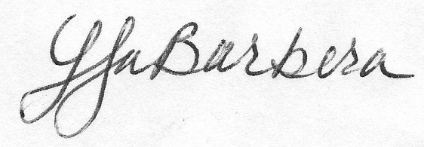

Lisa LaBarbera
Associate Director
University Housing, East Campus
North Carolina State University

