Muhammad Oomar Farook Damaree

Student ID : 21564419

batch: Monday 8.30 a.m to 10.30 a.m, venue: it lab ( Mauritian time)

Introduction to Software Enginnering Assignment.

Introduction

A very brief overview of the assignment that I have completed consist of 2 programs. One displays an image of the season depending on the use input whereas the other program will display messages on the screen depending on the user input or input from a file to help the user figure out if the temperature is high or low and more.

Module description

Original codes (before refactoring)

For the first program -the season program (country name and year.py) -, I have designed and implemented 3 modules, namely Name_Month() ,season1() and image()

Modularity

(i)country_name_and_year.py

Note:

1. ‘country name and year.py’ or country_name_and_year.py will need the following in the same folder to work properly.

autumn.png

birak.png

bunuru.png

dijiba.png

djeran.png

inter-monsoon.png

kambarang.png

makuru.png

monsoon.png

northeast monsoon.png

southeast monsoon.png

spring.png

summer.png

winter.png

wrong.png

To run country_name_and_year.py, the user will have to follow the prompts on the screen as shown below. The user has to enter the name of the country and the number of the month in order to determine the season

If the country name is wrong or not present in our database and the month number is right, the user will be prompted an error message.

If the country name is right but the month number is wrong, the program will prompt the user till he enters a correct month number.

Then, as output, the picture of the season and the country name along with the name of the season will appear as title of the picture.

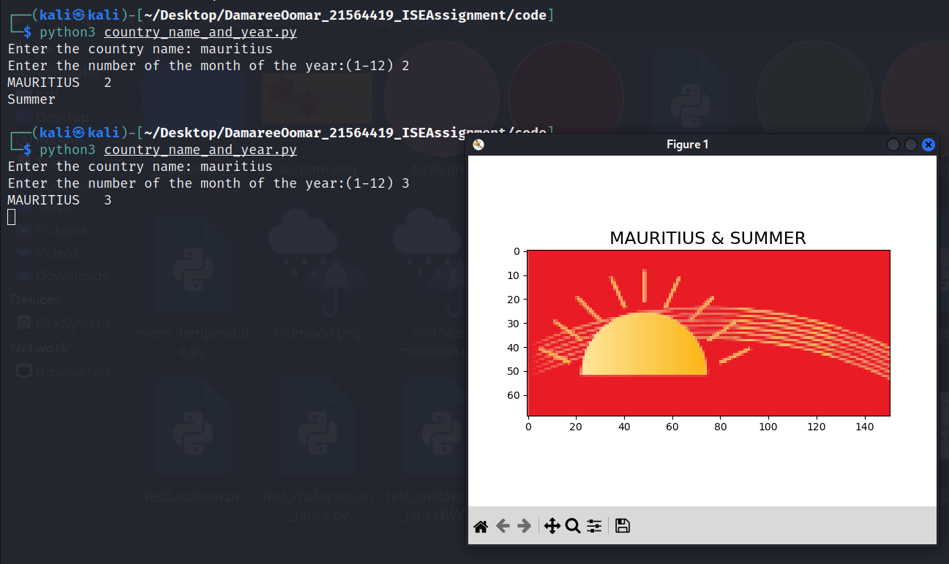

**Modularity concept review(before refactoring the code)**

|  |  |  |  |  |
| --- | --- | --- | --- | --- |
| Item | Checklist question related to modularity | Yes/No | How many times does it happens if no and applicable | Description of the issue if No is the answer? |
| 1 | Is the number of global variables zero? | No | 2 global variables | Can cause ambiguity and might become difficult to bring change to the program /high coupling |
| 2 | Do all our functions take parameters which do not acts as control flags? | No | 3 times | Causes low cohesion and high coupling |
| 3 | Are all functions performing only a single distinct task? | No | 1 time | Cause low cohesion |
| 4 | are we reusing our function to do the same task? | No | nil | Doing redundancy |
| 5 | Is there no overlapping of our code in our modules/functions/programs? | No | 2 | Doing redundancy |
| 6 | Are we using all part of our code? | No | 1 | Causing ambiguity and decreasing readability. Might cause an issue while debugging and refactoring. |

**Modularity concept review(After refactoring the code)**

|  |  |  |  |  |
| --- | --- | --- | --- | --- |
| Item | Checklist question related to modularity | Yes/No | How many times does it happens if no and applicable | Description of the issue if No is the answer? |
| 1 | Is the number of global variables zero? | No | 2 global variables | Can cause ambiguity and might become difficult to bring change to the program /high coupling |
| 2 | Do all our functions take parameters which do not acts as control flags? | No | 7 times | Causes low cohesion and high coupling |
| 3 | Are all functions performing only a single distinct task? | Yes | nil | Cause low cohesion |
| 4 | are we reusing our function to do the same task? | No |  | Doing redundancy |
| 5 | Is there no overlapping of our code in our modules/functions/programs? | Yes | nil | Doing redundancy |
| 6 | Are we using all part of our code? | yes | nil | Causing ambiguity and decreasing readability. Might cause an issue while debugging and refactoring. |

Various places we have decreased the level of redundancy, but it has increased the level of coupling.

Black-box testing

(i)country_name_and_year.py

**Assumption**: Name_month() module prevent any input of number of month to be out of the range of 1 and 12

**Equivalence Partitioning**

|  |  |  |
| --- | --- | --- |
| mauritius() |  |  |
| **Category (month)** | **Test Data** | **Results(season)** |
| 10< month< 13 or 1<= month <= 4 | month = 3 | season = "Summer" |
| month = 5 | month = 5 | season = "Autumn" |
| 5 < month < 10 | month = 7 | season = "Winter" |
| month = 10 | month = 10 | season = "Spring" |

**Equivalence Partitioning**

|  |  |  |
| --- | --- | --- |
| australia1() |  |  |
| Category (month) | Test Data | Results(season) |
| month = 12 or 1<= month <= 2 | month = 12 | season = "Summer" |
| 2< month < 6 | month = 5 | season = "Autumn" |
| 5 < month < 9 | month = 7 | season = "Winter" |
| 8< month < 12 | month = 10 | season = "Spring" |

**Equivalence Partitioning**

|  |  |  |
| --- | --- | --- |
| australia2() |  |  |
| **Category (month)** | **Test Data** | **Results(season)** |
| month = 12 or month = 1 | month = 1 | season ="Birak" |
| month = 2 or month = 3 | month =2 | season = "Bunuru" |
| month = 4 or month = 5 | month =4 | season = "Djeran" |
| month = 6 or month = 7 | month =6 | season = "Makuru" |
| month = 8 or month = 9 | month =8 | season = "Djilba" |
| month = 10 or month = 11 | month = 10 | season = "Kambarang" |

**Equivalence Partitioning**

|  |  |  |
| --- | --- | --- |
| spain_japan() |  |  |
| **Category (month)** | **Test Data** | **Results(season)** |
| month = 12 or 1<= month <= 2 | month = 12 | season = "Winter" |
| 2< month < 6 | month = 5 | season = "Spring" |
| 5 < month < 9 | month = 7 | season = "Summer" |
| 8< month < 12 | month = 10 | season = "Autumn" |

**Equivalence Partitioning**

|  |  |  |
| --- | --- | --- |
| malaysia_sri_lanka() |  |  |
| **Category (month)** | **Test Data** | **Results(season)** |
| month = 12 or 1<= month <= 2 | month = 1 | season = "Northeast Monsoon" |
| month = 3 or month =4 | month = 3 | season ="Inter-monsoon" |
| 5<= month <= 9 | month = 8 | season = "Southeast Monsoon" |
| month = 10 or month = 11 | month =10 | season ="Inter-monsoon" |

**Boundary value analysis**

|  |  |  |
| --- | --- | --- |
| malaysia_sri_lanka() |  |  |
| **boundary** | **value(month)** | **results (season)** |
| Boundary between "Northeast Monsoon" and "Inter-monsoon" | month = 2 | season = "Northeast Monsoon" |
| month = 3 | season = "Inter-monsoon" |
| Boundary between "Inter-monsoon" and "Southeast Monsoon" | month = 4 | season = "Inter-monsoon" |
| month = 5 | season= "Southeast Monsoon" |
| Boundary between "Inter-monsoon" and "Southeast Monsoon" | month = 9 | season= "Southeast Monsoon" |
| month = 10 | season = "Inter-monsoon" |
| Boundary between "Northeast Monsoon" and "Inter-monsoon" | month = 11 | season = "Inter-monsoon" |
| month = 12 | season = "Northeast Monsoon" |

(ii) mean_temperature.py

**Assumption**: it is very complicated to design black-box testing modules for this program and white-box testing will be better

White-box testing

(i)country_name_and_year.py

|  |  |  |
| --- | --- | --- |
| Name_Month() |  |  |
| **Path** | **Test Data** | **Expected Results** |
| name of country is inserted and loop is not entered because input of date is correct | line = "Damaree\n12\n" | "Enter the country name: Enter the number of the month of the year:(1-12) DAMAREE 12\n" |
| name of country is inserted and loop is entered because of wrong input of date | line = "Dubai\n4419\n2" | "Enter the country name: Enter the number of the month of the year:(1-12) Wrong input of month number. Try again (1 -12) DUBAI 2\n" |

|  |  |  |
| --- | --- | --- |
| location() |  |  |
| **Path** | **Test Data (country, month)** | **Expected Results** |
| country is Australia and passes through the first option of the loop | country ="AUSTRALIA",month = 1 , line ="1/n" | season ="Summer" |
| country is Australia and passes through the second option of the loop | country ="AUSTRALIA",month = 1, line ="2/n" | season = "Birak" |
| country is Mauritius | country ="MAURITIUS",month = 1 | season ="Summer" |
| country is Spain | country ="SPAIN",month = 1 | season = "Winter" |
| country is Japan | country = "JAPAN", month =3 | season = "Spring" |
| country is sri lanka | country = "SRI LANKA", month = 5 | season = "Southeast Monsoon" |
| country is Malaysia | country = "MALAYSIA", month =11 | season ="Inter-monsoon" |
| country input is wrong | country = "ASD",month = 4 | season ="Wrong" |

(ii) mean_temperature.py

|  |  |  |
| --- | --- | --- |
| choice() |  |  |
| **Category (input1,list1,error,message)** | **Test Data** | **Results(month number and country name)** |
| input is in list | input1 = 1 , list1 = [1,2,34], error = "error", message = "not in list" | input1 = 1 |
| input is not in list | input1 = 5 , list1 = [1,2,34], error = "error", message = "not in list" | "error/nnot in list" |

|  |  |  |
| --- | --- | --- |
| Detector() |  |  |
| **Category (location,time,temp)** | **Test Data** | **Results** |
| location is Perth, time morning and temp equal to average | location = 'perth', time = "M", temp = 18.2 | ""The temperature is equal to the average.\n" |
| location is Perth, time morning and temp above average but less than 5.0 c difference | location = 'perth', time = "M", temp = 20.0 | "The temperature is greater than the average this morning in Perth.\n\n" |
| location is Perth, time morning and temp above average but greater than 5.0 difference but less than maximum temperature | location = 'perth', time = "M", temp = 28.0 | The temperature is greater than the average this morning in Perth.\n\nThe difference from the mean temperature is more than 5.0 C\n\n\n |
| location is Perth, time morning and temp above average but greater than 5.0 difference but more than maximum temperature | location = 'perth', time = "M", temp = 47.0 | "The temperature is greater than the average this morning in Perth.\n\nThe difference between the mean is greater than 5.0 C and the temperature is above the maxmimum temperature in this area.\n\n\n" |
| location is Perth, time morning and temp below average but less than 5.0 c difference | location = 'perth', time = "M", temp = 16.0 | "The temperature is below average this morning in Perth.\n\n" |
| location is Perth, time morning and temp below average but greater than 5.0 difference but greater than minimum temperature | location = 'perth', time = "M", temp = 10.0 | "The temperature is below average this morning in Perth.\n\nThe difference from the mean temperature is above 5.0 C\n\n\n" |
| location is Perth, time morning and temp below average but greater than 5.0 difference but lower than minimum temperature | location = 'perth', time = "M", temp = 0.0 | "The temperature is below average this morning in Perth.\n\nThe difference between the mean is greater than 5.0 C and the temperature is below the minimum temperature in this area.\n\n\n" |
| location is Perth, time evening and temp equal to average | location = 'perth', time = "A", temp = 23.0 | "The temperature is equal to the average.\n" |
| location is Perth, time evening and temp above average but less than 5.0 c difference | location = 'perth', time = "A", temp = 25.0 | "The temperature is greater than the average this afternoon in Perth.\n\n" |
| location is Perth, time evening and temp above average but greater than 5.0 difference but greater than maximum temperature | location = 'perth', time = "A", temp = 29.0 | "The temperature is greater than the average this afternoon in Perth.\n\nThe difference from the mean temperature is more than 5.0 C\n\n\n" |
| location is Perth, time evening and temp above average but greater than 5.0 difference but more than maximum temperature | location = 'perth', time = "A", temp = 48.0 | "The temperature is greater than the average this afternoon in Perth.\n\nThe difference between the mean is greater than 5.0 C and the temperature is above the maxmimum temperature in this area.\n\n\n" |
| location is Perth, time evening and temp below average but less than 5.0 c difference | location = 'perth', time = "A", temp = 22.0 | "The temperature is below average this afternoon in Perth.\n\n" |
| location is Perth, time evening and temp below average but greater than 5.0 difference but higher than minimum temperature | location = 'perth', time = "A", temp = 17.0 | "The temperature is below average this afternoon in Perth.\n\nThe difference from the mean temperature is above 5.0 C\n\n\n" |
| location is Perth, time evening and temp below average but greater than 5.0 difference but lower than minimum temperature | location = 'perth', time = "A", temp = -1 | "The temperature is below average this afternoon in Perth.\n\nThe difference between the mean is greater than 5.0 C and the temperature is below the minimum temperature in this area.\n\n\n" |
| location is Adelaide, time morning and temp equal to average | location = 'adelaide', time = "M", temp = 16.5 | ""The temperature is equal to the average.\n" |
| location is Adelaide, time morning and temp above average but less than 5.0 c difference | location = 'adelaide', time = "M", temp = 18.0 | "The temperature is greater than the average this morning in Adelaide.\n\n" |
| location is Adelaide, time morning and temp above average but greater than 5.0 difference but less than maximum temperature | location = 'adelaide', time = "M", temp = 22.0 | The temperature is greater than the average this morning in Adelaide.\n\nThe difference from the mean temperature is more than 5.0 C\n\n\n |
| location is Adelaide, time morning and temp above average but greater than 5.0 difference but more than maximum temperature | location = 'adelaide', time = "M", temp = 50.0 | "The temperature is greater than the average this morning in Adelaide.\n\nThe difference between the mean is greater than 5.0 C and the temperature is above the maxmimum temperature in this area.\n\n\n" |
| location is Adelaide, time morning and temp below average but less than 5.0 c difference | location = 'adelaide', time = "M", temp = 16.0 | "The temperature is below average this morning in Adelaide.\n\n" |
| location is Adelaide, time morning and temp below average but greater than 5.0 difference but higher than minimum temperature | location = 'adelaide', time = "M", temp = 3.0 | "The temperature is below average this morning in Adelaide.\n\nThe difference from the mean temperature is above 5.0 C\n\n\n" |
| location is Adelaide, time morning and temp below average but greater than 5.0 difference but lower than minimum temperature | location = 'adelaide', time = "M", temp = -2.0 | "The temperature is below average this morning in Adelaide.\n\nThe difference between the mean is greater than 5.0 C and the temperature is below the minimum temperature in this area.\n\n\n" |
| location is Adelaide, time evening and temp equal to average | location = 'adelaide', time = "A", temp = 21.0 | "The temperature is equal to the average.\n" |
| location is Adelaide, time evening and temp above average but less than 5.0 c difference | location = 'adelaide', time = "A", temp = 23.0 | "The temperature is greater than the average this afternoon in Adelaide.\n\n" |
| location is Adelaide, time evening and temp above average but greater than 5.0 difference but less than maximum temperature | location = 'adelaide', time = "A", temp = 35.0 | "The temperature is greater than the average this afternoon in Adelaide.\n\nThe difference from the mean temperature is more than 5.0 C\n\n\n" |
| location is Adelaide, time evening and temp above average but greater than 5.0 difference but more than maximum temperature | location = 'adelaide', time = "A", temp = 55.0 | "The temperature is greater than the average this afternoon in Adelaide.\n\nThe difference between the mean is greater than 5.0 C and the temperature is above the maxmimum temperature in this area.\n\n\n" |
| location is Adelaide, time evening and temp below average but less than 5.0 c difference | location = 'adelaide', time = "A", temp = 19.0 | "The temperature is below average this afternoon in Adelaide.\n\n" |
| location is Adelaide, time evening and temp below average but greater than 5.0 difference but higher than minimum temperature | location = 'adelaide', time = "A", temp = 14.0 | "The temperature is below average this afternoon in Adelaide.\n\nThe difference from the mean temperature is above 5.0 C\n\n\n" |
| location is Adelaide, time evening and temp below average but greater than 5.0 difference but lower than minimum temperature | location = 'adelaide', time = "A", temp = -5.0 | "The temperature is below average this afternoon in Adelaide.\n\nThe difference between the mean is greater than 5.0 C and the temperature is below the minimum temperature in this area.\n\n\n" |

|  |  |
| --- | --- |
| Done |  |
| Not done |  |

Test implementation and execution

(i)country_name_and_year.py

|  |  |  |  |  |  |  |
| --- | --- | --- | --- | --- | --- | --- |
| Module name | BB test design (EP) | BB test design (BVA) | WB test design | EP test code(implemented/run) | BVA test code(implemented/run) | White-box testing (implemented /run) |
| Name_month() |  |  |  |  |  | Framework used |
| mauritius() |  |  |  | Framework not used |  |  |
| spain_japan() |  |  |  |  |  |  |
| australia_1() |  |  |  | Framework not used |  |  |
| australia_2() |  |  |  | Framework used |  |  |
| malaysia_sri_lanka() |  |  |  | Framework used | Framework used |  |
| location() |  |  |  |  |  | Framework used |
| image() |  |  |  |  |  |  |

(ii) mean_temperature.py

|  |  |  |  |  |  |  |
| --- | --- | --- | --- | --- | --- | --- |
| Module name | BB test design (EP) | BB test design (BVA) | WB test design | EP test code(implemented/run) | BVA test code(implemented/run) | White-box testing (implemented /run) |
| choice() |  |  |  |  |  |  |
| InputFile() |  |  |  |  |  |  |
| Detector() |  |  |  |  |  | Framework used |

Running the tests

**For all using modules not using frameworks:**

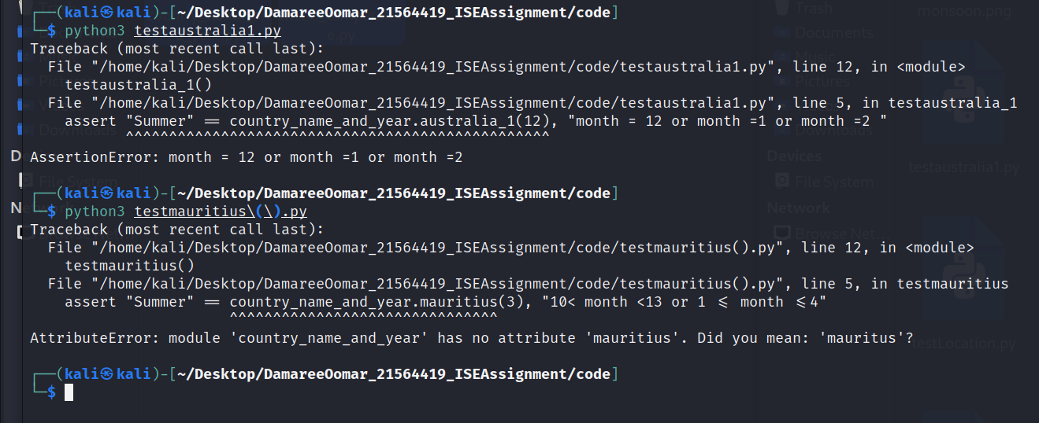

Summary of errors:

mauritius was wrongly written in the code. It was written as ‘mauritus’

Noogar seasons was assign instead of the traditional seasons

Some seasons in the mauritius() module were wrongly assigned.

**For all modules using framework:** 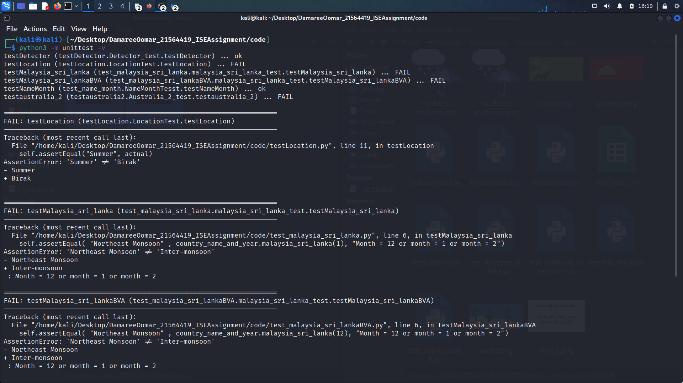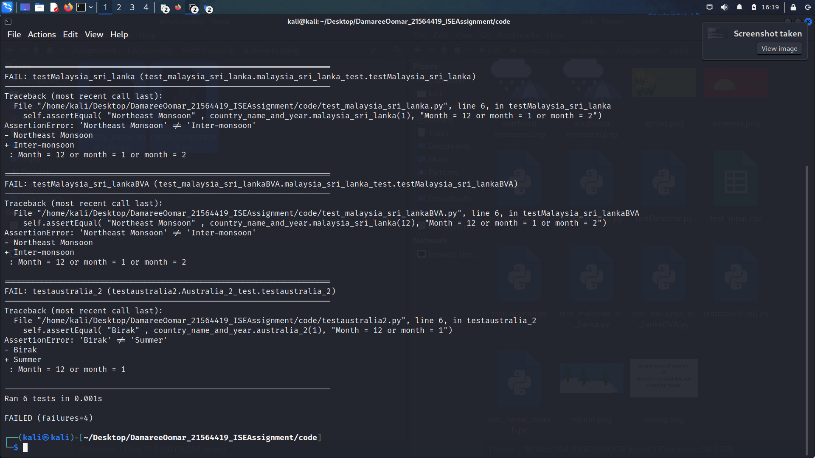

Summary of errors;

The name of the season Djilba was wrong assigned to the name of the picture causing an error.

One of the limits for malaysia_sri_lanka() module were wrongly written

**After correcting the errors(both with and without framework):**

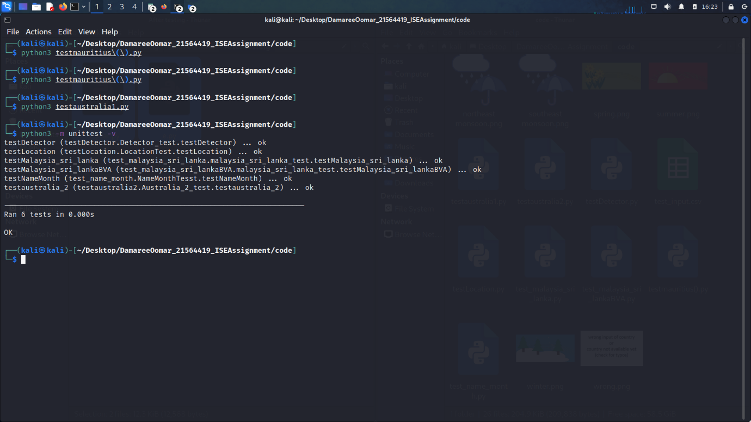

Version Control

This are only the commit before pushing to repositories 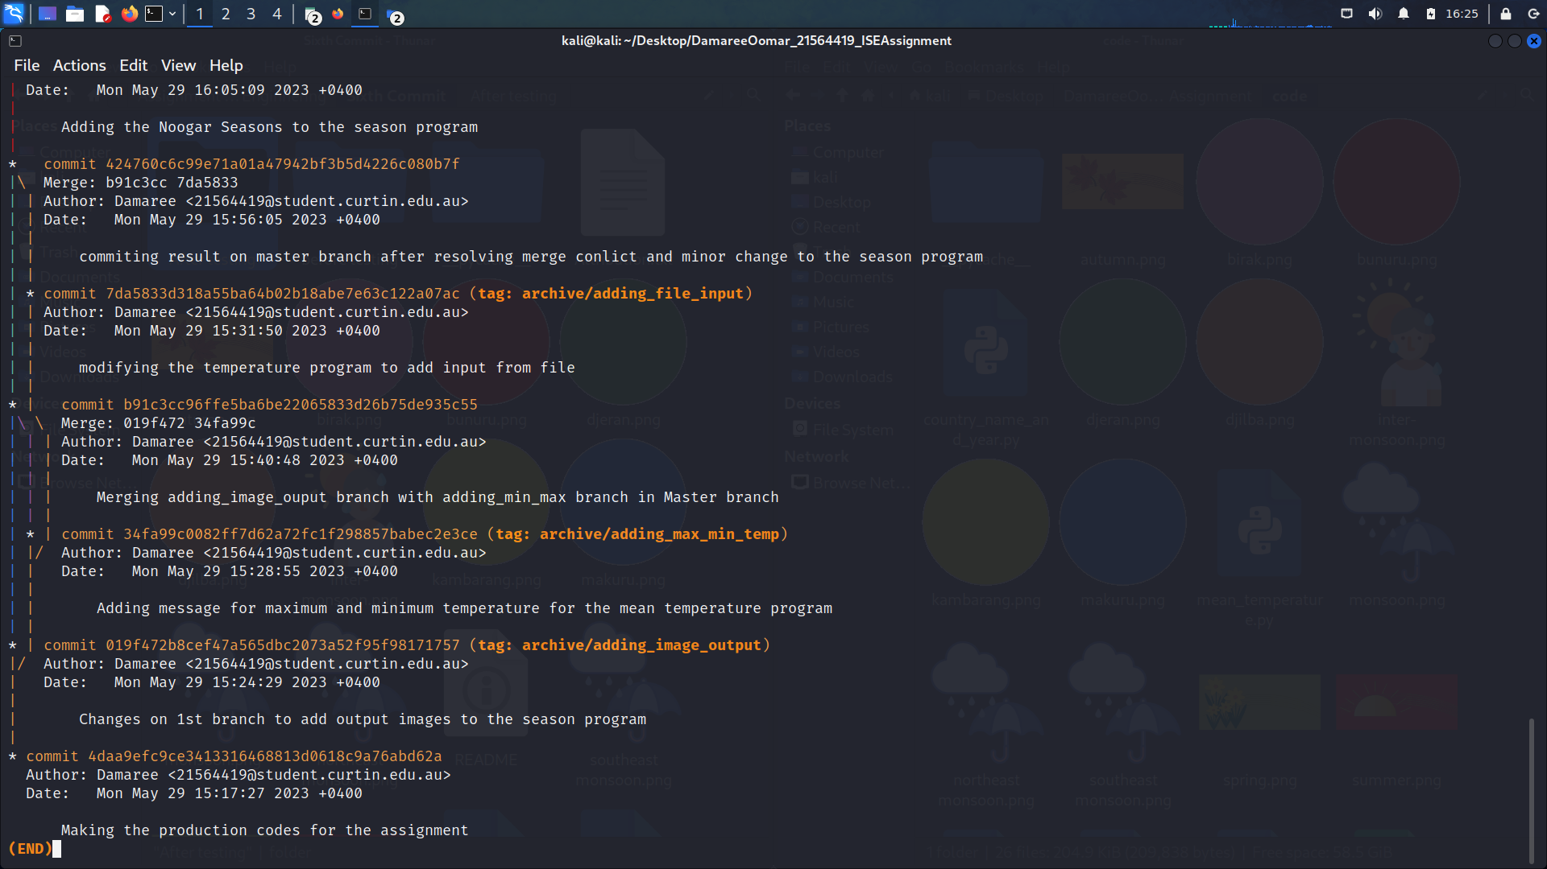

|  |  |
| --- | --- |
| **Commit** | **Description** |
| First commit | Creating production code of the 2 programs |
| Second commit | Branch 1: Adding the Noogar seasons to the season program  Branch 2: Modifying temperature program to consider max and min values of temperature.  Branch 3: Modifying temperature program to accept input from file  Branch 4(deleted branch): Modifying temperature program to write results to file  Branch 1, branch 2 and branch 3 are merged together to the master branch  Merge conflicts are then resolved and committed to the master branch |
| Third commit | Trying to refactor the temperature program  Adding the picture output for the Noogar season |
| Fourth commit | Modifying the temperature program to accept mean values of temperature.  Adding the picture output for Malaysia/Sri Lanka in the season program. |
| Fifth commit | Refactoring the season program only |
| Sixth commit | Designing and implementing testing programs for the temperature and season programs modules. |

Ethics and Professionalism

If one day, the codes that I have designed are used in a meteorological service station of a country and a person working there intentionally input wrong data to the program, this can result to faulty results, which scientist might use in turn in their research. If their research, for instance, a device using the results from my program is developed and it is used to predict natural calamities, this can cause harm to people in the concerned area. The person might be doing this in his/her personal interest, for example, paid by the company making the devices to hide any defects.

If according to the Australian Computer Society code (ACS), the person placed the public interest before his/her personal interest, if the person was competent, honest and professional in his work and if he really cared about enhancing the quality of life of those affected by his work, he would not have done that.

Discussion

The codes are can be improved in many ways such as prevent users from inputting wrong data, making an interactive menu for the user, making the program writing the output to a file and many other features which can be implemented.