Instructions for Copying and Sharing this Document
📣 DELETE THIS BOX BEFORE SUBMITTING!!

Step 1: Click “File -> Make a Copy” to make a copy of this document that you can edit.
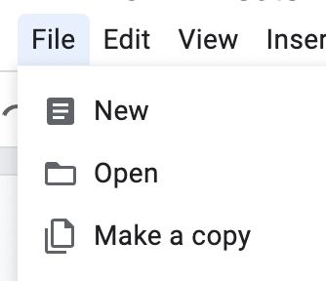
Step 2: Change the Share settings to “Anyone with Link -> Editor”. This will allow our graders to leave comments on your submission.

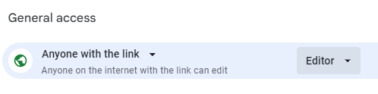

CYB102 Project 7 (🔗 Instructions Page)

👤 Student Name:
✉️ Student Email:

Reflection (Required)

🤔 Reflection Question #1: If I had to explain “what is an IOC” in 3 emojis, they would be…
(Feel free to put other comments about your experience in this unit here, too!)
🕵️‍♂️💻🚨

🧠Reflection Question #2: If you found out that an IP address was reported malicious a year ago, would you still consider it dangerous? Why or why not?
If an IP address was reported as malicious a year ago, I would still treat it as potentially dangerous but verify it through updated reputation tools like VirusTotal.

📣 Shoutouts: Share appreciation for anyone who helped you out with this project or made your day a little better!

Required Challenges (Required)

Match #1
Steps 1-2.5: General match data from Splunk (see Step 2.5)
Matched IP address: | TODO 13.59.205.66
The event date(s) and time(s): | TODO March 4, 2024 — 06:57:28
Affected computer(s): | TODO WS-SolarWave-212
Step 2.5: Screenshot of the match in Splunk
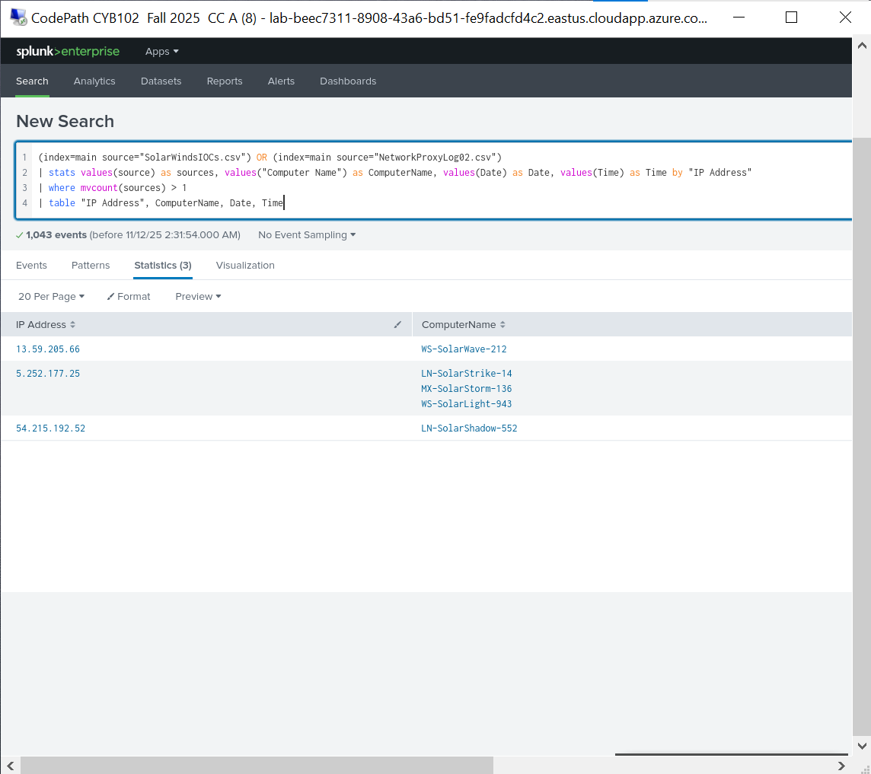
Step 3: Screenshot of VirusTotal search for the IP listed above
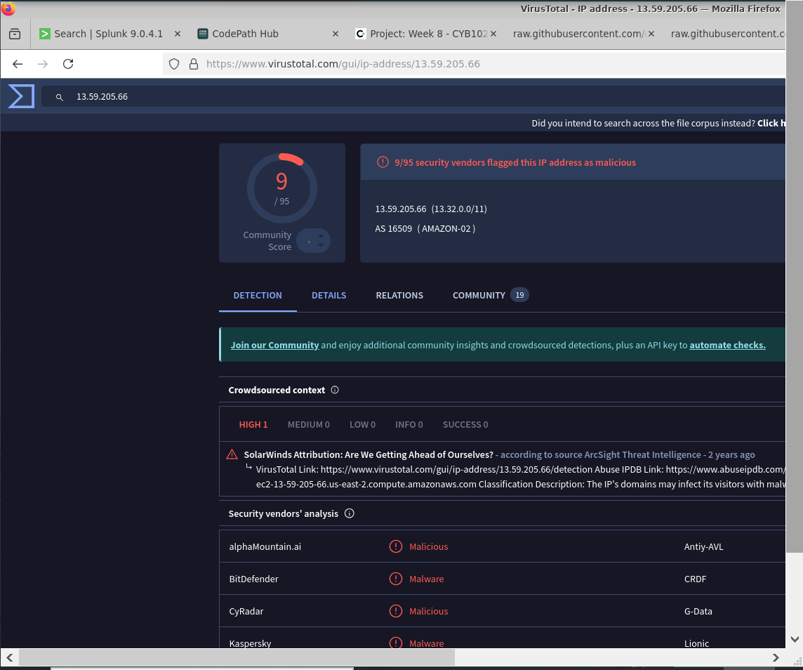

Match #2
Steps 1-2.5: General match data from Splunk (see Step 2.5)
Matched IP address: | TODO 5.252.177.25
The event date(s) and time(s): | TODO March 3–5, 2024 — 07:04:28, 07:11:28, 07:37:28
Affected computer(s): | TODO LN-SolarStrike-14, MX-SolarStorm-136, WS-SolarLight-943
Step 2.5: Screenshot of the match in Splunk
Step 3: Screenshot of VirusTotal search for the IP listed above
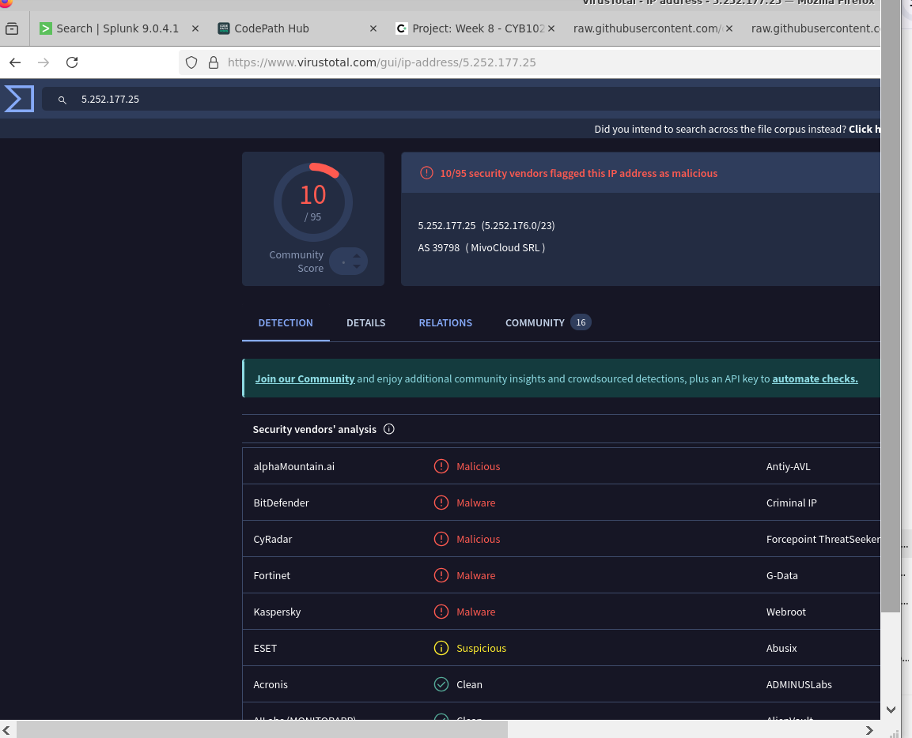
Steps 1-2.5: General match data from Splunk (see Step 2.5)

If you find a Match #3, enter it in the Stretch Challenge below!

Splunk Dashboard Query
Step 4: Enter the search query used to generate your Splunk Dashboard below
TODO
(index=main source="SolarWindsIOCs.csv") OR (index=main source="NetworkProxyLog02.csv")
| stats values(source) as sources, values("Computer Name") as ComputerName, values(Date) as Date, values(Time) as Time by "IP Address"
| where mvcount(sources) > 1
| table "IP Address", ComputerName, Date, Time

Stretch Challenge (Optional)

Match #3
Steps 1-2.5: General match data from Splunk (see Step 2.5)
Matched IP address: | TODO 54.215.192.52
The event date(s) and time(s): | TODO March 5, 2024 — 07:10:28
Affected computer(s): | TODO LN-SolarShadow-552
Step 2.5: Screenshot of the match in Splunk
Step 3: Screenshot of VirusTotal search for the IP listed above
[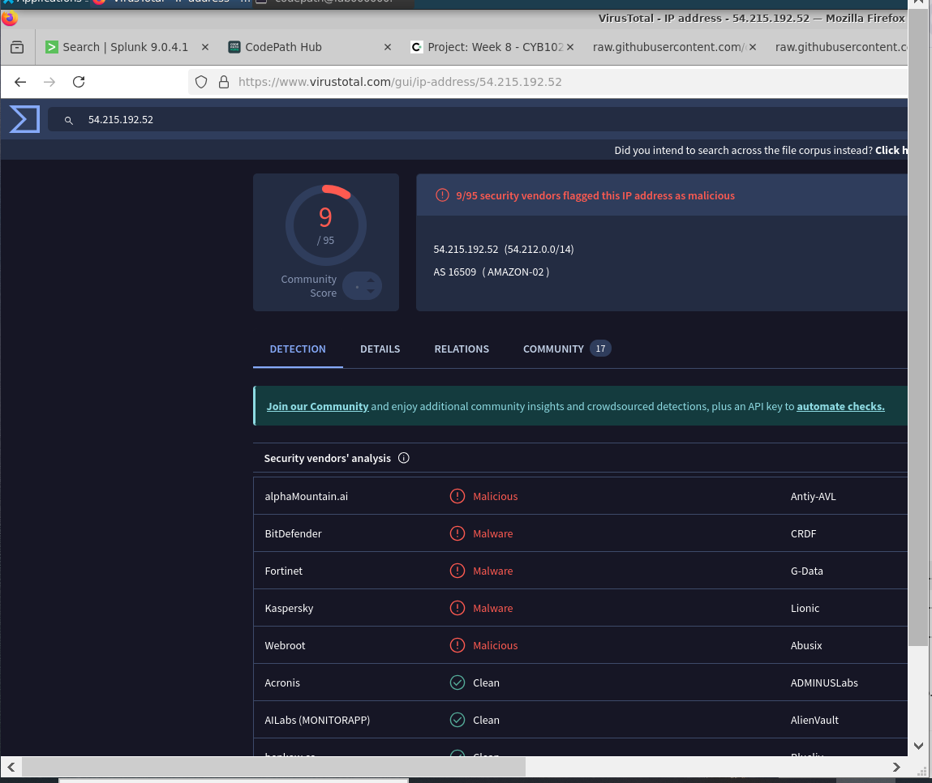
Steps 1-2.5: General match data from Splunk (see Step 2.5)

Bonus Task #1
Import a new set of IOC data into Splunk, then search your network data for matches.
A link to the threat source used:
TODO
Screenshot(s) of your Splunk search that shows you investigating with the newly imported data:
[Insert Screenshot(s) Here]
A short answer describing your findings: (Even if you didn’t find anything, you should explain where you looked and why!)
TODO

Submission Checklist
👉Check off each of the features you have completed. You will only be graded on the features you check off.

Required Challenges
- Match #1
- Match #2
- Splunk Dashboard Query

Stretch Challenge
- Match #3
- Bonus Task #1

💡Tip: You can see specific grading information, including points breakdown, by going to 🔗 the grading page on the course portal.

Submit your work!
Step 1: Click the Share button at the top of your screen double check that anyone with the link can edit.

Step 2: Copy the link to this document.
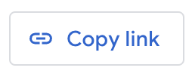

Step 3: Submit the link on the portal.

