**PREMIO**



**USABILITY TESTING**

**Oleh :**

**Nama : Damar Permadany**

**Nim : 16090137**

**POLITEKNIK HARAPAN BERSAMA**

**TEGAL**

**2019**

**Pengujian White Box**

1. FlowChart
2. 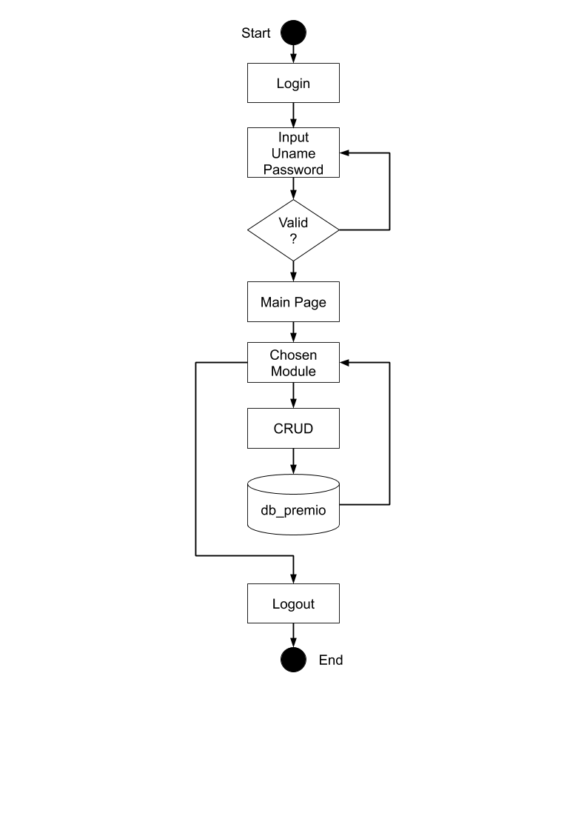Admin
3. 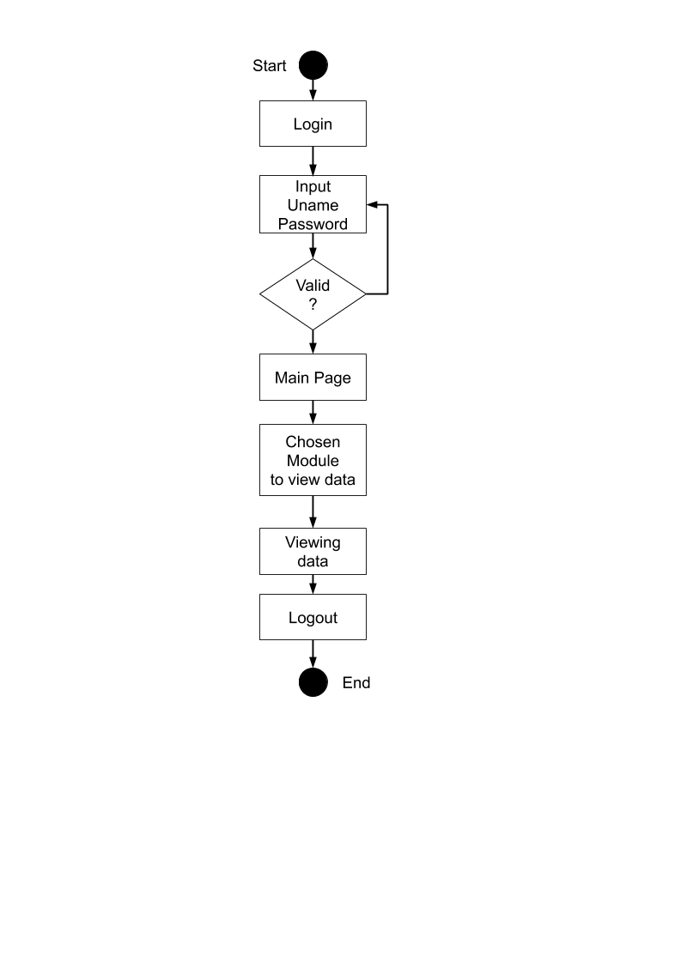Lecturer/Dosen
4. Students/Mahasiswa



1. CFG (Control Flow Graph)
2. 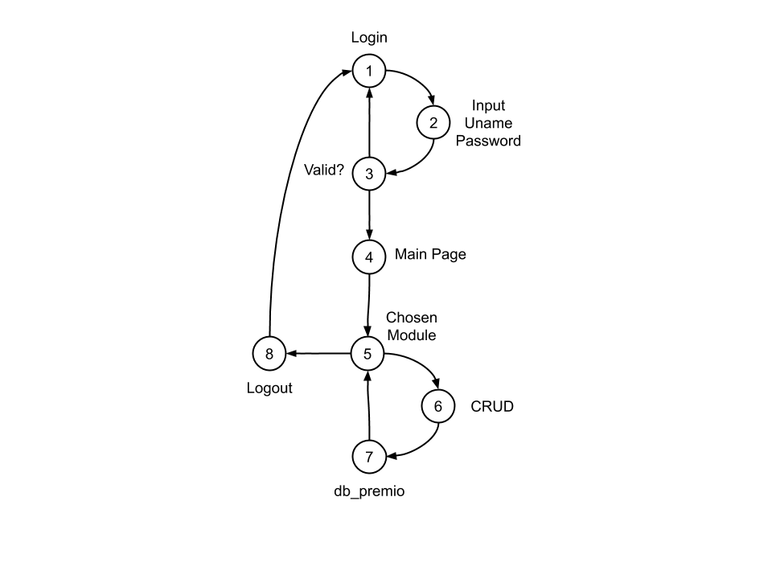Admin
3. Lecturer/Dosen

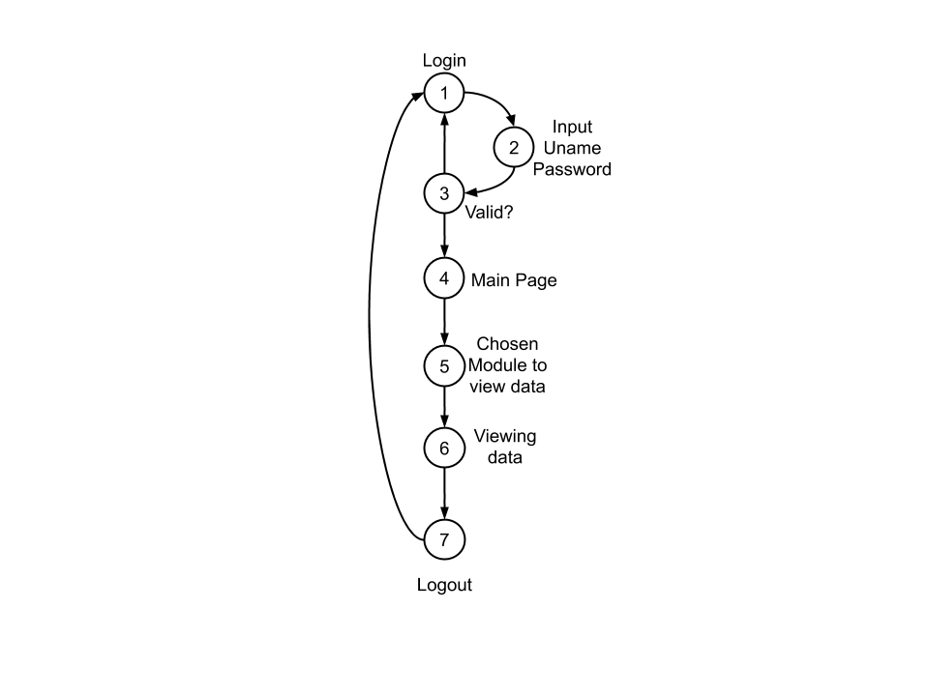

1. Students/Mahasiswa



1. Cyclomatic Complexity

Rumus = V(G) = E – N + 2

1. Admin

V(G) = 10 – 8 + 2

= 4

1. Lecturer/Dosen

V(G) = 8 – 7 + 2

= 3

1. Students/Mahasiswa

V(G) = 10 – 8 + 2

= 4

1. Basic Path
2. Admin

* 1-2-3-1
* 1-2-3-4-5-6-7-5-8-1
* 1-2-3-4-5-8-1
* 1-2-3-1-2-3-4-5-6-7-5-8-1

1. Lecturer/Dosen

* 1-2-3-1
* 1-2-3-4-5-6-7-8-1
* 1-2-3-1-2-3-4-5-6-7-8-1

1. Student/Mahasiswa

* 1-2-3-1
* 1-2-3-4-5-6-7-5-8-1
* 1-2-3-4-5-8-1
* 1-2-3-1-2-3-4-5-6-7-5-8-1

**Pengujian BlackBox**

1. **Equivalence Partitioning**

* Validasi untuk ukuran file gambar

|  |  |  |
| --- | --- | --- |
| Invalid | Valid | Invalid |
| …….,-1,0 | 1, 2 | 3, 4, …… |

* Validasi untuk memasukan NIM dan NIPY yang panjang karakternya 8

|  |  |  |
| --- | --- | --- |
| Invalid | Valid | Invalid |
| …….,6,7 | 8 | 9, 10, …… |

* Validasi untuk memasukan Nama/Name yang panjang karakter maksimalnya 50

|  |  |  |
| --- | --- | --- |
| Invalid | Valid | Invalid |
| …….,-1,0 | 1,2,3,…50 | 50, 51, …… |

* Validasi untuk memasukan Kelas/Grade yang panjang karakternya harus 2

|  |  |  |
| --- | --- | --- |
| Invalid | Valid | Invalid |
| …….,,0,1 | 2 | 3, 4, …… |

* Validasi untuk memasukan Date of Birth/Tanggal Lahir

|  |  |  |
| --- | --- | --- |
| Invalid | Valid | Invalid |
| …….,-1,0 | 1,2,3,…31 | 32, 33, …… |

1. **Tabel Kebenaran**

* Validasi untuk login

|  |  |  |  |  |
| --- | --- | --- | --- | --- |
| Email | F | F | T | T |
| Password | F | T | F | T |
|  | error | error | error | berhasil |

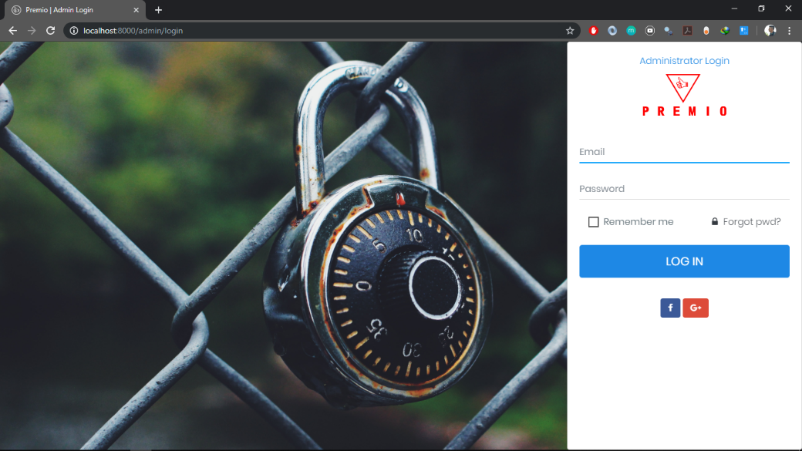

* Validasi untuk tambah Student/Mahasiswa

|  |  |  |  |  |  |  |
| --- | --- | --- | --- | --- | --- | --- |
| Nim | T | T | T | T | T | T |
| Nama | - | T | T | T | T | T |
| Kelas | - | - | T | T | T | T |
| Email | - | - | - | T | T | T |
| Gender | - | - | - | - | T | T |
| Phone | - | - | - | - | F | T |
|  | error | error | error | error | error | berhasil |

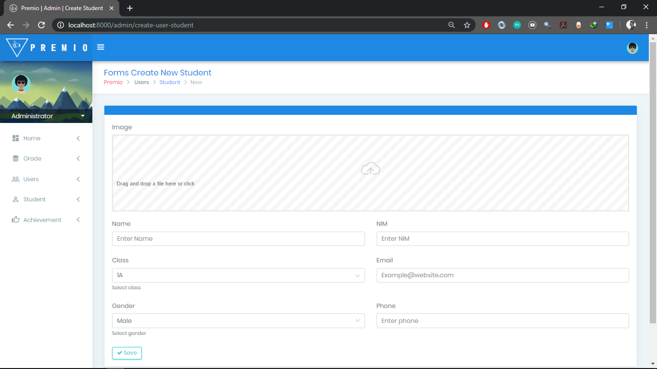

* Validasi untuk tambah Lecturer/Dosen

|  |  |  |  |  |  |
| --- | --- | --- | --- | --- | --- |
| Gambar | T | T | T | T | T |
| NIPY | - | T | T | T | T |
| Nama | - | - | T | T | T |
| Email | - | - | - | T | T |
| Password | - | - | - | F | T |
|  | error | error | error | error | berhasil |

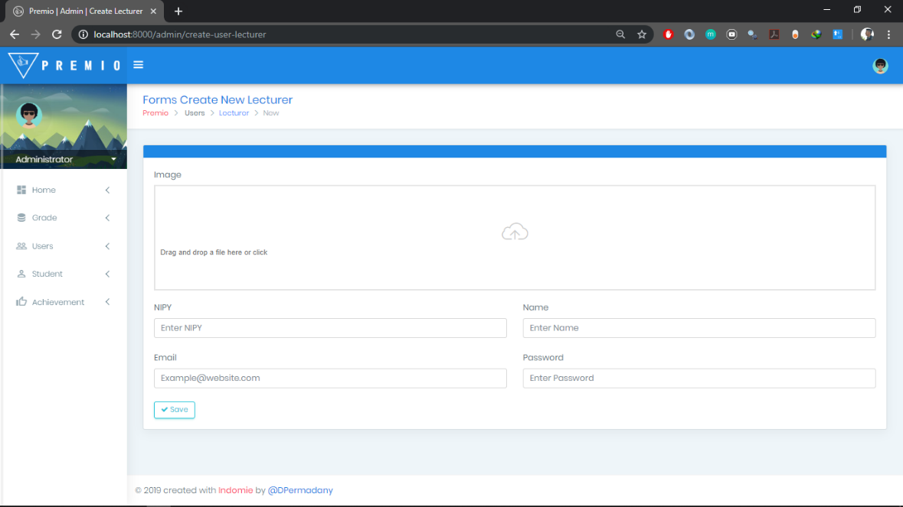

* Validasi untuk tambah Admin

|  |  |  |  |  |
| --- | --- | --- | --- | --- |
| Gambar | T | T | T | T |
| Nama | - | T | T | T |
| Email | - | - | T | T |
| Password | - | - | F | T |
|  | error | error | Error | berhasil |

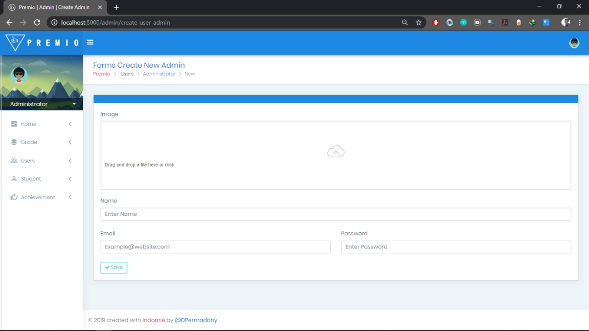

* Validasi untuk tambah Grade/Kelas

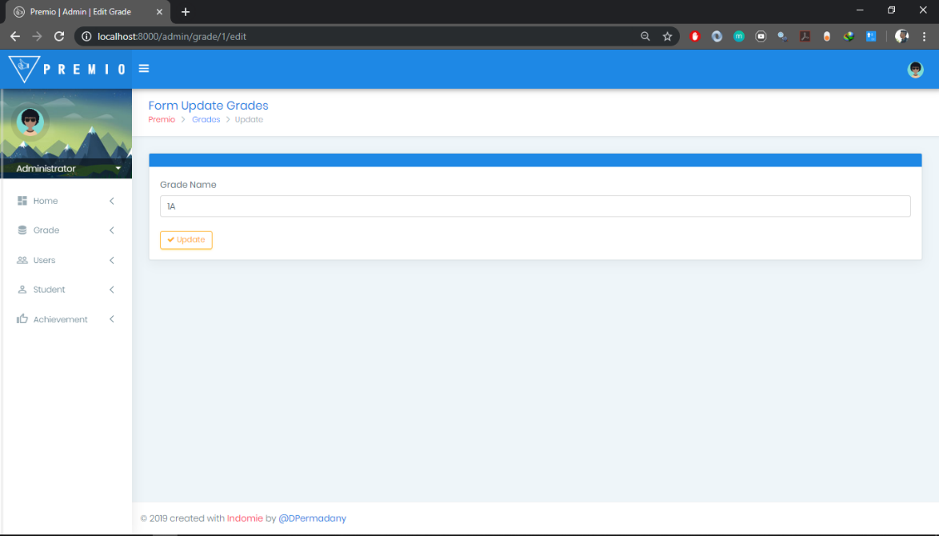

|  |  |
| --- | --- |
| Grade | T |
|  | Berhasil |