University of Southern California

ITP 348/ Professor Parke /Fall 2020

User Documentation

Daniel Masters

damaster@usc.edu

**USER GUIDE**

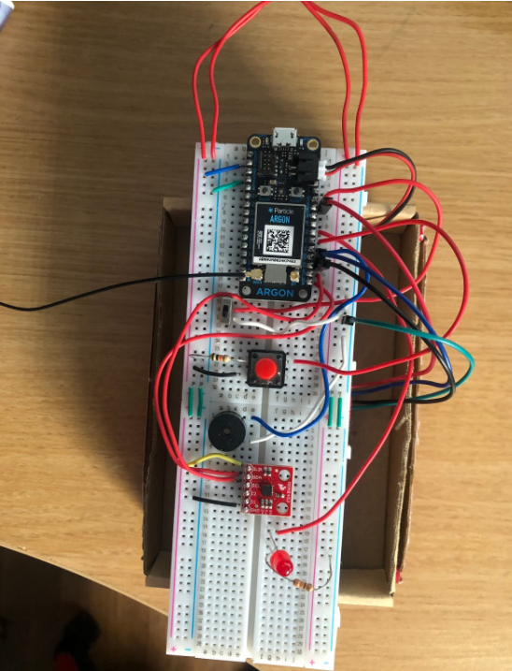

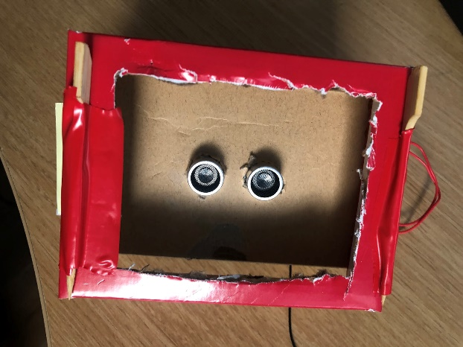

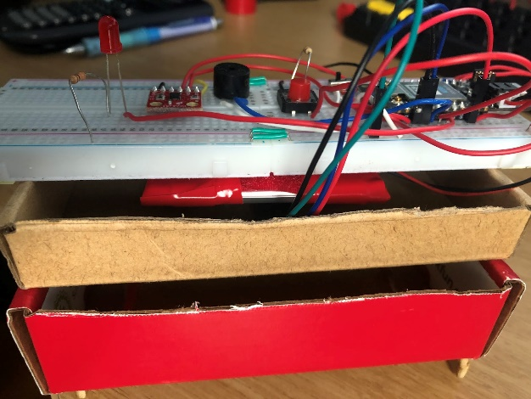

To begin using the Fluid Consumption Tracker and Reminder, download the Particle App and flip the switch to turn on the device (the device will begin blinking blue). Make sure the device in your app is connected to “DanielsArgonV2.” After ensuring it’s connection to the device, click on the functions tab where you will be presented with three different options: “User Amount”, “User Interval” and “User Start.” For “User Amount” click on the pull down tab and enter the goal amount of fluid you would like to consume. This amount is measured in ounces (reminder: one US cup is equivalent to EIGHT fluid ounces). Click “send” or “enter” on your keyboard and black text will appear to the right of “User Amount” showing the amount you entered. For “User Interval” click on the pull down tab and enter the rate at which you want to be reminded to drink the fluid in your cup. This is measured in minutes and you MUST enter a number above one and MUST NOT include any decimals. Once the device is on, place the device horizontally over the top of the cup. Once it is in place type “Start”, “start” or “START” and Click “send” or “enter” on your keyboard to begin. Once you have done this, you can take a sip at any time before or directly after the alarm goes off. Before taking a sip, remove the device and place it on it’s side. Take a sip. After you are finished taking a sip, place the cup over the top of your cup (for the most accurate measurements wait 5-10 seconds before doing this). An alarm will sound and the LED will flash at the end of the interval until you reach your goal amount. To monitor your current water level, consumption after each sip or total consumption, visit [www.initalstate.com](http://www.initalstate.com) to view this information. If you have finished the fluid in your cup and would like to refill it, repeat the same steps as you would for taking a sip. Remove the device, place it on its side, refill the cup, but before you place the device back over the cup, press and hold the red button for two seconds. After this, immediately place the device over your cup again. When you have reached your goal amount, the Argon will blink red and automatically restart. If you want to begin the process once again, you must re-input the values in your Particle app once and type “start”. If you do not want to do this you may turn off the device by flipping the switch in the opposite direction (away from the Argon). If you wish to pause the device you can go to your Particle App and type “Pause”, “pause” or PAUSE” in the “User Start” pulldown tab at any time. If you wish to turn off the device, you can flip the switch located on the device in the opposite direction (away from the Argon) at any time.

**IMPORTANT NOTE**

This device is only compatible with cups that have a diameter of more than 7.5 centimeters. This diameter measurement must be consistent throughout the entirety of the cup and not just the top of it. Failure to obtain a cup with such measurements will result in inaccurate fluid amount measurements and render the device unusable.