|  |
| --- |
| **3D Volume Rendering and Interaction with Dicom Files**  **MM-804 B1 – Final Project Report**  **Damayanti Ghosh**  **Student ID: 1505857** |

1. **Abstract**

3D Volume Rendering of medical data like Dicom Files is now widely prevalent to help in surgical planning and diagnosis in clinical applications. In particular, qualitative visualization of 3D medical data is something which is improved to a great extent by volume rendering. In this paper, a volume rendering based interactive 3D dicom file is represented. Interaction of the dicom files with the help of two planar widgets and their corresponding visualisations in 2D images have been shown as well.

1. **Introduction**

The contemporary medical images like CT, MRI, Dicom etc can produce 3D images. These 3D images are now widely prevalent in the qualitative and quantitative diagnosis in clinical applications. It helps both the physicians and the patients to help visualise the intricate details with much precision in a highly interactive manner.

Surface rendering and volume rendering are the two main branches of volume visualizations. Though volume rendering is computationally more expensive than surface rendering, it can visualize the volume directly without ant reconstruction or segmentation operations.

1. **Method**

The entire setup of volume rendering and interaction with the dicom files has been done with the Visualisation Toolkit (version: 6.3.0 ) and Python(version: 2.7.13) .

The task was divided into mainly three parts:

* 1. Rendering the Dicom file in 3D format .
  2. Introducing the interactive plane widgets.
  3. Representing the slices of the dicom file clipped by the plane widgets in 2D image format.

**3.1 3D Volume Rendering**

The Dicom file was first read using vtkDICOMImageReader and the volume was rendered using vtkSmartVolumeMapper function. Then the 3D volume rendering of the dicom file was achieved using different paramenters for different tissues in vtkColorTransferFunction. The opacity transfer was also applied using vtkPiecewiseFunction.

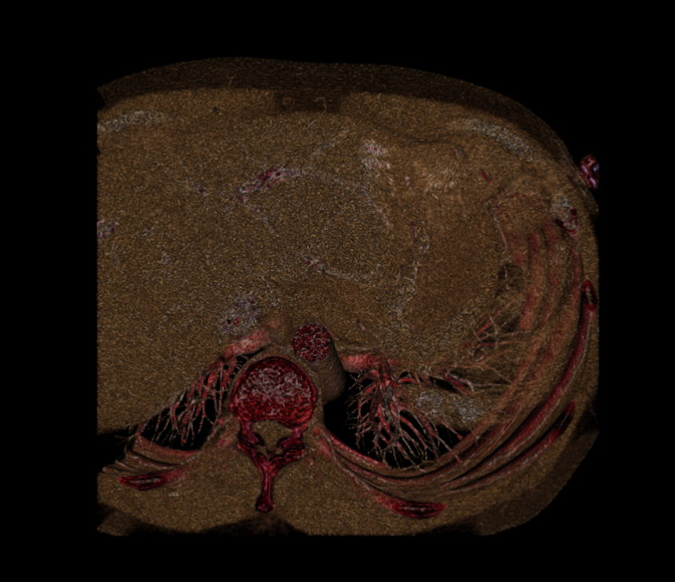

Fig 1 : 3D Volume Rendering of the Dicom file

**3.2 Interactive Plane Widgets**

The plane widgets in vtk has been made interactive using vtkImagePlaneWidget library. Some more attributes like Plane orientation, colormap, slice index etc have been added to the library . Apart from that, sliders using vtkSliderRepresentation2 has been added for the two planar widgets namely X-axis and Y-axis so that it is effectively a lot more easier for users of every platform(MaxOSX, Windows, Linux) to interact with the 3D data file interactively.

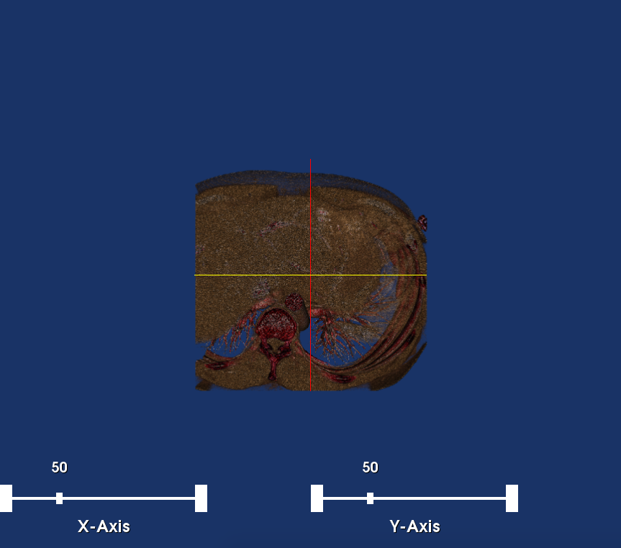

Fig 2. Representation of the 3D volume of dicom with 2 planar axes and their corresponding sliders

* 1. **Representation of the dicom slices clipped by plane axes in 2D**

The sliced portion of the Dicom file that has been clipped by the axes is presented in 2D format using GetResliceOutput function.

This function is attached to both the plane axes so that with the movement of the axes the 2D images also get updated real-time.

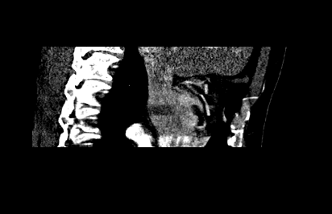

Fig 4. Representation of the Dicom slice clipped by X-Axis

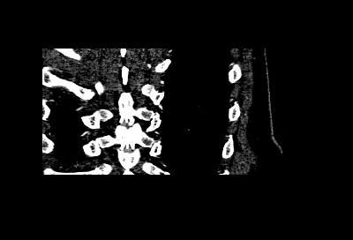

Fig 5. Representation of the Dicom slice clipped by Y-Axis

The above shown images get updated real time with the movement of the sliders for the respective plane axes.

The entire representation of the working environment looks like the following:

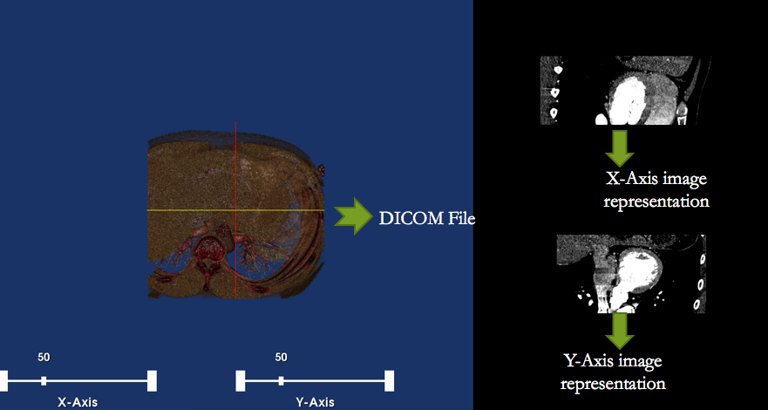

Fig 6: Working file representation

1. **Future work**

This project is still in the beta phase and is to provided with a GUI using PyQt4.

For further introspection of clarity and detailing, contour detection and representation using Mayavi is also in the pipeline. Other image processing techniques like filtering, edge detection will be introduced using **Insight Segmentation and Registration Toolkit (ITK).**

1. **References:**

[1] McCane, B. (2005). *Proceedings, Image and Vision Computing New Zealand 2005: University of Otago, Dunedin, New Zealand, 28th-29th November 2005*. Dunedin, N.Z.: Dept. of Computer Science, University of Otago.

[2] Zhao, M., & Sha, J. (2012). *Communications and Information Processing International Conference, ICCIP 2012, Aveiro, Portugal, March 7-11, 2012, Revised selected papers. Part II*. Berlin: Springer

[3] Class notes and snippets provided in the class material.