The following are recommended to Big Mountain Resort, Montana after a careful data analysis:

* The new Weekend Adult ticket Price: $94.22.

This price amount was calculated taking into consideration few advanced features of the resort mainly vertical drop, Snow Making area, total number of chairs, number of fast four person chair, runs, longest run and skiable terrain area. These features of the resort are more advance than the average of the resorts in market, accordingly the predicted price from the model is more than the average market price $81.00. The distribution of the above mentioned features are shown below in the plots. In all these plots, the vertical line (red) represents for Big Mountain, Montana.

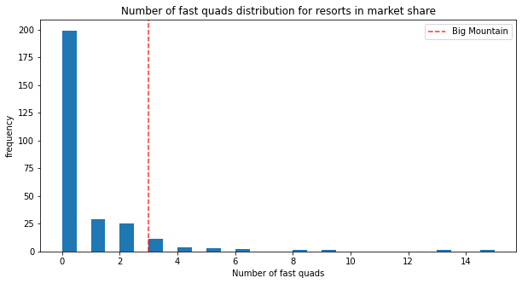

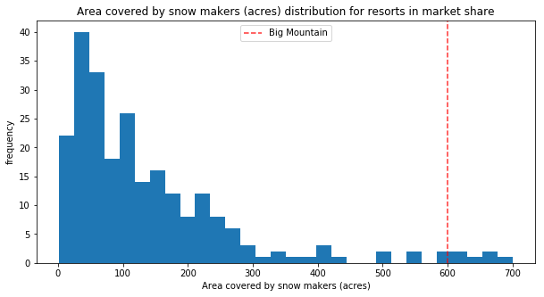

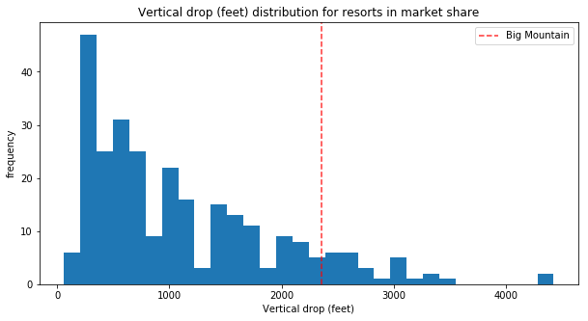

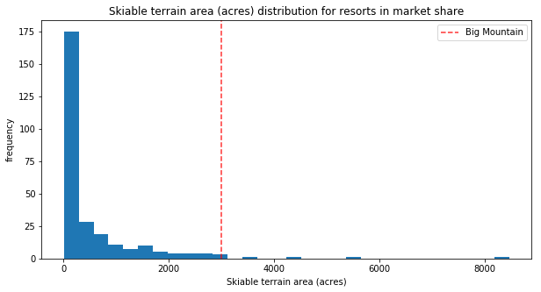

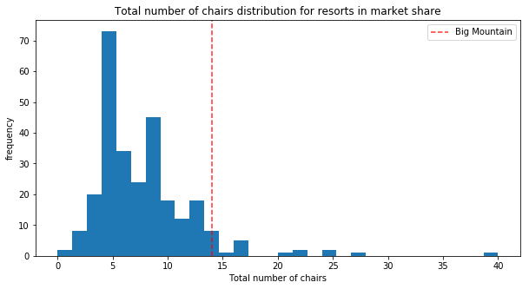

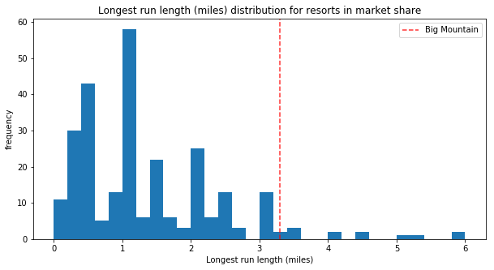

* There is a further scope of increase in ticket price of $10.39.
* One additional chair lift supports the increase in the ticket price of $8.46. This will result in revenue increase of $ $14811594 which will support the operating cost.
* Closure of upto 5 runs can be considered based on model’s prediction:

1. Closing one run makes no difference both on ticket price and revenue collection.
2. Closing 2 and 3 runs successively reduce (though not significant) ticket price and revenue.
3. Closing 3, 4 or 5 runs have same loss on ticket price and revenue.
4. Increasing the run closure down to 6 or more leads to a further large drop in both ticket and revenue.

Hence, maximum upto 5 runs can be closed with no significant effect on ticket price and revenue. The two plots below reveal the details on “Ticket price vs Runs closed” and “Revenue vs Runs closed”.

