**ROBOTICS AND ARTIFICIAL INTELLIGENCE**

1. In what type of reinforcement learning algorithmsthe agent uses a transition model of the environment to help interpret the reward signals and to make decisions about how to act? **Model-based reinforcement learning**

2. Choose all instances of agents in cooperative environments: **Virtual AI Tutor, Self driving car**

3. Which algorithm selects the most promising option at each state based on heuristic evaluation , without considering future consequences? **Best-first search ?**

4. The utility of a state is determined by: **selecting the action with the maximum Q-value for that state**

5. Heuristic evaluation functions can be used to calculate an estimate of the expected utility of the game from a given position. **True**

6. What type of technique is used in game trees to improve the efficiency of the minimax algorithm, by pruning branches that are guaranteed not to influence the final decision? **Alpha-beta pruning**

7. Match the following elements for a language assistent MDP (Markov Decision Process):

-Action -> **next word (ex. “It”, “chair”, “purple”,...)**

-Transitions -> **append word to sequence of words**

-State -> **sequence of words seen so far (ex. “What is population of NYC?”)**

-Reward -> **human feedback (ex. thumb-up, thumb-down)**

8. In constraint satisfaction problems (CSPs), a problem is solved when each variable has a value that satisfies all the constraints on the variable. **True**

9. Select all the listed risks associated with AI: **Lethal autonomous weapons, Biased decision making, Privacy and surveilance, Disinformation and persuasion.**

10. Constraint satisfactions problems, (CSPs) are a specialized class of search problems that consist of the following elements: **variables, domains, constraints**

11. Heuristic search algorithms always guarantee to find the optimal solution. **False**

12. Choose all the elements that apply to the game of poker: **randomness(chance), imperfect information, zero-sum game**

13. In additive discounted rewards, as the discount factor y approaches 0 , the agent **is less willing to wait for long term rewards**

14. Which stage of a generic algorithm introduces random changes or perturbations to the genertic material of candidate solutions? **Mutation ?**

15. Local search algorithms systematically explore the full search space. **False**

16. What type of graph is used for representing constraint satisfaction problems (CSPs)? **Constraint graph**

17. A reinforcement is a measure of the success or failure of the agent’s action. **True**

18. Markov decision process (MDP) is a sequential decision problem for a fully observable, deterministic environment. **False**

19. In Q-learning the optimal policy can be derived by selecting the action with the highest Q-value for each state. **True**

20. Choose all agents listed: **Human driver, Traffic light, Autonomous drone, Chatbot, Robot vacuum cleaner**

21. What kind of intelligence refers to AI systems that are designed and trained for specific tasks or domains? **Artificial Narrow Intelligence (ANI)**

22. Informed search strategies can be useful for problems where a quick solution is need or when the search space is too large to be exhaustively explored. **True**

23. A rational agent chooses whichever action maximizes the expected value of the performance measure given the percept sequence to date. **True**

24. Minimum Remaining Values (MRV) is a heuristic used in constraint satisfaction problems , that selects the variable with the fewest remaining legal values in its domain for assignment. **True**

25. In the constraint satisfaction (CSP) problem of map coloring each region in Australia either red, green or blue in such a way that no neighboring regions have the same color, the following constraint Tasmania ≠ green is a **unary constraint**

26. If the next state of the environment is completely determined by the current state and the action executed by the agent, then we say the environment is stochastic. **False**

27. Select all the uninformed search strategies listed below: **Breadth-first search, Uniform-cost search, Depth-first search**

28. Specify the task environment through a PEAS description (Performance Measure, Environment, Actuators, Sensors) for the following AI medical diagnosis system:

- Sensors -> **Keyboard entry of symptoms,findings, patient’s answers**

- Performance measure -> **Healthy patient, reduced costs**

- Actuators -> **Display of questions, tests, diagnoses, treatments, referrals**

- Environment -> **Patient, hospital, staff**

29. In non-deterministic games, what serves as a generalization of the minimax value found in deterministic games? **expectiminimax**

30. Choose all instances illustrating reinforcement learning:

**- Developing an autonomous vehicle that learns to drive safely by receiving positive feedback for obeying traffic rules and negative feedback for violating them**

- Identifying outliners in data that deviate from normal behavior

**- Fine tuning a chatbot that improves its conversational skills over time by receiving positive feedback from users**

**- Teaching an AI to play chess by rewarding wins, penalizing losses, and providing intermediate rewards for achieving strategic board positions**

- Finding optimal solutions to optimization problems using Genetic Algorithms

31. What is the minimax value of node C? **2**

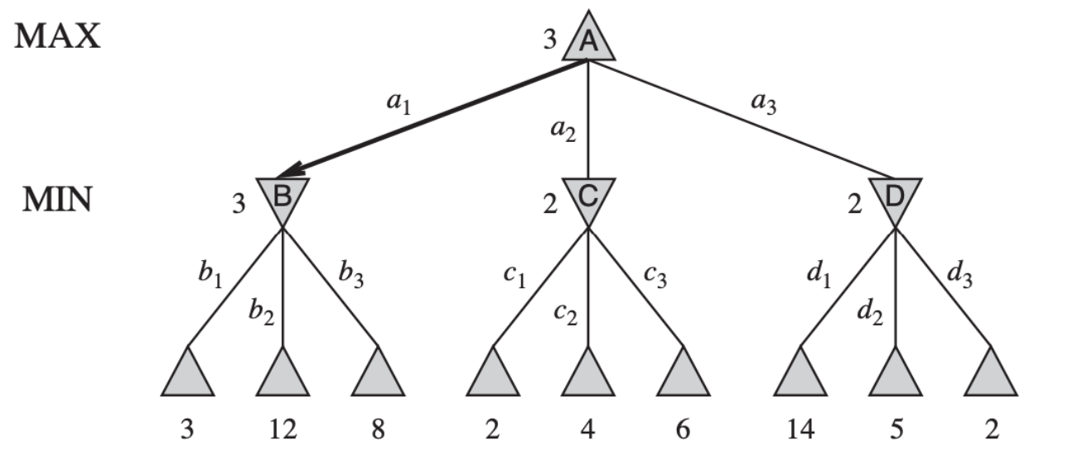

32. What kind of search strategy is shown in the image? **Depth-first search**

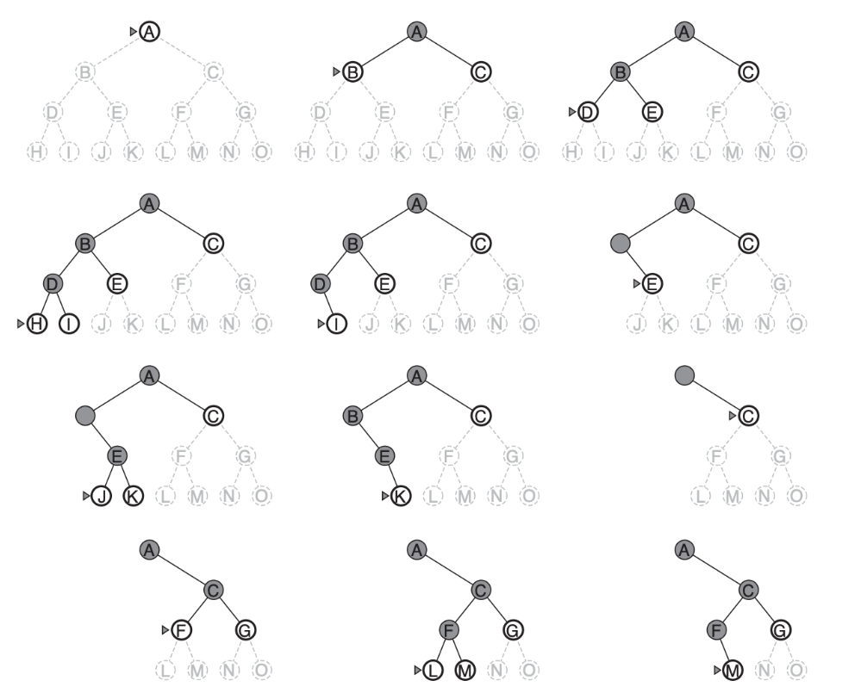

33. **Deep Learning; Mchine Learning; Artificial Intelligence**

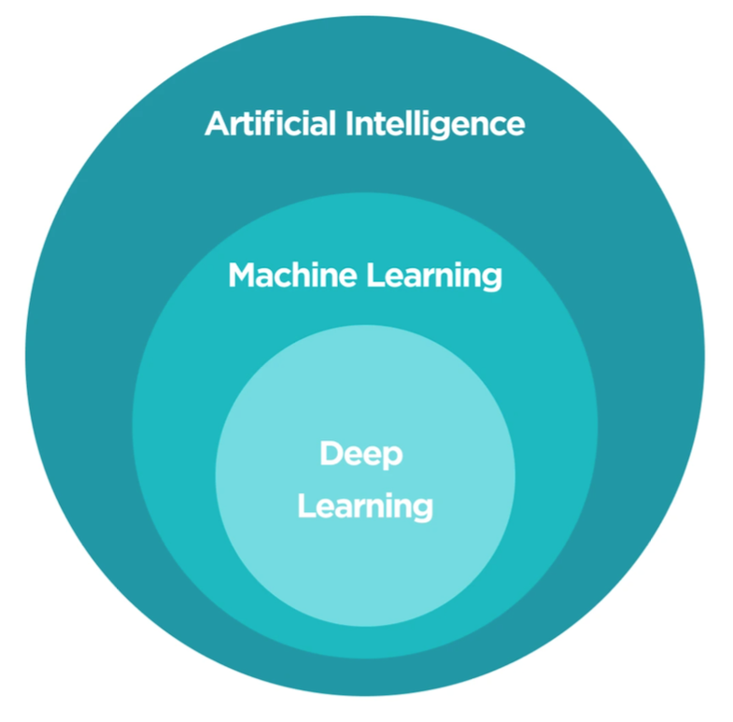

34. What kind of agent is illustrated in the following image? **Learning agent**

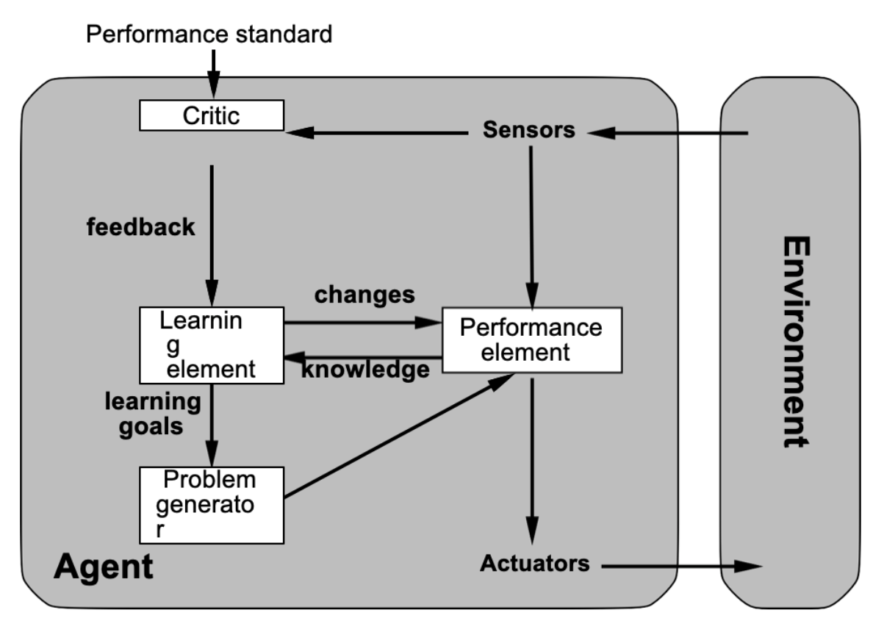

35. In the CSP problem of map coloring, as depicted in the image, what constitutes the domain for the variable representing Western Australia? **Red, Green, Blue**

