

Deployment Guide

Version 1.0

Redisoft_Gcalendar2XLS_POC

Corporate Office & Development Center
DAMCO SOLUTIONS PVT. LTD.
108, HSIDC Industrial Complex, Sector 31,
Faridabad – 121008, Haryana.

Name | Role |  | Date of Preparation | Signature
Author
Rohit Agarwal | Sr. Developer | May 10th 2017
Reviewer(s)
Chetan Kaushik | Engagement Manager/Tech Arch. | May 11th 2017
Approver
Mamta Talwar | Chief Delivery Officer | May 12th 2017
Revision History
Name | Date of Release | Section/ Page # Changed |  | Details of Changes

TABLE OF CONTENTS

1 Software Requirement 4
2 How to import Project on Eclipse 4
3 How to run project 4

- Software Requirement :

- JDK 1.8
- Tomcat 7 or above Server
- Maven build tool latest version
- Eclipse used for development as IDE.

2. How to import Project on Eclipse :

- Import project in eclipse as existing maven project.
- Run clean and install Job of Maven.

3. How to run project:

- Run project on tomcat 7 or above server.
- You will prompt to upload CSV file as shown in diagram 1.0

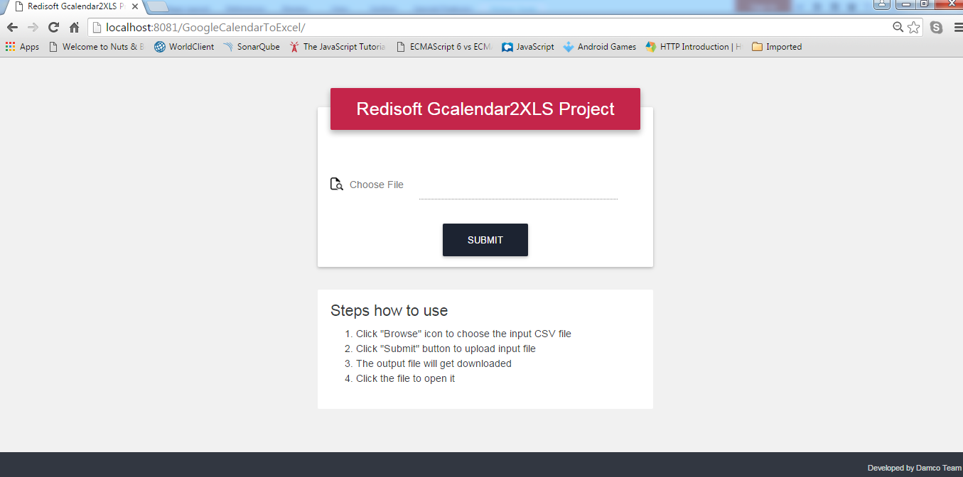

Diagram 1.0

- Upload a well formatted CSV file.

- When you will upload CSV file FIRST time, then you will be prompted to give permission to Google API to access your Google calendar.

A default browser will open which will first ask you to login with your Google account if you are not already logged in.

After that, a screen to Allow permission will come :-

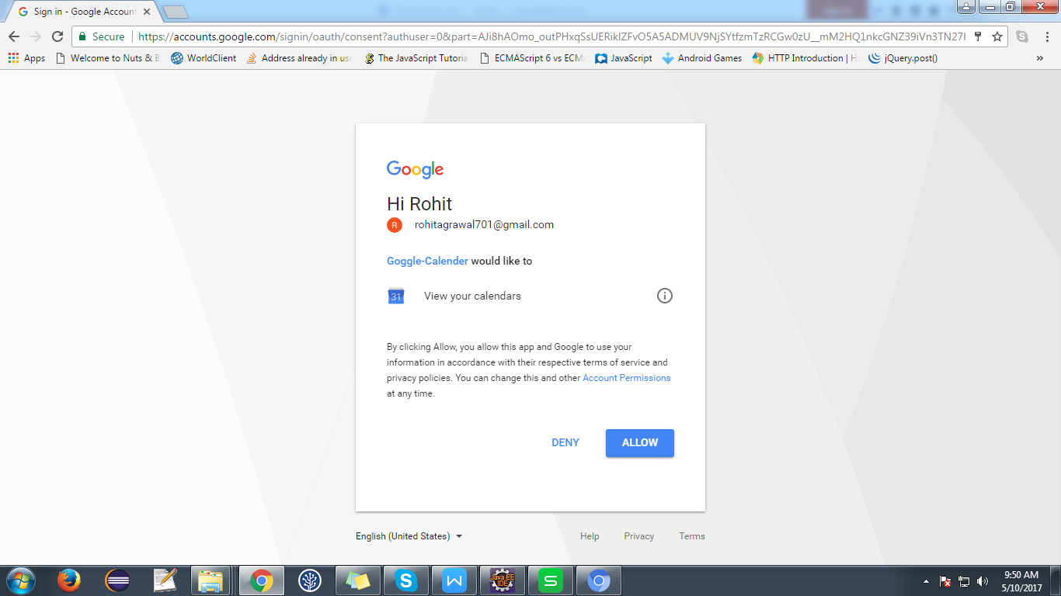

Just, “Allow” it.

After allowing this, program will start working

- Output Excel file will be downloaded with calendar event details.

