DE2-115 Board I/O Pin Assignments: Switches, LEDs, and 7-Segment Displays
Table 1: Daughter Board Pin assignments
Signal Name | FPGA Pin No. | Description
SW3_DB | PIN_AB22 | Rocker Switch[3]
SW2_DB | PIN_AB21 | Rocker Switch[2]
SW1_DB | PIN_AC21 | Rocker Switch[1]
SW0_DB | PIN_AD21 | Rocker Switch[0]
KEY1_DB | PIN_AC19 | Push-button[1]
KEY0_DB | PIN_AD19 | Push-button[0]
LEDR3_DB | PIN_AF24 | LED Red[3]
LEDR2_DB | PIN_AF25 | LED Red[2]
LEDR1_DB | PIN_AE22 | LED Red[1]
LEDR0_DB | PIN_AF22 | LED Red[0]
LEDG1_DB | PIN_AG25 | LED Green[1]
LEDG0_DB | PIN_AH25 | LED Green[0]

Table 2: Pin assignments for slide switches
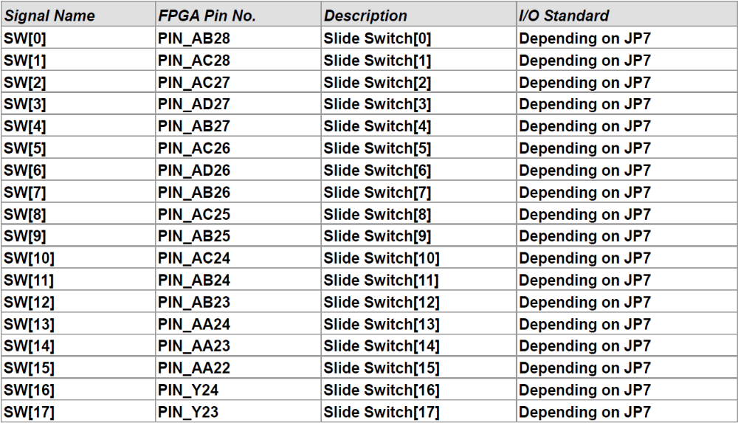
Table 3: Pin assignments for pushbutton (debounced) switches
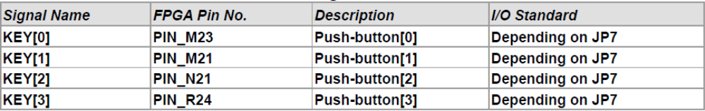

Table 4: Pin assignments for LEDs
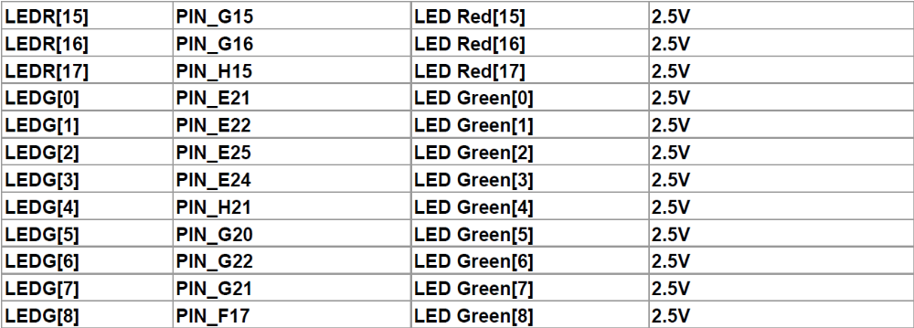
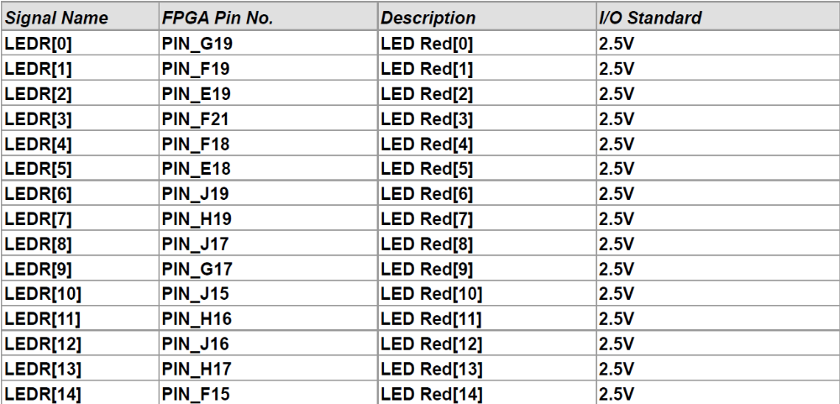

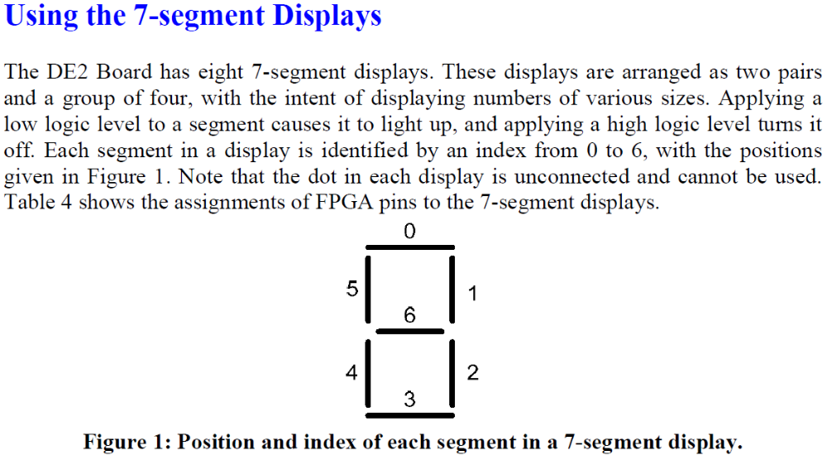

Table 5: Pin assignments for 7-segment displays
Signal Name | FPGA Pin No. | Description | I/O Standard
HEX0[0] | PIN_G18 | Seven Segment Digit 0[0] | 2.5V
HEX0[1] | PIN_F22 | Seven Segment Digit 0[1] | 2.5V
HEX0[2] | PIN_E17 | Seven Segment Digit 0[2] | 2.5V
HEX0[3] | PIN_L26 | Seven Segment Digit 0[3] | Depending on JP7
HEX0[4] | PIN_L25 | Seven Segment Digit 0[4] | Depending on JP7
HEX0[5] | PIN_J22 | Seven Segment Digit 0[5] | Depending on JP7
HEX0[6] | PIN_H22 | Seven Segment Digit 0[6] | Depending on JP7
HEX1[0] | PIN_M24 | Seven Segment Digit 1[0] | Depending on JP7
HEX1[1] | PIN_Y22 | Seven Segment Digit 1[1] | Depending on JP7
HEX1[2] | PIN_W21 | Seven Segment Digit 1[2] | Depending on JP7
HEX1[3] | PIN_W22 | Seven Segment Digit 1[3] | Depending on JP7
HEX1[4] | PIN_W25 | Seven Segment Digit 1[4] | Depending on JP7
HEX1[5] | PIN_U23 | Seven Segment Digit 1[5] | Depending on JP7
HEX1[6] | PIN_U24 | Seven Segment Digit 1[6] | Depending on JP7
HEX2[0] | PIN_AA25 | Seven Segment Digit 2[0] | Depending on JP7
HEX2[1] | PIN_AA26 | Seven Segment Digit 2[1] | Depending on JP7
HEX2[2] | PIN_Y25 | Seven Segment Digit 2[2] | Depending on JP7
HEX2[3] | PIN_W26 | Seven Segment Digit 2[3] | Depending on JP7
HEX2[4] | PIN_Y26 | Seven Segment Digit 2[4] | Depending on JP7
HEX2[5] | PIN_W27 | Seven Segment Digit 2[5] | Depending on JP7
HEX2[6] | PIN_W28 | Seven Segment Digit 2[6] | Depending on JP7

Signal Name | FPGA Pin No. | Description | I/O Standard
HEX3[0] | PIN_V21 | Seven Segment Digit 3[0] | Depending on JP7
HEX3[1] | PIN_U21 | Seven Segment Digit 3[1] | Depending on JP7
HEX3[2] | PIN_AB20 | Seven Segment Digit 3[2] | Depending on JP7
HEX3[3] | PIN_AA21 | Seven Segment Digit 3[3] | Depending on JP7
HEX3[4] | PIN_AD24 | Seven Segment Digit 3[4] | Depending on JP7
HEX3[5] | PIN_AF23 | Seven Segment Digit 3[5] | Depending on JP7
HEX3[6] | PIN_Y19 | Seven Segment Digit 3[6] | Depending on JP7
HEX4[0] | PIN_AB19 | Seven Segment Digit 4[0] | Depending on JP7
HEX4[1] | PIN_AA19 | Seven Segment Digit 4[1] | Depending on JP7
HEX4[2] | PIN_AG21 | Seven Segment Digit 4[2] | Depending on JP7
HEX4[3] | PIN_AH21 | Seven Segment Digit 4[3] | Depending on JP7
HEX4[4] | PIN_AE19 | Seven Segment Digit 4[4] | Depending on JP7
HEX4[5] | PIN_AF19 | Seven Segment Digit 4[5] | Depending on JP7
HEX4[6] | PIN_AE18 | Seven Segment Digit 4[6] | Depending on JP7
HEX5[0] | PIN_AD18 | Seven Segment Digit 5[0] | Depending on JP7
HEX5[1] | PIN_AC18 | Seven Segment Digit 5[1] | Depending on JP7
HEX5[2] | PIN_AB18 | Seven Segment Digit 5[2] | Depending on JP7
HEX5[3] | PIN_AH19 | Seven Segment Digit 5[3] | Depending on JP7
HEX5[4] | PIN_AG19 | Seven Segment Digit 5[4] | Depending on JP7
HEX5[5] | PIN_AF18 | Seven Segment Digit 5[5] | Depending on JP7
HEX5[6] | PIN_AH18 | Seven Segment Digit 5[6] | Depending on JP7
HEX6[0] | PIN_AA17 | Seven Segment Digit 6[0] | Depending on JP7
HEX6[1] | PIN_AB16 | Seven Segment Digit 6[1] | Depending on JP7
HEX6[2] | PIN_AA16 | Seven Segment Digit 6[2] | Depending on JP7
HEX6[3] | PIN_AB17 | Seven Segment Digit 6[3] | Depending on JP7
HEX6[4] | PIN_AB15 | Seven Segment Digit 6[4] | Depending on JP7
HEX6[5] | PIN_AA15 | Seven Segment Digit 6[5] | Depending on JP7
HEX6[6] | PIN_AC17 | Seven Segment Digit 6[6] | Depending on JP7
HEX7[0] | PIN_AD17 | Seven Segment Digit 7[0] | Depending on JP7
HEX7[1] | PIN_AE17 | Seven Segment Digit 7[1] | Depending on JP7
HEX7[2] | PIN_AG17 | Seven Segment Digit 7[2] | Depending on JP7
HEX7[3] | PIN_AH17 | Seven Segment Digit 7[3] | Depending on JP7
HEX7[4] | PIN_AF17 | Seven Segment Digit 7[4] | Depending on JP7
HEX7[5] | PIN_AG18 | Seven Segment Digit 7[5] | Depending on JP7
HEX7[6] | PIN_AA14 | Seven Segment Digit 7[6] | 3.3V

Table 6: Pin assignments for clock inputs
