Lab 3: Simplex, Constrained and Optimal Control Methods Report

By: Dylan Dam z5115759

# Task 1: Simplex Method

## Task 1a):

|  |  |  |  |  |
| --- | --- | --- | --- | --- |
|  | **D1** | **D2** | **D3** | **Supply** |
| **O1** | 8 | 6 | 10 | 2000 |
| **O2** | 10 | 4 | 9 | 2500 |
| **Demand** | 1500 | 2000 | 1000 |  |

Table 1: Transportation Tableau

From table 1, the minimisation cost equations and constraints are:

Cost equations:

$$z= 8x_{1}+6x_{2}+10x_{3}+10x_{4}+4x_{5}+9x_{6}$$

Constraint equations:

$$x_{1}+x_{2}+x_{3}=2000$$

$$x_{4}+x_{5}+x_{6}=2500$$

$$x_{1}+x_{4}=1500$$

$$x_{2}+x_{5}=2000$$

$$x_{3}+x_{6}=1000$$

The Matrix/Vector:

$$\left[\begin{matrix}1 & 1 & 1 & 0 & 0 & 0 \\ 0 & 0 & 0 & 1 & 1 & 1 \\ 1 & 0 & 0 & 1 & 0 & 0 \\ 0 & 1 & 0 & 0 & 1 & 0 \\ 0 & 0 & 1 & 0 & 0 & 1\end{matrix}\right]*\left[\begin{aligned}x_{1} \\ x_{2} \\ x_{3} \\ x_{4} \\ x_{5} \\ x_{6}\end{aligned}\right]=\left[\begin{aligned}2000 \\ 2500 \\ 1500 \\ 2000 \\ 1000\end{aligned}\right]$$

The Transportation Tableau

|  |  |  |  |  |
| --- | --- | --- | --- | --- |
|  | **D1** | **D2** | **D3** | **Supply** |
| **O1** | Min (1500,2000) = 1500 |  |  | 2000-1500=500 |
| **O2** | 1500 – D1 = 0 |  |  | 2500 |
| **Demand** | 1500-1500 = 0 | 2000 | 1000 |  |

|  |  |  |  |  |
| --- | --- | --- | --- | --- |
|  | **D1** | **D2** | **D3** | **Supply** |
| **O1** | 1500 | Min (500,2000) = 500 |  | 500-500 |
| **O2** | 0 | 2000 – 500 = 1500 |  | 2500-1500 |
| **Demand** | 0 | 2000 | 1000 |  |

|  |  |  |  |  |
| --- | --- | --- | --- | --- |
|  | **D1** | **D2** | **D3** | **Supply** |
| **O1** | 1500 | 500 | Min (0,1000) = 0 | 0 |
| **O2** | 0 | 1500 | 1000 – 0 = 1000 | 1000-1000=0 |
| **Demand** | 0 | 0 | 1000-1000=0 |  |

|  |  |  |  |  |
| --- | --- | --- | --- | --- |
|  | **D1** | **D2** | **D3** | **Supply** |
| **O1** | 1500 | 500 | 0 | 0 |
| **O2** | 0 | 1500 | 1000 | 0 |
| **Demand** | 0 | 0 | 0 |  |

## Task 1b):

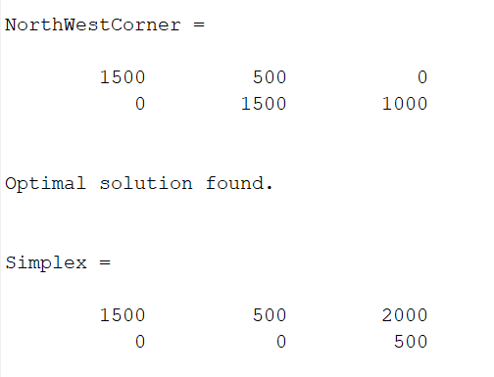

Figure 1: North-West Corner Method and Simplex

When comparing the results gained between the North West Corner Method, we can see that there is a discrepancy between the two. How North West Corner Method works is that as it starts from the North West corner and continually finds the minimum value between the demand and the supply and continually works its way to the right-hand side. This method is optimal if a fast solution is required on the stop, but what it fails to do is find the optimum solution as it does not consider the weighting of each cell. Simplex method on the other hand takes into consideration the weighting between the cells and correctly allocates the resources based on weighting.

# Task 2: Lagrange Multipliers

## Task 2a):

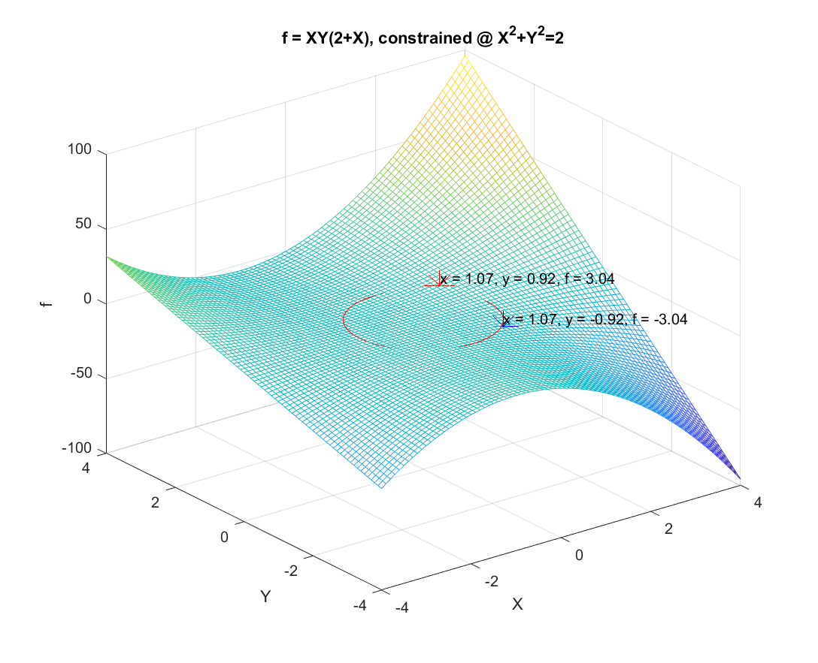

The red point is the maximum value for the objective function constrained by the circle and the blue point is the minimum value constrained by the circle. The max and min was determined via finding Lagrange Multiplier method and the max and min was determined by finding the largest and smallest value were determined by subbing in the x and y points determined by the Lagrange Multiplier Method.

## Task 2b):

The objective function is:

$$f(x_{1},x_{2},x_{3}) = x_{1}x_{2}x_{3}$$

$$g\left(x_{1},x_{2},x_{3}\right)=2x_{1}^{2}+2x_{2}^{2}+2x_{3}^{2}=10$$

$$L\left(x_{1},x_{2},x_{3},λ\right)= x_{1}x_{2}x_{3}+λ(2x_{1}^{2}+2x_{2}^{2}+2x_{3}^{2}-10)$$

$$\frac{∂L}{∂x_{1}}=4λx_{1}+x_{2}x_{3}…(1)$$

$$\frac{∂L}{∂x_{2}}=4λx_{2}+x_{1}x_{3}…(2)$$

$$\frac{∂L}{∂x_{3}}=4λx_{3}+x_{1}x_{2}…(3)$$

$$\frac{∂L}{∂λ}=2x_{1}^{2}+2x_{2}^{2}+2x_{3}^{2}-10…(4)$$

$$Solve the set of equations simultaneously$$

$$from \left(1\right):λ=-\frac{x_{2}x_{3}}{4_{x1}}… (5)$$

$$from \left(2\right):λ=-\frac{x_{1}x_{2}}{4x_{3}}…(6)$$

$$from \left(3\right):λ=-\frac{x_{1}x_{3}}{4x_{2}}…(7)$$

$$\left(5\right)=(6)$$

$$-\frac{x_{2}x_{3}}{4x_{1}}=-\frac{x_{1}x_{2}}{4x_{3}}$$

$$x_{1}=x_{3}$$

$$\left(6\right)=(7)$$

$$-\frac{x_{1}x_{2}}{4x_{3}}=-\frac{x_{1}x_{3}}{4x_{2}}$$

$$Sub in x_{1}$$

$$-4x_{3}^{3}=-4x_{3}x_{2}^{2}$$

$$Therefore x_{2}=x_{3}=x_{1} Therefore λ= -\frac{x_{1}}{4}= -\frac{x_{2}}{4}=-\frac{x_{3}}{4}$$

$$Subbing back into g, we get:$$

$$6x_{1}^{2}=10$$

$$Therefore x_{1}=x_{2}=x_{3}=\sqrt{\frac{10}{6}} =1.291 and λ=\frac{\sqrt{\frac{10}{6}}}{4}=0.3227$$

## Task 2c)

$$P\left(x_{1},x_{2},x_{3}\right)=8x_{1}x_{2}x_{3}-200(x_{1}+x_{2}+x_{3})$$

$$g\left(x_{1},x_{2},x_{3}\right)=x_{1}+x_{2}+x_{3}=100$$

$$L\left(x_{1},x_{2},x_{3},λ\right)= 8x_{1}x_{2}x_{3}-200\left(x_{1}+x_{2}+x_{3}\right)+λ(x_{1}+x_{2}+x_{3}-100)$$

$$\frac{∂L}{∂x_{1}}=8x_{2}x_{3}^{2}+λ-200…(1)$$

$$\frac{∂L}{∂x_{2}}=8x_{1}x_{3}^{2}+λ-200…(2)$$

$$\frac{∂L}{∂x_{3}}=16x_{1}x_{2}x_{3}+λ-200…(3)$$

$$\frac{∂L}{∂λ}=x_{1}+x_{2}+x_{3}-100…(4)$$

$$From \left(1\right)…\left(3\right) we get:$$

$$λ=200-x_{2}x_{3}^{2}…(5)$$

$$λ=200-x_{1}x_{3}^{2}…(6)$$

$$λ=200-16x_{1}x_{2}x_{3}…(7)$$

$$\left(5\right)=(6)$$

$$200-x_{2}x_{3}^{2}=200-x_{1}x_{3}^{2}$$

$$x_{1}=x_{2}$$

$\left(6\right)=(7)$

$$200-x_{1}x_{3}^{2}=200-16x_{1}x_{2}x_{3}$$

$$x_{3}=2x_{1}=2x_{1}$$

$$Sub x_{1}into (7)$$

$$λ=200-32x_{1}^{3}…(8)$$

$$Solve for x_{1},x_{2} and x_{3}$$

$$Using g\left(x_{1},x_{2},x_{3}\right) and how the variables relate:$$

$$4x_{1}=100$$

$$x_{1},x_{2}=25 and x_{3}=50$$

$$Sub x_{1},x_{2},x_{3} into (8)$$

$$λ= 200-16\left(25*25*50\right)= -499800$$

$Therefore x_{1}=25,x_{2}=25,x_{3}=50 and λ=-499800$

# Task 3): Karush and Kuhn and Tucker Conditions

## Task 3a)

$$f\left(x_{1},x_{2}\right)={\left(x_{1}-1\right)}^{2}+{\left(x_{2}-2\right)}^{2}$$

$$g_{1}\left(x_{1},x_{2}\right)=x_{1}+x_{2}≤2$$

$$g_{2}\left(x_{1},x_{2}\right)=x_{2}-x_{1}=1$$

$$L(x_{1},x_{2},λ_{1},λ_{2})={\left(x_{1}-1\right)}^{2}+{\left(x_{2}-2\right)}^{2}-λ_{1}\left(x_{1}+x_{2}-2\right)+λ_{2}(x_{2}-x_{1}-1)$$

$$The Jacobian obtained is:$$

$$\frac{dL}{dx_{1}}=2x_{1}-2+λ_{2}-λ_{1}…(1)$$

$$\frac{dL}{dx_{2}}=2x_{2}-4+λ_{1}+λ_{2}…(2)$$

$$Constrained by:$$

$$λ_{1}\left(x_{1}+x_{2}-2\right)…(3)$$

$$λ_{2}\left(x_{2}-x_{1}-1\right)…(4)$$

$$In this scenario, 4 cases arises.$$

### Case 1

$$If λ_{1}=0$$

$$2x_{1}-2+λ_{2}-0…(5)$$

$$2x_{2}-4+0+λ_{2}…(6)$$

$$λ_{2}\left(x_{2}-x_{1}-1\right)=0$$

$$λ_{2}=0$$

$$x_{2}=x_{1}+1$$

$$Sub x_{2} into (5)$$

$$2\left(x_{1}+1\right)-4=0$$

$$x_{1}=1$$

$$x_{2}=2$$

$$λ_{2}=1$$

$$2x_{1}-1=0 (from 5)$$

$$x_{1}=\frac{1}{2}$$

$$x_{2}=\frac{3}{2}$$

### Case 2:

$$If (x_{1}+x_{2}-2)=0$$

$$x_{1}=2-x_{2}$$

$$Sub x_{1} into 2 and 4$$

$$2\left(2-x_{2}\right)-2+λ_{1}+λ_{2}=0$$

$$4-2x_{2}-2+λ_{1}+λ_{2}=0…(7)$$

$$λ_{2}\left(x_{2}-\left(2-x_{2}\right)-1\right)=0$$

$$λ_{2}\left(2x_{2}-3\right)=0$$

$$If λ_{2}=0$$

$$x_{2}=\frac{3}{2}$$

$$Sub into x_{1}=2-x_{2}$$

$$x_{1}=\frac{1}{2}$$

$$Sub all x_{1},x_{2} amd λ_{2} into 3$$

$$λ_{1}=1$$

### Case 3:

$$If λ_{2}=0$$

$$1,2 becomes$$

$$2x_{1}-2+λ_{1}=0…(8)$$

$$2x_{2}-4+λ_{1}=0…(9)$$

$$λ_{1}\left(x_{1}+x_{2}-2\right)= 0$$

$$If λ_{1}=0$$

$$2x_{1}=2$$

$$x_{1}=1$$

$$x_{2}=2$$

$$If λ_{1}=1$$

$$x_{2}=2-x_{1}$$

$$2x_{1}-2+1=0 (from 8)$$

$$x_{1}=\frac{1}{2}$$

$$x_{2}=\frac{3}{2}$$

### Case 4

$$If x_{2}-x_{1}=1$$

$$x_{2}=x_{1}+1$$

$$2x_{1}-2+λ_{1}-λ_{2}=0…(9)$$

$$2+2x_{1}-4+λ_{1}+λ_{2}=0…(10)$$

$$λ_{1}\left(2x_{1}-1\right)=0$$

$$If λ_{1}=0$$

$$λ_{2}=2x_{1}-2…\left(11 from equation 9\right)$$

$$λ_{2}=2x_{1}-2…(12 from equation 10)$$

$$11=12$$

$$x_{1}=1$$

$$x_{2}=2$$

$$λ_{2}=0 from 9 after subbing in all variables$$

$$If λ_{1}=1$$

$$x_{1}=\frac{1}{2}$$

$$x_{2}=\frac{3}{2}$$

$$λ_{2}=0$$

$$Only solution that does not violate any constraints is x_{1}=\frac{1}{2}, x_{2}=\frac{3}{2},λ_{1}=1,λ_{2}=0$$

## Task 3b)

$$f\left(x_{1},x_{2}\right)=3x_{1}+\sqrt{3}x_{2}$$

$$g\left(x_{1},x_{2}\right)=3-\frac{18}{x_{1}}-\frac{6\sqrt{3}}{x_{2}}≥ 0$$

$$The x_{1}≥5.73 and x_{2}≥7.17 can be screened manually$$

$$L\left(x_{1},x_{2},λ\right)= 3x_{1}+\sqrt{3}x_{2}+λ(3-\frac{18}{x_{1}}-\frac{6\sqrt{3}}{x_{2}})$$

$$\frac{∂L}{∂x_{1}}=3-\frac{18λ}{x_{1}^{2}}=0…(1)$$

$$\frac{∂L}{∂x_{2}}=\sqrt{3}-\frac{6\sqrt{3}λ}{x_{2}^{2}}=0…(2)$$

$$λ\left(3-\frac{18}{x_{1}}-\frac{6\sqrt{3}}{x_{2}}\right)=0…(3)$$

### Case 1:

$$If λ=0$$

$$From 1$$

$$3-18*\frac{0}{x_{1}^{2}}≠0$$

$$\sqrt{3}-\frac{6\sqrt{3}}{x_{2}^{2}}*0≠0$$

### Case 2:

$$If \left(3-\frac{18}{x_{1}}-\frac{6\sqrt{3}}{x_{2}}\right)=0$$

$$\frac{18}{x_{1}}=3+\frac{6\sqrt{3}}{x_{2}}$$

$$x_{1}=\frac{18x_{2}}{3x_{2}-6\sqrt{3}}$$

$$Using 1$$

$$3-\frac{λ{\left(3x_{2}-6\sqrt{3}\right)}^{2}}{18x^{2}}=0…(4)$$

$$Solving 2 and 4 simultaneously, we get two sets of solution$$

$$Set 1$$

$$λ=1.0718, x_{2}=-2.5359$$

$$Subbing into g$$

$$x_{1}=2.5359$$

$$Set 2$$

$$λ=14.9282,x_{2}=9.4641$$

$$Subbing into g$$

$$x_{1}=9.4641$$

$$Set 2 does not violate x_{1}≥5.73 and x_{2}≥7.17$$

# Task 4 Optimal Control

## Task 4a)

$$\dot{x}=f\left(x,u\right)=ax+bu where a>0,b>0, x\left(T\right)=x_{T}$$

$$J= \int_{0}^{T}{F\left(x,u\right)dt+G(x(T))}$$

$$J=\frac{1}{2}\int_{0}^{T}{u^{2}dt}+\frac{1}{2}x^{2}\left(T\right)where F=\frac{1}{2}u^{2} and G=\frac{1}{2}x^{2}$$

$$H=F+λf=\frac{1}{2}u^{2}+λ(ax+bu)$$

$$δJ=\left[F\left(x\left(T\right),u\left(T\right)\right)+\frac{∂G}{∂x}f\right]δT+λ\left(0\right)δx\left(0\right)+\left[\frac{∂G}{∂x}-λ\left(I\right)\right]δx\left(T\right)+\int_{0}^{π}{\frac{∂H}{∂u}δu\left(t\right)dt}$$

$$\frac{∂G}{ ∂X}=λ\left(T\right)=x(T)$$

$$∂J= \int_{0}^{T}{\frac{∂H}{∂u}δu(t)dt} where\frac{∂H}{∂u}=u+bλ=0$$

$$u= -bλ$$

$$λ=-\frac{∂H}{∂λ}= -aλ$$

$$\dot{λ}=-aλ$$

$$\dot{λ}+aλ=0$$

$$By multiplying e^{at} to both sides$$

$$\dot{λ}e^{at}+ae^{at}λ=0$$

$$\frac{d}{dt}\left(e^{at}λ\right)dt=0$$

$$\int{\frac{d}{dt}\left(e^{at}λ\right)dt= \int{0dt}}$$

$$Let e^{at}=C$$

$$λ=Ce^{-at}$$

$$λ\left(T\right)=e^{-at}=x(T)$$

$$C=x\left(T\right)e^{at}$$

$$u= -bλ=-bCe^{-at}$$

$$u= -bx\left(T\right)e^{aT}e^{-at}$$

$$\dot{x}=ax+bu$$

$$\dot{x}=ax-b^{2}x\left(T\right)e^{aT}e^{-at}$$

$$\dot{x}-ax=-b^{2}x\left(T\right)e^{aT}e^{-at}$$

$$Multiply by e^{-at} on both sides$$

$$e^{-at}\dot{x}-ae^{-at}x=-b^{2}x\left(T\right)e6-e^{a(T-2t)}$$

$$\int{\frac{d}{dt}\left(e^{-at}x\right)dt=\int{-b^{2}x\left(T\right)e^{-aT}*e^{-2at}dt}}$$

$$e^{-at}x=-b^{2}x\left(T\right)e^{at}\int{e^{-2at}}+C$$

$$e^{-at}x=\frac{b^{2}x\left(T\right)e^{-at}}{2a}e^{-2at}+C$$

$$x\left(0\right)=x_{0} @ t=0$$

$$e^{0}x_{0}=-\frac{b^{2}x\left(T\right)e^{aT}}{2a}e^{0}+C$$

$$C=-\frac{b^{2}x\left(T\right)e^{a\left(0\right)}}{2a}+x_{0}$$

$$e^{-at}x=\frac{b^{2}x\left(T\right)e^{-at}}{2a}e^{-2at}=-\frac{b^{2}x\left(T\right)e^{a\left(0\right)}}{2a}+x_{0}$$

$$x(t)=-\frac{b^{2}x\left(T\right)e^{aT}}{2a}\left(e^{-at}-e^{at}\right)+x_{0}e^{at}$$

## Task 4b)

$$J= \int_{0}^{T}{1dt}$$

$$\dot{x_{1}}=x_{2}, \dot{x_{2}}=μ and v^{2}=(μ-(-α))(β-μ)$$

$$J^{*}=\int_{0}^{T}{1+λ_{1}\left(\dot{x_{1}}-x_{2}\right)+λ_{2}\left(\dot{x_{2}}-μ\right)+λ_{3}}(μ-(-α))(β-μ)dt$$

$$\frac{∂F}{∂x_{1}}-\frac{d}{dt}\left(\frac{∂F}{∂\dot{x_{1}}}\right) =0…(1)$$

$$\frac{∂F}{∂x_{2}}-\frac{d}{dt}\left(\frac{∂F}{∂\dot{x_{2}}}\right)=0…(2)$$

$$\frac{∂F}{∂u}=0…(3)$$

$$\frac{∂F}{∂v}=0…(4)$$

$$From (1):0 - \dot{λ_{1}}=0…(5)$$

$$From \left(2\right): -λ_{1}-\dot{λ_{2}}=0…(6)$$

$$From \left(3\right): -λ_{2}-λ_{3}\left(2μ+α-β\right)=0… (7)$$

$$From \left(4\right):2λ_{3}v=0…\left(8\right)$$

$$From \left(8\right) either λ_{3}=0 or v=0$$

$$If λ_{3}=0$$

$$λ_{2} and λ_{1}=0$$

$$Trivial solution as J= \int_{0}^{T}{1dt}$$

$$If v=0$$

$$\left(μ+α\right)\left(β-μ\right)=0$$

$$μ= -α, β$$

$$Establishing Boundary Conditions$$

$$Speed=\left[\begin{matrix}x_{2}\left(0\right)=0, x_{2}\left(T\right)=0 \\ x_{1}\left(0\right)=0,x_{1}\left(T\right)=A\end{matrix}\right]$$

$$μ=\{\begin{matrix}β for t=τ \\ -α for T≥t≥τ\end{matrix}$$

$$\dot{x_{2}}=μ→x_{2}= \int{\dot{x_{2}}}dt$$

$$\dot{x_{2}}=\begin{matrix}\int_{0}^{t}{β}dt when t≤τ \\ \int_{0}^{t}{β}dt+\int_{τ}^{T}{-αdt} when τ≤t≤T\end{matrix}$$

$$x_{2}=\begin{matrix}βt for t≤τ \\ βτ+\left(-α\right) .\left(t-τ\right) for t≥τ\end{matrix}$$

$$βτ+\left(-α\right)*\left(T-τ\right)=0$$

$$τ=\frac{β}{α+β}T$$

## Task 4c Part 1)

$$Dynamic System: \dot{x}=Ax+Bu…(1)$$

$$Objective Function:J=\frac{1}{2}\int_{0}^{T}{x^{T}Q_{x}x+u^{T}Q_{u}u}dt+\frac{1}{2}x^{T}\left(T\right)P_{x}\left(T\right)…(2)$$

$$Hamiltonian:\frac{1}{2}x^{T}Q_{x}x+\frac{1}{2}u^{T}Q_{u}u+λ^{T}\left(Ax+Bu\right)…(3)$$

$$Optimal Solution is based on Pontryagin^{'}s Maximum Principle$$

$$\dot{x}=\frac{∂H}{∂λ}=Ax+Bu…(4)$$

$$\dot{-λ}=\frac{∂H}{∂x}=Q_{x}x+A^{T}λ…(5)$$

$$\frac{∂H}{∂u}=Q_{u}u+B^{T}λ$$

$$Setting λ=px, \dot{p}=0,\dot{λ}=\dot{p}x+p\dot{x}=p\dot{x}$$

$$-P\dot{x}=Q_{x}x+A^{T}Px$$

$$P\dot{x}+Q_{x}x+A^{T}P.x=0…(7)$$

$$Putting 4 into 7$$

$$p\left(Ax+Bu\right)+Q_{x}x+A^{T}Px=0…(8)$$

$$From 6$$

$$u=-Q_{u}^{-1}B^{T}λ=-Q_{u}^{-1}B^{T}P.x sub into (8)$$

$$P\left(Ax-B*Q_{u}^{-1}B^{T}px\right)+Q_{x}x+A^{T}Px=0$$

$$\left(P.A-P.B.Q_{u}^{-1}B^{T}P+Q_{x}+A^{T}P\right)x=0$$

$$P.A-P.B.Q_{u}^{-1}B^{T}P+Q_{x}+A^{T}P=0…(10)$$

## Task 4c Part 2)

$$For A=\left[\begin{matrix}0 \\ 0\end{matrix} \begin{matrix}1 \\ 0\end{matrix}\right] and B=\left[\begin{matrix}0 \\ 1\end{matrix}\right]$$

$$\dot{x}=Ax+Bu$$

$$\dot{x}=\left[\begin{matrix}0 \\ 0\end{matrix} \begin{matrix}1 \\ 0\end{matrix}\right]x+\left[\begin{matrix}0 \\ 1\end{matrix}\right]u$$

$$Q_{x}=\left[\begin{matrix}q^{2} \\ 0\end{matrix} \begin{matrix}0 \\ 0\end{matrix}\right] and Q_{u}=1$$

$$K= -Q_{u}^{-1}B^{T}P=\left[q \sqrt{2q}\right]…(11)$$

Part 11 was proved on MATLAB (See Appendix A).

$$q=5, and Q_{u}=1$$

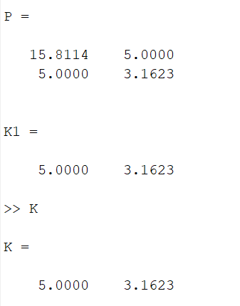

Which proves equation 11.