Problem 1:

Problem 2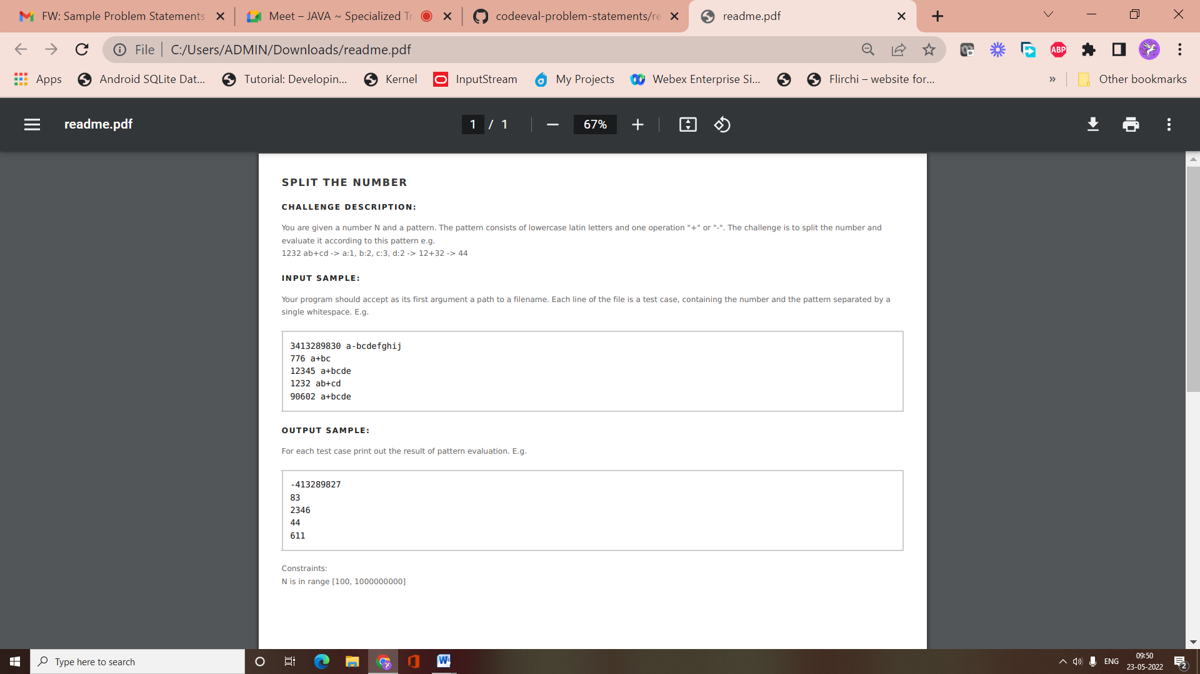

**Sum to Zero**

**Challenge Description:**

You are given an array of integers. Count the numbers of ways in which the sum of 4 elements in this array results in zero.

**Input sample:**

Your program should accept as its first argument a path to a filename. Each line in this file consist of comma separated positive and negative integers. E.g.

2,3,1,0,-4,-1

0,-1,3,-2

**Output sample:**

Print out the count of the different number of ways that 4 elements sum to zero. E.g.

2

1

Problem 3

You are given a positive integer number. This represents the sales made that day in your department store. The payables department however, needs this printed out in english. NOTE: The correct spelling of 40 is Forty. (NOT Fourty)

### Input sample:

Your program should accept as its first argument a path to a filename.The input file contains several lines. Each line is one test case. Each line contains a positive integer. E.g.

3

10

21

466

1234

### Output sample:

For each set of input produce a single line of output which is the english textual representation of that integer. The output should be unspaced and in Camelcase. Always assume plural quantities. You can also assume that the numbers are < 1000000000 (1 billion). In case of ambiguities e.g. 2200 could be TwoThousandTwoHundredDollars or TwentyTwoHundredDollars, always choose the representation with the larger base i.e. TwoThousandTwoHundredDollars. For the examples shown above, the answer would be:

ThreeDollars

TenDollars

TwentyOneDollars

FourHundredSixtySixDollars

OneThousandTwoHundredThirtyFourDollars

Problem 4

## Sum of Primes

### Challenge Description:

Write a program which determines the sum of the first 1000 prime numbers.

### Input sample:

There is no input for this program.

### Output sample:

Print to stdout the sum of the first 1000 prime numbers.

3682913

Problem 5

## Calculate Distance

### Challenge Description:

You have coordinates of 2 points and need to find the distance between them.

### Input sample:

Your program should accept as its first argument a path to a filename. Input example is the following

(25, 4) (1, -6)

(47, 43) (-25, -11)

All numbers in input are integers between **-100** and **100**.

### Output sample:

Print results in the following way.

26

90

You don't need to round the results you receive. They must be integer numbers

Problem 6

Write a program which swaps letters' case in a sentence. All non-letter characters should remain the same.

### Input sample:

Your program should accept as its first argument a path to a filename. Input example is the following

Hello world!

JavaScript language 1.8

A letter

### Output sample:

Print results in the following way.

hELLO WORLD!

jAVAsCRIPT LANGUAGE 1.8

a LETTER