Apache Camel + Spring + ActiveMQ + JBoss Fuse

We will implement a simple Apache camel integration project with Apache Camel using Spring DSL and deploy it on Red Hat JBoss Fuse.

The project structure shoud look like below.

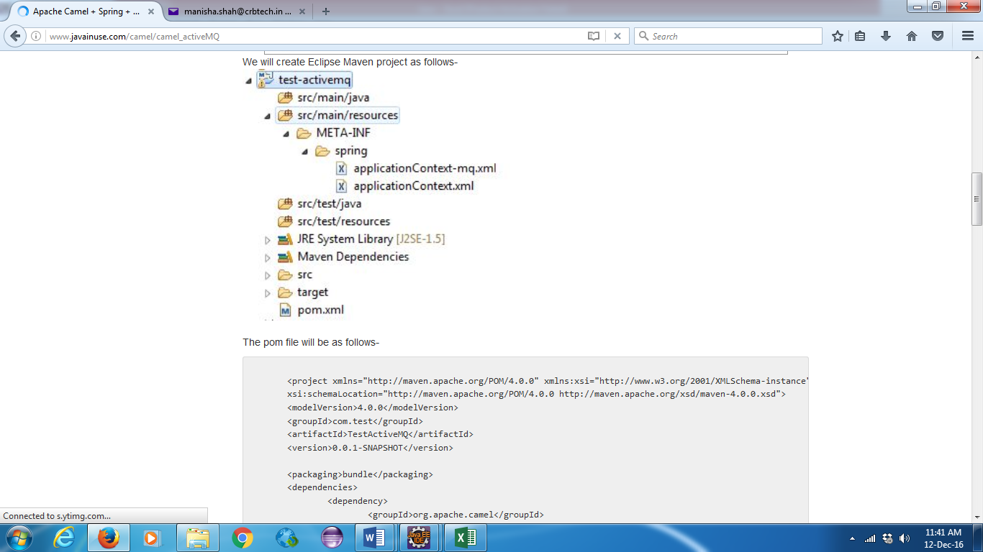

<project xmlns="http://maven.apache.org/POM/4.0.0" xmlns:xsi="http://www.w3.org/2001/XMLSchema-instance"

xsi:schemaLocation="http://maven.apache.org/POM/4.0.0 http://maven.apache.org/xsd/maven-4.0.0.xsd">

<modelVersion>4.0.0</modelVersion>

<groupId>com.test</groupId>

<artifactId>TestActiveMQ</artifactId>

<version>0.0.1-SNAPSHOT</version>

<packaging>bundle</packaging>

<dependencies>

<dependency>

<groupId>org.apache.camel</groupId>

<artifactId>camel-core</artifactId>

<version>2.8.0</version>

</dependency>

<dependency>

<groupId>org.apache.camel</groupId>

<artifactId>camel-spring</artifactId>

<version>2.8.0</version>

</dependency>

</dependencies>

<build>

<plugins>

<plugin>

<groupId>org.apache.maven.plugins</groupId>

<artifactId>maven-compiler-plugin</artifactId>

<version>3.1</version>

</plugin>

<plugin>

<groupId>org.apache.felix</groupId>

<artifactId>maven-bundle-plugin</artifactId>

<extensions>true</extensions>

<version>2.4.0</version>

</plugin>

</plugins>

</build>

</project>

The config file **applicationContext.xml** will be as follows. We have created a **camel context**. Inside the context we have written a camel route. This route logs any message that is sent to our queue.

<?xml version="1.0" encoding="UTF-8"?>

<beans xmlns="http://www.springframework.org/schema/beans"

xmlns:xsi="http://www.w3.org/2001/XMLSchema-instance" xmlns:camel="http://camel.apache.org/schema/spring"

xmlns:osgi="http://www.springframework.org/schema/osgi" xmlns:cxf="http://camel.apache.org/schema/cxf"

xsi:schemaLocation="http://www.springframework.org/schema/beans http://www.springframework.org/schema/beans/spring-beans.xsd http://www.springframework.org/schema/osgi http://www.springframework.org/schema/osgi/spring-osgi.xsd http://camel.apache.org/schema/spring http://camel.apache.org/schema/spring/camel-spring.xsd http://camel.apache.org/schema/cxf http://camel.apache.org/schema/cxf/camel-cxf-2.8.3.xsd">

<camelContext id="camelId" xmlns="http://camel.apache.org/schema/spring">

<camel:route>

<camel:from uri="amq:queue:queue1" />

<camel:log message="Message returned from the queue is ${body}" />

</camel:route>

</camelContext>

</beans>

We also need a file for configuring the ActiveMQ.

<?xml version="1.0" encoding="UTF-8"?>

<beans xmlns="http://www.springframework.org/schema/beans"

xmlns:xsi="http://www.w3.org/2001/XMLSchema-instance" xmlns:camel="http://camel.apache.org/schema/spring"

xmlns:osgi="http://www.springframework.org/schema/osgi" xmlns:cxf="http://camel.apache.org/schema/cxf"

xsi:schemaLocation="http://www.springframework.org/schema/beans http://www.springframework.org/schema/beans/spring-beans.xsd http://www.springframework.org/schema/osgi http://www.springframework.org/schema/osgi/spring-osgi.xsd http://camel.apache.org/schema/spring http://camel.apache.org/schema/spring/camel-spring.xsd http://camel.apache.org/schema/cxf http://camel.apache.org/schema/cxf/camel-cxf-2.8.3.xsd">

<bean class="org.apache.activemq.camel.component.ActiveMQComponent"

id="amq">

<property name="connectionFactory" ref="singleCF" />

<property name="useSingleConnection" value="true" />

<property name="usePooledConnection" value="false" />

<property name="preserveMessageQos" value="true" />

</bean>

<bean class="org.springframework.jms.connection.SingleConnectionFactory"

id="singleCF">

<property name="targetConnectionFactory" ref="AMQCF" />

</bean>

<bean class="org.apache.activemq.ActiveMQConnectionFactory" id="AMQCF">

<property name="userName" value="admin" />

<property name="password" value="admin" />

<property name="brokerURL" value="tcp://localhost:61616" />

</bean>

</beans>

That is the only code required.

Now run the following Maven command -**clean:install**  
Next go to **fuse.bat** and start it by double clicking on it.   
To run the jar file that is generated in .m2 repo type the following command  
**-install mvn:com.javainuse/test-activemq/0.0.1-SNAPSHOT.**  
This gives us a bundle-id. Next run the start bundle-id command

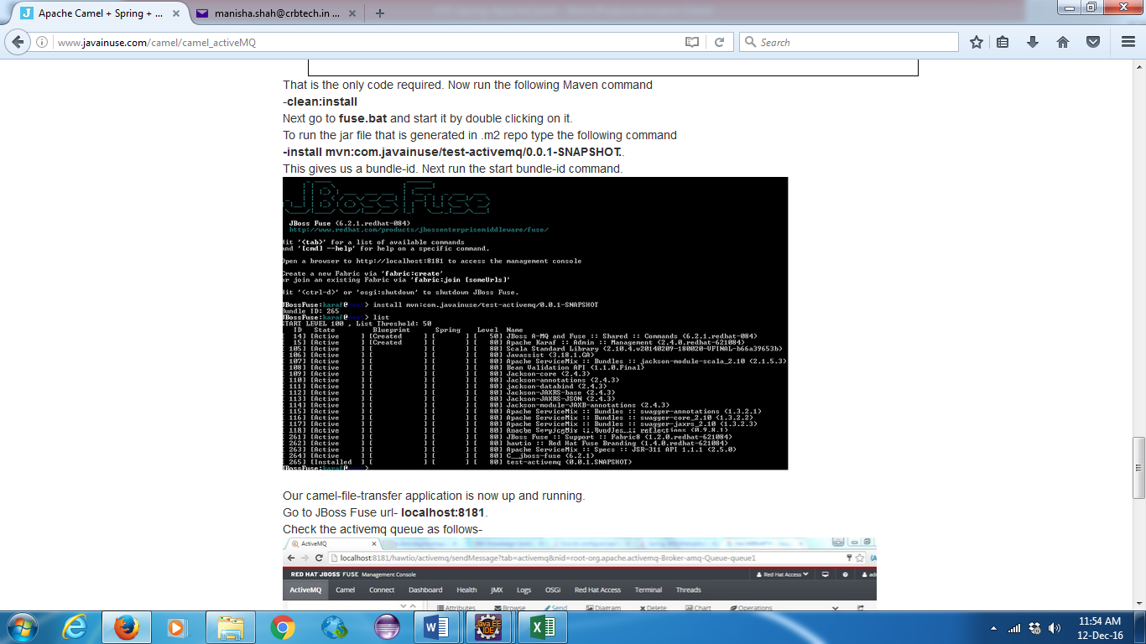

Our camel-file-transfer application is now up and running.  
Go to JBoss Fuse url- **localhost:8181**.  
Check the activemq queue as follows-

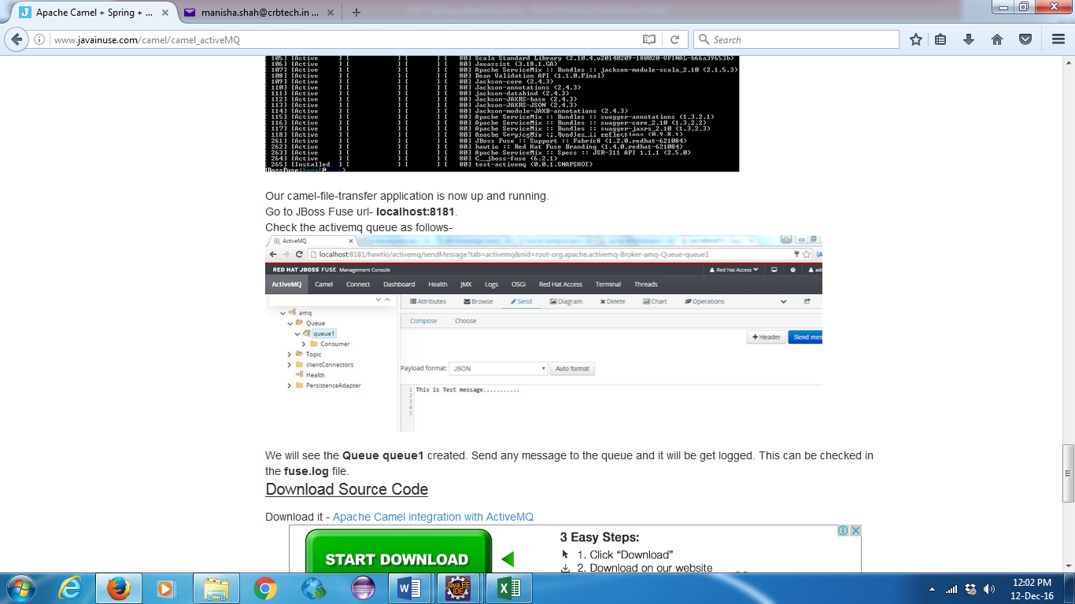

We will see the **Queue queue1** created. Send any message to the queue and it will be get logged. This can be checked in the **fuse.log** file