Camel First Example

To create a camel project, create a maven project from eclipse plugin. If maven plugin is not installed, then install maven plugin first. To install maven plugin in eclipse from Help -> Eclipse Marketplace->Maven.

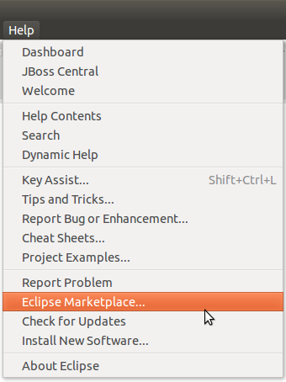

Step 1:- After the installation of maven plugin, now create a new maven project. To create a maven project browse to file->new->other->maven.

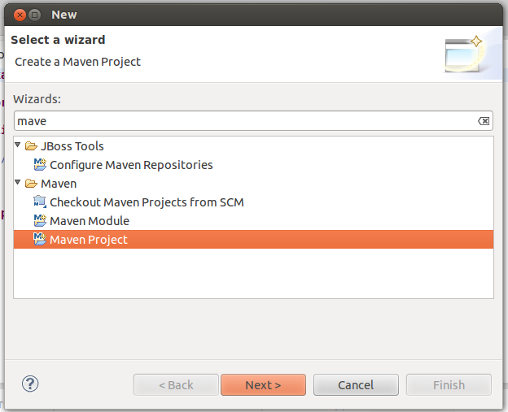
Step 2 :- After clicking on the next button the below screen we appear. Tick the first option for the project creation.

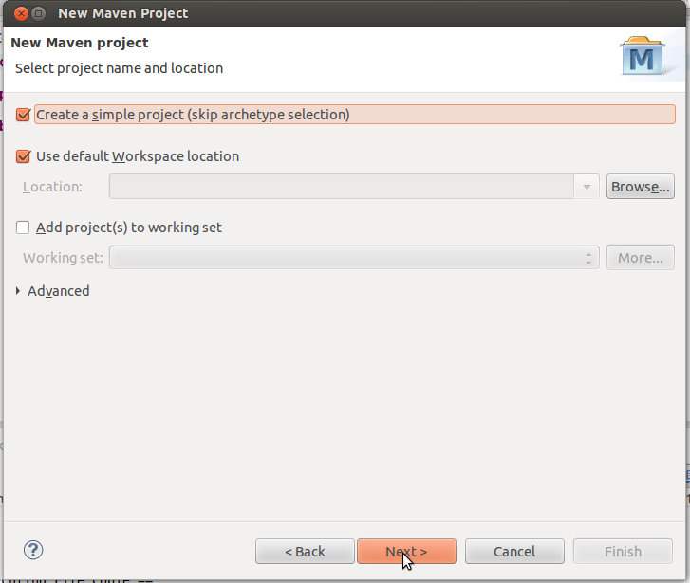

Step 3:- In the below screen we have to provide the group id, artifact id for the project created and click on finish.

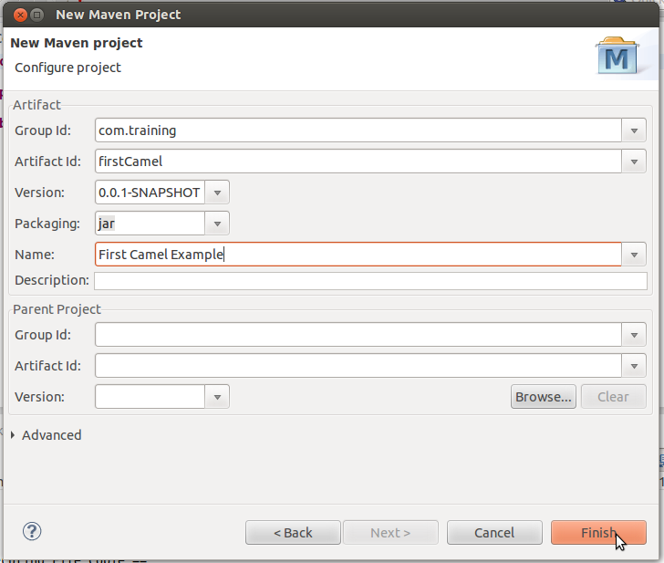
Step 4:- Once clicking on the finish the below project structure will be created.

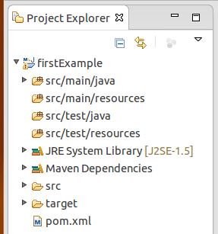

Step 5:- Now edit the pom.xml file, select dependencies from the bottom menu and add the dependency jar.

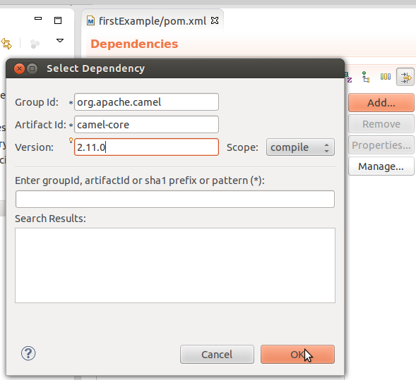
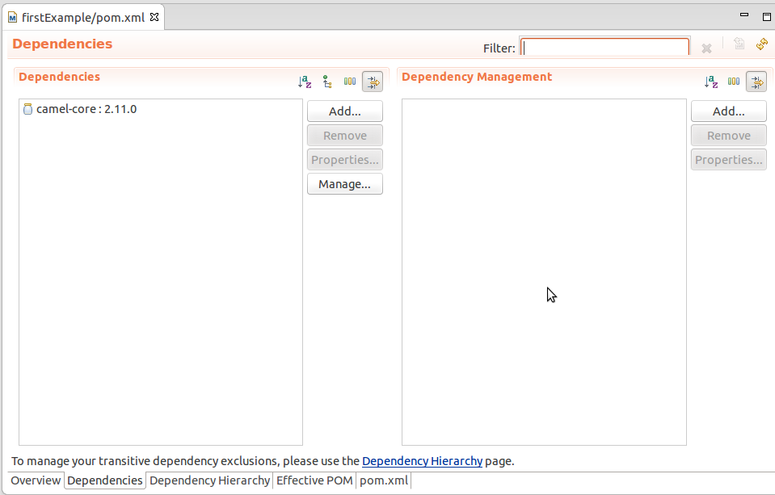

Step 6:- After adding the dependency jar for camel, now create a class file for copying the file from one place to the other using camel.

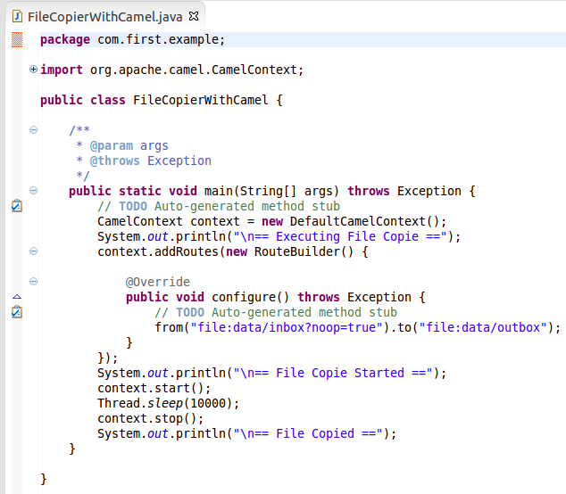

Stet 7:- Create a file sample.txt in the following structure data/inbox/sample.txt within the project.

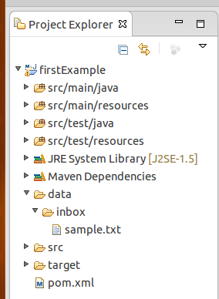

Step 8:- After completing all the above steps, now run you project as a java application you will get the following output.

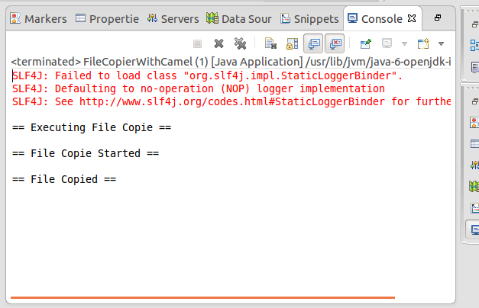
Step 9 :- After getting the above output referesh your project structure you will get the following folder structure created where the outbox folder will contain the sample.txt
