EPI Content Based Router

- Content-Based Router (CBR) is a message router that routes a message to a destination based on its content

- To do the conditional routing required by the CBR, Camel introduces a few key-words in the DSL. The choice method creates a CBR processor, and conditions are
added by following choice with a combination of a when method and a predicate.

Steps For Performing Content Based Routing

Step 1:- Create a maven project in eclipse with an appropriate name

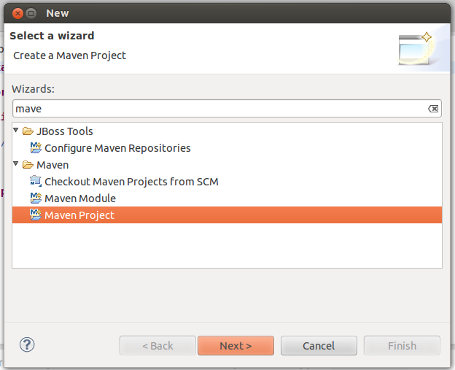

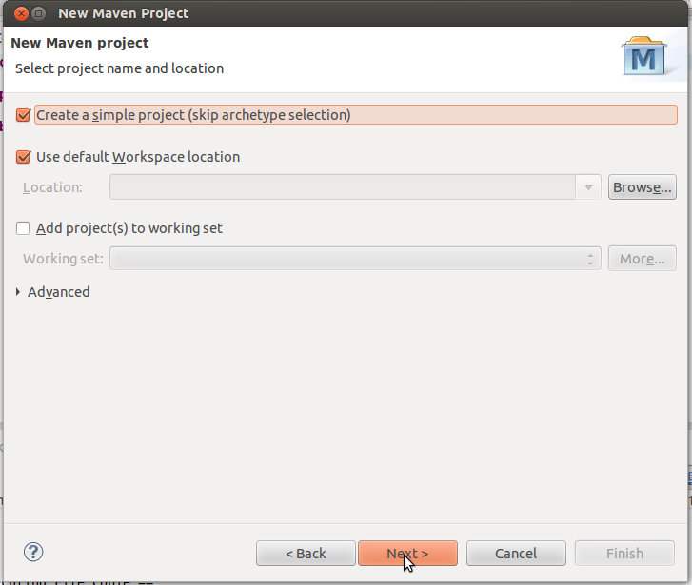
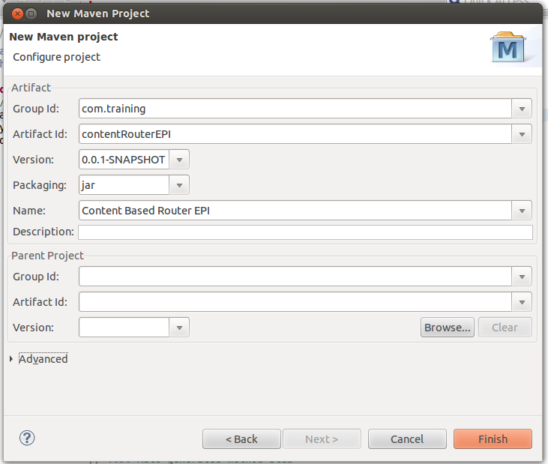
Step 2:- Edit the pom.xml file add the dependency jars to the project

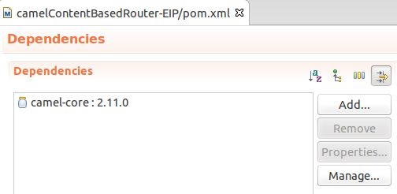

Step 3:- Create the class file for the execution of the project
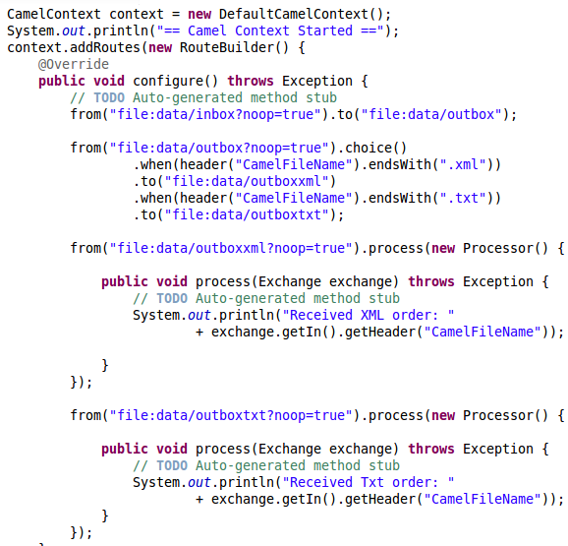

package com.epi.contentbased.router;

import org.apache.camel.CamelContext;
import org.apache.camel.Exchange;
import org.apache.camel.Processor;
import org.apache.camel.builder.RouteBuilder;
import org.apache.camel.impl.DefaultCamelContext;

public class RouterMainApplication {

public static void main(String[] args) throws Exception {
// TODO Auto-generated method stub
CamelContext context = new DefaultCamelContext();
System.out.println("== Camel Context Started ==");
context.addRoutes(new RouteBuilder() {
@Override
public void configure() throws Exception {
// TODO Auto-generated method stub
from("file:data/inbox?noop=true").to("file:data/outbox");

from("file:data/outbox?noop=true").choice()
.when(header("CamelFileName").endsWith(".xml"))
.to("file:data/outboxxml")
.when(header("CamelFileName").endsWith(".txt"))
.to("file:data/outboxtxt");

from("file:data/outboxxml?noop=true").process(new Processor() {

public void process(Exchange exchange) throws Exception {
// TODO Auto-generated method stub
System.out.println("Received XML order: "
+ exchange.getIn().getHeader("CamelFileName"));

}
});

from("file:data/outboxtxt?noop=true").process(new Processor() {

public void process(Exchange exchange) throws Exception {
// TODO Auto-generated method stub
System.out.println("Received Txt order: "
+ exchange.getIn().getHeader("CamelFileName"));
}
});
}
});

System.out.println("\n== File Copie Started ==");
context.start();
Thread.sleep(10000);
context.stop();
System.out.println("\n== File Copied ==");
}
}

Step 4:- Create a data/inbox folder within the project and add two files in it one .xml and one with .txt extension
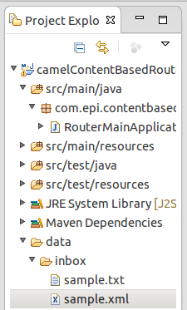
Step 5:- After executing the project the files will be copied to the specific folders based on the extension provided.

