Master Test Plan For [insert Project Name here]

Prepared by:
Prepared for:
Date submitted:
Project Sponsor:
Client Acceptor:
Project Manager:
Business Analyst:
Test Manager
Filename: | Document109
Document Number:
Last Edit: | _______________ by __________
Comments: | Important Notice: This template includes instructional summaries at the beginning of each section. They use a style called instructions that has been configured as hidden text. This means you can choose to display and/or print them at will. Under normal circumstances, these should be hidden when you distribute your actual reports, unless you judge that the instructions themselves provide value to your readers. Please see the next page in this template for step-by-step instructions on how to see and print hidden text, along with shortcut keys for the various styles used in the template.

About Viewing/Printing Hidden Text Instructions
Microsoft® Word has a font characteristic called hidden text that allows for selective viewing and printing. Each of these two functions is controlled separately. When made visible, Word indicates that a text passage is configured as hidden by including a faint dotted underline. When made invisible, Word collapses the space that is normally taken up by hidden text, so that you don’t get big, white, blank spaces in your document.
This template employs a customized style called instructions that uses the hidden text attribute. The instructions appear as blue text under each header in the template. If you do not see them, you have not told Microsoft® Word to display hidden text. Here is how you do it:
- Select Tools/Options from the menu bar. The Options menu appears as shown below.
- To control display, check or uncheck Hidden Text on the View tab.
- To control printing, check or uncheck Hidden Text on the Print tab.

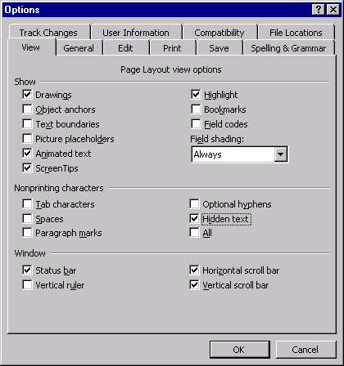

About Using Microsoft® Word Templates
By default, Microsoft® Word stores its templates in subfolders under the Program Files/Microsoft® Office/Templates folder on your C drive. While normal Word documents have the .doc file extension, templates have a .dot file extension. This template is an example of this.
To prepare this template for use, use Windows Explorer to create a subfolder called Business Analysis underneath the Program Files/Microsoft® Office/Templates folder. Copy this template into your Business Analysis folder.
To create a document that uses this template, select File/New from the menu bar. Word automatically opens the Program Files/Microsoft® Office/Templates for you. You will see that Word has added a tab for your Business Analysis folder. Click on the tab, double click the template file. Word opens a new document (.doc) that uses the template.
NOTE: In the above discussion, we have used Business Analysis as a sample folder name only. You may call this folder anything you wish. However, it is recommended that you place any special non-Microsoft® issue templates in their own folders for ease of navigation and sharing with other users.

Table of Contents
About Viewing/Printing Hidden Text Instructions ii
About Using Microsoft® Word Templates ii
Executive Summary 2
Part 1: Approvals 2
Part 2: Introduction 2
Section 2.1: Purpose 2
Section 2.2: Intended Audience 2
Section 2.3: Background of the Solution 2
Section 2.4: Assumptions and Constraints 2
Section 2.5: References 2
Part 3: Test Scope 2
Section 3.1: Test Items 2
Section 3.2: Features to be Tested 2
Section 3.3: Features not to be Tested 2
Part 4: Master Test Strategy 2
Section 4.1: Test Goals 2
Section 4.2: Test Strategies 2
Section 4.2.1: Unit Testing 2
Section 4.2.1.1: Functional Testing 2
Section 4.2.1.2: Nonfunctional (Quality of Service) Testing 2
Section 4.2.1.3: Structural Testing 2
Section 4.2.2: Integration Testing 2
Section 4.2.2.1: Functional Testing 2
Section 4.2.2.2: Nonfunctional (Quality of Service) Testing 2
Section 4.2.2.3: Structural Testing 2
Section 4.2.3: System Testing 2
Section 4.2.3.1: Functional Testing 2
Section 4.2.3.2: Nonfunctional (Quality of Service) Testing 2
Section 4.2.3.3: Structural Testing 2
Section 4.2.4: User Testing 2
Section 4.2.4.1: Functional Testing 2
Section 4.2.4.2: Nonfunctional (Quality of Service) Testing 2
Section 4.2.4.3: Structural Testing 2
Section 4.2.5: Acceptance Testing 2
Section 4.2.6: Satisfaction Assessment 2
Part 5: Acceptance Criteria 2
Part 6: Test Deliverables 2
Part 7: Test data/Data Transition Management 2
Part 8: Risks 2
Part 9: Impact Analysis 2
Part 10: Project Management 2
Section 10.1: Resources 2
Section 10.1.1: Responsibilities 2
Section 10.1.2: Environmental Needs 2
Section 10.2: Schedule 2
Section 10.3: Cost 2
Part 11: Revision Log 2
Part 12: Lessons Learned 2
Part 13: Appendixes 2
Appendix A: Traceability Matrix 2
Appendix B: Glossary 2
Appendix C: WBS 2
Appendix D: Test Cases and Scenarios 2
Trademark Acknowledgement 2

Executive Summary
Add an executive summary highlighting the key details of the Master Test Plan, including which levels and types of testing will be performed, the associated costs, and key milestones.
- Part 1: Approvals
This part documents the approvals required for sign-off of the master test plan and key testing milestones. Each signatory is described by both organizational title and project functional role. Required signatories are the business analyst and key stakeholders, such as the client acceptor. Other signatories may be required by your company policy.
Decision Making and Approval Process
In some cases, projects will have a number of key stakeholders who must discuss and provide interim approval for all or for specific sections of the business requirements document. However, there must always be a single client acceptor who will ultimately approve the document, representing the requirements viewpoint of the business area addressed by the project.
Within project management and business analysis, the identification of the client acceptor is a key delegation. The delegation of client acceptor may be awarded to the same individual who serves as business/project sponsor.
This document has been approved as the official master test plan for the __________ project and accurately reflects the current understanding of the plan for validating requirements and verifying the solution. Following approval of this document, changes to the plan will be governed by the project’s change management process, including impact analysis, appropriate reviews, and approvals, under the general control of the project plan and according to company policy.

Prepared by
_________________________ | _______________
Business Analyst | Date
Approved by
_________________________ | _______________
Client Acceptor | Date

Part 2: Introduction
This is a template that conforms to industry best practices in business analysis but may be scaled as appropriate for a project.
In this part, provide a high-level introduction to the scope and goals of the test plan. Highlight the key stakeholders in the project, as well as provide a description of the documents to be validated and the solutions to be verified.

Section 2.1: Purpose
The Master Test Plan is a major deliverable representing the achievement of the testing milestone in a typical project management methodology. As such, it requires formal review and sign-off by the client acceptor (representing the interests of business area stakeholders). Under normal circumstances, the senior business analyst delegated to a project plays a significant role in helping to develop the Master Test Plan.

Section 2.2: Intended Audience
Both readers and approvers of the Master Test Plan are identified here. Organizational titles and functional project roles for each individual are included. An organization chart is very helpful in complex reader/approver environments.
In priority order, the main reviewers of this document are—
- Client Acceptor—reviews and approves
- Test Manager—develops and ensures the test plan is followed
- Business Analyst—assists with development of the test plan to ensure plan is consistent with the Business Requirements Document and the needs of the business
- Project Manager—reviews and integrates into construction project phase
- Functional Management—reviews and provides resources for business testing activities
- Systems Analyst—reviews and assists with development of test planning for integration and system testing
- Developers—develop the strategy, test scenarios, and test cases for unit level testing of the software code they develop and review the test plans, test results, and test deliverables of other developers
- Testers—review and perform testing, and participate in the development of test strategies and test cases

Section 2.3: Background of the Solution
In this section, a high-level description of the solution should be written. This explanation should include a description of why the solution is under development or has been developed (what business need does the solution satisfy)?

Section 2.4: Assumptions and Constraints
In this section, any assumptions and/or constraints identified during the planning process should be documented. An assumption is a factor that is considered to be true, real, or certain and is often used as a basis for decision making. A constraint is a restriction that affects the scope of the project, usually with regard to availability, assignment, or use of project cost, schedule, or resources. Constraints may involve time, resources, budget, technical issues or limitations, and so on.

Section 2.5: References
This section lists references used to create the Master Test Plan. These may include standards (for example, IEEE Std. 829-1998), quality assurance plans, relevant policies, configuration management plans, and so on.
The business requirements document (BRD) should be referenced in this section, along with a reference to the BRD’s location.

Part 3: Test Scope
In this section, the scope of the testing process is defined by detailing the test items and features of the solution to be tested. It is also important to document those features not to be tested to justify any features not included in the plan.

Section 3.1: Test Items
All items to be tested, including documents, processes, code, and so forth, must be documented in this section. References to the latest version and location of the items should also be included and updated as the test items are updated.
Test items to be excluded from the test effort should also be referenced.

Section 3.2: Features to Be Tested
All features of the solution that will be tested should be documented in this section. Features may include security, disaster or backup recovery, performance, and so on. Specific test cases and scenarios developed to test these features should be referenced here (note these cases and scenarios should also be included in the Appendix of this document).

Section 3.3: Features Not to Be Tested
Any features not to be tested under this plan should be documented in this section. The reasons for not testing these features should also be included.

Part 4: Master Test Strategy
This part outlines the strategy for the solution testing effort. The master test strategy should align with the IT strategy as defined by the organization. The development of the test strategy is an iterative process that begins during the development of the Vision and Scope document.
The following sections outline the test goals and solution verification strategy, which together serve as the master test strategy for the solution testing effort.

Section 4.1: Test Goals
In this section, the business analyst should document the test goals for this testing effort. To identify the test goals, the business analyst should identify what resources are required to perform the work to meet the test goal and determine what solution functions must be proven when testing is complete. The business analyst should also consider what solution characteristics must also be proven to conform to the expectations from management and/or users regarding the types of testing that might be conducted for quality of service (nonfunctional) requirements such as functionality, performance, stability, reliability, recoverability, usability, security, and availability.

Section 4.2: Test Strategies
In this section, the business analyst should document the test strategies for each level of testing. To document the strategies, decisions must be made regarding what deliverables have been (will be) defined for the solution and what is the risk that the deliverables will result in a solution that will not meet the expectations because they are defective, incomplete, inconsistent, incorrect, or missed. The test strategies should also consider what must be done to manage the risks.
The following subsections document the levels of testing that will be covered during the test effort and the types of testing to be performed at each level. The following V-model should be altered to reflect the levels of testing required. The purpose of each level to be performed during the testing effort should be discussed briefly in the following subsections.
The following model depicts the levels of testing that will be performed during this testing effort—
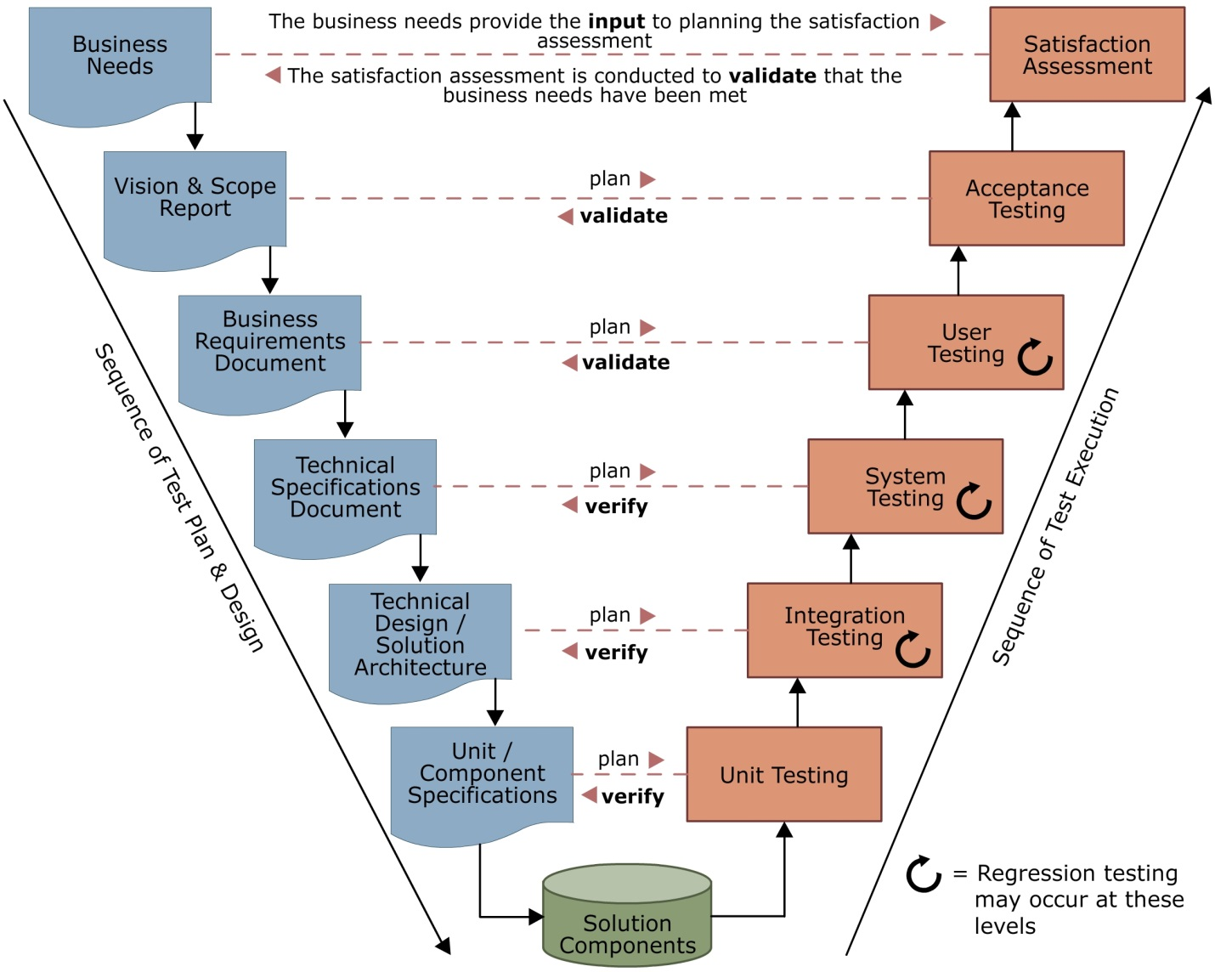
- Section 4.2.1: Unit Testing
In this subsection, provide a definition of unit testing and why it should be performed in this testing effort. The test strategy and approach for conducting unit testing should be documented here to explicitly state how unit testing will meet the business need and who will be responsible for performing the testing at this level. As part of documenting the strategy, this section should explain the types of testing that will be performed to conduct unit testing.

Section 4.2.1.1: Functional Testing
In this subsection, the types of functional testing to be used during the testing effort should be documented. If necessary, a short definition of the testing type should also be included. If functional testing is to be based on specific use cases and scenarios, their locations should be referenced.

Section 4.2.1.2: Nonfunctional (Quality of Service) Testing
In this subsection, the types of nonfunctional testing to be used during the testing effort should be documented.
The International Institute for Business Analysis (IIBA™)’s Business Analysis Body of Knowledge (BABOK®) includes a list of nonfunctional requirements under the name quality of service requirements.

Section 4.2.1.3: Structural Testing
In this subsection, the types of structural testing to be used during the testing effort should be documented. If necessary, a short definition of the testing type should also be included. If structural testing is to be based on specific use cases and scenarios, their locations should be referenced.

Section 4.2.2: Integration Testing
In this subsection, provide a definition of integration testing and why it should be performed in this testing effort. The test strategy and approach for conducting integration testing should be documented here to explicitly state how integration testing will meet the business need and who will be responsible for performing the testing at this level. As part of documenting the strategy, this section should explain the types of testing that will be performed to conduct integration testing.

Section 4.2.2.1: Functional Testing
In this subsection, the types of functional testing to be used during the testing effort should be documented. If necessary, a short definition of the testing type should also be included. If functional testing is to be based on specific use cases and scenarios, their locations should be referenced.

Section 4.2.2.2: Nonfunctional (Quality of Service) Testing
In this subsection, the types of nonfunctional testing to be used during the testing effort should be documented.
The International Institute for Business Analysis (IIBA™)’s Business Analysis Body of Knowledge (BABOK®) includes a list of nonfunctional requirements under the name quality of service requirements.

Section 4.2.2.3: Structural Testing
In this subsection, the types of structural testing to be used during the testing effort should be documented. If necessary, a short definition of the testing type should also be included. If structural testing is to be based on specific use cases and scenarios, their locations should be referenced.

Section 4.2.3: System Testing
In this subsection, provide a definition of system testing and why it should be performed in this testing effort. The test strategy and approach for conducting system testing should be documented here to explicitly state how system testing will meet the business need and who will be responsible for performing the testing at this level. As part of documenting the strategy, this section should explain the types of testing that will be performed to conduct system testing.

Section 4.2.3.1: Functional Testing
In this subsection, the types of functional testing to be used during the testing effort should be documented. If necessary, a short definition of the testing type should also be included. If functional testing is to be based on specific use cases and scenarios, their locations should be referenced.

Section 4.2.3.2: Nonfunctional (Quality of Service) Testing
In this subsection, the types of nonfunctional testing to be used during the testing effort should be documented.
The International Institute for Business Analysis (IIBA™)’s Business Analysis Body of Knowledge (BABOK®) includes a list of nonfunctional requirements under the name quality of service requirements.

Section 4.2.3.3: Structural Testing
In this subsection, the types of structural testing to be used during the testing effort should be documented. If necessary, a short definition of the testing type should also be included. If structural testing is to be based on specific use cases and scenarios, their locations should be referenced.

Section 4.2.4: User Testing
In this subsection, provide a definition of user testing and why it should be performed in this testing effort. The test strategy and approach for conducting user testing should be documented here to explicitly state how user testing will meet the business need and who will be responsible for performing the testing at this level. As part of documenting the strategy, this section should explain the types of testing that will be performed to conduct user testing.

Section 4.2.4.1: Functional Testing
In this subsection, the types of functional testing to be used during the testing effort should be documented. If necessary, a short definition of the testing type should also be included. If functional testing is to be based on specific use cases and scenarios, their locations should be referenced.

Section 4.2.4.2: Nonfunctional (Quality of Service) Testing
In this subsection, the types of nonfunctional testing to be used during the testing effort should be documented.
The International Institute for Business Analysis (IIBA™)’s Business Analysis Body of Knowledge (BABOK®) includes a list of nonfunctional requirements under the name quality of service requirements.

Section 4.2.4.3: Structural Testing
In this subsection, the types of structural testing to be used during the testing effort should be documented. If necessary, a short definition of the testing type should also be included. If structural testing is to be based on specific use cases and scenarios, their locations should be referenced.

Section 4.2.5: Acceptance Testing
In this subsection, provide a definition of acceptance testing and why it should be performed in this testing effort. The approach for the acceptance test should be documented, as well as key stakeholders who are involved in the acceptance process and team members who will perform demonstrations of the solution.

Section 4.2.6: Satisfaction Assessment
In this subsection, provide a short definition of a satisfaction assessment and why it should be performed in this testing effort. The approach for the satisfaction assessment should be documented and should address key stakeholders to be involved in the assessment, surveys to be used, and the amount of time after delivery before the assessment is conducted.

Part 5: Acceptance Criteria
This part documents the specific criteria that the solution and corresponding documentation must meet to determine whether the solution satisfies the requirements outlined in the BRD.
In this part, document the acceptance criteria that will be used for each level and type of testing for the testing effort. NOTE: all acceptance criteria should be signed off by the client acceptor, business sponsor, test manager, business analyst, and other relevant stakeholders.

Part 6: Test Deliverables
This part lists the deliverables expected to be completed during the testing effort. References to the location of test deliverables already complete are provided.
In this part, list all deliverables of the testing effort and references to the locations of those deliverables already complete. Deliverables may include—
- Test cases
- Test scenarios
- Test scripts
- Test data
- Test procedures
- Test logs for each test level and/or type
- Execution logs
- Incident reports
- Correction actions

Part 7: Test data/Data Transition Management
This part outlines the test data that will be used for the testing effort and how the test data will be prepared or provided.
This part documents the steps necessary to ensure the proper test data is available for the testing effort. If test data files have been already created, their location should be referenced here. Any special considerations or risks for creating test data should be documented here including where the “master” files will come from, who will create them, and what controls need to be in place as the files/data tables are created. A test data conversion and migration process must exist and be documented here if production data currently in use will need to be modified for use in the testing effort.

Part 8: Risks
This part describes the risks associated with the testing effort, their probability of occurring, the impact, and any risk response strategies, which are documented in the Risk Response Matrix below.
This part documents project risks that—
- The business analysis uncovered
- Relate to the testing effort itself (such as not having adequate time to perform testing and nonavailability of key resources)
- Will result from the testing effort
In the form of a matrix, list and analyze each risk event by documenting the risk type (threat or opportunity); a description of the risk; the qualitative probability rating (high, medium, low); the qualitative impact rating (high, medium, low); and a response strategy (avoid, transfer, mitigate, and accept or exploit, share, and enhance); and a person responsible for the risk.
Risk ID | Risk Type | Risk Description | Probability | Impact | Risk Response
1
2
3
4
5
6
7
8
9
10

Part 9: Impact Analysis
This part documents the factors that may impact test planning and test execution.
In this part, document any factors that can impact test planning including—
- Risk
- Development models (predictive, iterative, agile)
- The acquisition method for the software (that is, in-house development, outsourced development, COTS product, developed for a global environment or local environment, and so forth)
Impact analysis is a recognized way of defining the impact any changes made to one application will have on any other application with which it interfaces (either directly or indirectly). These interfaces are critical to determining the scope of the project and must be documented and integrated here into the overall Master Test Plan.

Part 10: Project Management
In this part, the costs, resources, and schedule are documented. The sections below provide the details for ensuring the triple constraints of the testing effort are managed.
Document the cost, resources, and schedule required for the testing effort in the sections below. References to other key documents, such as a business case, the BRD, a detailed WBS, and so on, should be included as necessary.

Section 10.1: Resources
Document all resources (personnel, equipment, facilities, and so on) required for the testing effort, including the planning phase.

Section 10.1.1: Responsibilities
In this subsection, document all personnel and skills required for the testing effort. Where possible, include estimated costs for obtaining or training personnel.
Complete the Roles and Responsibilities Matrix below. The matrix is an uncomplicated way of showing which “resource” (person) is responsible for each task or group of tasks. It is simply a grid with people identified along one axis and tasks along the other. Each person’s role in relation to a particular task may then be highlighted as in the following example. Assigning levels of responsibilities for each type of task, as opposed to just checking them off, can also be helpful in planning and managing your resource requirements.
Roles and Responsibilities Matrix
 | Roles and Responsibilities
Tasks | Role 1 | Role 2 | Role 3 | Role 4 | Role 5 | Role 6 | Role 7 | Role 8 | Role 9 | Role 10

R = Responsible
A = Accountable/Approve
C = Consulted
I = Informed

Section 10.1.2: Environmental Needs
In this subsection, all environmental needs and nonpersonnel resources should be documented for the testing effort. Environmental needs may include test laboratories, different test environments, or test tools.

Section 10.2: Schedule
In this section, the key milestones for the testing effort along with start and finish dates should be documented. If appropriate, a high-level network diagram may also be included here.

Section 10.3: Cost
Document the cost estimates for the testing effort that have been derived from the required schedule and resources.

Part 11: Revision Log
This part logs all revisions to this document that have occurred over successive documentation iterations during testing planning or execution activities. The log below should be maintained and updated on a regular basis throughout the entire testing effort.
Revision Number | Revision Date | Revision | Revision made by

Part 12: Lessons Learned
In this section, document what has worked with the testing effort to-date, what could have been planned or executed better, and any additional lessons learned during the planning and execution process. This section should be updated as the testing process evolves.

Part 13: Appendixes
Each appendix must have—
- A separate header, numbered A-Z, with an appropriate descriptive title. For example
Appendix A – Regulatory Requirements
- NOTE: Use the Heading 1 Style for each appendix header. This style will automatically insert a page break.

Appendix A: Traceability Matrix
In this part, create a matrix that traces all functional requirements to higher-level requirements. This is to ensure that all functions support the business/user requirements. This matrix should be updated on a regular basis throughout the testing effort.
Functional Requirement Reference Number | User | Operational | Tactical | Strategic | Regulatory

Appendix B: Glossary
This part identifies any industry or line of business jargon, acronyms, common words used in special context, and special terms that are used within the project and the BRD. Pay particular attention to acronyms that may have multiple meanings (such as a commonly used meaning and a meaning that has special significance to the business area). For example, the acronym PMO is an industry-wide acronym for project management office. It may also stand for prime minister’s office or preventive maintenance optimization. The project and business context determine the meaning.
If appropriate, it may be necessary to reference the Glossary in the BRD only.

Appendix C: WBS
In this appendix, either include the entire WBS for the testing process or include a reference to the location of the WBS.

Appendix D: Test Cases and Scenarios
In this appendix, either include all test cases and scenarios developed for the test effort or include a reference to their locations.

Trademark Acknowledgement
“Microsoft,” “Word,” and “Windows” are either registered trademarks or trademarks of Microsoft Corporation in the United States and/or other countries.
“Oracle” is a registered trademark of Oracle Corporation and/or its affiliates.

