Practical Exercise for Students
Students must perform the following independently.
Task 1
Test:
GET /api/students
Record:
- Request method
- URL :http://localhost:3000/api/students
- Status code
- Response
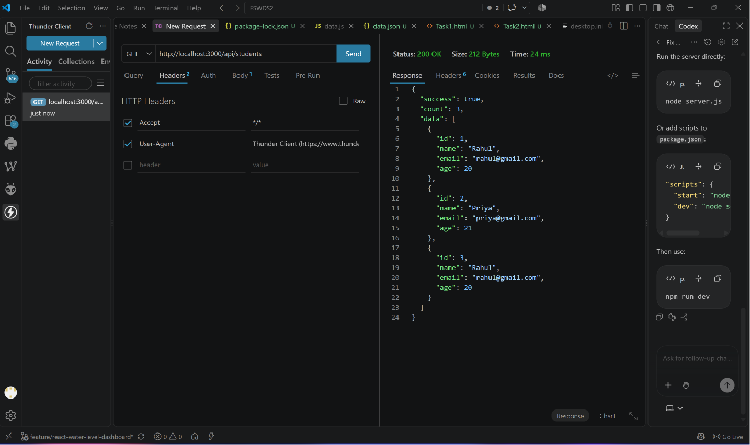

Task 2
Create a student using:
POST /api/students
Use:
{
"name": "Student Name",
"email": "student@gmail.com",
"age": 21
}
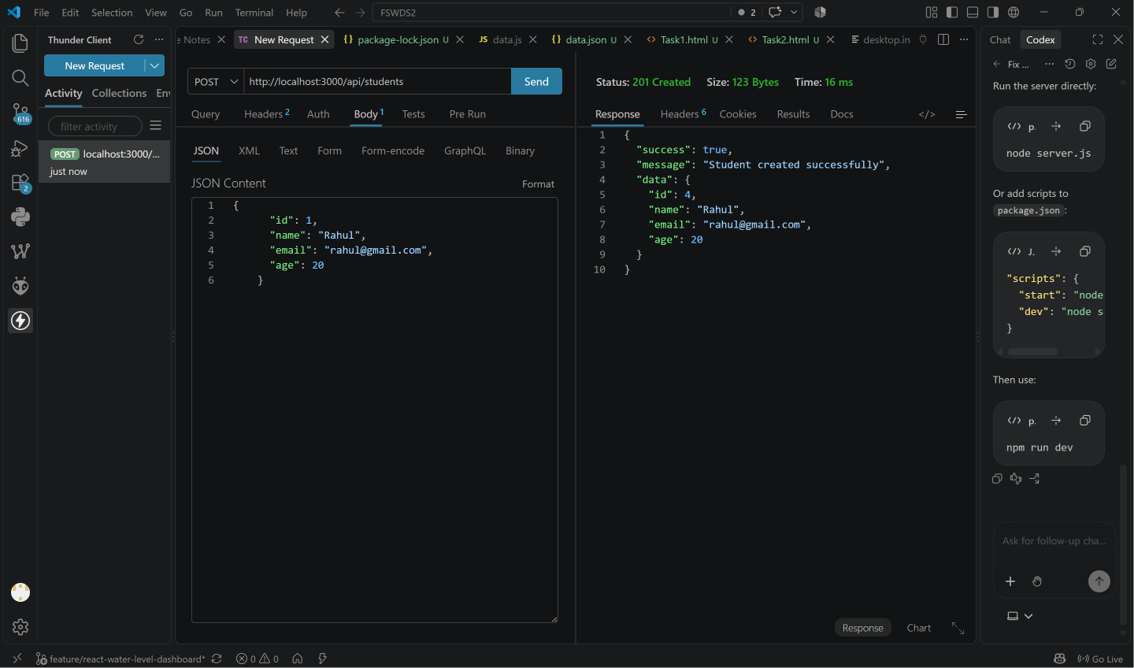

Task 3
Send an invalid student without email.
{
"name": "Student Name",
"age": 21
}
Observe:
400 Bad Request
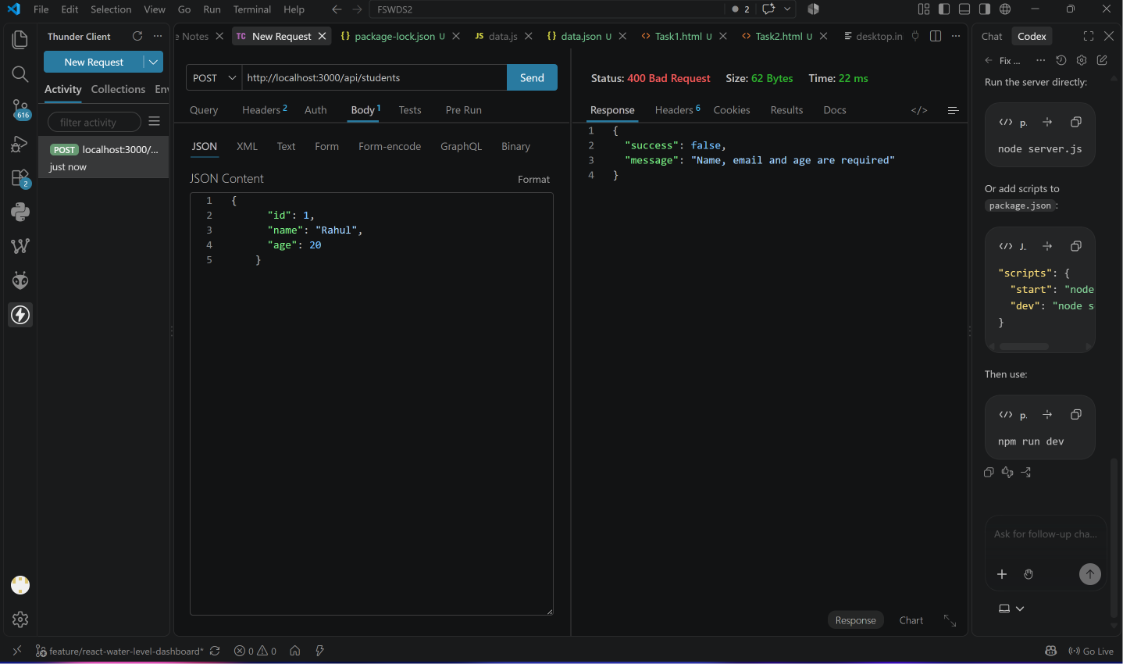

Task 4
Send an invalid age:
{
"name": "Student Name",
"email": "student@gmail.com",
"age": 12
}
Observe the validation response.
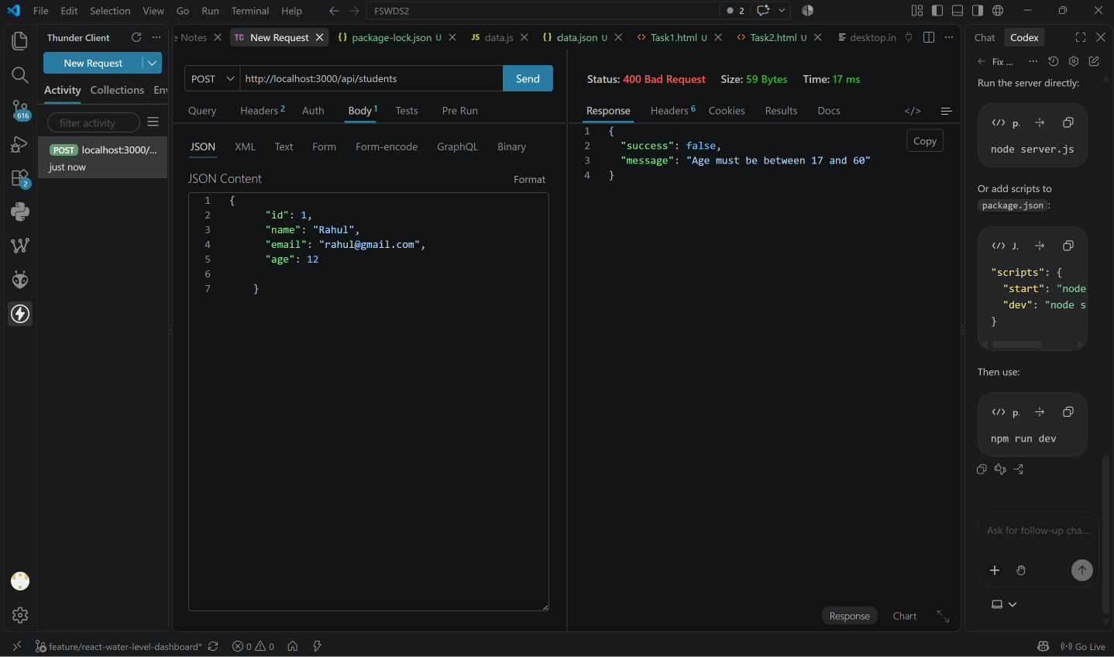

Task 5
Test:
GET /api/products
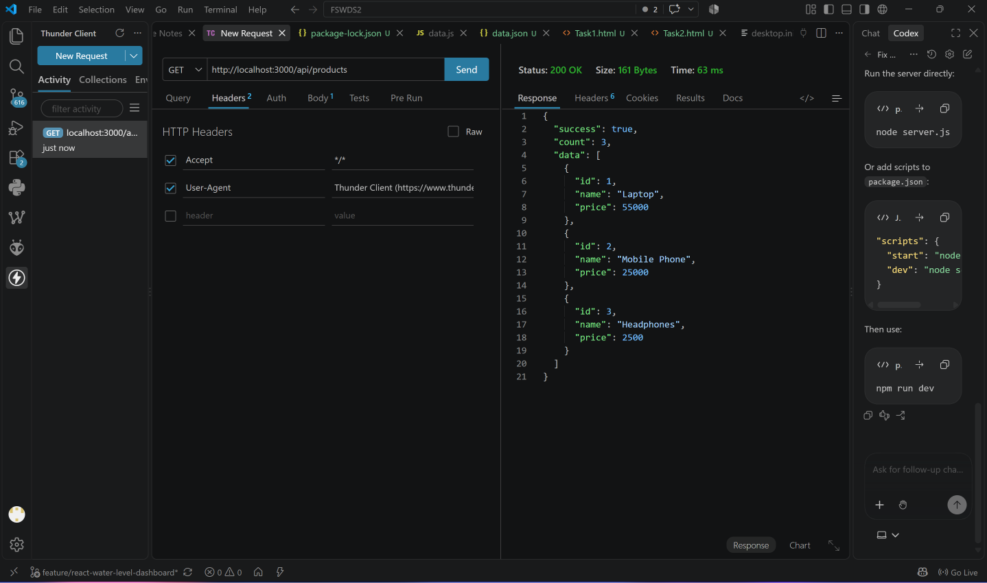

Task 6
Create a product:
{
"name": "Mouse",
"price": 800
}
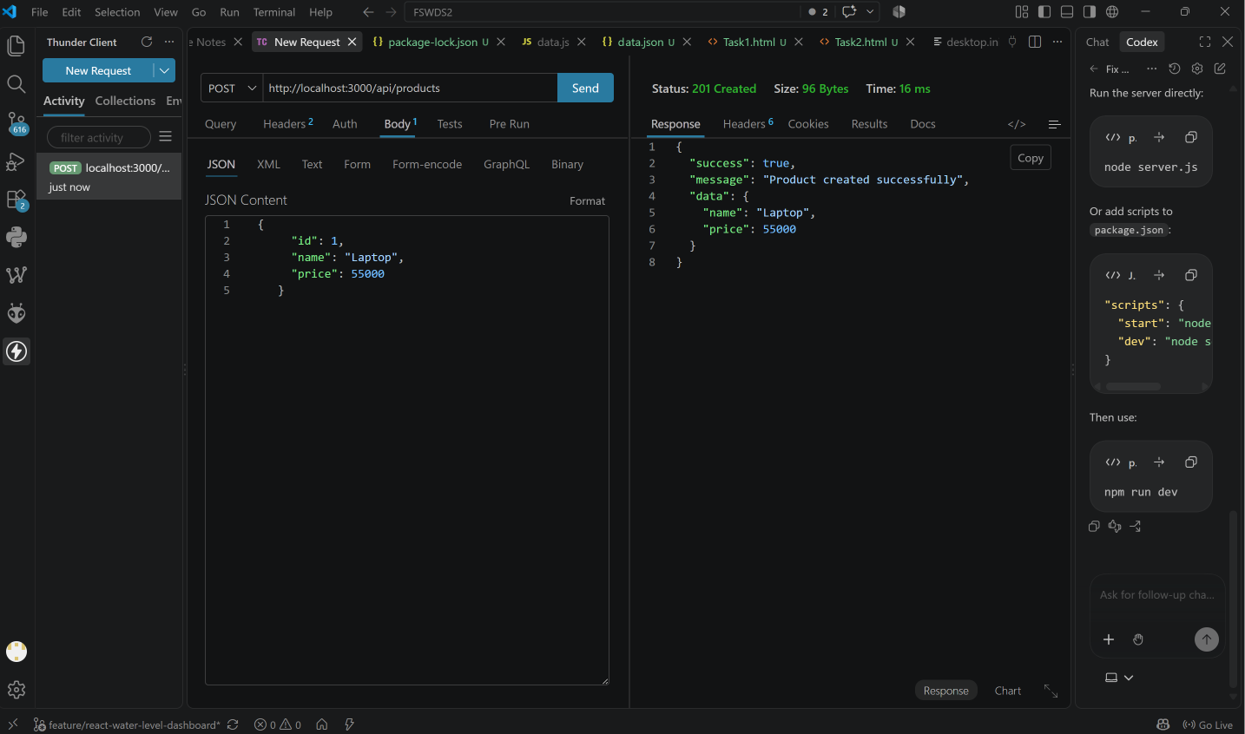

Task 7
Send an invalid product:
{
"name": "Mouse",
"price": -500
}
Observe:
400 Bad Request
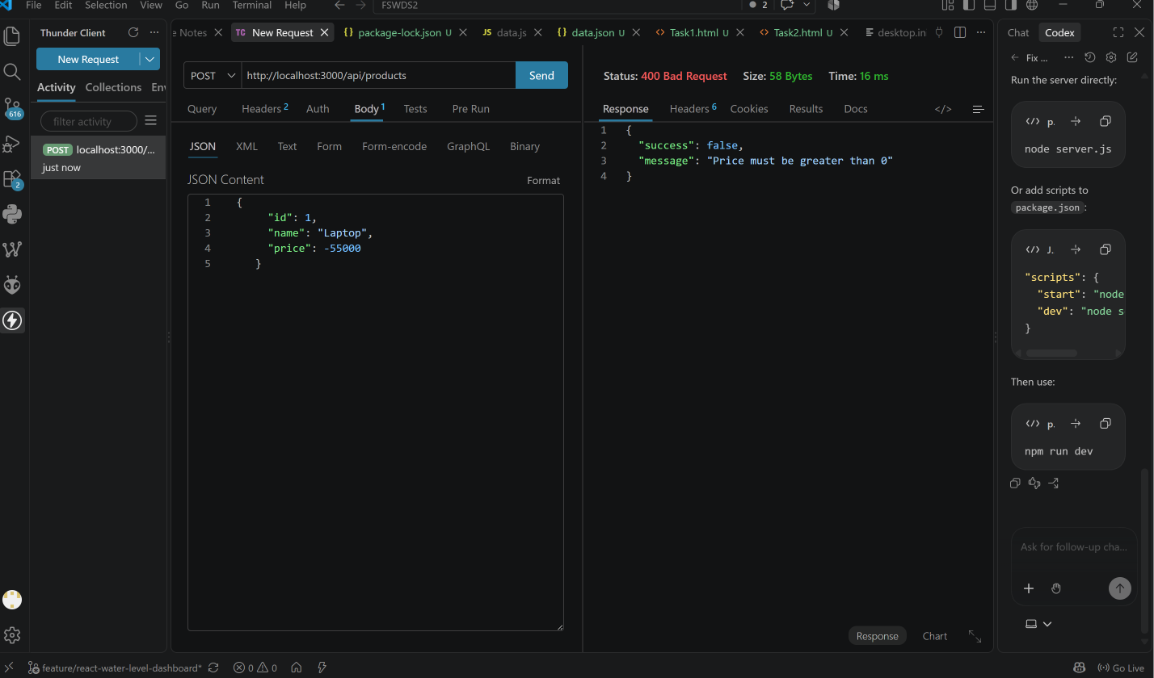

Task 8
Test the 404 error:
GET /api/hello
Expected:
404 Not Found
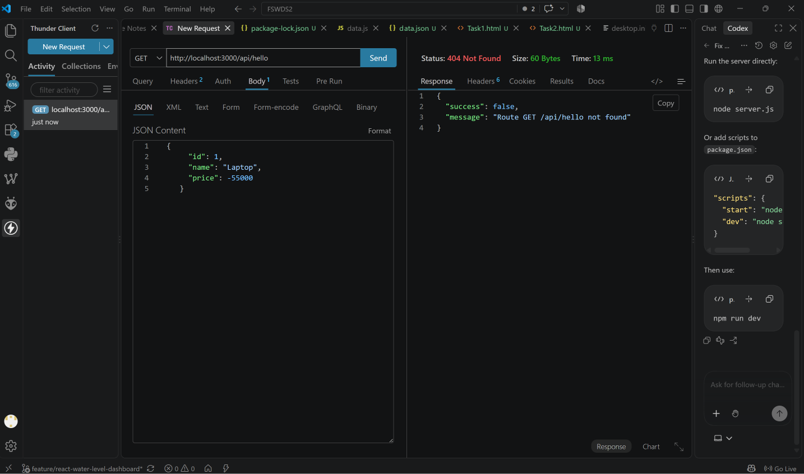

Task 9
Test:
GET /api/error
Expected:
500 Internal Server Error
