**This Document.**

This document lists various hardware options for very low cost personal instrumentation. These are listed in order by cost / ease of implementation / solderless breadboard friendliness.

**Summary:**

There are some basic assumptions.

First is that the hardware is part of the Arduino ecosystem and the embedded firmware is developed using the Arduino IDE.

Most all hardware platforms in the Arduino world have built in ADCs of some speed / resolution so any / all can provide a basic analog input / “oscilloscope” type instrument. They also generally provide at least one fixed DC power supply voltage available for the user. Digital inputs and outputs are available with one or more that can be programed as square wave PWM outputs.

Very few if any have internal DAC analog output(s) that could provide an analog waveform generator output (AWG) function. External components, such as serial (SPI) DAC integrated circuits, generally need to be added to generate analog waveforms. These add-on external circuits (modules) add cost and wiring complexity up to and including mounting everything on a carrier PCB which adds labor and cost.

As an alternate, but less desire able solution, analog outputs can be generated by modulating and low pass filtering one or more digital PWM outputs. The added cost could be as little as a passive resistor and capacitor but the output will not be buffered. A buffer op-amp or active filter circuit could be added.

The options presented here provide some solutions that provide various levels of cost, performance and complexity.

**Version based on XIAO SAMD21**

Performance Specs:

* Up to 3 12 bit Scope channels, 50 KSPS for one channel, 25 KSPS per channel for two channels or 16.667 KSPS for all three channels.
* One 8 bit AWG channel at 50 KSPS
* Up to 6 digital input channels at same sample rate as analog scope
* 1 PWM digital output or 1 PWM “analog” AWG output

Parts List: Total, $ 5.40 (plus import Tariff)

Seeed Studio XIAO SAMD21:

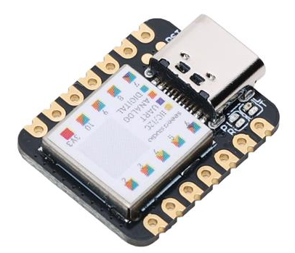

Many experiment setups can be done with just the one 14 pin module, so with installed male pin headers it can be easily inserted into a solderless breadboard and effectively becomes just another “part” in the experimental setup.

Solderless Breadboard Layout:

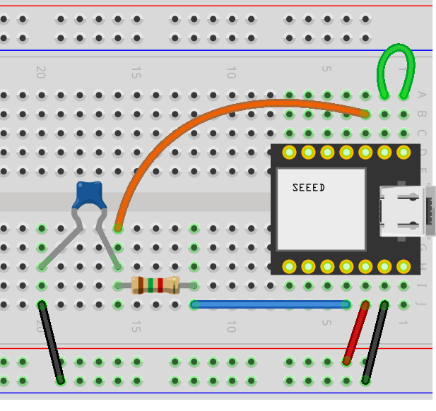

Includes RC low pass filter on PWM AWG output.

**Version based on XIAO RP2040 + SPI DAC**

Performance Specs:

* Up to 3 12 bit Scope channels at up to 200 KSPS for one channel, 125 KSPS for 2 channels, 83.333 KSPS for three channels.
* Up to two 8/10/12 bit AWG channels at 50 KSPS.
* Up to 4 digital input channels at same sample rate as analog scope.

Parts List: Total, $ 9.13 (plus import Tariff)

Seeed Studio XIAO RP2040:

* Price: Unit Price: $5.40 (plus import Tariff)
* Digi-Key Part Number: 1597-102010428-ND
* Manufacturer: Seeed Technology Co., Ltd
* Manufacturer Product Number: 102010428
* Description: SEEED STUDIO XIAO RP2040 ARDUINO

Dual DAC for AWG outputs: MCP4922-E/P

* Unit Price: $3.73
* Digi-Key Part Number, MCP4922-E/P-ND
* Manufacturer :Microchip Technology
* Manufacturer Product Number: MCP4922-E/P
* Description: IC DAC 12BIT V-OUT 14DIP

Alternate Dual DAC for AWG outputs: MCP4822-E/P

* Unit Price: $4.28
* Digi-Key Part Number, MCP4822-E/P-ND
* Manufacturer :Microchip Technology
* Manufacturer Product Number: MCP4822-E/P
* Description: IC DAC 12BIT V-OUT 8DIP

Alternate 10 and 8 bit dual DACs:

* MCP4812-E/P, $3.01
* MCP4802-E/P, $2.11
* LTC1661CN8, $5.43, 10BIT V-OUT 8DIP
* AD7303BNZ, $11.24, 8BIT V-OUT 8DIP

Again only the two components and some wires are used in this scheme so even more solderless breadboard friendly with the 14 pin XIAO module vs the 40 pin Pi Pico Module.

Solderless Breadboard Layout including two DAC reconstruction low pass filters.

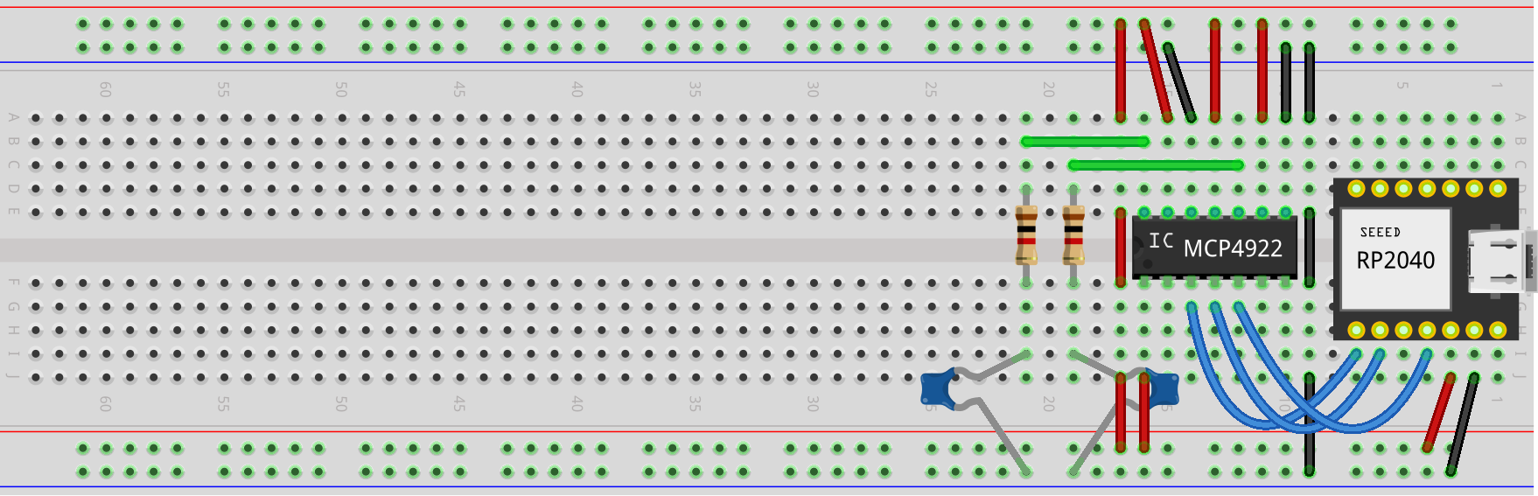

For relative size comparison.

The XIAO module along with SPI DAC could additionally be permanently mounted on a solder breadboard such as this one from Digi-Key: Cost $1.48.

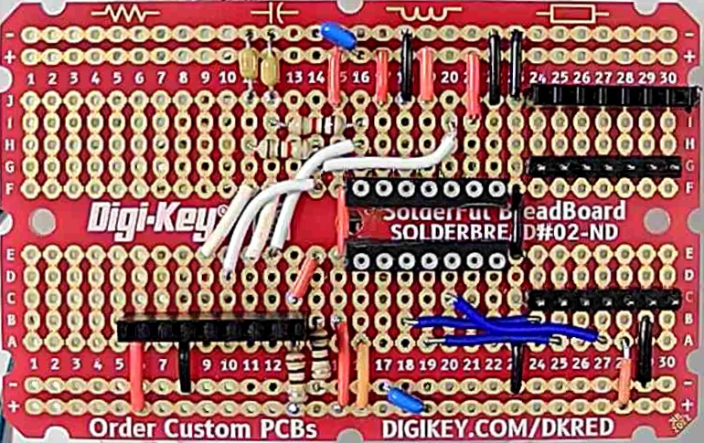

Solder breadboard wiring without active components installed

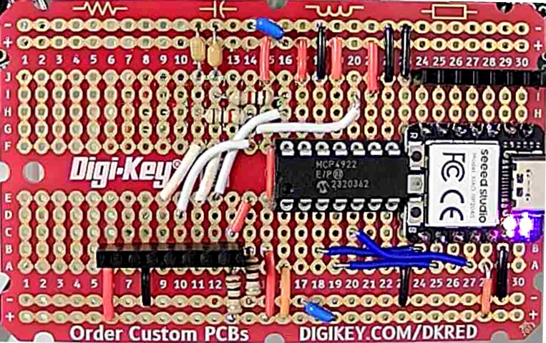

Solder breadboard wiring with active components installed

Digi-Key part number: DKS-SOLDERBREAD-02, 30 ROW SOLDERFUL BREADBOARD

Breadboard, General Purpose Plated Through Hole (PTH) 5 Hole Pad (Both Sides) 0.100" (2.54mm)

**Version based on Raspberry Pi Pico + SPI DAC**

Performance Specs:

* Up to 3 12 bit Scope channels at up to 200 KSPS for one channel, 125 KSPS for 2 channels, 83.333 KSPS for three channels.
* Up to two 8/10/12 bit AWG channels at 50 KSPS.
* Up to 8 digital input channels at same sample rate as analog scope.
* 1 PWM digital output.

Parts List: Total, $ 8.73 (plus import Tariff)

Raspberry Pi Pico RP2040 with headers:

* Unit price: $5.00 ($4.00 w/o headers)
* Digi-Key Part Number: 2648-SC0917-ND
* Manufacturer: Raspberry Pi, Manufacturer Product Number SC0917
* Description :RASPBERRY PI PICO H RP2040 Detailed Description :RP2040 Raspberry Pi Pico - ARM® Cortex®-M0+ MCU 32-Bit Embedded Evaluation Board

Dual DAC for AWG outputs: MCP4922-E/P

* Unit Price: $3.73
* Digi-Key Part Number, MCP4922-E/P-ND
* Manufacturer :Microchip Technology
* Manufacturer Product Number: MCP4922-E/P
* Description: IC DAC 12BIT V-OUT 14DIP

Alternate Dual DAC for AWG outputs: MCP4822-E/P

* Unit Price: $4.28
* Digi-Key Part Number, MCP4822-E/P-ND
* Manufacturer :Microchip Technology
* Manufacturer Product Number: MCP4822-E/P
* Description: IC DAC 12BIT V-OUT 8DIP

Alternate 10 and 8 bit dual DACs:

* MCP4912, MCP4812-E/P, $3.01
* MCP4902, MCP4802-E/P, $2.11
* LTC1661CN8, $5.43, 10BIT V-OUT 8DIP
* AD7303BNZ, $11.24, 8BIT V-OUT 8DIP

Only the two components and some wires are used in this scheme so somewhat solderless breadboard friendly.

Solderless breadboard layout (minus DAC reconstruction filter):

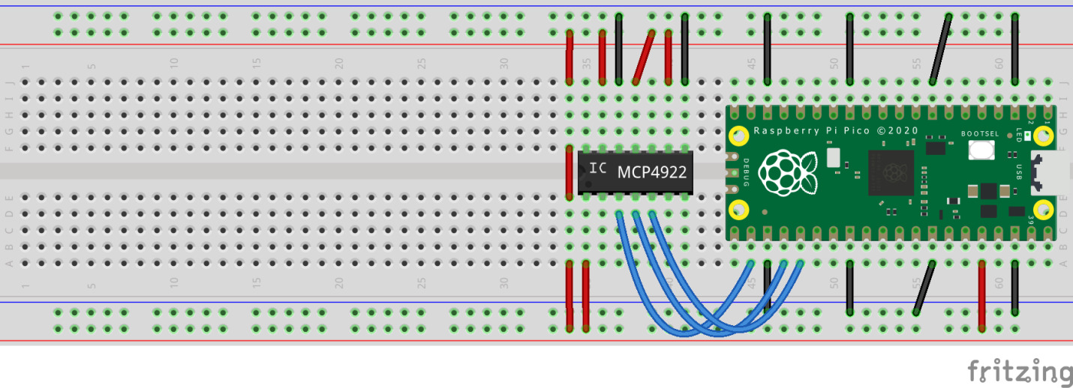

For relative size comparison. About ½ of a full length breadboard is needed.

**Version based on Raspberry Pi Pico + Resistor Networks**

Performance Specs:

* Up to 3 12 bit Scope channels at up to 200 KSPS for one channel, 125 KSPS for 2 channels, 83.333 KSPS for three channels.
* Up to two 8 bit AWG channels at 100 KSPS
* Up 6 digital input channels at same sample rate as analog scope
* 1 PWM digital output

List of Hardware:

Total parts cost less than $10 not including any PCB to mount parts on or a full length solderless breadboard.

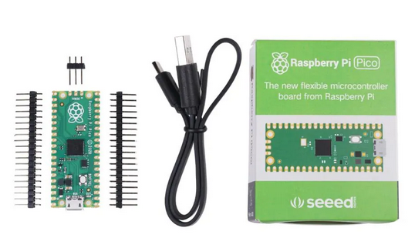

Pi Pico Board Basic Kit $6.38 each or $4.00 for just board no headers or $5.00 with installed headers: (SC0915 Description RASPBERRY PI PICO RP2040)

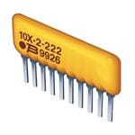

2X - 10 K R/2R ladder network for AWG DACs $ 0.51 each (4606X-R2R-103LF) at Mouser $0.71 at Digi-Key

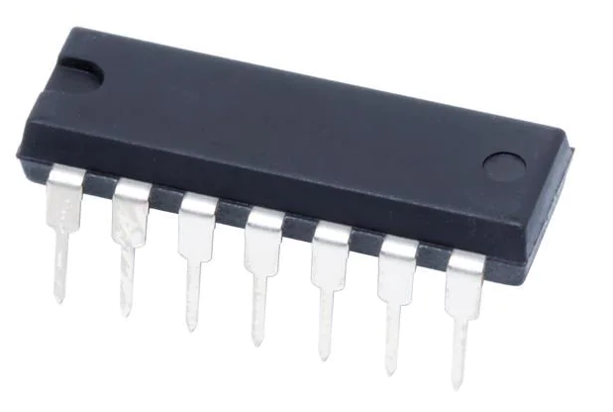

2X - LM324 Quad Op-amp for AWG DAC buffers / Scope Input buffers $0.59 each at Mouser $0.11 at Digi-Key

Up to 16 – 20 1/8 watt resistors various values.

Not particularly solderless breadboard friendly so a PCB to mount everything will be a useful approach.

PC Board Layout:

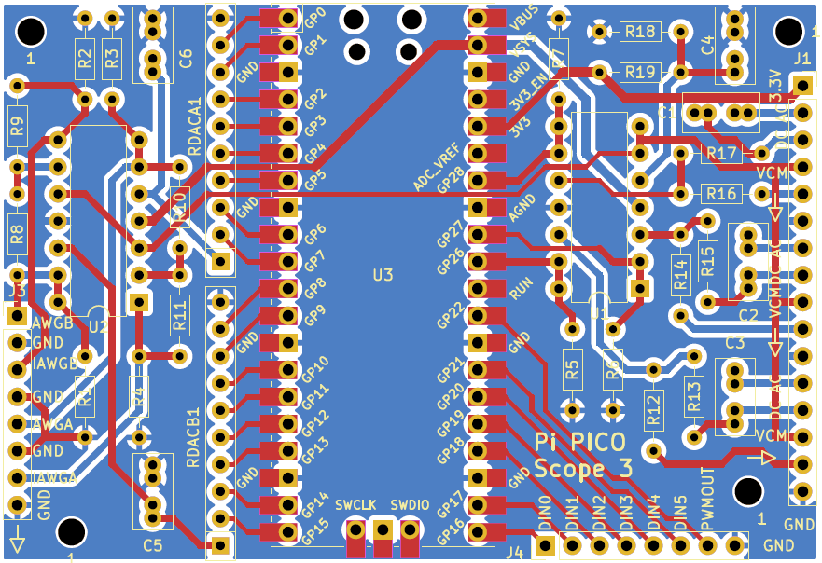

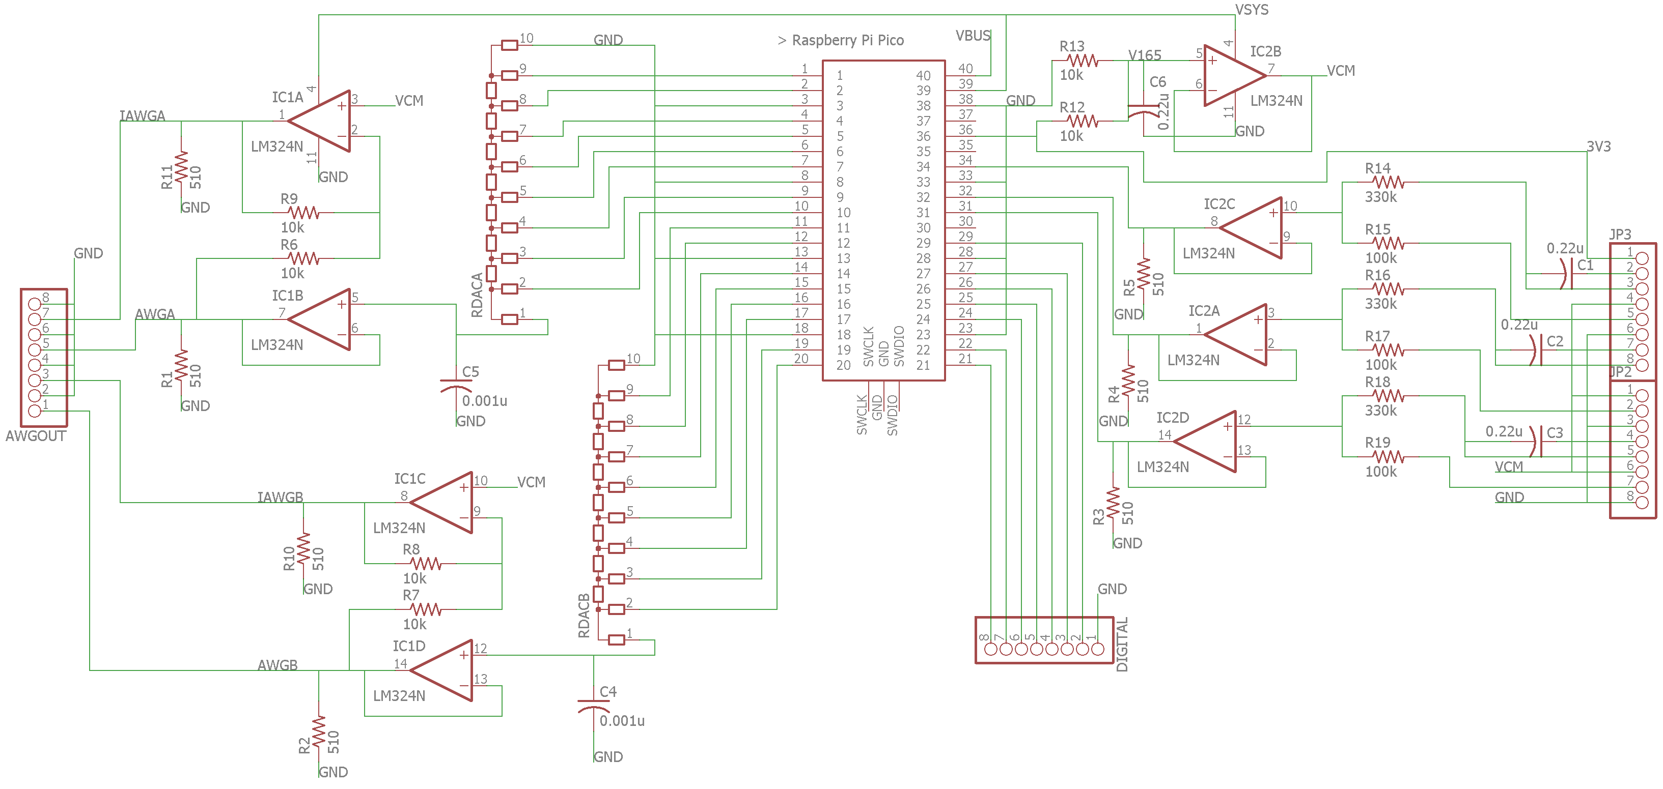

PCB Schematic