An ordered list of steps to program Seeed Studio XIAO SAMD21:

First: Download Arduino IDE for your computer operating system from here: https://www.arduino.cc/en/software

Second: Run the installer software you just down loaded.

Third: Run the Arduino IDE by double clicking on the newly installed desktop icon.

Under Files click on Open and open the XIAO_Scope_pwm_awg.ino file you down loaded from here:

https://github.com/damercer/Arduino-Scopes/blob/main/XIAO/XIAO_Scope_pwm_awg/XIAO_Scope_pwm_awg.ino

Alternately when you installed Arduino it should have connected the .ino file extension with Arduino and double clicking on the .ino file should open it in the Arduino IDE.

Arduino will probably throw up a message about the file needing to be in a folder by itself. Just click OK and it will move the file for you. You should see the source code now.

Fourth: Under File > Click on Preferences. Should see below.

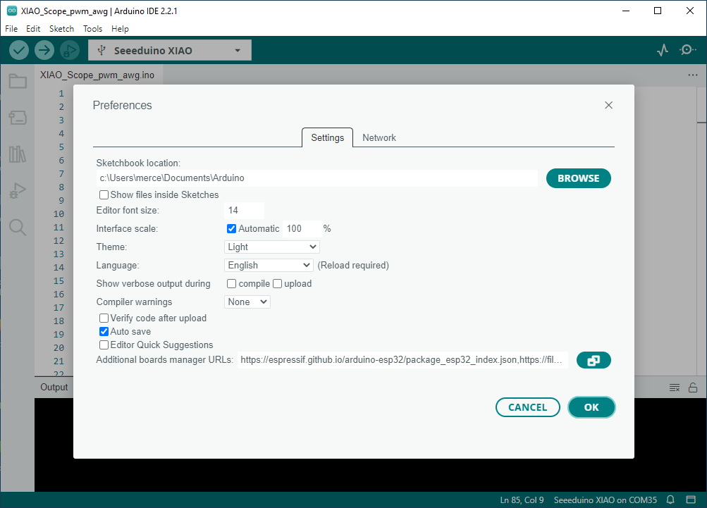

Click on the blue button to the right of the line Additional boards manager URLs: Below should appear.

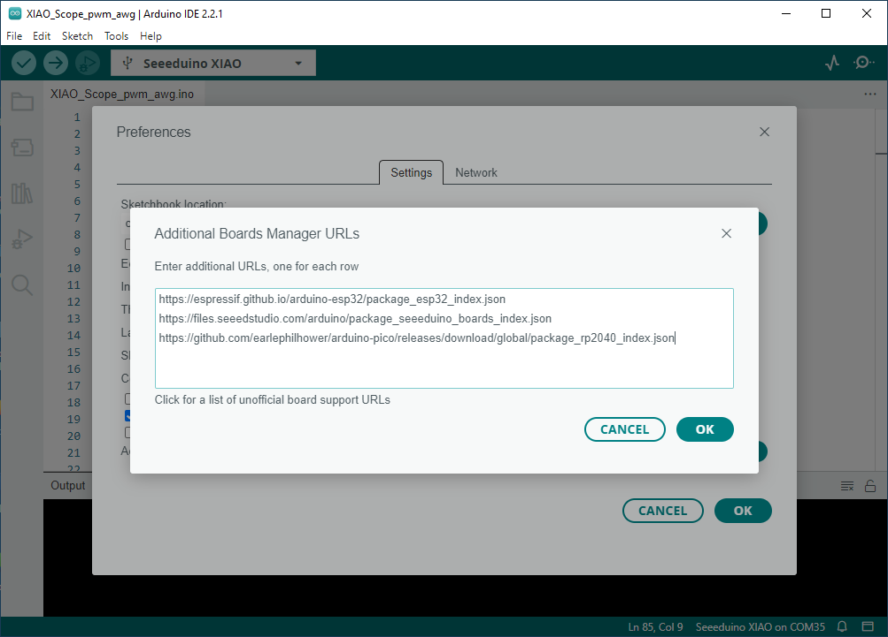

The above is from software which already has this step done so... Copy and paste the following into the edit window and click OK.

https://files.seeedstudio.com/arduino/package_seeeduino_boards_index.json

Once the link to the Seeed Studio package has been added to the above list it still needs to be installed for the SAMD21 board. Open the Boards Manager and type XIAO in the Search bar. Scroll down until you see the Seeed SAMD Boards listed. Click on Install. Should look like the following:

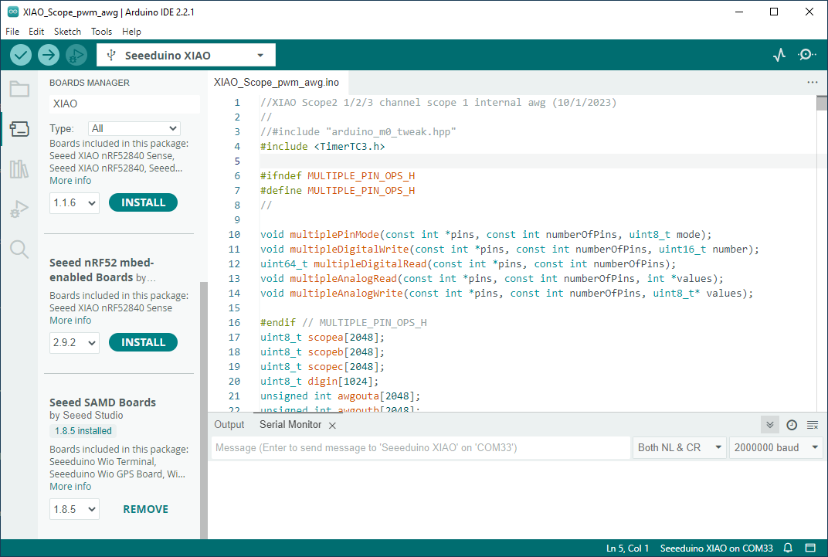

Fifth: with the XIAO board plugged into a USB port click on Tools > Board > Board Manager. Should see something like below. But again this is from a version with this step already done. For you there won't be anything next to Board: because you have not selected one yet. You should be able to find the correct one in the list as shown below.

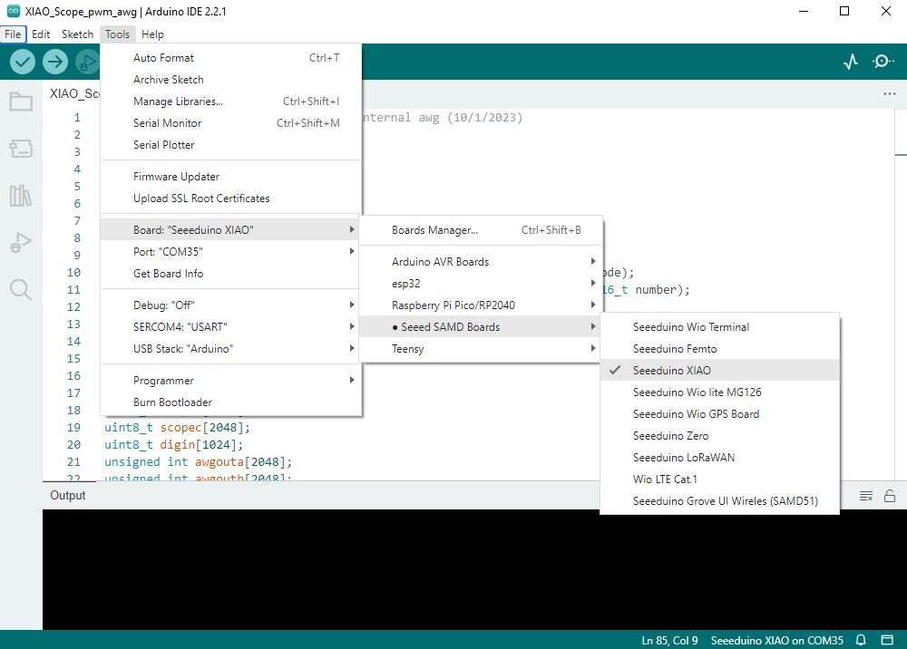

Sixth:

Click on Tools > Ports and select the correct COM port for the board. Again your COM port number may be different, should be some number larger than 3 or 4 depending on how many other USB devices you might have used in the past.

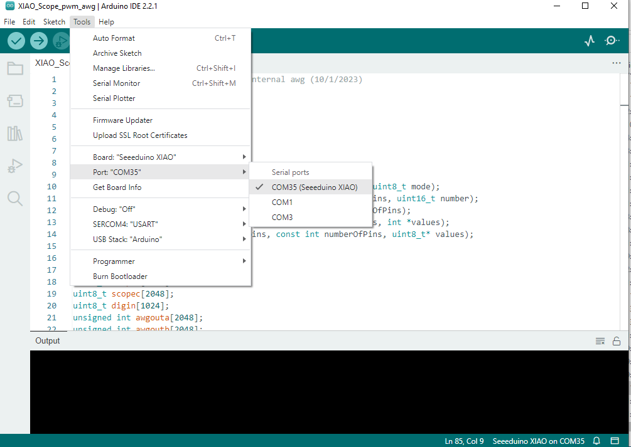

On the bottom of the screen you should see an indication like: Seeeduino XIAO on COMXX.

Seventh: Click on the Right pointing Arrow to compile and up load the software to the board.

The XIAO SAMD21 board should now be programed to work with Universal ALICE GUI.

There is one additional "test" step (not necessary to continue) that is useful to confirm that the software on the board is functioning. Again you don't need to do this step.

In the Arduino IDE in the upper right there a two small icons, one that looks like a squiggle and one that looks like a circle with a dot. The circle with a dot one opens the Serial Monitor which is used to help debug operation and to communicate with the board. Open the Serial Monitor. A place to enter test will appear near the middle of the screen under where the source code is. Type a capital I and type enter. The board should respond with the ID string "XIAO Scope 3.0". This will confirm that the code is loaded and running