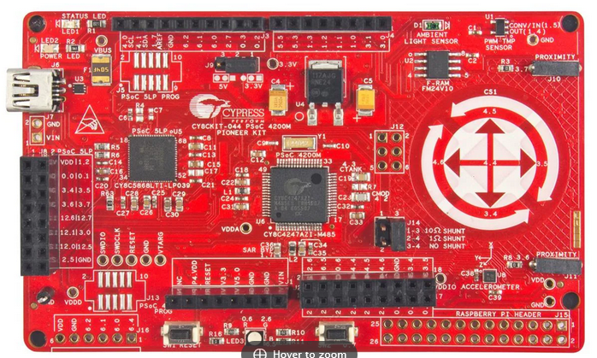

CY8CKIT-044 PCB

Pin 14: PWM Out: P12[5]

+5V Pin 1:

AWG B Output P0[0] Pin 3:

P3[4] Pin 5:

Scope B P3[6] Pin 7:

D1 P12[6] Pin 9:

D2 P12[1] Pin 11:

D3 P12[0] Pin 13:

Scope D P2[5] Pin 15:

Pin 16: GND

Pin 4: AWG A Output P0[1]:

Pin 6: Ext Trigger In: P3[5]:

Pin 12: Scope A P3[0]:

Pin 2: P1[2] Scope C

Pin 8: P3[7] AUX DAC Output

Pin 10: P12[7] D0

CY8CKIT-044 2X8 Header pinout

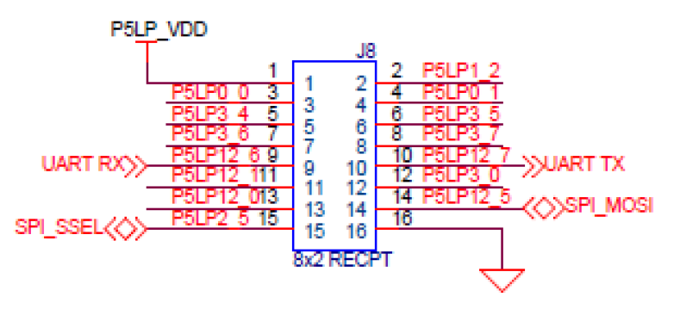

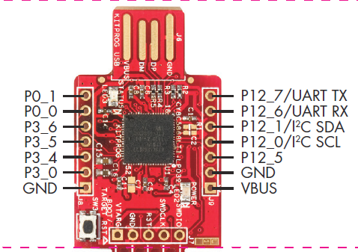

CY8CKIT-043 Header pinout

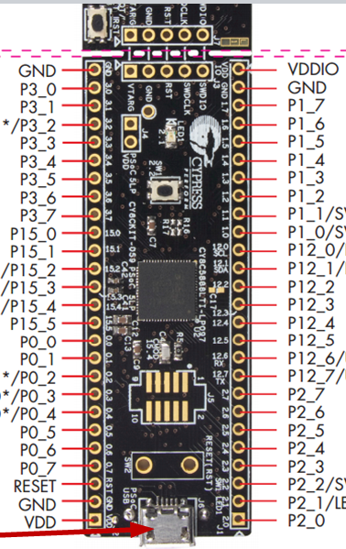

**Scope A**

**Scope B**

**Scope C**

**Scope D**

**AWG B**

**AWG A**

**Aux DAC**

**1 V REF**

**Ext Trig In**

**Trig Out**

**PWM Out**

**PWM Out B**

**D0 Out**

**D1 Out**

**D2 Out**

**D3 Out**

**D4 Out**

**D0 In**

**D1 In**

**D2 IN**

**D3 In**

**D4 In**

CY8CKIT-059 Header pinout

Pins for the CY8CKIT-044. The pins used for the CY8CKIT-044 can be found in the PSoC Creator Design Wide Resources in PSoC Creator.

Pin Map Between the three Dev Kits:

|  |  |  |  |
| --- | --- | --- | --- |
| Function | CY8CKIT-043 | CY8CKIT-044 | CY8CKIT-059 |
| Scope A In | P 3_0 | P 3_0 | P 3_0 |
| Scope B In | P 3_6 | P 3_6 | P 1_7 |
| Scope C In | P 3_5 | P 1_2 | P 1_6 |
| Scope D In |  | P 2_5 | P 1_5 |
| AWG A Out | P 0_1 | P 0_1 | P 0_1 |
| AWG B Out | P 0_0 | P 0_0 | P 0_0 |
| Aux DAC out | P 3_4 | P 3_7 | P 3_7 |
| 1 V Ref Output |  |  | P 3_6 |
| Ext Trig In |  | P 3_5 | P 3_5 |
| Trig Out | P 12_2 | P 12_2 | P 12_0 |
| PWM Out | P 12_5 | P 12_5 | P 0_6 |
| PWM Out B |  |  | P 0_7 |
| D 0 Out | P 12_7 | P 12_7 | P 12_5 |
| D 1 Out | P 12_6 | P 12_6 | P 12_4 |
| D 2 Out | P 12_1 | P 12_1 | P 12_3 |
| D 3 Out | P 12_0 | P 12_0 | P 12_2 |
| D 4 Out | P 12_3 | P 12_3 | P 12_1 |
| D 0 In |  |  | P 2_3 |
| D 1 IN |  |  | P 2_4 |
| D 2 IN |  |  | P 2_5 |
| D 3 IN |  |  | P 2_6 |
| D 4 IN |  |  | P 2_7 |
| LED |  |  | P 2_1 |
| User Button |  |  | P 2_2 |