PSoC 5LP Oscilloscope and Waveform Generator

Contents

Overview 2

Getting Started 2

Hardware 2

Pin Assignments 3

Connectors 4

USB Connections 5

Power Considerations 5

Firmware (PSoC) 5

Software (PC GUI) 7

Modifying the Software 7

Using the CY8CKIT-059 as a Function Generator and Oscilloscope 9

USB Connection 9

Waveform Generator 9

Oscilloscope 10

Digital Inputs and Outputs 11

Inputs 11

Outputs 11

# Overview

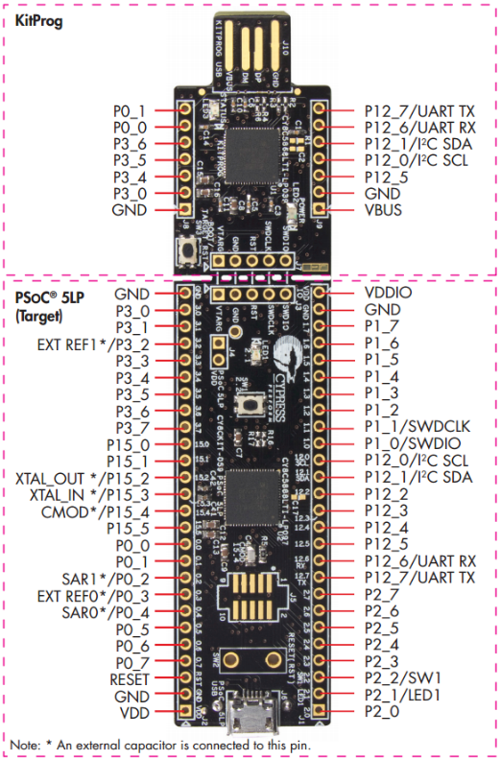The CY8CKIT-059 PSoC 5LP Prototyping Kit is a small but very powerful system. It contains a PSoC (Programmable System on a Chip) 5LP device which brings together the features of an ARM Cortex M3 microcontroller, a programmable logic device, and many analog functions into one package. A programmable routing fabric between the peripherals and the pins allows any function to be mapped to any pin.

The PSoC target device on the kit includes full speed USB device capability which makes it possible to use it to interface from the PSoC target device to a PC using standard USB drivers.

The example application provided below turns the CY8CKIT-059 kit into a two channel arbitrary waveform generator and four channel oscilloscope. A PWM output with adjustable duty cycle, 5 digital outputs, and 5 digital inputs are also provided.

# Getting Started

## Hardware

The following hardware is required:

* CY8CKIT-059 PSoC 5LP Prototyping Kit
* USB A to Micro-B cable
* Header Connectors, wire, and jumper wires oscilloscope inputs and waveform generator outputs:

## Pin Assignments

The pin assignments for the waveform generator outputs and oscilloscope inputs are shown in the figure below. The various functions are placed in different ports to guarantee optimal analog performance. For example, Port 3 is used for Scope A, Port 1 is used for Scope B, Port 0 is used for waveform outputs, and Ports 2, 12 are used for digital inputs and outputs. Also, the scope inputs are placed next to board ground connections to provide a solid ground reference.

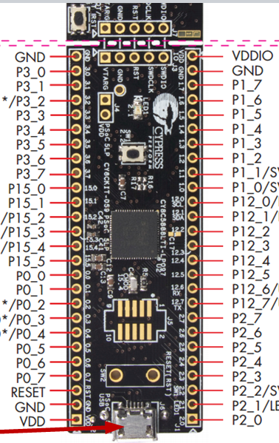

**Scope A**

**Scope B**

**Scope C**

**Scope D**

**AWG B**

**AWG A**

**Aux DAC**

**1 V REF**

**Ext Trig In**

**Trig Out**

**PWM Out**

**PWM Out B**

**D0 Out**

**D1 Out**

**D2 Out**

**D3 Out**

**D4 Out**

**D0 In**

**D1 In**

**D2 IN**

**D3 In**

**D4 In**

**Micro USB Connector**

CY8CKIT-059 Header pinout

## Connectors

A CY8CKIT-059 with all inputs and outputs populated is shown below. The oscilloscope inputs (Scope A and Scope B) and the waveform generator output are keyed connectors so that the cables can only be connected one way.

Examples of the cables are shown below. The keyed connector must match the direction of the connector that is soldered onto the CY8CKIT-059 board.

## USB Connections

The CY8CKIT-059 actually contains two PSoC 5LP devices – one is the target device and the other is used to program and debug the target device. Both devices have USB capability. The target device connects to a standard USB Micro type-B connector (labeled PSoC USB) while the programmer device connects to a board edge connector (labeled KITPROG USB). This board edge connector can be plugged directly into a USB type-A socket with no cable required.

Therefore, use the edge connector when you want to program the target device, and use the Micro type-B connector when you want to use the target device (i.e. when you are using the PSoC 5LP as a waveform generator and oscilloscope).

Note: a USB type-A male to USB type-A female extension cable can be used if the board is mounted in such a way to make it difficult to plug directly into a USB type-A socket.

## Power Considerations

The CY8CKIT-059 can be powered in three ways:

1. USB bus powered from the card edge connector
2. USB bus powered from the Micro-B connector
3. External 3.3V – 5.5V supplied at the VDD or VDDIO pins

The kit will automatically draw power from the highest voltage supply so if an external supply is being used along with a USB connection then the external supply should be 5V or greater.

## Firmware (PSoC)

The project (firmware) for the oscilloscope is written using PSoC Creator. There are two ways to program the project into the kit. You can either open the project in PSoC Creator to program the kit from inside the tool, or you can use PSoC Programmer to download an existing project’s file to the kit. If you want to modify the project for any reason, PSoC Creator is the tool that you would use.

The creator development software is all free and is available from the following locations. Each row is a superset of the row above it so if you want everything, just download and run the CY8CKIT-059 kit setup installer.

|  |  |
| --- | --- |
| **Purpose** | **Web Site** |
| Program firmware to the kit | [www.cypress.com/psocprogrammer](http://www.cypress.com/psocprogrammer) |
| View and modify the project or create your own custom project and program it to the kit | [www.cypress.com/psoccreator](http://www.cypress.com/psoccreator)  (The installer includes PSoC Programmer) |
| View kit documentation and design | [www.cypress.com/cy8ckit-059](http://www.cypress.com/cy8ckit-059)  (Kit Setup includes PSoC Creator and PSoC Programmer, Kit Only includes just the kit file) |

In order to program the project into the CY8CKIT-059 using PSoC Creator, follow the steps below.

1. If you have not already done so, install PSoC Creator.
2. Plug in the card edge connector from the CY8CKIT-059 into a USB port on your computer.
3. Navigate to the folder containing the project (in the GitHub repository, it is in ScopePSoC). Double-click on the PSoC Creator workspace file (Scope.cywrk) to open it in PSoC Creator.
4. Select the menu item “Build > Build Scope”.
5. Once the build is complete, you should see “Build Succeeded” in the Output window. (see the figure below for this step and all subsequent steps).
6. Select the menu item “Debug > Program”.
7. Once programming is done, you should see a message at the bottom of the Output window indicating that the device was successfully programmed.
8. If you want to explore the project in detail, you can click on the schematic tabs or double-click on main.c from the Workspace Explorer.

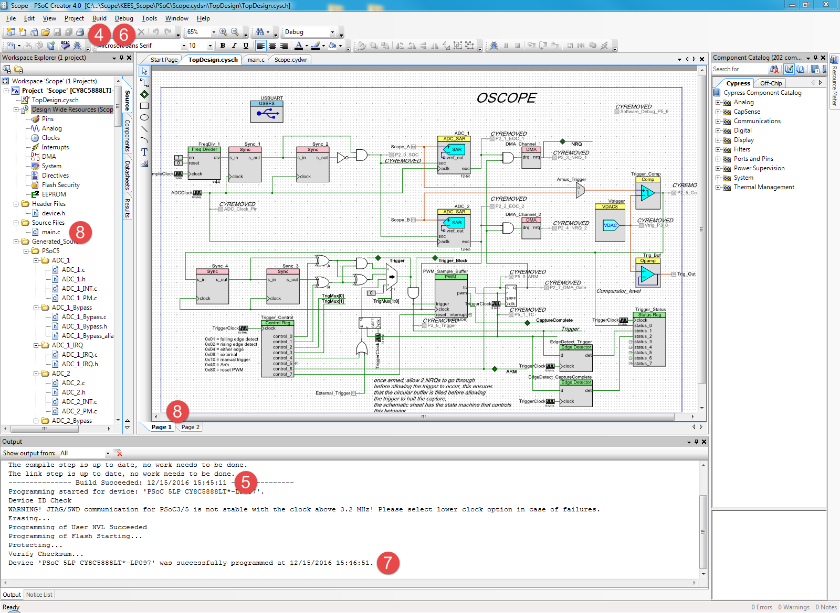

## Software (PC GUI)

The User Interface software used for this project is written in Python and is based on the Universal ALICE Project (). The source code is provided under the GNU General Public License. A Hardware specific level interface file is provided to work with the features of the CY8CKIT-059.

In the GitHub repository, the software is in the folder named Universal ALICE. Inside that folder is a shortcut “”. Double-click on it to start the software.

Once the software starts, you should see a main window and an AWG control window like the figure below. The oscilloscope controls are on the top, bottom and right side of the main window, the waveform generator controls are in the separate window, and the digital output / PWM controls are in an optional Window. More detail on each of these is included Universal ALICE User’s Guide document.

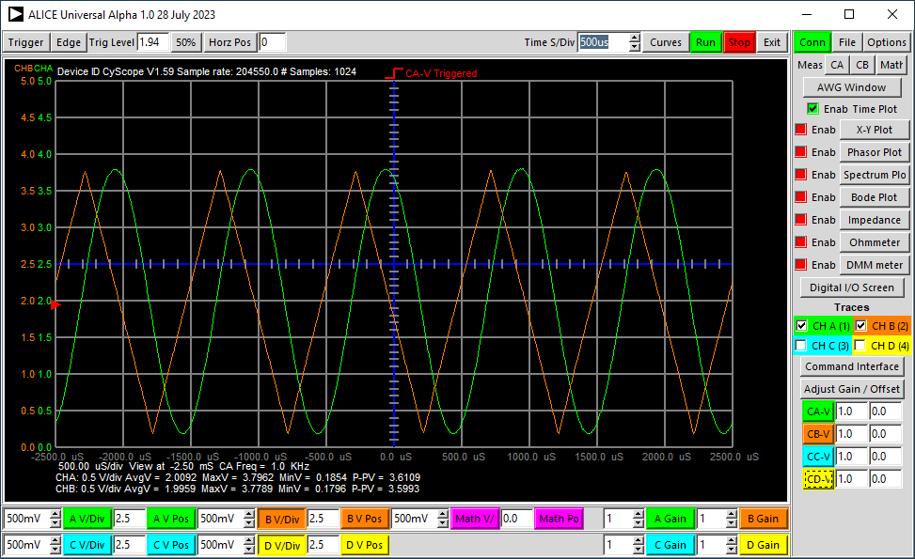

### Modifying the Software

The source code for the software is contained in the folder “”. You can modify the source code if desired.

# Using the CY8CKIT-059 as a Function Generator and Oscilloscope

## USB Connection

Once the firmware has been programmed into the kit, connect it to a PC using a USB type A to Micro B cable. After drivers have installed, you will see the device appear as a “Cypress USB UART”. This will appear in the device manager under “Ports (COM & LPT)”.

If the driver does not install automatically for some reason, you can manually install the driver which is included in the ScopeGUI.zip file. The folder “USBUART_Driver” inside that zip file contains the USB driver required for the 059 kit USB UART Bridge.

Once the driver is installed, open the GUI by double-clicking on. The GUI should search all available COM ports for a matching device. If no, you may see the following window. If you do, try “Auto Detect…” first and then “Manual”. If all else fails, close the GUI, un-plug and re-plug the kit to the USB port and try again.

If you use "Manual Select" (this is also available from the Hardware -> Connect menu), a list will appear after ~20 seconds. Select the device that says COM<xx> <USB Serial Device > and click Connect.

## Waveform Generator

The waveform generator controls are along the right side of the main window.

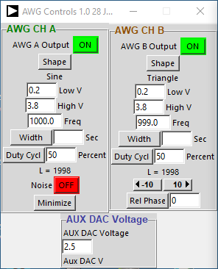

You must select one of the waveform shapes configure the low and high voltage levels as well as the output frequency and turn on the Output before you will see any output .

You can use the value entries shown to set low (minimum) value, high (maximum) value, and frequency. For some waveform shapes the duty cycle can be set as well. The maximum range of the output waveform is 0 – 4 V.

The frequency can be set from 3.2 Hz to 100 kHz. You can also click on the frequency value itself and enter a number directly (3). If you click on the value at the bottom or top of the frequency slider you can restrict the slider’s range but you cannot set the minimum below 3.2 Hz or the maximum above 10 kHz.

The PWM and PWM# output can be enabled by using the slider to select the desired duty cycle (4). The output frequency has 10 possible selections in the drop down menu ranging from 72 kHz down to 35 Hz.

## Oscilloscope

The oscilloscope controls are along the top, bottom and right side of the main window.

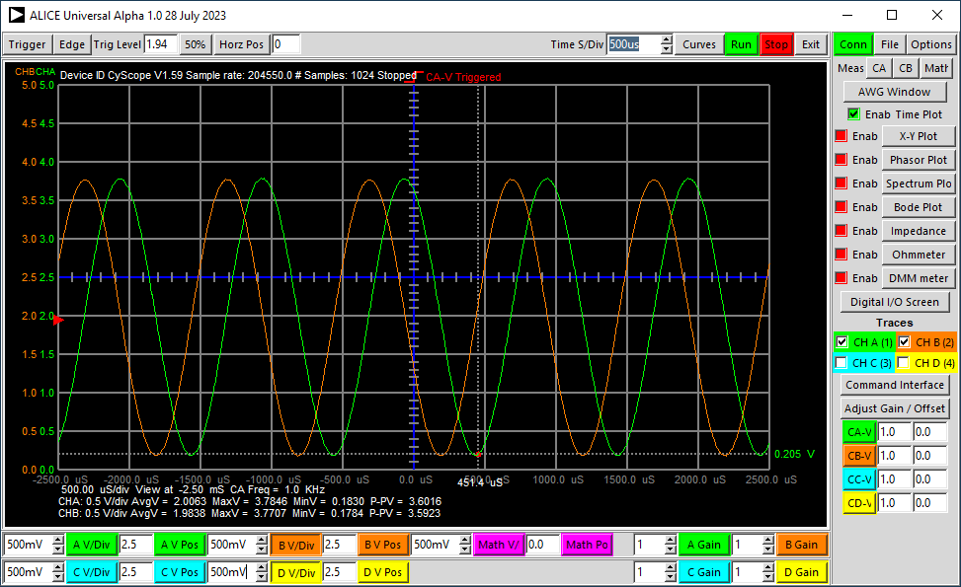

The oscilloscope can be set from 1 second per division to 5 us per division using the Time S/Div spin-box entry at the top of the window. While hovering over the spin-box entry, the mouse wheel can be used to increase or decrease the horizontal time scale. The oscilloscope is capable of measuring input signals from DC up to about 100 kHz. Along the bottom of the window are controls to set the vertical voltage range scale (V/Div) for each of the 4 channel can be set from 10 V to 1 mV per division. The vertical position, voltage level at the blue centerline, can be set as well. This is particularly useful if you want to measure a smaller AC signal riding on top of a DC offset since this allows you to set the center level of the screen. Again the mouse wheel can be used like a thumb wheel to adjust the entry values. The digit at the text cursor will move up or down one digit as the mouse wheel is turned.

The trigger controls (5) allow Auto, Normal, Single-Shot or External. The trigger edge can be Plus or Minus and either channel can be used as the trigger source.

In the Curves Drop down menu you will find selections to toggle cursors for time and voltage.

## Digital Inputs and Outputs

There are 4 digital Output pins that can be controlled from the software.

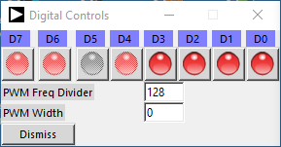

### Outputs

The digital outputs in the software are control buttons. Click on any given button to change the state of that output from low (red) to high (green). Any outputs set to drive low will appear red while those set to drive high will appear green.

One output pin is connected to the user LED on the CY8CKIT-059 board (LED1). Click on that button (4) to toggle the state of the LED. The other outputs (5) are general purpose outputs that can be driven either high or low. They all start in the low state.