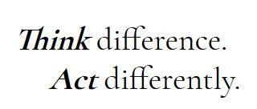

**Professor Taylor Meets Abdul - Transcript**

* So we met in the library to go over the final stages of the project.
* I started off the meeting by discussing the project and what we needed to do.
* As I was talking, I noticed Barbara using her phone instead of listening to what I was saying. It was really rude.
* When I asked her if she was listening to me, she barely lifted her eyes from the phone.
* Anyway, when I tried to keep my project on track, she started discussing other issues which I felt weren’t very important, so I asked her to take notes.
* She seemed to get very upset with this.
* Then suddenly, Charlie got up and left. He seemed very annoyed too…
* He doesn’t say very much. I was expecting more from him, being the other man in the group…