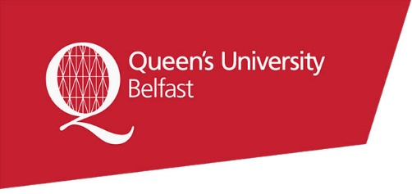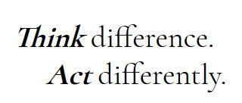

**Professor Taylor Meets Barbara - Transcript**

* Our meeting was a disaster really. We met up to go through the final stages of the project.
* Abdul started talking and I could barely understand what he was saying. His accent is so strong. How is he supposed to know anything if he can barely speak English!?
* Anyway, I tried to talk about the requirements but then he interrupted me and started to talk to Charlie instead – ignoring me. It was so rude.
* He then asked me to take notes as if my opinion didn’t matter. That was the final straw!
* And as for Charlie, he didn’t do anything. He just sat there the whole time nodding, not saying anything. And then he just got up and left.
* I would rather, the next time, we get to choose who we are on a team with and I’m not put on a project with people who can *barely* speak English…. or don’t speak at all!