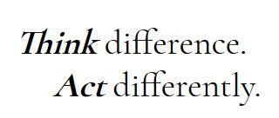

**Professor Taylor Meets Charlie - Transcript**

* I met up with Abdul and Barbara at about 10 o’clock in the library. We had met a few times before and each time, I felt a little uncomfortable.
* We never really took any time to get to know one another, you know, to have a chat or ease into things. I think that I would have found this valuable. I’ve Asperger syndrome and I haven’t told anyone about this in my year. My main problem is that it can be difficult to work with new people. I just need some time to feel at ease in their company. Once I do, I’m fine. I may find it a little difficult to pick up on some things like facial expressions and tone of voice or sarcasm, but if I know the group, this is usually a little easier.
* My group has not been easy to work with. And I think we could do with some help.