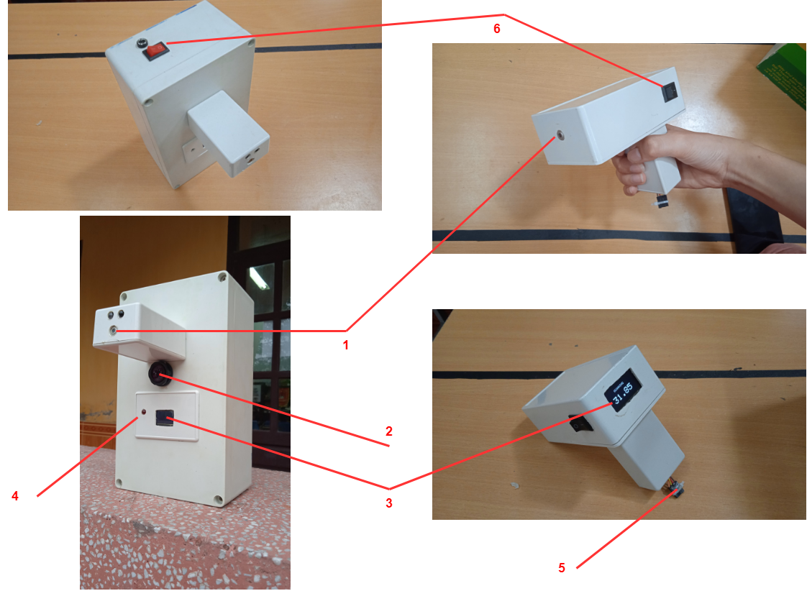

(1) I2C MLX90614 non-contact infrared thermometer

(2) Proximity sensor E18-D50NK

(3) OLED I2C 1.3inch SH1106 screen

(4) LED

(5) Charging port and screen cord (if needed)

(6) Switch