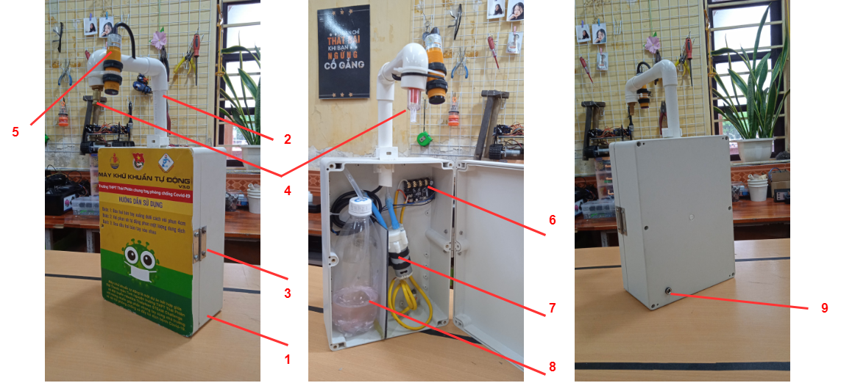

(1) ABS plastic box

(2) Plastic pipe

(3) Hinge

(4) Mist nozzel

(5) Proximity sensor

(6) Delay board (8) Sanitizer bottle

(7) Pump (9) Male DC jack