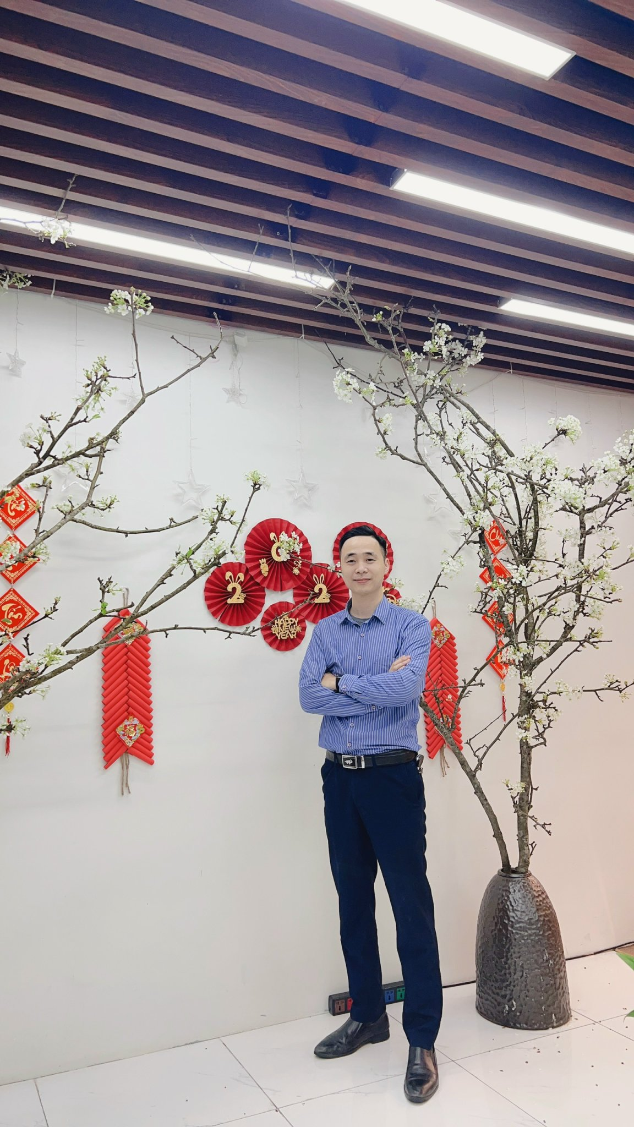**DAM HUY KHAI**

**Date of birth**  January 7, 1987

**Gender**  Male

**Phone**  0 333 377 911

**Email**  [damhuykhoiutehy@gmail.com​](mailto:damhuykhoiutehy@gmail.com)

**Address**  Vinhomes Smart City Tay Mo, Nam Tu Liem, Hanoi

**CAREER GOALS**



With over 10 years of experience in programming, I seek opportunities to contribute to a dynamic and creative team working environment. Committed to creating solid and effective technical solutions, I look forward to sharing my deep understanding with my teammates and building high-quality applications. The combination of extensive experience and passion for technology is the main driving force behind my career goals .



|  |  |
| --- | --- |
| **EDUCATION** | **CERTIFICATE** |
| October 2005 - June 2010  **Bachelor of IT, Hung Yen University of Technology and Technology**  Department: Software Technology | * JLPT Japanese N3 Certificate * ISO27001-2013 certificate * Agilearn Scrum Essence 2.0-2022 Certification * Studying for CC Google Project Management |



**WORK EXPERIENCE**



|  |  |
| --- | --- |
| 0 April 2022 - Now  (2 years) | **DEVELOPER.NET, LEADER** **Company Limited - Huong Viet Group *Hanoi*** |
| * Lead and manage a dev team of nearly 10 members involved in building and developing Web applications using ASP.NET, .NET Core * Establish efficient workflows and optimize product development processes. * Conduct periodic performance reviews and team training to enhance skills. * Take on the role of Scrum Master of a software project from inception to completion. * Participate in software development stages from planning, estimating, design, construction and product deployment. |
|  |  |
| 0 May 2020 - April 202 2  ( 2 years) | **DEVELOPER.NET** **Company Limited - Huong Viet Group *Hanoi*** |
| * Participate in analyzing customer requirements and proposing solutions: PM system IntestPro test bank, exam website, online supervision and assignment of exercises CLS-K12... * Carry out software development, testing and deployment phases for customers. * Support project management in dividing tasks, scheduling, progress and quality of implementation of tasks in the project. * Coordinate with team members to ensure cooperation and completion of work according to required schedule and quality. * Summarize reports on the dev team's work results weekly, monthly, and quarterly with PM. |
|  |  |
| 0 February 201 8 - 05/20 19​  ( 2.5 years) | **DEVELOPER.NET ,** **At** **Panasonic R&D Center Vietnam *Hanoi*** |
| * 1) Participate in building and developing the VI MonitorPlus surveillance camera software system. * Research and develop integrated Plugins: Bus route monitoring, facial recognition, door card... * Converting modules from VB.NET to WPF improves product quality. |
| * 2) Participate in building and developing web applications for Japanese customers using PHP (CodeIgnite, Laravel Framework): Sports, sales, insurance, job placement websites. |
| October 201 7 - 11 /20 18  ( one year) | **FREELANCE,** **DEVELOPER.NET**   * Directly engage in discussions with customers to clarify project requirements, timelines, and budgets. * Join an outsourcing team, implement some projects using C#, VB.NET : Coffee shop, karaoke, revenue and expenditure management system . .. |
|  |  |
| 0 1 /20 14 - 07/2017  (3 years) | **AUTOCAD Engineer,** **At MasikoTekkin Co., Ltd in Japan** ***Ibaraki, Japan*** |
| * Implement AutoCad drawings according to project requirements and provide technical support at construction sites |
|  |  |
| 11/20 10 - 12/2013  (3 years) | **DEVELOPER.NET,** **At School Informatics Technology - School@Net *Hanoi*** |
| * Participate in building and developing the online test bank software system - iQBLeo8.0, Timetable support software - TKB8.0. |
|  |  |

**SKILL**



|  |  |
| --- | --- |
| **Professional skills** | * skills in .NET programming, including C#, ASP.NET, .NET Core and Entity Framework. * Take on the role of Team Leader with the ability to manage projects, schedule work, assign work, and ensure progress. * Mastery in database management, especially using SQL Server and MySQL. Skills in optimizing application and database performance to ensure smooth and efficient operations . * System design analysis and database design skills * Communicate coherently, effectively in collaboration with stakeholders and ensure strong understanding within the team. * Strong courage under great work pressure. |
|  |  |
| **Programming language** | * ***Back-end:*** .NET Core , ASP.NET MVC, OOP, Web API, LINQ, PHP(Laravel, CodeIgniter), WordPress. * ***Front-end:*** Angular 2+, HTML/CSS, Bootstrap, TypeScript, DevExpress, Telerik UI |
| **Database** | * Good use of SQL Server, MySQL, SQLite. Have worked with Oracle. |
| **Server/Hosting** | * Experience in setting up webserver configuration and related services on Windows Server/VPS Linux (CentOS, Ubuntu...) |
|  |  |
| **other skill** | * Good use of project management tools: MS Project, Gantt Pro, Excel, JIRA, Trello, Mantis, Redmine, Git, SVN... * Proficient in using Agile model and Waterfall model * Using Photoshop well, Figma can design and edit photos at a decent level. * Good ability to read and understand English documents. |
|  |  |

**PROJECT**



**OF CLS E-LEARNING SYSTEM – ONLINE HUMAN RESOURCES TRAINING** (April 2022 – Present )

|  |  |
| --- | --- |
| **describe project** | The system deploys an online training platform for personnel in the organization, providing training materials, tasks, tests and managing learning progress. |
| **Number of members** | ten |
| **Job position** | .Net Core Developer, Team leader |
| **Role in the project** | * As the Team Leader of the project, directly discuss, receive and clarify the requirements and desires of Stakeholders about the product. * As a Scrum master, take advantage of professional knowledge and combine it with leadership and communication skills to ensure an effective Agile development process. * Divide tasks and work with the development team to build and upgrade product features that meet Stackeholder requirements. * Deploy and hand over products in each phase to customers. * Summarize reports on the dev team's work results weekly, monthly, and quarterly with PM. |
| **Technology used** | * BE: ASP.NET Core 3.1, Entity Framework Core 3.1, WEB API * FE: Angular 7, TypeScript, HTML/CSS, Bootstrap * Database: SQL Server 2019 * Other: Micro - service, Docker, Message MQ, API Gateways, Jenkins |

**BUILDING A SMART TEST BANKING SYSTEM – INTEST.PRO** (May 2020 – April 2022)

|  |  |
| --- | --- |
| **describe project** | The system provides effective support tools in the process of testing, evaluating and innovating exams with a quality question bank system. |
| **Number of members** | ten |
| **Job position** | DEVELOPER.NET, LEADER |
| **Role in the project** | * Participate in analyzing customer requirements and proposing solutions: PM system IntestPro test bank, exam website, online supervision and assignment of exercises CLS-K12... * Carry out software development, testing and deployment phases for customers. * Support project management in dividing tasks, scheduling, progress and quality of implementation of tasks in the project. * Coordinate with team members to ensure cooperation and completion of work according to required schedule and quality. * Summarize reports on the dev team's work results weekly, monthly, and quarterly with PM. |
| **Technology used** | * WPF (C#), XAML, MVVM Model, Entity-Framework, DI(Dependency Injection), Visual Studio * FE: Telerik UI, DevExpress * Library: Prism Library 5.0, SignalR (Client-Server) * Database: MySQL, SQLite * Other: ORC- Image and text recognition |

**BUILDING A SYSTEM Surveillance Camera Software - VI MonitorPlus** (May 2019 - April 2020)

|  |  |
| --- | --- |
| **describe project** | Management, monitoring, and control system for camera equipment and security systems for buildings, factories, and public transportation. |
| **Number of members** | >10 |
| **Job position** | DEVELOPER.NET |
| **Role in the project** | * Understand project requirements, participate in the design process of system features and modules. * Design and program user interfaces for reception modules. * Process data and integrate into the database, work with the database to store and retrieve information from surveillance cameras. * Develop surveillance camera functions: build functions such as live view, video recording, remote control, image analysis from cameras... * Ensure system security through the use of encryption and access control. * Perform unit testing and integration testing to ensure the software is stable and reliable. * Optimize source code and improve system performance. |
| **Technology used** | * WPF (C#), XAML, MVVM Model, Entity-Framework, DI(Dependency Injection), SignalR- Real-time connection, FFmpeg- Video data processing and conversion ; FE: DevExpress * Database: SQL Server 2017 |

**MORE ABOUT YOURSELF**



As a creative programmer, I am committed to bringing value through a combination of technical expertise and communication and team management abilities. Desire to contribute to a dynamic working environment, promoting creativity and personal and team development.