The Twin Instrument: The Fertility-Investment Trade-off

Sonia Bhalotra Damian Clarke
July 1, 2013

Abstract
The incidence of twins has been used to identify the impact of changes in fertility on measures of investment in children born prior to the twins, and the emerging consensus in this literature is that there is no evidence of a quantity-quality trade-off. We argue that the standard approach is flawed for two reasons. First, even if twin conception is random, bringing twins to term is a function of maternal health which is difficult to fully observe and which tends to be correlated with child quality, rendering the instrument invalid. Second, twins will only constitute a shock to family size if their occurrence takes family size across the desired level. The neglect of both of these considerations in the literature will tend to lead to under-estimation of the Q-Q trade-off and so could contribute to explaining the negative results in the literature. Using a large sample of microdata from developing countries, we show that a significant trade-off emerges upon correcting for these biases.

Introduction
9. For intro note that
**In Roz-Wolpin 1980 original paper, twins are cast as a shock to price of quantity (it drops), so quantity (=fert) increases and so quality is expected to decline unless quantity and quality are strong complements in the parents' util function

**we expect a weaker qq tradeoff in richer countries because (a) perfect capital markets permit optimal investment in children even in large families and (b) importance of family resources is limited by presence of welfare state/ public schooling/ subsidies for children.

So a priori expect stronger tradeoff in our LDC sample.
Also expect both of our innovations to be more relevant in LDC sample:

**Absolute level of health of women in poor countries much lower, likely to influence prob of mult birth more.
(Similarly controlling for age of women is esp important in poor countries because prob of twinning increases with age of mother and although women in poor countries start fert earlier they have more children on average and so more births may occur to older mothers. But this is 2ndary to our story because we can control for mother's age).

**Unclear a priori whether our pt about whether twins lead to fert>desired fert is empirically more important in richer or poorer countries. my sense now is that it is probably more relevant in the higher income sample where desired fert is lower and so twins will on average more often take fert across desired level. we shd check this comparing our high and low income samples.

Twin Literature

Methodology
Angrist et al. (2010) define the following specification to estimate the effect of additional births c on child outcomes y:
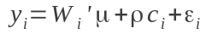
where W includes a vector of controls for subjects' and subjects' mother's ages, maternal age at first birth, parental place of birth and age at immigration (where relevant), and survey year controls. Our first innovation is to introduce controls for maternal health and other socio-economic variables. We augment (1) to give the following estimable specification:
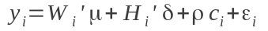
where H refers to observed maternal health variables such as BMI, height, and in some cases alcohol and drug-taking behaviour. When identifying based upon twin births, we can test the validity of including H in (2) by regressing maternal health characteristics on twinning:
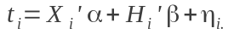
Here X includes controls which are typical in the twin literature: mother's age, age at first birth, and race, and full country and year of birth dummies for the child. We can test whether the additional health and socio-economic controls H are necessary by looking at the sign on estimated β. If healthier mothers are more likely to give birth to twins, we expect that β>0.
Our second innovation is to focus only on additional children resulting from twinning where the incidence of multiple birth takes families above their desired family size. In order to assess this we use subjective reports of desired fertility (and region-specific averages of desired fertility). Analogously to (2) we estimate:
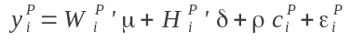
where superscript P refers to those twins born once ideal family size has been reached.
…
We identify the effect of an additional birth by constructing two sets of birth-order-specific control and treatment groups. The first set of treatment groups consists of any family in which a twin birth occurs. For example we define a group ‘Twin2’ which consists of all families of three children in which a twin birth occurs. We then define the corresponding control group (for simplicity denominated ‘Control2’) which consists of two child families where all births are singleton. In other words, we compare two groups of families who have had two births, the only difference being that one of these groups–the treated–has produced three children in two births, while the other group of families has produced just two singletons. Such a treatment setup is defined for two reasons: firstly because it allows us to identify the effect of an additional unplanned birth on child outcomes, and secondly because it allows us to avoid concerns that birth order effects may confound the identification of the Q-Q tradeoff [CITE BLACK ET AL HERE I THINK]. Analogously to the Twin2 and Control2 groups we then construct Twin3,…,Twin6 and Control3,…,Control6 which allow us to examine the effect of additional unplanned children in 3, 4, 5 and 6 birth families.
[ASIDE ABOUT ROSENZWEIG&ZHANG AND LOOKING AT AVERAGE QUALITY?]
Our second set of control groups consists of all families with multiple births, where the multiple birth pushed the family over their desired size or occurred after the desired size had been reached. This restricts the treatment groups above by removing children from those families where twins occurred early in the birth order, allowing parents to still achieve their desired total size. Removing these ‘non-binding’ multiple births from the above treatment groups we define the groups PostTwin2,…,PostTwin6, and the corresponding control groups PostControl2,…,PostContro6.
Data
The estimation of the Q-Q model requires information on maternal characteristics and child outcomes. In order to estimate specification (1), observations of child ‘quality’ outcomes plus a mother's full birth history (including a measure of twin or singleton births) are required. In order to test (partially) the hypothesis of twin endogeneity implied in equation (3), stricter data requirements must be met. Along with child outcomes, the mother's health, and family socioeconomic characteristics must be observed.

We use comprehensive information available on maternal and child outcomes from the Demographic and Health Surveys (hereafter DHS) to estimate the Q-Q model. The DHS are a nationally representative set of surveys administered principally in low and lower-middle income countries. Every publicly available survey administered between 1990 and 2012 has been used to create a pooled dataset, resulting in 170 surveys from 68 countries. A full list of surveys by country and year is available in appendix table A. DHS survey data on educational and health outcomes of each member in surveyed households has been merged with characteristics of the individual’s mother including her weight, body mass index (BMI), education along with other household level socioeconomic variables. This merge results in 3,617,428 matched children with both educational and maternal health and education data. Of this sample, 68,603 (or 1.89%) correspond to children born in multiple births.

Survey countries are classified according to country income level in order to allow for a disaggregation of Q-Q results by country group. This classification is obtained from the World Bank, with DHS surveyed countries falling into two broad groups: low-income economies (GNI per capita of $1,005 or less), and middle-income economies ($1,006-$12,275). Details regarding this classification are provided in Appendix table A.

The large sample size of the pooled dataset is important given the relative infrequency of multiple births. Twin birth is more common in low-income countries than in middle income countries. This is a natural result of the correlation between twinning and birth order (and maternal age): while less than 1% of first births result in multiple offspring, this increases to approximately 4% at the tenth birth (see figure 1). Twin births are not fully offset by reductions in future childbearing as indicated in figure 2. The distribution of family size in families where at least one multiple birth has occurred dominates the corresponding distribution for all-singleton families. This is expected given imperfect fertility control and given that some twins will occur on a family’s final birth. Such a result is required for identification of the Q-Q trade-off using twins. We return to the effect size of twinning on total fertility in section XX.

Child quality is measured using individual educational results and health outcomes collected during DHS surveys. Survey results are available for all children of surveyed mothers living at home at the time of the survey. In the full sample this includes offspring between the ages of 0 and 41, however given concerns of non-representability, we remove those offspring over the age of 21 (XX% of individuals) from the estimation sample. Educational quality variables include standardized years of schooling – calculated by comparing each child’s years of attainment with his or her age cohort and country of residence – and whether or not the child reaches high school. For health outcomes we examine infant and child mortality, defined as survival to the ages of 1 and 5. The educational variables school_zscore and highschool are defined only for those children over the ages of 6 and 11 respectively, while infant_mort and child_mort restrict the sample to children who exceed the given survival threshold of 1 and 5 years. Means and standard deviations of each of these child outcome variables, along with maternal and family characteristics are presented in table 1.

Finally, we use data on self-reported ideal family size to assess the importance of our second point: that not all twins cause a family to exceed its desired family size. Figure 3 displays the distribution of reported desired family size by the mother at the time of survey. While the majority of mothers report wanting a family with 4 children or less, nearly 15% report desired fertility of 10 children or greater, or report wanting “as many children as possible” or leaving it “up to god”. When estimating the Q-Q tradeoff in section XX, we then examine two situations – one which identifies the effect based upon any twin births, and another which is based only upon those twin births where the family is exceeding their reported desired size. As a consistency check we calculate the average desired fertility by country sub-region, and restrict to twin births which occur at parity greater than this regional average.

Results

Conclusions

Figures
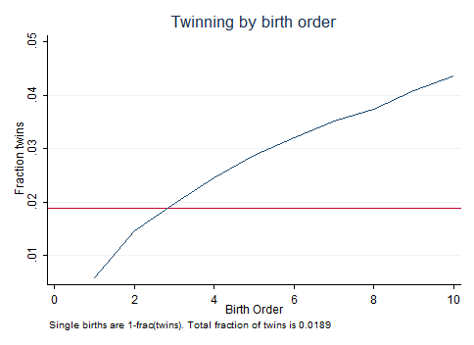
Figure 1: Proportion of twin births by birth order

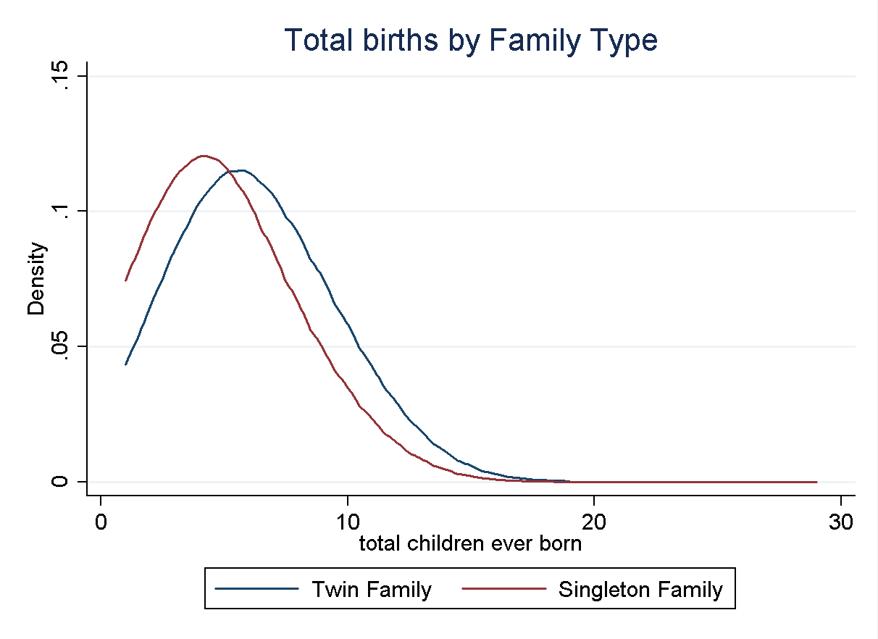
Figure 2: Twin births and total fertility

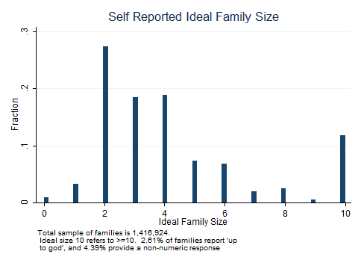
Figure : Distribution of ideal family size

Tables
 | Low Income |  |  | Middle Income
 | Single | Twins |  | Single | Twins
FERTILITY
Birth order | 3.545 | 4.867 |  | 3.056 | 4.133
 | (2.344) | (2.498) |  | (2.148) | (2.408)
Fertility | 5.232 | 6.754 |  | 4.581 | 5.794
 | (2.687) | (2.699) |  | (2.596) | (2.754)
Mother's age | 33.78 | 35.43 |  | 34.67 | 35.89
 | (7.864) | (7.344) |  | (7.764) | (7.437)
Ideal family size | 5.539 | 6.122 |  | 4.346 | 4.798
 | (2.916) | (2.921) |  | (2.906) | (3.026)
Fraction twin | 0.0233 |  |  | 0.0167
 | (0.1511) |  |  | (0.1258)
EDUCATION
Maternal Education | 2.670 | 2.687 |  | 5.079 | 5.325
 | (3.556) | (3.612) |  | (4.760) | (4.913)
Child Education | 2.546 | 2.336 |  | 4.758 | 4.443
 | (3.051) | (2.854) |  | (3.964) | (3.845)
Attendance | 0.6189 | 0.6285 |  | 0.7176 | 0.7266
 | (0.4856) | (0.4832) |  | (0.4501) | (0.4457)
HEALTH
Infant mortality | 0.0121 | 0.0605 |  | 0.0073 | 0.0390
 | (0.1093) | (0.2383) |  | (0.0853) | (0.1936)
Child mortality | 0.0186 | 0.0712 |  | 0.0097 | 0.0426
 | (0.1349) | (0.2572) |  | (0.0978) | (0.2018)
Maternal Height | 157.1 | 158.6 |  | 154.9 | 156.9
 | (7.172) | (6.904) |  | (7.072) | (6.999)
Maternal BMI | 21.76 | 22.31 |  | 24.50 | 25.29
 | (3.624) | (3.818) |  | (5.159) | (5.276)
Number of Countries | 27 | 27 |  | 41 | 41
Observations | 1,162,044 | 27,822 |  | 2,386,781 | 40,781
Note: Group means are presented with standard deviation below in parenthesis. Education is reported as years total attained, attendance is a binary variable indicating current attendance status. Infant mortality refers to the proportion of a child's siblings who die before 1 year of age, while child mortality refers to the proportion who die before 5 years. Maternal height is reported in centimetres. Summary statistics are for the full sample of 3,617,428 children. For a full list of country and years of survey, see appendix table A.
Table : Summary statistics

 | (1) | (2) | (3) |  |  | (4) |  | (5)
Twin*100 | All | INCOME |  |  |  |  | TIME
 |  | Low inc | Middle inc |  |  | Pre-1990 |  | Post-1990
Mother’s age | -0.0884*** | -0.0321 | -0.130*** |  |  | -0.0306 |  | -0.0522
 | (0.0250) | (0.0352) | (0.0286) |  |  | (0.0379) |  | (0.0448)
MAge² | -0.00161*** | -0.00308*** | -0.000577 |  |  | -0.00326*** |  | -0.000933
 | (0.000450) | (0.000576) | (0.000467) |  |  | (0.000709) |  | (0.000672)
Maternal Educ 1-4 | 0.319*** | 0.385*** | 0.267* |  |  | 0.412*** |  | 0.0719
 | (0.0956) | (0.101) | (0.150) |  |  | (0.113) |  | (0.113)
Maternal Educ 5-6 | 0.574*** | 0.534** | 0.562*** |  |  | 0.668*** |  | 0.315**
 | (0.127) | (0.194) | (0.176) |  |  | (0.147) |  | (0.141)
Maternal Educ 7-10 | 0.883*** | 1.092*** | 0.740*** |  |  | 0.946*** |  | 0.660***
 | (0.159) | (0.176) | (0.213) |  |  | (0.175) |  | (0.139)
Maternal Educ 11+ | 1.319*** | 0.615 | 1.302*** |  |  | 1.360*** |  | 1.088***
 | (0.170) | (0.395) | (0.207) |  |  | (0.205) |  | (0.258)
Mother’s Height | 0.0609*** | 0.0607*** | 0.0598*** |  |  | 0.0665*** |  | 0.0451***
 | (0.00705) | (0.00716) | (0.0109) |  |  | (0.00669) |  | (0.0105)
Mother’s BMI | 0.0651*** | 0.0808*** | 0.0584*** |  |  | 0.0612*** |  | 0.0687***
 | (0.00941) | (0.0130) | (0.0118) |  |  | (0.0110) |  | (0.0102)
Age First Birth | 0.343*** | 0.360*** | 0.327*** |  |  | 0.389*** |  | 0.260***
 | (0.0254) | (0.0378) | (0.0321) |  |  | (0.0313) |  | (0.0232)
Constant | -10.78*** | -10.86*** | -10.71*** |  |  | -16.16*** |  | -9.388***
 | (1.426) | (1.072) | (2.352) |  |  | (1.927) |  | (2.206)
Observations | 2,117,298 | 846,090 | 1,271,208 |  |  | 1,514,418 |  | 602,880
R-squared | 0.013 | 0.014 | 0.011 |  |  | 0.014 |  | 0.011
Robust standard errors in parentheses
*** p<0.01, ** p<0.05, * p<0.1
Note to table: All specifications include a full set of year of birth and country dummies and are estimated as linear probability models. Results are robust to the inclusion of birth order dummies (rather than a single discrete variable). Twin is multiplied by 100 for presentation. Height is measured in cm and BMI in points. Maternal education is included as dummies by level, with no education the omitted base.

Table : Probability of Giving Birth to Multiple Children

 | Birth order=2 |  |  | Birth order=3 |  |  |  |  | Birth order=4 |  |  |  |  | Birth order=5 |  |  |  |  | Birth order=6
 | Base  controls | + Maternal health |  | Base  controls | + Maternal health |  |  | Base  controls |  | + Maternal health |  |  | Base  controls |  | + Maternal health |  |  | Base controls |  | + Maternal health
PANEL A:
EFFECT OF ANY TWINS
Twin Family | -0.0108 | -0.0617*** |  | -0.0543*** | -0.0573*** |  |  | -0.0348*** |  | -0.0419*** |  |  | -0.0201** |  | -0.0527*** |  |  | -0.00920 |  | -0.0376***
 | (0.0165) | (0.0183) |  | (0.0128) | (0.0123) |  |  | (0.0105) |  | (0.0118) |  |  | (0.00966) |  | (0.0107) |  |  | (0.00961) |  | (0.0106)
Obs | 117,003 | 114,564 |  | 194,692 | 190,154 |  |  | 203,963 |  | 198,164 |  |  | 185,056 |  | 178,307 |  |  | 161,670 |  | 154,599
R² | 0.077 | 0.140 |  | 0.060 | 0.138 |  |  | 0.046 |  | 0.139 |  |  | 0.041 |  | 0.132 |  |  | 0.043 |  | 0.133
PANEL B:
EFFECT OF TWINS>DESIRED
Twin Family | -0.0747** | -0.109*** |  | -0.0390** | -0.0488** |  |  | -0.0379** |  | -0.0552*** |  |  | -0.0653*** |  | -0.00265 |  |  | -0.0209 |  | -0.0530***
 | (0.0330) | (0.0363) |  | (0.0184) | (0.0202) |  |  | (0.0163) |  | (0.0189) |  |  | (0.0170) |  | (0.0149) |  |  | (0.0145) |  | (0.0165)
Obs | 70,493 | 69,874 |  | 126,279 | 124,844 |  |  | 145,087 |  | 142,827 |  |  | 127,369 |  | 124,763 |  |  | 116,150 |  | 113,160
R² | 0.085 | 0.133 |  | 0.068 | 0.132 |  |  | 0.057 |  | 0.140 |  |  | 0.053 |  | 0.135 |  |  | 0.055 |  | 0.139

Notes: Each cell in panel A and B represents a separate regression, where the outcome variable is school Z-score. Panel A presents the results for the Twin treatment, and panel B presents results for PostTwin. Base controls include child gender, mother’s age and age squared, mother’s age at first birth, child year of birth, child age, and country of residence. + Maternal health adds additional controls for maternal health (height and BMI) and education. All standard errors are clustered at the country level. Significance levels correspond to: *** p<0.01, ** p<0.05, * p<0.1

NB: fix this table so each birth order regression is run for the same estimation sample.
References
Appendices
 |  | SURVEY YEAR
COUNTRY | INCOME | 1 | 2 | 3 | 4 | 5
Albania | Middle | 2008 | - | - | - | -
Armenia | Middle | 2000 | 2005 | 2010 | - | -
Azerbaijan | Middle | 2006 | - | - | - | -
Bangladesh | Low | 1994 | 1997 | 2000 | 2004 | 2007
Benin | Low | 1996 | 2001 | 2006 | - | -
Bolivia | Middle | 1994 | 1998 | 2003 | 2008 | -
Brazil | Middle | 1991 | 1996 | - | - | -
Burkina-Faso | Low | 1993 | 1999 | 2003 | - | -
Burundi | Low | 2010 | - | - | - | -
CAR | Low | 2004 | - | - | - | -
Cambodia | Low | 2000 | 2005 | 2010 | - | -
Cameroon | Middle | 1991 | 1998 | 2004 | - | -
Chad | Low | 1997 | 2004 | - | - | -
Colombia | Middle | 1990 | 1995 | 2000 | 2005 | 2010
Comoros | Low | 1996 | - | - | - | -
Congo-Brazzaville | Middle | 2005 | - | - | - | -
Congo-Democratic-Republic | Low | 2007 | - | - | - | -
Cote-d-Ivoire | Middle | 1994 | 1998 | - | - | -
Dominican-Republic | Middle | 1991 | 1996 | 1999 | 2002 | 2007
Egypt | Middle | 1992 | 1995 | 2000 | 2005 | 2008
Ethiopia | Low | 2000 | 2005 | 2011 | - | -
Gabon | Middle | 2000 | - | - | - | -
Ghana | Middle | 1993 | 1998 | 2003 | 2008 | -
Guatemala | Middle | 1995 | - | - | - | -
Guinea | Low | 1999 | 2005 | - | - | -
Guyana | Middle | 2009 | - | - | - | -
Haiti | Low | 1994 | 2000 | 2006 | - | -
Honduras | Middle | 2005 | - | - | - | -
India | Middle | 1993 | 1999 | 2006 | - | -
Indonesia | Middle | 1991 | 1994 | 1997 | 2003 | 2007
Jordan | Middle | 1990 | 1997 | 2002 | 2007 | -
Kazakhstan | Middle | 1995 | 1999 | - | - | -
Kenya | Low | 1993 | 1998 | 2003 | 2008 | -
Kyrgyz-Republic | Low | 1997 | - | - | - | -
Lesotho | Middle | 2004 | 2009 | - | - | -
Liberia | Low | 2007 | - | - | - | -
Madagascar | Low | 1992 | 1997 | 2004 | 2008 | -
Malawi | Low | 1992 | 2000 | 2004 | 2010 | -
Maldives | Middle | 2009 | - | - | - | -
Mali | Low | 1996 | 2001 | 2006 | - | -
Moldova | Middle | 2005 | - | - | - | -
Morocco | Middle | 1992 | 2003 | - | - | -
Mozambique | Low | 1997 | 2003 | - | - | -
Namibia | Middle | 1992 | 2000 | 2006 | - | -
Nepal | Low | 1996 | 2001 | 2005 | 2011 | -
Nicaragua | Middle | 1998 | 2001 | - | - | -
Niger | Low | 1992 | 1998 | 2006 | - | -
Nigeria | Middle | 1990 | 1999 | 2003 | 2008 | -
Pakistan | Middle | 1991 | 2006 | - | - | -
Paraguay | Middle | 1990 | - | - | - | -
Peru | Middle | 1992 | 1996 | 2000 | - | -
Philippines | Middle | 1993 | 1998 | 2003 | 2008 | -
Rwanda | Low | 1992 | 2000 | 2005 | 2010 | -
Sao-Tome-and-Principe | Middle | 2008 | - | - | - | -
Senegal | Middle | 1993 | 1997 | 2005 | 2010 | -
Sierra-Leone | Low | 2008 | - | - | - | -
South-Africa | Middle | 1998 | - | - | - | -
Swaziland | Middle | 2006 | - | - | - | -
Tanzania | Low | 1992 | 1996 | 1999 | 2004 | 2010
Togo | Low | 1998 | - | - | - | -
Turkey | Middle | 1993 | 1998 | 2003 | - | -
Uganda | Low | 1995 | 2000 | 2006 | - | -
Ukraine | Middle | 2007 | - | - | - | -
Uzbekistan | Middle | 1996 | - | - | - | -
Vietnam | Middle | 1997 | 2002 | - | - | -
Yemen | Middle | 1991 | - | - | - | -
Zambia | Middle | 1992 | 1996 | 2002 | 2007 | -
Zimbabwe | Low | 1994 | 1999 | 2005 | 2010 | -
Notes to table: Country income status is based upon World Bank classifications available at http://data.worldbank.org/about/country-classifications/country-and-lending-groups (consulted 8 July, 2013). Middle refers to both lower-middle and upper-middle income countries, while low refers just to those considered to be Low-income economies.

Appendix Table A: Country and Survey Years

 | (1)
VARIABLES | Twin*100
Mother age birth | 0.451*** | Preg Normal Weight | 0.820**
 | (0.129) |  | (0.417)
MAge^2 | -0.00738*** | Preg Overweight | 1.10**
 | (0.00223) |  | (0.490)
Indigenous | -1.11*** | Preg Obese | -0.908
 | (0.384) |  | (0.695)
Poor | 0.903** | Preg Anemia | 0.854*
 | (0.421) |  | (0.481)
Meduc Preschool | -1.06 | Preg No Checkup | -1.74***
 | (1.36) |  | (0.668)
Meduc Primary | 0.572 | Preg Smoked | -0.611
 | (1.35) |  | (0.400)
Meduc Secondary1 | 0.885 | Preg drugs 1 | -0.157
 | (1.36) |  | (1.60)
Meduc Secondary2 | 0.738 | Preg drugs 2 | -1.84***
 | (1.33) |  | (0.352)
Meduc Technical1 | 1.26 | Preg alcohol 1 | -0.151
 | (1.44) |  | (0.549)
Meduc Technical2 | 1.52 | Preg alcohol 2 | -1.85***
 | (1.45) |  | (0.296)
Meduc Tertiary1 | 1.82 | Preg private hosp. | -1.17***
 | (1.45) |  | (0.351)
Meduc Tertiary2 | 2.51* | Rural | -0.0758
 | (1.50) |  | (0.450)
Constant | -3.94 | Observations | 14,900
 | (2.70) | R-squared | 0.005
Notes to table: Data comes from the Encuesta Longitudinal de Primera Infancia (ELPI) from Chile. Education at each level are dummy variables, ‘no education’ is the omitted base. Regional controls and child age fixed effects are omitted for clarity. Heteroscedasticity robust standard errors are presented in parenthesis.

Appendix Table B: Probability of Giving Birth to Multiple Children (ELPI)

? People to acknowledge: Paul Devereux (speak to him about this), James Fenske, Frank Windmeijer, Carol Propper, Nidhiya Menon, others. Seminar participants at CMPO Bristol, CSAE Oxford and the European Society for Population Economics conference.
? University of Bristol. Contact: s.bhalotra@bristol.ac.uk.
? University of Oxford. Contact: damian.clarke@economics.ox.ac.uk.

