The Twin Instrument: The Fertility-Investment Trade-off[1]

Sonia Bhalotra[2] Damian Clarke[3]

August 1, 2013

**Abstract**

The incidence of twins has been used to identify the impact of changes in fertility on measures of investment in children born prior to the twins, and the emerging consensus in this literature is that there is no evidence of a quantity-quality trade-off. We argue that the standard approach is flawed for two reasons. First, even if twin conception is random, bringing twins to term is a function of maternal health which is difficult to fully observe and which tends to be correlated with child quality, rendering the instrument invalid. Second, twins will only constitute a shock to family size if their occurrence takes family size across the desired level. The neglect of both of these considerations in the literature will tend to lead to under-estimation of the Q-Q trade-off and so could contribute to explaining the negative results in the literature. Using a large sample of microdata from developing countries, we show that a significant trade-off emerges upon correcting for these biases.

**1 Introduction**

Twin studies since at least Rosenzweig and Wolpin (1980) have attempted to leverage the occurrence of twin births to estimate the effect of family size on child outcomes. Presumably, if twin births occur at random, these fertility shocks will act to increase family size in a way unrelated to family characteristics, parental preferences, and other unobservables which may be related to child quality. This has provided economists with a way to estimate the quantity-quality (Q-Q) model of Becker and Lewis (1973). In order for twin births to act as a reliable exclusion restriction in a Q-Q setup, these births must truly be random, or at least depend upon variables observed by the econometrician. This implies that both twin conception and twin gestation cannot depend upon unobservable characteristics of the family.

The emerging consensus in the literature using twin births to test the Q-Q model is that no such causal trade-off exists, or if it does, the importance of this is very minor. In this paper we re-examine the validity of these results, and suggest two important innovations. Firstly, we suggest that twin births are not truly exogenous, but instead depend upon maternal health stocks and behaviour during pregnancy. Secondly, we suggest that not all twin births truly constitute a shock to family size. For families in which twin births occur before their desired parity has been reached, future contraceptive behaviour can result in an optimal family size and optimal investment behaviour despite the twin birth.

In order to test the validity of assumptions of twin exogeneity maintained in the twin literature, we examine whether giving birth to live twins depends upon maternal characteristics not typically controlled for in previous studies. We find that rather than appearing to be random events, twin births depend upon maternal and family characteristics in a way that is likely to invalidate strategies which rely on this exogeneity assumption. Principally, we show that twin births are more likely to occur when a mother is heavier, taller, and more highly educated, along with a range of risky behaviours during pregnancy. This result holds both preceding and following the introduction of in-vitro fertilisation (IVF). We also take advantage of a mother’s self reported desired family size (and regional averages of this variable) to identify those twins which cause families to exceed their optimal plan.

We find that both of these innovations result in significant changes to estimates of the Q-Q trade-off. Ignoring these considerations we find that the effect of a twin birth is minor, or not significantly different to zero for a number of important child outcome variables. However when taking into account both innovations we find that a trade-off *does* exist, and that an additional twin birth reduces average school attainment in a family by approximately 0.1sd, and increases the likelihood of infant mortality by approximately 0.1 to 0.2 percentage points.

Whether a Q-Q trade-off occurs is an important question for developing economies. Cleland et al. (2006) suggest that the main motivation for the introduction of family planning policies in Asia was as a manner to “enhance prospects for socioeconomic development by reducing population growth”. Family planning is also still considered a concern according to policy makers in the developing world. A recent survey of national governments[4] suggests that fertility was perceived as too high in 50% of developing countries, with this figure rising to 86% among the least developed countries (United Nations, 2010). Whilst there are a range of other motivations for family planning policies, in what follows this paper aims to examine the perception that reducing the number of children results in an increase in per-child investments at a family level. We will proceed as follows: section 2 discusses the use of the twin instrument in prior literature. Section 3 discusses our methodology, and lays out more formally the two innovations we have discussed above, while section 4 discusses the large sample of data we use to test the validity and importance of these points. Results are presented in section 5, and section 6 concludes.

**2 Twin Studies**

Despite the empirically observed regularity linking an individual's sibship size and their measured ‘quality’, testing whether such a trade-off represents a causal relationship is not trivial. Particularly, concerns exist that parental decisions regarding the production of child quality and quantity are jointly made and possibly influenced by unobserved factors. Concerns regarding unobservable heterogeneity at the family level and omitted variable bias have spawned an entire literature which aims to isolate the causal effect of sibship size. In order to determine whether increases in child quantity actually cause families to lower investments in quality, exogenous shocks to family size must be exploited. The economic literature has suggested a number of ways that this can be done, with one of the most common being the unexpected rise in family size resulting from a multiple or twin birth. Other strategies which have been proposed to identify the quantity-quality (Q-Q) model involve gender mix and parental stopping rules (Conley and Glauber, 2006), son-preference (Lee, 2008), and natural experiments based upon the relaxation of government fertility policies (Qian, 2009). In what follows, we only focus on the use of multiple births as an instrument.

The use of twin births to address the problem of endogeneity in the Q-Q model seems to have been initially proposed by Rosenzweig and Wolpin (1980). They derive the theoretical requirements to estimate the size of the trade-off when the shadow price of child quality depends on the number of children and vice versa. By relying on the assumption that multiple births are an exogenous shock to family size (once accounting for the total number of a mother's pregnancies) they estimate the effect of a twin birth upon the educational attainment of children in the twins' family.

Subsequent papers employing a twin-birth methodology have proposed a number of strategies which enable them to obtain consistent estimates of the Q-Q trade-off while relaxing Rosenzweig and Wolpin's exogeneity assumption. Black et al. (2005) extend the controls to account for the fact that the probability of multiple birth increases with maternal age as described by Jacobsen et al. (1999) and others. They include a set of parental age and education controls, however note that they are unable to reject the hypothesis that parental education has no effect on the probability of multiple birth. Likewise, Cáceres-Delpiano (2006) includes controls for mother's age, race, and education, suggesting that the use of these and pre-1980 US Census data should be sufficient to approximate conditional exogeneity.[5] Finally, Angrist et al. (2010) recognise that twin birth varies with maternal age at birth and race, including twinning as one of three instruments to estimate the Q-Q model.

Angrist et al. join recent work from Rosenzweig and Zhang (2009) in questioning the validity of twin instrumentation in another sense. These authors suggest that the error term in the Q-Q equation is unlikely to be orthogonal to the instrument given that twinning imposes predictable and unobserved family responses in investment decisions. Particularly, these studies question the effect that close birth spacing and an endowment effect - where parental behaviours respond to the lower health at birth of twins compared to single births[6] - has on investments in pre-twin siblings. Based upon this critique, Rosenzweig and Zhang suggest a technique to compute an upper and a lower bound of the Q-Q trade-off. They suggest that if parents reinforce child endowments, and given the relative costliness of investing in twins due to their close birth-spacing, parents are likely to shift resources away from (low endowment)twins and towards (higher endowment) singletons following twin births. As a result, the effect of twinning on twins (the own-effect) will overstate the true effect of the Q-Q trade-off, and the effect on non-twin siblings (the cross effect) will understate this effect. In the following section we return to this point when we discuss the empirical framework of this paper.

More recently, instrumentation using twin births has been applied to estimate a Q-Q model in the developing world. Ponczek and Souza (2012), Fitzsimons and Malde (2010), Sanhueza (2009) and Li et al. (2008) have applied a similar methodology to that of Angrist et al., examining twin births in Brazil ,Mexico, Chile and China respectively. These studies find mixed results depending upon the country under examination and once again, while considering the invalidity of the twin exclusion restriction inthe Q-Q model in terms of maternal education, do not examine this in terms of non-random twin births due to maternal health or other behaviours.

**3 Methodology**

Previous twin studies (see for example Angrist et al. (2010)) define the following specification to estimate the effect of sibship *c* on child outcomes *y*:

|  |  |  |
| --- | --- | --- |
|  | $$y_{i}=W_{i}^{'}μ+ ρc_{i}+ ε_{i}$$ | (1) |

where *W* includes a vector of controls for subjects' and subjects' mother's ages, maternal age at first birth, parental place of birth and age at immigration (where relevant), and survey year controls. Our first innovation is to introduce controls for maternal health and other socio-economic variables. We augment (1) to give the following estimable specification:

|  |  |  |
| --- | --- | --- |
|  | $$y_{i}=W_{i}^{'}μ+H_{i}^{'}δ+ ρc_{i}+ ε_{i}$$ | (2) |

Where *H* refers to observed maternal health variables such as BMI, height, and in some cases alcohol consumption and drug-taking behaviour during pregnancy. When identifying based upon twin births, we can test the necessity of including *H* in (2) by regressing twinning on maternal health characteristics:

|  |  |  |
| --- | --- | --- |
|  | $$t_{i}=X_{i}^{'}α+H_{i}^{'}β+u_{i}$$ | (3) |

Here *X* includes controls which are typical in the twin literature: mother's age, age at first birth, and race, and full country and year of birth dummies for the child.[7] We can test whether the additional health and socio-economic controls *H* are necessary by looking at the sign on estimated $β$. If healthier mothers are more likely to give birth to twins, we expect that $β>0$.

Our second innovation is to focus only on additional children resulting from twinning where the incidence of multiple birth takes families above their desired family size. In order to assess this we use subjective (mother-specific) reports of desired fertility (although we also investigate using region-specific averages of this variable because the individual reports may be a function of individual parity at the time that the question is posed). Analogously to (2) we estimate:

|  |  |  |
| --- | --- | --- |
|  | $y_{i}^{P}=W_{i}^{P}'μ+H_{i}^{P'}δ+ ρc_{i}^{P}+ ε_{i}^{P}$, | (4) |

and here superscript *P* refers to those twins born once ideal family size has been reached.

For child i of family size c in which b births occur,[8] we identify the effect of an additional birth by constructing two sets of family-size-specific control and treatment groups. The first set of treatment groups consists of any family in which a twin birth occurs. For each *t $∀$* {1,…,6}, we define a group *Twint* if child *i* is a member of a twin family who has had *b = t* births, and hence has a family sizeof *c = t + 1*. We then define a corresponding control group for each *t* (for simplicity denominated *Controlt*) which consists of children in families in which all births are singleton, and who have had *b = t* births, and hence a total family size of *c = t*. In other words, we compare children from two groups of families who have also had *b* births, the only difference being that one of these groups - the treated - has produced *t + 1* children in *b* births, while the other group of families has produced just *t* children. To be explicit; we define a group *Twin2*which consists of all families of three children in which a twin birth occurs (at birth orders one or two). This is then compared to the group *Control2*, which consists of families who produced two single children in each of their two births. Analogously to the comparison between *Twin2*and *Control2* groups we then construct *Twin3*, …,*Twin6*and *Control3*, …,*Control6* which allow us to examine the effect of additional unplanned children in 3, 4, 5 and 6 birth families. Such a treatment setup is defined for two reasons: firstly because it allows us to identify the effect of an additional unplanned birth on child outcomes, and secondly because it allows us to avoid concerns that birth order effects may confound the identification of the Q-Q trade-off (see for example Black et al. (2005)).

These control and treatment groups consist of all children in twin and non-twin families, and hence include the twins as part of the treatment group. Such an estimation sample allows us to estimate the average effect of an additional twin birth on all children in the twin family. However, it is well known that twins generally have lower endowments at birth, with shorter average gestational length and lower birth weights than singleton births (see Hall (2003) and related literature). If this is the case, and further, if parents engage in reinforcing behaviour of human capital endowments, the presence of twins in the treatment group will overstate the size of the effect on non-twins. For this reason, we estimate a similar model but including only on children born prior to twins in our treatment groups. A focus on pre-twins is common in the existing twin literature, and the comparison of the average effect on all children to just that on pre-twins allows us to test a basic assumption of the Q-Q model: that all children are of the same quality.[9]

Our second set of treatment groups consists of all families with multiple births, where the multiple birth pushed the family over their desired size or occurred after the desired size had been reached Each mother reports *d*, the total desired number of children in her family.[10] We once again define *t $∀$* {1, …, 6} treatment and control groups corresponding to family sizes of *b=t* total births. These treatment groups are denominated *PostTwint* and include all children *i* in a twin family with *b = t* births (and so *t +1* children) *and* in which the twin birth occurs at a parity greater than or equal to *d*. Under this definition, our treatment group only includes twin families for whom the twins truly were a shock to fertility in the sense that they could not be corrected for by reducing future child bearing. The corresponding treatment group, P*ostControlt* then consists of all children in families of *b = t* births, with *c = t* (singleton) children, and for whom *b ≥ d*.[11]

To illustrate, if desired family size is reported to be *d = 3* and twins occur at birth order *b = 3*, hence pushing the family to *c = 4* children (exceeding their desired threshold), this family will be included in the *PostTwin3* group. The family will be compared to a similar family who reports that *d = 3* (or greater) and who has a singleton birth at *b = 3*, so that both *b = c = 3*. However, were the family to report that its desired family size was *d = 4*, a twin birth at *b = 3* would not be considered a shock to fertility, given that the family is still able to achieve its desired number of children. In the *Twin3* specification above, and in earlier papers which use twins to identify the Q-Q trade-off, such a twin family would be treated as a ‘complier’, even if the family always intended to give birth to, and optimally invest in the four children it finally had.

We estimate $\hat{ρ}$ from (2) and (4) by replacing *ci* by *Twinti* and *PostTwinti* respectively. This results in a series of 6 reduced form regressions for each of (2) and (4). These parity-specific results allow us to identify a shock to fertility for families with 1, 2, …, 6 births, which (ex-ante) we do not restrict to be constant. As a further robustness check, we estimate (2) and (4) using 2SLS, where twin births are used to instrument fertility. In this case we use the specification which is ‘typical’ in recent twin literature (ie Angrist et al. (2010)), although augment their specification (1) with the mother's health variables as per (2). We describe this construction of this IV estimation more completely in appendix A.

**4 Data**

**4.1 Data and Descriptive Statistics**

The estimation of the Q-Q model requires information on maternal characteristics and child outcomes. In order to estimate specification (2), observations of child `quality' outcomes plus a mother's full birth history (including a measure of twin or singleton births) are required. In order to test (partially) the hypothesis of twin endogeneity implied in equation (3), stricter data requirements must be met. Along with child outcomes, the mother's health, and family socioeconomic characteristics must be observed.

We use comprehensive information available on maternal and child outcomes from the Demographic and Health Surveys (hereafter DHS) to estimate the Q-Q model. The DHS are a nationally representative set of surveys administered principally in low and lower-middle income countries. Every publicly available survey administered between 1990 and 2012 has been used to create a pooled dataset, resulting in 170 surveys from 68 countries. A full list of surveys by country and year is available in Appendix Table 9. DHS survey data on educational and health outcomes of each member in surveyed households has been merged with characteristics of the individual's mother including her weight, body mass index (BMI), and education, along with other household level socioeconomic variables. This merge results in 3,617,428 matched children of 1,416,765 mothers with both educational and maternal health and education data. Of this sample, 68,603 (or 1.89%) are children born in twin births. We drop from the estimation sample families who have experienced a multiple birth of size greater than two, due to concerns that these are very different than 2 or 3 additional births with normal birth spacing. These non-twin multiple births (triplets and quintuplets) make up a very small portion of the sample: 756 children from 253 families.

Survey countries are classified according to country income level in order to allow for a disaggregation of Q-Q results by income group. This classification is obtained from the World Bank, with DHS surveyed countries falling into two broad groups: low-income economies (GNI per capita of $1,005 or less), and middle-income economies ($1,006-$12,275). Details regarding this classification are provided in Appendix Table 9.

The large sample size of the pooled dataset is important given the relative infrequency of twin births. Twin birth is more common in low-income countries than in middle income countries. This is despite the fact that, as we shall demonstrate, the probability of twin births is increasing in maternal health, education and wealth. It would appear to be because low income countries have higher fertility and the probability of a twin birth (“twinning”) is increasing in birth order (and maternal age): while less than 1% of first births result in multiple offspring, this increases to approximately 4% at the tenth birth (see Figure 1).

Twin births are not fully offset by reductions in future childbearing as indicated in Figure 2. The distribution of family size in families where at least one multiple birth has occurred dominates the corresponding distribution for all-singleton families. This is expected given imperfect fertility control and - even if fertility were perfectly controlled by families - given that some twins will occur on a family's final birth. Such a result is required for identification of the Q-Q trade-off using twins.

We use data on self-reported ideal family size to assess the importance of our second point: that not all twins cause a family to exceed its desired family size. We require such a measure of desired fertility, *d*, to estimate (4). Figure 3 displays the distribution of reported desired family size by the mother at the time of survey. While the majority of mothers report wanting a family with 4 children or less, nearly 15% report desired fertility of 10 children or greater, or report wanting “as many children as possible” or leaving it “up to god”. While those women who report wanting “as many as possible” or leaving their fertility decision “up to god” are included in Figure 3 as desiring 10 or more births (the final bar), they are removed - along with those who give a non-numeric response - from our final estimation sample. This accounts for 8.78% of our total merged sample, or 315,965 children. A small number of mothers (13,066 or 0.93% of the entire sample) report wanting no children.

In order to be considered part of the *PostTwin* treatment groups, families must exceed their reported desired family size. Table 1 describes the frequency of families who exceed their desired family size. In the full sample 37.2% of mothers have greater than their desired number of children, however when examining those mothers who are approximately at the end of their fertile life, this rises to 51.4%. Interestingly, we see that less mothers in low income countries (LICs) (where fertility control is less readily available) are less likely to exceed their desired fertility (33.8% versus 39% in middle income countries). However, as we discuss below, this is likely due to the fact that desired fertility is considerably higher in LICs. Figures 4a and 4b suggest that desired fertility is quite closely related to the number of children a woman has. This could be seen in two ways: it may be that desired fertility drives actual fertility, however it may also be that mothers define their desired fertility based upon the number of children they actually have, essentially updating their reported desired fertility in line with outcomes. The results from Table 1 suggest that this second situation may not be such a concern, as many mothers report wanting a different amount (both higher and lower) of children, however, as a consistency check we estimate (4) with both individual and regional level desired fertility.

Child quality is measured using individual educational results and health outcomes collected during DHS surveys. Survey results are available for all children of surveyed mothers living at home at the time of the survey. In the full sample this includes offspring between the ages of 0 and 41, however given concerns of non-representability, we remove those offspring who remain living at home over the age of 18 (7.12% of individuals) from the estimation sample. Educational quality variables include standardized years of schooling - calculated using the mean and standard deviation of years of schooling of the cohort and country of residence of the child, and an indicator for whether or not the child was ever enrolled in high school.[12] For health outcomes we examine infant and child mortality, defined as survival to the ages of 1 and 5. Means and standard deviations of each of these child outcome variables, along with maternal and family characteristics are presented in Table 2.

**4.2 Sample Groups**

The educational variables *school z-score* and *high school* are defined only for those children over the ages of 6 and 11 respectively, while *infant mortality* and *child mortality* restrict the samples to children who are fully exposed to the risk of infant and under-5 death respectively. So for instance if an individual is born 8 months before the date of survey then at that date they have not been fully exposed to the 12-month interval in which infant mortality may occur - they may be alive at the 8 month mark but not survive to the 12 month mark and so these children are dropped from the sample used to estimate infant mortality. Similarly children who are alive but under the age of 60 months are dropped from the sample used to estimate under-5 mortality.

In each case, we estimate the relevant Q-Q specification for a particular age-specific subgroup of the population. In Table 3 we present the sample size of each group, along with its age distribution. As expected, the largest subsample exists for the outcome *infant mortality* (nearly 3,000,000) children, and the smallest for *highschool* (slightly less than 1,000,000).

**5. Results**

**5.1 Twin Exogeneity**

In table 4 we report the results from specification (3). These results suggest that twin births are not random, even after conditioning on maternal age and child birth order as done in previous work. The inclusion of a full set of country and year of birth dummies (not reported in table 4) will capture any trend in probability of twin birth across time or regions, and country dummies will absorb all time invariant differences in the probability of a twin birth across countries. The estimated coefficients and signs support the idea discussed in section 1 that higher ‘investments’ (for example in maternal health) required to maintain multiple healthy fetuses in utero may result in non-random twin births. Initially results from the pooled DHS data are presented as this provides a particularly large sample with which to test the hypothesis of twin exogeneity. This is represented in table 4 column (1) and provides considerable evidence that live multiple births respond to family `choice' variables such as education (tests for the joint significance of both socioeconomic variables and health variables are rejected with p-values of 0.0000).

The fact that maternal health is correlated with twinning is supported by medical literature, al-though is not a point that has been incorporated into prior economic studies of twinning. Hall (2003) for example suggests that follicle-stimulating hormone (FSH) is associated with an increased likelihood of twinning, and is found in higher concentrations in older, heavier and taller mothers. Further, she suggests “that adequate maternal folic acid consumption could affect the number of twins coming to term” (see p. 741, and further discussion in Li et al. (2003)). Given that twinning also increases in cases where the mother undergoes fertility treatment, we run a similar regression for children born in a period not potentially affected by IVF.[13] These results are included in columns (4) and (5), and although education is now no longer always significant, mother's height and weight, and family socioeconomic variables remain economically and statistically significant.

If the reason non-random twin births are observed is due to insufficient investment in the developing fetus, it seems likely that twin ‘selection’ will be more pronounced in lower income settings, and settings where the mother is less well resourced during gestation. This is tested in columns (2) and (3), where it is shown that the violation of the twin exclusion restriction is particularly strong in low income countries. Here maternal health is a more important predictor, and the explained portion of this set of variables is larger that in middle-income countries.[14]

These results call into question the veracity of the conditional exogeneity (or ‘as good as random’) assumption required to estimate $ρ$ consistently in (1). This implies that omitting factors such as familyincome, maternal health and maternal education would result in inconsistent estimates of $ρ$, at leastin the case of the data from the DHS surveys. Indeed, we suspect (although can never fully prove do the unobserved nature of many behaviours and decisions of the mother during pregnancy), that even estimates in our augmented specifications (2) and (4) are inconsistent (although less so than those for (1)). This is the case given that many relevant behaviours which predict the probability of giving live birth to twin fetuses are not observed by the econometrician. In order to provide suggestive evidence of such a case, we run a similar regression on an alternative dataset from Chile which collects richer measures of a mother's health and behaviour during pregnancy. These results are available in Appendix Table 10, and suggest that along with education and BMI, smoking, drug taking, alcohol consumption, and medical check-ups during pregnancy, affect the probability of giving birth to twins.

**5.2 Q-Q Trade-off: OLS Estimates**

As is typically found in empirical studies of the Q-Q trade-off, correlations between family size and child outcome variables are negative, and strongly significant. Table 5 shows OLS estimates of total fertility on each of the quality variables. These results suggest that an additional sibling is associated with an approximately 0.1 sd decrease in school z-score, a 3% decreased likelihood of attending high school, and a 0.7 and 0.5% increase in child and infant mortality respectively.

Of course, this empirically observed relationship between an individual's sibship size and their measured ‘quality’ does not necessarily imply that such a trade-off exists if parental decisions regarding the production of child quality and quantity are jointly made and possibly influenced by unobserved factors. Principally here we are concerned with unobserved parental behaviours which may favour both lower family size and higher child quality. Qian (2009) suggests that such a mechanism will exist where parents who value education more highly also decide to have less children. The OLS results are consistent with such a result, as the inclusion of maternal education and maternal health controls – likely correlated with desires for smaller family size and higher investments per child - reduce the magnitude of this observed trade-off.

**5.3 Q-Q Trade-off: Estimates Using Twin Births**

Rather than focusing on these - likely endogenous - OLS results, we turn to estimates which rely on twin births to identify the Q-Q trade-off. As we outline in section 5.1, the assumption of ‘as good as random’ twin births is unlikely to hold, even when conditioning on the augmented set of controls proposed in (2). If this is the case, we will be unable to consistently estimate $ρ$ using twin births.

However, it is likely that the $ρ$ that we estimate using twin births will provide us with a strict lowerbound of the magnitude of the Q-Q trade-off. Given that we expect that the bias in this estimate is due to those mothers who invest more in their children in utero (and likely post-birth) being more likely to give birth to twins (and hence having larger family sizes), and at the same time we expect that twin births are negatively correlated with child quality, then relegating health variables to the error term will result in a positive (negative) bias on the twin coefficient if the outcome is negatively (positively) related to twin births.[15]In order to determine the effect that these omitted variables have on estimates of the Q-Q trade-off, we turn to results for models (2) and (4): firstly looking at the effect of all twins, and then only twins which occur *after* ideal family size has been reached.

**5.3.1 Estimates Based on All Twins**

Table 6 presents results for the Q-Q trade-off (for two outcome variables, the other two outcome variables are included as Appendix Table 11), for average child quality in families. Here we focus on the left-hand panel for each outcome variable which examines all twin families.

We see that generally - although with two exceptions in the school z-score variable - as expected the inclusion of socioeconomic and health controls results in an increase in the magnitude of the estimated Q-Q trade-off. The first column includes the base case of the controls typical in much of the twin literature, column 2 adds controls for maternal education, and column 3 adds controls for maternal health. The addition of these controls is generally minimal, particularly in the case of infant and child mortality. However, we see that when considering the average child in all families with twin births that there is a significant, and relatively small effect of having an additional twin sibling: approximately 0.05 of a sd in school z-score, or a 0.1% increase in the probability of a child not surviving to 60 months.

Turning to Table7, the effect on only siblings preceding twins is less than the effect of the average child in the family – likely due to the higher endowments of singleton children than twins, and perhaps owing to reinforcing behaviour of parents. For school-z-score the Q-Q trade-off only appears for larger families: those who had at least 5, 6 or 7 births. Interestingly, we see that for the case of infant and child mortality the effect of twin births appears to work in the *opposite* direction on pre-twins than on the average child in the family. Here we see that pre-twins are actually *less* likely to die before 1 or 5 years. This should not necessarily be surprising given that the arrival of twins must be at least 9 months, and often more than 5 years later than pre-twins, in which case the additional birth will have no effect on infant mortality, and a relatively minor effect on under 5 mortality. Indeed, the apparent positive effect of twin births may be due to the results discussed in section 5.1: that healthier and more educated mothers are likely to give birth to twins, in which case we would suspect that those children born before twins would enjoy the benefits of a healthier mother in early life, without the shock of an additional birth in later life. While the point estimate for school z-score provide some suggestive evidence that this is the case – adding education and health controls seems to reduce the magnitude of the point estimate – these are not estimated precisely enough for the differences to be significant.

**5.3.2 Estimates Based on Twins Above Desired Family Size**

Turning to our second point – that only twins which occur above a mother’s desired fertility are shocks to fertility, we see that the magnitude of the Q-Q trade-off is considerably higher in this group. The right-hand panel of Table 6 (and Appendix Table 11) shows that the effect of an additional twin in this group results in a reduction in school z-score of approximately 0.1sd, considerably higher than the approximately 0.05sd estimated in the previous section. The effect on child and infant mortality appears to be similar, or slightly lower, once again approximately an increased risk of 0.1% that the average child in the family will not survive to 60 months. Here however, we see that the addition of education and health controls actually reduces the magnitude of the Q-Q trade-off rather than increasing it, as we found in the previous section, and as our theory would predict. Given the select nature of the treatment group here – those that are less able to control their fertility[16] - this result, and the theory driving itis not as clear cut as in the full sample.

For those siblings born before twins (rather than the average child discussed above), we see once again that the size of the Q-Q trade-off for school z-score is approximately doubled, although this is only significant in larger family sizes. Again, we see that pre-twins are somewhat *less* likely to die before the ages of 1 and 5 years old in twin families, a result which is in line with the discussion at the end of section 5.3.1.

**5.4 Robustness Checks**

**5.4.1 IV Estimates**

Appendix Table 14 presents results from the estimation of the Q-Q trade-off using a 2SLS instrumental variable set-up as described in Appendix A. This specification focuses only on pre-twins (as is typical in a number of existing twin studies). We see here that the inclusion of socioeconomic and health controls *is* an important consideration, at least for the outcome variable school z-score. In this case, at higher birth orders a significant, although somewhat small effect appears for those children who are followed by an additional sibling owing to twin births.

The IV estimates for alternate outcome variables: infant and child mortality, and high school attendance, are not significantly different to zero. In the case of infant and child mortality we once again expect that this should be the case, given that twins frequently are not born by the time their sibling has completely passed through the period in which these outcomes could occur.

**5.4.2 Heterogeneity**

Finally we examine results by subgroup. We estimate whether male or female children are more likely to suffer from additional siblings, and then examine by country income groups. Table 8 and Appendix Table 13 present results for all outcome variables, and are estimated using specification (4): the average effect on all (male or female) children in families, or all children in families in low- and middle-income countries.

Generally neither boys nor girls seem to be particularly disadvantaged by additional siblings. For each gender, the results are approximately similar to those reported in section 5.3.2, a 0.1 sd decrease in school z-score, or a 0.1-0.2% increase in child mortality risk. In terms of country income groups, the results are also surprisingly similar, although this may be due to the somewhat crude nature of the country income classification. Perhaps the main difference between these two country groups is in terms of at which family sizes the Q-Q trade-off appears to take place. In low income countries the result is largely felt when additional births occur in larger families (with five, six, or seven births), while in middle income countries it appears in smaller families, with between two and 4 births.

**6 Conclusion**

In this paper we provide results which suggest that the growing body of evidence against the Q-Q trade-off may be incomplete. We suggest that prior results omit two important considerations. Firstly, a number of twin studies do not account for the fact that – at least in low income countries – twins do not appear to be exogenous, instead depending upon maternal health. Secondly, we argue that twin births are not necessarily shocks to family size if the multiple birth does not push the family over its true desired threshold.

In taking this to a large sample of microdata – more than 3,000,000 children and more than 1,000,000 mothers – we find that these considerations do affect estimates of the Q-Q trade-off. Particularly, focusing only on twins which drive families to exceed their desired fertility approximately doubles the estimated effect of an additional birth on average educational attainment in the family, resulting in estimates of approximately 0.1 sd in country specific school z-scores.

Going forward, we aim to test these findings on administrative data from Norway. Presumably, twins should appear much more ‘random’ when all mothers are heavier and healthier. In moving to an administrative dataset, we also aim to test a wider range of outcomes over a longer period of time than those available in the DHS, which only follows a child until they leave the parental home.

**References**

D. Almond, K. Y. Chay, and D. S. Lee. The costs of low birth weight.*The Quarterly Journal of Economics*, 120(3):1031-1083, August 2005.

J. Angrist, V. Lavy, and A. Schlosser. Multiple experiments for the causal link between the quantity and quality of children.*Journal of Labor Economics*, 28(4):pp. 773-824, 2010.

G. S. Becker and H. G. Lewis.On the interaction between the quantity and quality of children.*Journal of Political Economy*, 81(2):S279-88, Part II, 1973.

S. E. Black, P. J. Devereux, and K. G. Salvanes. The more the merrier? the effect of family size and birth order on children's education. *The Quarterly Journal of Economics*, 120(2):669-700, 2005.

J. Cáceres-Delpiano. The impacts of family size on investment in child quality.*Journal of Human Resources*, 41(4):738-754, 2006.

D. Conley and R. Glauber. Parental educational investment and children's academic risk: Estimatesof the impact of sibship size and birth order from exogenous variation in fertility. *The Journal ofHuman Resources*, 41(4):pp. 722-737, 2006.

E. Fitzsimons and B. Malde. Empirically probing the quantity-quality model. IFS Working Papers W10/20, Institute for Fiscal Studies, Sep 2010.

J. G. Hall. Twinning.*The Lancet*, 362(6736):735-43, August 2003.

J. P. Jacobsen, J. W. P. III, and J. L. Rosenbloom. The effects of childbearing on married women'slabor supply and earnings: Using twin births as a natural experiment. *Journal of Human Resources*,34(3):449-474, 1999.

J. Lee. Sibling size and investment in children's education: an Asian instrument. *Journal of Population Economics*, 21(4):855-875, October 2008.

H. Li, J. Zhang, and Y. Zhu. The quantity-quality trade-off of children in a developing country: Identification using Chinese twins. *Demography*, 45:223-243, 2008.

Z. Li, J. Gindler, and H. Wang. Folic acid supplements during early pregnancy and likelihood of multiplebirths: a population-based cohort study. *The Lancet*, 361:380-84, 2003.

V. Ponczek and A. P. Souza. New evidence of the causal effect of family size on child quality in a developing country.*Journal of Human Resources*, 47(1):64-106, 2012.

N. Qian. Quantity-quality and the one child policy: The only-child disadvantage in school enrolment inrural China. NBER Working Papers 14973, National Bureau of Economic Research, Inc, May 2009.

M. R. Rosenzweig and K. I. Wolpin.Testing the quantity-quality fertility model: The use of twins asa natural experiment. *Econometrica*, 48(1):227-40, January 1980.

M. R. Rosenzweig and J. Zhang. Do population control policies induce more human capital investment?twins, birth weight and China's one-child policy. *Review of Economic Studies*, 76(3):1149-1174, 07 2009.

C. Sanhueza. Tamaño de familia y orden de nacimiento en Chile: Usando gemelos como experimentonatural. *Revista de Análisis Económico -EconomicAnalysisReview*,24(2):133-152, Dec 2009.

**Figures**

Figure 1: Proportion of Twins by Birth Order

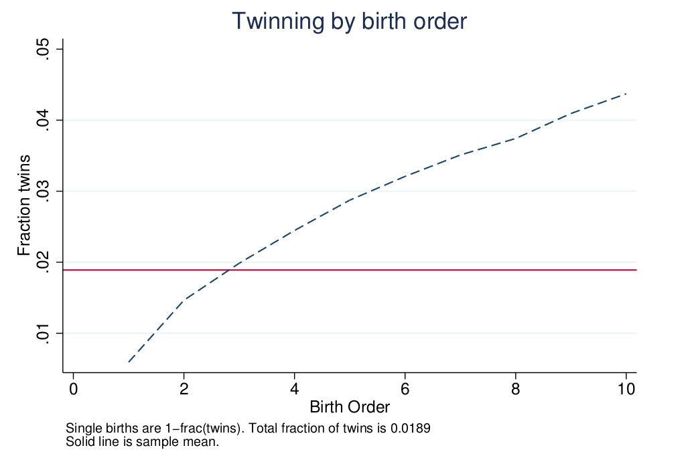

Figure 2: Twin Births and Total Fertility

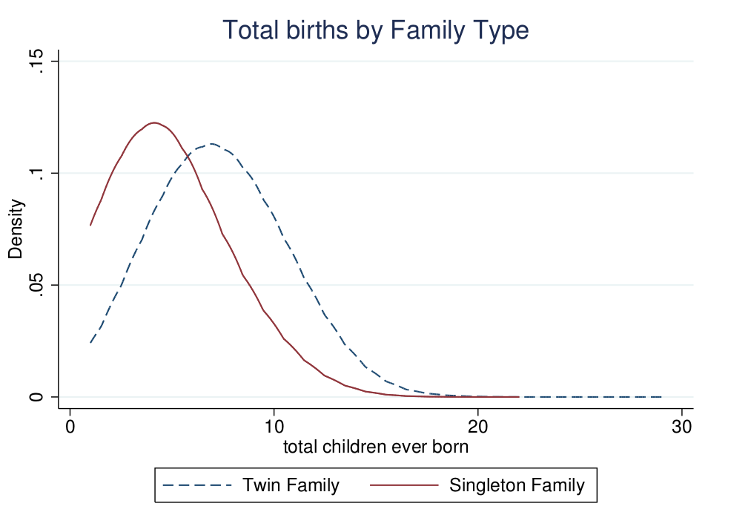

Figure 3: Distribution of Ideal Family Size

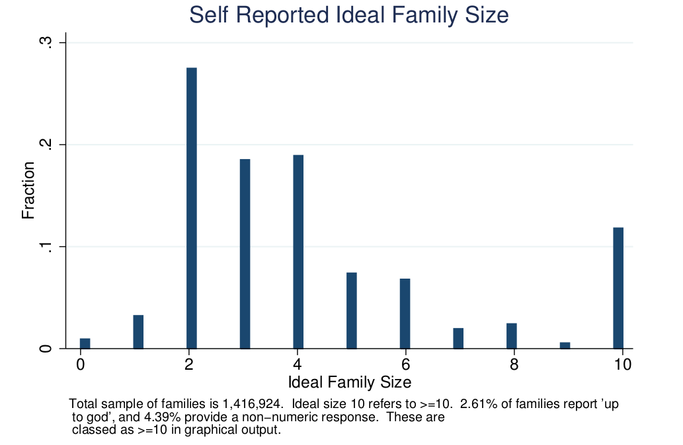

Figures 4a: Ideal Family Size by Total Fertility

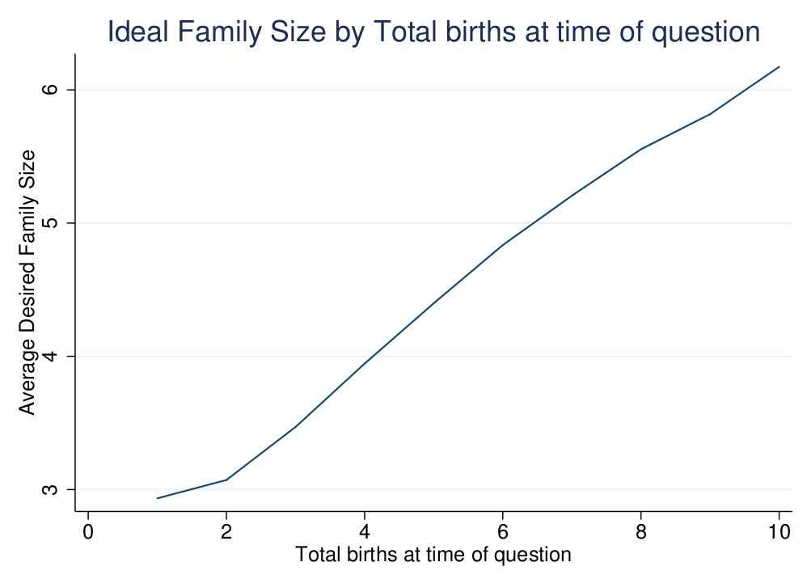

Figures 4b: Ideal Family Size by Mother’s Age

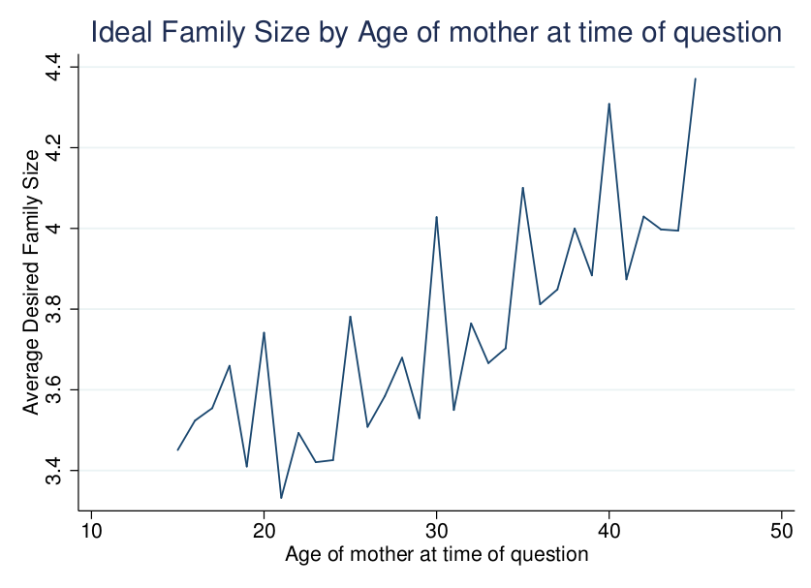

**Tables**

Table 1: Ability to Obtain Ideal Family Size

|  |  |  |  |  |  |
| --- | --- | --- | --- | --- | --- |
| Has family obtained ideal size? | All | Under 35 | Over 35 | Low Income | Middle Income |
| NUMBER |  |  |  |  |  |
| < ideal number | 1,268,871 | 902.932 | 365.939 | 509.265 | 759.606 |
| Ideal number | 681.462 | 433.978 | 247.484 | 176.215 | 505.247 |
| > than ideal number | 1,157,657 | 508.846 | 648.811 | 349.636 | 808.021 |
| Total | 3,107,990 | 1,845,756 | 1,262,234 | 1,035,116 | 2,072,874 |
| PERCENT |  |  |  |  |  |
| < ideal number | 40.8 | 48.9 | 29 | 49.2 | 36.6 |
| Ideal number | 21.9 | 23.5 | 19.6 | 17 | 24.4 |
| > than ideal number | 37.2 | 27.6 | 51.4 | 33.8 | 39 |
| Total | 100 | 100 | 100 | 100 | 100 |

Table 2: Summary Statistics

|  |  |  |  |  |  |
| --- | --- | --- | --- | --- | --- |
|  | Low Income | |  | Middle Income | |
|  | Single | Twins |  | Single | Twins |
| FERTILITY |  |  |  |  |  |
| Birth order | 3.545 | 4.867 |  | 3.056 | 4.133 |
|  | (2.344) | (2.498) |  | (2.148) | (2.408) |
| Fertility | 5.232 | 6.754 |  | 4.581 | 5.794 |
|  | (2.687) | (2.699) |  | (2.596) | (2.754) |
| Ideal family size | 5.539 | 6.122 |  | 4.346 | 4.798 |
|  | (2.916) | (2.921) |  | (2.906) | (3.026) |
| Fraction twin | 0.0233 | |  | 0.0167 | |
|  | (0.1511) | |  | (0.1258) | |
| MOTHER'S CHARACTERISTICS | |  |  |  |  |
| Age | 33.78 | 35.43 |  | 34.67 | 35.89 |
|  | (7.864) | (7.344) |  | (7.764) | (7.437) |
| Education | 2.670 | 2.687 |  | 5.079 | 5.325 |
|  | (3.556) | (3.612) |  | (4.760) | (4.913) |
| Height | 157.1 | 158.6 |  | 154.9 | 156.9 |
|  | (7.172) | (6.904) |  | (7.072) | (6.999) |
| BMI | 21.76 | 22.31 |  | 24.50 | 25.29 |
|  | (3.624) | (3.818) |  | (5.159) | (5.276) |
| CHILDREN'S OUTCOMES | |  |  |  |  |
| Education (Years) | 2.546 | 2.336 |  | 4.758 | 4.443 |
|  | (3.051) | (2.854) |  | (3.964) | (3.845) |
| Education (Z-Score) | 0.001 | -0.027 |  | 0.000 | -0.028 |
|  | (1.000) | (0.954) |  | (1.000) | (0.966) |
| High School | 0.185 | 0.134 |  | 0.482 | 0.467 |
|  | (0.388) | (0.340) |  | (0.500) | (0.498) |
| Infant mortality | 0.0121 | 0.0605 |  | 0.0073 | 0.0390 |
|  | (0.1093) | (0.2383) |  | (0.0853) | (0.1936) |
| Child mortality | 0.0186 | 0.0712 |  | 0.0097 | 0.0426 |
|  | (0.1349) | (0.2572) |  | (0.0978) | (0.2018) |
| Number of Countries | 27 | 27 |  | 41 | 41 |
| Number of Children | 1,092,071 | 26,510 |  | 2,141,615 | 37,322 |
| Number of Mothers | 423,670 | 14,664 |  | 893.719 | 20,138 |
| Note: Group means are presented with standard deviation below in parenthesis. Education is reported as years total attained, attendance is a binary variable indicating current attendance status. Infant mortality refers to the proportion of children who die before 1 year of age, while child mortality refers to the proportion who die before 5 years. Maternal height is reported in cm. Summary statistics are for the full sample of 3,206,902 children. For a full list of country and years of survey, see Appendix Table 9. | | | | | |

Table 3: Subsamples for Different Outcome Variables

|  |  |  |  |  |  |
| --- | --- | --- | --- | --- | --- |
|  | Observations | Mean | Std.Dev. | Minimum | Maximum |
| School Z-Score | 1845139 | 10.79 | 3.33 | 6 | 17 |
| High school | 929499 | 13.67 | 1.93 | 11 | 17 |
| Infant Mortality | 2954190 | 7.95 | 4.68 | 1 | 17 |
| Child Mortality | 2091335 | 10.21 | 3.6 | 5 | 17 |
| Notes: All summary statistics refer to age of the child. Descriptions of each outcome variable are described in the data section. | | | | | |

Table 4: Probability of Giving Birth to Multiple Children

|  |  |  |  |  |  |  |
| --- | --- | --- | --- | --- | --- | --- |
|  | (1) | (2) | (3) |  | (4) | (5) |
| Twin*100 | All | INCOME | |  | TIME | |
|  | Low | Middle |  | 1990-2011 | 1972-1989 |
| MOTHER'S CHARACTERISTICS | | |  |  |  |  |
|  |  |  |  |  |  |  |
| Age | -0.0874*** | -0.0307 | -0.128*** |  | -0.0262 | -0.0681 |
|  | (0.0244) | (0.0348) | (0.0283) |  | (0.0382) | (0.0416) |
| Age Squared | -0.00163*** | -0.00309*** | -0.000602 |  | -0.00333*** | -0.000707 |
|  | (0.000435) | (0.000563) | (0.000452) |  | (0.000718) | (0.000613) |
| Age First Birth | 0.342*** | 0.359*** | 0.327*** |  | 0.388*** | 0.260*** |
|  | (0.0257) | (0.0377) | (0.0331) |  | (0.0320) | (0.0228) |
| Education | 0.133*** | 0.191*** | 0.118** |  | 0.153*** | 0.0711** |
|  | (0.0336) | (0.0440) | (0.0477) |  | (0.0387) | (0.0285) |
| Education Squared | -0.00266 | -0.00958** | -0.00192 |  | -0.00399 | 0.000709 |
|  | (0.00214) | (0.00430) | (0.00289) |  | (0.00262) | (0.00201) |
| Height | 0.0608*** | 0.0600*** | 0.0603*** |  | 0.0660*** | 0.0458*** |
|  | (0.00715) | (0.00731) | (0.0111) |  | (0.00688) | (0.0106) |
| BMI | 0.0651*** | 0.0826*** | 0.0580*** |  | 0.0637*** | 0.0642*** |
|  | (0.00859) | (0.0126) | (0.0104) |  | (0.0108) | (0.00900) |
| Constant | -10.75*** | -10.82*** | -10.87*** |  | -16.20*** | -9.101*** |
|  | (1.479) | (1.148) | (2.439) |  | (1.996) | (2.210) |
|  |  |  |  |  |  |  |
| Observations | 2,125,896 | 846,450 | 1,279,446 |  | 1,518,922 | 606,974 |
| R-squared | 0.013 | 0.014 | 0.011 |  | 0.014 | 0.011 |
| Robust standard errors in parentheses | | | | | | |
| *** p<0.01, ** p<0.05, * p<0.1 | | | | | | |
| Note to table: All specifications include a full set of year of birth and country dummies and are estimated as linear probability models. Twin is multiplied by 100 for presentation. Height is measured in cm and BMI is weight in kg divided by height in cm squared. | | | | | | |

Table 5: OLS Estimates of the Q-Q Trade-off

|  |  |  |  |  |  |  |  |  |  |  |  |  |  |  |  |
| --- | --- | --- | --- | --- | --- | --- | --- | --- | --- | --- | --- | --- | --- | --- | --- |
|  | School Z-Score | | |  | High School | | |  | Child Mortality | | |  | Infant Mortality | | |
|  | Base | +S | +S&H |  | Base | +S | +S&H |  | Base | +S | +S&H |  | Base | +S | +S&H |
| ALL | -0.117*** | -0.0775*** | -0.0749*** |  | -0.0422*** | -0.0288*** | -0.0278*** |  | 0.00738*** | 0.00717*** | 0.00714*** |  | 0.00516*** | 0.00509*** | 0.00507*** |
|  | (0.00881) | (0.00701) | (0.00698) |  | (0.00387) | (0.00278) | (0.00273) |  | (0.00103) | (0.000978) | (0.000975) |  | (0.000692) | (0.000672) | (0.000670) |
|  |  |  |  |  |  |  |  |  |  |  |  |  |  |  |  |
| Observations | 1,248,208 | 1,248,208 | 1,248,208 |  | 703,651 | 703,651 | 703,651 |  | 1,379,402 | 1,379,402 | 1,379,402 |  | 1,953,910 | 1,953,910 | 1,953,910 |
| R-squared | 0.079 | 0.152 | 0.159 |  | 0.412 | 0.446 | 0.450 |  | 0.058 | 0.058 | 0.057 |  | 0.029 | 0.029 | 0.029 |
|  |  |  |  |  |  |  |  |  |  |  |  |  |  |  |  |
| LOW INCOME | -0.0930*** | -0.0603*** | -0.0585*** |  | -0.0326*** | -0.0228*** | -0.0222*** |  | 0.00857*** | 0.00844*** | 0.00842*** |  | 0.00608*** | 0.00605*** | 0.00604*** |
|  | (0.00838) | (0.00724) | (0.00648) |  | (0.00425) | (0.00348) | (0.00317) |  | (0.00155) | (0.00151) | (0.00151) |  | (0.00106) | (0.00105) | (0.00104) |
|  |  |  |  |  |  |  |  |  |  |  |  |  |  |  |  |
| Observations | 466,549 | 466,549 | 466,549 |  | 237,712 | 237,712 | 237,712 |  | 517,497 | 517,497 | 517,497 |  | 766,966 | 766,966 | 766,966 |
| R-squared | 0.070 | 0.160 | 0.174 |  | 0.297 | 0.346 | 0.356 |  | 0.074 | 0.074 | 0.074 |  | 0.037 | 0.037 | 0.037 |
|  |  |  |  |  |  |  |  |  |  |  |  |  |  |  |  |
| MIDDLE INCOME | -0.131*** | -0.0883*** | -0.0860*** |  | -0.0461*** | -0.0308*** | -0.0299*** |  | 0.00669*** | 0.00642*** | 0.00638*** |  | 0.00453*** | 0.00442*** | 0.00440*** |
|  | (0.0103) | (0.00814) | (0.00814) |  | (0.00459) | (0.00346) | (0.00342) |  | (0.00145) | (0.00141) | (0.00141) |  | (0.000951) | (0.000925) | (0.000921) |
|  |  |  |  |  |  |  |  |  |  |  |  |  |  |  |  |
| Observations | 781,659 | 781,659 | 781,659 |  | 465,939 | 465,939 | 465,939 |  | 861,905 | 861,905 | 861,905 |  | 1,186,944 | 1,186,944 | 1,186,944 |
| R-squared | 0.090 | 0.155 | 0.160 |  | 0.358 | 0.393 | 0.396 |  | 0.025 | 0.026 | 0.026 |  | 0.016 | 0.016 | 0.016 |
| Notes: Each cell shows the coefficient on fertility from an OLS regression. The left-hand column (base) includes controls for child gender, maternal age, maternal age squared, maternal age at first birth, and country and year of birth dummies. The centre column (+S) augments Base to include mother's education controls, while the right hand side (+S&H) includes maternal education, height and BMI. Standard errors are clustered at the country level. | | | | | | | | | | | | | | | |

Table 6: Estimates of the Q-Q Trade-off Using Twin Births

|  |  |  |  |  |  |  |  |
| --- | --- | --- | --- | --- | --- | --- | --- |
| **Panel 1: School Z-Score** | | |  |  |  |  |  |
|  | All | | |  | Post Desired Family Size | | |
|  | Base | +S | +S&H |  | Base | +S | +S&H |
| B=2 | -0.0629*** | -0.0680*** | -0.0691*** |  | - | - | - |
|  | (0.0195) | (0.0191) | (0.0190) |  |  |  |  |
| B=3 | -0.0609*** | -0.0522*** | -0.0546*** |  | -0.0465 | -0.0645 | -0.0628 |
|  | (0.0131) | (0.0126) | (0.0125) |  | (0.0485) | (0.0445) | (0.0438) |
| B=4 | -0.0577*** | -0.0466*** | -0.0490*** |  | -0.122*** | -0.0911*** | -0.0988*** |
|  | (0.0126) | (0.0121) | (0.0121) |  | (0.0370) | (0.0351) | (0.0352) |
| B=5 | -0.0412*** | -0.0479*** | -0.0532*** |  | -0.111*** | -0.0756*** | -0.0858*** |
|  | (0.0111) | (0.0116) | (0.0110) |  | (0.0280) | (0.0272) | (0.0272) |
| B=6 | -0.0344*** | -0.0342*** | -0.0364*** |  | -0.189*** | -0.126*** | -0.127*** |
|  | (0.0117) | (0.0111) | (0.0110) |  | (0.0291) | (0.0277) | (0.0274) |
| B=7 | -0.0291*** | -0.0287*** | -0.0373*** |  | -0.137*** | -0.0785*** | -0.0848*** |
|  | (0.0112) | (0.0107) | (0.0106) |  | (0.0220) | (0.0210) | (0.0209) |
|  |  |  |  |  |  |  |  |
| **Panel 2: Child Mortality** | | |  |  |  |  |  |
|  | All | | |  | Post Desired Family Size | | |
|  | Base | +S | +S&H |  | Base | +S | +S&H |
| B=2 | 0.00760*** | 0.00765*** | 0.00769*** |  | - | - | - |
|  | (0.00208) | (0.00208) | (0.00208) |  |  |  |  |
| B=3 | 0.0132*** | 0.0132*** | 0.0133*** |  | 0.0120 | 0.0121 | 0.0121 |
|  | (0.00217) | (0.00217) | (0.00217) |  | (0.00884) | (0.00883) | (0.00883) |
| B=4 | 0.0188*** | 0.0187*** | 0.0188*** |  | 0.00751* | 0.00727* | 0.00741* |
|  | (0.00214) | (0.00214) | (0.00214) |  | (0.00404) | (0.00404) | (0.00404) |
| B=5 | 0.0139*** | 0.0138*** | 0.0139*** |  | 0.00950*** | 0.00921** | 0.00943*** |
|  | (0.00192) | (0.00192) | (0.00193) |  | (0.00360) | (0.00359) | (0.00359) |
| B=6 | 0.0205*** | 0.0205*** | 0.0206*** |  | 0.0169*** | 0.0165*** | 0.0165*** |
|  | (0.00223) | (0.00223) | (0.00223) |  | (0.00434) | (0.00435) | (0.00435) |
| B=7 | 0.0144*** | 0.0144*** | 0.0147*** |  | 0.0151*** | 0.0146*** | 0.0148*** |
|  | (0.00225) | (0.00225) | (0.00225) |  | (0.00387) | (0.00388) | (0.00388) |
| Notes to table: Base controls include mother's age, mother's age squared, male child, mother's age at first birth and full country, survey year, and year of birth dummies. Additional socioeconomic and health (S&H) controls include maternal education, BMI and height. Standard errors are clustered at the level of country of residence. | | | | | | | |

Table 7: Estimates of the Q-Q Trade-off Using Twin Births – Pre-twins only

|  |  |  |  |  |  |  |  |
| --- | --- | --- | --- | --- | --- | --- | --- |
| **Panel 1: School Z-Score** | | |  |  |  |  |  |
|  | All | | |  | Post Desired Family Size | | |
|  | Base | +S | +S&H |  | Base | +S | +S&H |
| B=2 | -0.0738* | -0.0671 | -0.0657 |  | - | - | - |
|  | (0.0434) | (0.0427) | (0.0426) |  |  |  |  |
| B=3 | -0.0222 | -0.0231 | -0.0240 |  | -0.112 | -0.114 | -0.115 |
|  | (0.0195) | (0.0187) | (0.0186) |  | (0.106) | (0.0980) | (0.0961) |
| B=4 | -0.0276 | -0.0166 | -0.0189 |  | -0.0205 | -0.0150 | -0.0175 |
|  | (0.0180) | (0.0172) | (0.0172) |  | (0.0452) | (0.0436) | (0.0437) |
| B=5 | -0.0396** | -0.0280* | -0.0358** |  | -0.0329 | -0.0493 | -0.0597 |
|  | (0.0161) | (0.0151) | (0.0150) |  | (0.0441) | (0.0412) | (0.0412) |
| B=6 | -0.0326** | -0.0317** | -0.0322** |  | -0.109*** | -0.0694* | -0.0814** |
|  | (0.0158) | (0.0149) | (0.0147) |  | (0.0371) | (0.0357) | (0.0355) |
| B=7 | -0.0358** | -0.0297** | -0.0349** |  | -0.104*** | -0.0657** | -0.0741** |
|  | (0.0153) | (0.0145) | (0.0145) |  | (0.0327) | (0.0316) | (0.0314) |
|  |  |  |  |  |  |  |  |
| **Panel 2: Child Mortality** | | |  |  |  |  |  |
|  | All | | |  | Post Desired Family Size | | |
|  | Base | +S | +S&H |  | Base | +S | +S&H |
| B=2 | -0.00948*** | -0.00954*** | -0.00951*** |  | - | - | - |
|  | (0.00280) | (0.00280) | (0.00280) |  |  |  |  |
| B=3 | -0.00912*** | -0.00910*** | -0.00905*** |  | -0.00656*** | -0.00668*** | -0.00664*** |
|  | (0.00152) | (0.00152) | (0.00152) |  | (0.000837) | (0.000856) | (0.000869) |
| B=4 | -0.00827*** | -0.00832*** | -0.00822*** |  | -0.00219 | -0.00227 | -0.00210 |
|  | (0.00195) | (0.00195) | (0.00195) |  | (0.00474) | (0.00473) | (0.00473) |
| B=5 | -0.00996*** | -0.0100*** | -0.00993*** |  | -0.00675** | -0.00673** | -0.00655** |
|  | (0.00204) | (0.00204) | (0.00203) |  | (0.00299) | (0.00299) | (0.00299) |
| B=6 | -0.00976*** | -0.00977*** | -0.00974*** |  | -0.00144 | -0.00176 | -0.00170 |
|  | (0.00232) | (0.00233) | (0.00233) |  | (0.00414) | (0.00414) | (0.00414) |
| B=7 | -0.0172*** | -0.0173*** | -0.0171*** |  | -0.00243 | -0.00276 | -0.00254 |
|  | (0.00221) | (0.00221) | (0.00221) |  | (0.00400) | (0.00399) | (0.00399) |

Table 8: Q-Q Trade-off by Subgroup

|  |  |  |  |  |
| --- | --- | --- | --- | --- |
| **Panel A: School Z-Score** | |  |  |  |
|  | Male | Female | Low Income | Middle Income |
|  |  |  |  |  |
| Bord=2 | -0.0937** | -0.108 | -0.0742 | -0.109*** |
|  | (0.0412) | (0.0663) | (0.108) | (0.0406) |
| Bord=3 | -0.0628** | -0.0345 | -0.0777 | -0.0487** |
|  | (0.0285) | (0.0290) | (0.0510) | (0.0223) |
| Bord=4 | -0.0348 | -0.0924*** | -0.0796** | -0.0548** |
|  | (0.0268) | (0.0274) | (0.0338) | (0.0229) |
| Bord=5 | -0.0760*** | -0.0561** | -0.0692** | -0.0668*** |
|  | (0.0246) | (0.0246) | (0.0282) | (0.0220) |
| Bord=6 | -0.0125 | -0.0885*** | -0.0519** | -0.0495** |
|  | (0.0234) | (0.0251) | (0.0249) | (0.0238) |
| Bord=7 | -0.0196 | -0.0375 | -0.0235 | -0.0381* |
|  | (0.0220) | (0.0231) | (0.0225) | (0.0229) |
|  |  |  |  |  |
| **Panel B: Child Mortality** | |  |  |  |
|  | Male | Female | Low Income | Middle Income |
|  |  |  |  |  |
| Bord=2 | 0.00680 | 0.00533 | 0.0136 | 0.00543* |
|  | (0.00528) | (0.00352) | (0.0153) | (0.00296) |
| Bord=3 | 0.0233*** | 0.0141** | 0.0190** | 0.0189*** |
|  | (0.00574) | (0.00561) | (0.00876) | (0.00451) |
| Bord=4 | 0.0211*** | 0.0151*** | 0.0195*** | 0.0181*** |
|  | (0.00532) | (0.00432) | (0.00600) | (0.00416) |
| Bord=5 | 0.0242*** | 0.00934*** | 0.0152*** | 0.0177*** |
|  | (0.00469) | (0.00361) | (0.00477) | (0.00378) |
| Bord=6 | 0.0187*** | 0.0180*** | 0.0202*** | 0.0168*** |
|  | (0.00444) | (0.00449) | (0.00503) | (0.00397) |
| Bord=7 | 0.0171*** | 0.0186*** | 0.0206*** | 0.0152*** |
|  | (0.00459) | (0.00432) | (0.00492) | (0.00400) |
|  |  |  |  |  |
| Robust standard errors in parentheses | | | | |
| *** p<0.01, ** p<0.05, * p<0.1 | | | | |
| Notes: Each cell represents a regression from the sample of families of twins born after idea family size has been reached. All regressions base and S&H controls. Clustered standard errors reported in parentheses. | | | | |

**Appendices**

**A IV Estimation of the Quality-Quantity Trade-off**

Recent twin studies using twin birth to instrument fertility in the first stage of a 2SLS framework (for example Black et al. (2005), Angrist et al. (2010)), generally focus on older siblings born before twins. They form parity specific estimation samples denominated 2+, 3+ and so on. The 2+ sample includes all first born children in families with at least two births. Similarly, the 3+ sample includes all first- and second-born children in families with at least three births. These are then instrumented by twin births at the second (for 2+) and third birth, in order to isolate the effect of additional births on children born prior to twins. Similarly to these 2+ and 3+ groups, we also form a 4+ and 5+ group to estimate the effect of twin births occurring at higher parity, given the relatively large family sizes in DHS data. These results are included in Appendix Table 14, and are discussed in the text in section 5.4.

**B Appendix Tables**

Table 9: Full Survey Countries and Years

|  |  |  |  |  |  |  |
| --- | --- | --- | --- | --- | --- | --- |
|  |  | SURVEY YEAR | | | | |
| COUNTRY | INCOME | 1 | 2 | 3 | 4 | 5 |
| Bangladesh | Low | 1994 | 1997 | 2000 | 2004 | 2007 |
| Benin | Low | 1996 | 2001 | 2006 | - | - |
| Burkina-Faso | Low | 1993 | 1999 | 2003 | - | - |
| Burundi | Low | 2010 | - | - | - | - |
| Cambodia | Low | 2000 | 2005 | 2010 | - | - |
| CAR | Low | 2004 | - | - | - | - |
| Chad | Low | 1997 | 2004 | - | - | - |
| Comoros | Low | 1996 | - | - | - | - |
| Congo-Democratic-Republic | Low | 2007 | - | - | - | - |
| Ethiopia | Low | 2000 | 2005 | 2011 | - | - |
| Guinea | Low | 1999 | 2005 | - | - | - |
| Guyana | Low | 2009 | - | - | - | - |
| Haiti | Low | 1994 | 2000 | 2006 | - | - |
| Jordan | Low | 1990 | 1997 | 2002 | 2007 | - |
| Kenya | Low | 1993 | 1998 | 2003 | 2008 | - |
| Kyrgyz-Republic | Low | 1997 | - | - | - | - |
| Liberia | Low | 2007 | - | - | - | - |
| Madagascar | Low | 1992 | 1997 | 2004 | 2008 | - |
| Malawi | Low | 1992 | 2000 | 2004 | 2010 | - |
| Mali | Low | 1996 | 2001 | 2006 | - | - |
| Mozambique | Low | 1997 | 2003 | - | - | - |
| Nepal | Low | 1996 | 2001 | 2005 | 2011 | - |
| Niger | Low | 1992 | 1998 | 2006 | - | - |
| Rwanda | Low | 1992 | 2000 | 2005 | 2010 | - |
| Sierra-Leone | Low | 2008 | - | - | - | - |
| Tanzania | Low | 1992 | 1996 | 1999 | 2004 | 2010 |
| Togo | Low | 1998 | - | - | - | - |
| Uganda | Low | 1995 | 2000 | 2006 | - | - |
| Zimbabwe | Low | 1994 | 1999 | 2005 | 2010 | - |
| Albania | Middle | 2008 | - | - | - | - |
| Armenia | Middle | 2000 | 2005 | 2010 | - | - |
| Azerbaijan | Middle | 2006 | - | - | - | - |
| Bolivia | Middle | 1994 | 1998 | 2003 | 2008 | - |
| Brazil | Middle | 1991 | 1996 | - | - | - |
| Cameroon | Middle | 1991 | 1998 | 2004 | - | - |
| Colombia | Middle | 1990 | 1995 | 2000 | 2005 | 2010 |
| Congo-Brazzaville | Middle | 2005 | - | - | - | - |
| C'ote D'Ivoire | Middle | 1994 | 1998 | - | - | - |
| Dominican-Republic | Middle | 1991 | 1996 | 1999 | 2002 | 2007 |
| Egypt | Middle | 1992 | 1995 | 2000 | 2005 | 2008 |
| Gabon | Middle | 2000 | - | - | - | - |
| Ghana | Middle | 1993 | 1998 | 2003 | 2008 | - |
| Guatemala | Middle | 1995 | - | - | - | - |
| Honduras | Middle | 2005 | - | - | - | - |
| India | Middle | 1993 | 1999 | 2006 | - | - |
| Indonesia | Middle | 1991 | 1994 | 1997 | 2003 | 2007 |
| Kazakhstan | Middle | 1995 | 1999 | - | - | - |
| Lesotho | Middle | 2004 | 2009 | - | - | - |
| Maldives | Middle | 2009 | - | - | - | - |
| Moldova | Middle | 2005 | - | - | - | - |
| Morocco | Middle | 1992 | 2003 | - | - | - |
| Namibia | Middle | 1992 | 2000 | 2006 | - | - |
| Nicaragua | Middle | 1998 | 2001 | - | - | - |
| Nigeria | Middle | 1990 | 1999 | 2003 | 2008 | - |
| Pakistan | Middle | 1991 | 2006 | - | - | - |
| Paraguay | Middle | 1990 | - | - | - | - |
| Peru | Middle | 1992 | 1996 | 2000 | - | - |
| Philippines | Middle | 1993 | 1998 | 2003 | 2008 | - |
| Sao Tome and Principe | Middle | 2008 | - | - | - | - |
| Senegal | Middle | 1993 | 1997 | 2005 | 2010 | - |
| South-Africa | Middle | 1998 | - | - | - | - |
| Swaziland | Middle | 2006 | - | - | - | - |
| Turkey | Middle | 1993 | 1998 | 2003 | - | - |
| Ukraine | Middle | 2007 | - | - | - | - |
| Uzbekistan | Middle | 1996 | - | - | - | - |
| Vietnam | Middle | 1997 | 2002 | - | - | - |
| Yemen | Middle | 1991 | - | - | - | - |
| Zambia | Middle | 1992 | 1996 | 2002 | 2007 | - |
| Note: Country income status is based upon World Bank classifications available at http://data.worldbank.org/about/country-classifications/country-and-lending-groups (consulted 8 July, 2013). Middle refers to both lower-middle and upper-middle income countries, while low refers just to those considered to be Low-income economies. | | | | | | |

Table 10: Probability of Giving Birth to Multiple Children (ELPI)

|  |  |  |  |
| --- | --- | --- | --- |
|  | (1) |  |  |
|  | twin |  |  |
| MOTHER CHARACTERISTICS | | PREGNANCY BEHAVIOUR | |
| Age at First Birth | 0.00451*** | Normal Weight | 0.00820** |
|  | (0.00129) |  | (0.00417) |
| Age Squared | -7.38e-05*** | Overweight | 0.0110** |
|  | (2.23e-05) |  | (0.00490) |
| Indigenous | -0.0111*** | Obese | -0.00908 |
|  | (0.00384) |  | (0.00695) |
| Poor | 0.00903** | Anemia | 0.00854* |
|  | (0.00421) |  | (0.00481) |
| Preschool Education | -0.0106 | No Check-Up | -0.0174*** |
|  | (0.0136) |  | (0.00668) |
| Primary Education | 0.00572 | Smoked | -0.00611 |
|  | (0.0135) |  | (0.00400) |
| Secondary Education 1 | 0.00885 | Drugs (Infrequent) | -0.00157 |
|  | (0.0136) |  | (0.0160) |
| Secondary Education 2 | 0.00738 | Drugs (Regularly) | -0.0184*** |
|  | (0.0133) |  | (0.00352) |
| Technical Education 1 | 0.0126 | Alcohol (Infrequent) | -0.00151 |
|  | (0.0144) |  | (0.00549) |
| Technical Education 2 | 0.0152 | Alcohol (Regularly) | -0.0185*** |
|  | (0.0145) |  | (0.00296) |
| University Education 1 | 0.0182 | Birth State Hospital | -0.0117*** |
|  | (0.0145) |  | (0.00351) |
| University Education 2 | 0.0251* | Rural | -7.58e-05 |
|  | (0.0150) |  | (0.00450) |
|  |  |  |  |
| Constant | -0.0394 | Observations | 14,900 |
|  | (0.0270) | R-squared | 0.005 |
| Notes to table: Data comes from the Encuesta Longitudinal de Primera Infancia (ELPI) from Chile. Education at each level are dummy variables, ‘no education’ is the omitted base. Regional controls and child age fixed effects are omitted for clarity. Heteroscedasticity robust standard errors are presented in parenthesis. | | | |

Table 11: Estimates of the Q-Q Trade-off Using Twins (Alternative Outcomes)

|  |  |  |  |  |  |  |  |
| --- | --- | --- | --- | --- | --- | --- | --- |
| **Panel C1: High school** | |  |  |  |  |  |  |
|  | All | | |  | Post Desired Family Size | | |
|  | Base | +S | +S&H |  | Base | +S | +S&H |
| B=2 | 0.0199 | 0.0142 | 0.0127 |  | - | - | - |
|  | (0.0130) | (0.0128) | (0.0127) |  |  |  |  |
| B=3 | -0.0113 | -0.00810 | -0.00886 |  | 0.0253 | 0.0117 | 0.00976 |
|  | (0.00910) | (0.00889) | (0.00884) |  | (0.0287) | (0.0279) | (0.0281) |
| B=4 | -0.0215*** | -0.0175** | -0.0183** |  | -0.0394** | -0.0332* | -0.0367* |
|  | (0.00783) | (0.00764) | (0.00766) |  | (0.0197) | (0.0192) | (0.0194) |
| B=5 | -0.0145** | -0.0108* | -0.0152** |  | -0.0435*** | -0.0325** | -0.0365** |
|  | (0.00670) | (0.00651) | (0.00650) |  | (0.0164) | (0.0162) | (0.0163) |
| B=6 | -0.00645 | -0.00682 | -0.00736 |  | -0.0127 | 0.00713 | 0.00707 |
|  | (0.00599) | (0.00575) | (0.00569) |  | (0.0137) | (0.0133) | (0.0132) |
| B=7 | -0.00483 | -0.00483 | -0.00778 |  | -0.0471*** | -0.0307*** | -0.0324*** |
|  | (0.00564) | (0.00547) | (0.00546) |  | (0.0111) | (0.0108) | (0.0108) |
|  |  |  |  |  |  |  |  |
| **Panel C2: Infant Mortality** | | |  |  |  |  |  |
|  | All | | |  | Post Desired Family Size | | |
|  | Base | +S | +S&H |  | Base | +S | +S&H |
| B=2 | 0.00786*** | 0.00787*** | 0.00789*** |  | - | - | - |
|  | (0.00141) | (0.00141) | (0.00141) |  |  |  |  |
| B=3 | 0.0102*** | 0.0102*** | 0.0103*** |  | 0.0119* | 0.0119* | 0.0119* |
|  | (0.00145) | (0.00145) | (0.00145) |  | (0.00685) | (0.00684) | (0.00684) |
| B=4 | 0.0155*** | 0.0155*** | 0.0155*** |  | 0.00590* | 0.00582* | 0.00592** |
|  | (0.00158) | (0.00158) | (0.00158) |  | (0.00302) | (0.00302) | (0.00302) |
| B=5 | 0.0114*** | 0.0114*** | 0.0114*** |  | 0.0112*** | 0.0110*** | 0.0111*** |
|  | (0.00134) | (0.00134) | (0.00134) |  | (0.00300) | (0.00300) | (0.00299) |
| B=6 | 0.0159*** | 0.0159*** | 0.0159*** |  | 0.0126*** | 0.0125*** | 0.0125*** |
|  | (0.00160) | (0.00160) | (0.00160) |  | (0.00318) | (0.00318) | (0.00318) |
| B=7 | 0.0138*** | 0.0138*** | 0.0140*** |  | 0.0142*** | 0.0139*** | 0.0141*** |
|  | (0.00164) | (0.00163) | (0.00164) |  | (0.00298) | (0.00298) | (0.00298) |
| Notes to table: Base controls include mother's age, mother's age squared, male child, mother's age at first birth and full country, survey year, and year of birth dummies. Additional socioeconomic and health (S&H) controls include maternal education, BMI and height. Standard errors are clustered at the level of country of residence. | | | | | | | |

Table 12: Estimates of the Q-Q Trade-off Using Twin Births – Pre-twins only

|  |  |  |  |  |  |  |  |
| --- | --- | --- | --- | --- | --- | --- | --- |
| **Panel D1: High school** | | |  |  |  |  |  |
|  | All | | |  | Post Desired Family Size | | |
|  | Base | +S | +S&H |  | Base | +S | +S&H |
| B=2 | -0.0111 | -0.0143 | -0.0134 |  | - | - | - |
|  | (0.0301) | (0.0292) | (0.0289) |  |  |  |  |
| B=3 | 0.00394 | 0.00148 | 0.000647 |  | -0.0119 | -0.00750 | -0.00893 |
|  | (0.0134) | (0.0131) | (0.0130) |  | (0.0540) | (0.0539) | (0.0536) |
| B=4 | -0.00940 | -0.00559 | -0.00569 |  | -0.0380 | -0.0356 | -0.0357 |
|  | (0.0105) | (0.0103) | (0.0103) |  | (0.0264) | (0.0260) | (0.0261) |
| B=5 | -0.0157* | -0.00984 | -0.0124 |  | -0.0139 | -0.0224 | -0.0265 |
|  | (0.00850) | (0.00823) | (0.00820) |  | (0.0227) | (0.0216) | (0.0216) |
| B=6 | 0.00301 | 0.00271 | 0.00266 |  | -0.0265 | -0.0143 | -0.0188 |
|  | (0.00751) | (0.00719) | (0.00710) |  | (0.0182) | (0.0180) | (0.0180) |
| B=7 | -0.00282 | -0.00215 | -0.00382 |  | -0.0149 | -0.00485 | -0.00715 |
|  | (0.00705) | (0.00685) | (0.00684) |  | (0.0156) | (0.0154) | (0.0154) |
|  |  |  |  |  |  |  |  |
| **Panel D2: Infant Mortality** | | |  |  |  |  |  |
|  | All | | |  | Post Desired Family Size | | |
|  | Base | +S | +S&H |  | Base | +S | +S&H |
| B=2 | -0.00489*** | -0.00491*** | -0.00490*** |  | - | - | - |
|  | (0.00152) | (0.00152) | (0.00152) |  |  |  |  |
| B=3 | -0.00584*** | -0.00583*** | -0.00582*** |  | -0.00476*** | -0.00482*** | -0.00482*** |
|  | (0.000894) | (0.000894) | (0.000894) |  | (0.000495) | (0.000504) | (0.000507) |
| B=4 | -0.00302* | -0.00303* | -0.00296* |  | -0.00324 | -0.00327 | -0.00311 |
|  | (0.00161) | (0.00161) | (0.00161) |  | (0.00329) | (0.00329) | (0.00329) |
| B=5 | -0.00350** | -0.00352** | -0.00348** |  | -0.000516 | -0.000564 | -0.000535 |
|  | (0.00168) | (0.00168) | (0.00168) |  | (0.00308) | (0.00308) | (0.00307) |
| B=6 | -0.00441** | -0.00441** | -0.00439** |  | -0.000456 | -0.000592 | -0.000499 |
|  | (0.00186) | (0.00186) | (0.00186) |  | (0.00332) | (0.00332) | (0.00332) |
| B=7 | -0.00722*** | -0.00724*** | -0.00713*** |  | -0.00229 | -0.00240 | -0.00222 |
|  | (0.00188) | (0.00188) | (0.00188) |  | (0.00301) | (0.00301) | (0.00301) |

Table 13: Q-Q Trade-off by Subgroup (Alternative Outcomes)

|  |  |  |  |  |
| --- | --- | --- | --- | --- |
| **Panel B: High school** | |  |  |  |
|  | Male | Female | Low Income | Middle Income |
|  |  |  |  |  |
| Bord=2 | 0.00318 | -0.0165 | -0.0825 | 0.00506 |
|  | (0.0293) | (0.0425) | (0.0894) | (0.0257) |
| Bord=3 | -0.0186 | 0.00560 | -0.000782 | -0.00611 |
|  | (0.0207) | (0.0202) | (0.0368) | (0.0158) |
| Bord=4 | -0.00833 | -0.0160 | 0.00169 | -0.0147 |
|  | (0.0168) | (0.0171) | (0.0221) | (0.0139) |
| Bord=5 | -0.0380*** | 0.000459 | -0.00536 | -0.0247* |
|  | (0.0145) | (0.0160) | (0.0157) | (0.0137) |
| Bord=6 | 0.0110 | -0.0298** | -0.0212* | -0.000713 |
|  | (0.0132) | (0.0131) | (0.0121) | (0.0135) |
| Bord=7 | -0.0107 | -0.0319** | -0.0242*** | -0.00217 |
|  | (0.0120) | (0.0140) | (0.00935) | (0.0135) |
|  |  |  |  |  |
| **Panel D: Infant Mortality** | |  |  |  |
|  | Male | Female | Low Income | Middle Income |
|  |  |  |  |  |
| Bord=2 | 0.00468 | 0.00290 | 0.00975 | 0.00259 |
|  | (0.00330) | (0.00217) | (0.00887) | (0.00171) |
| Bord=3 | 0.0168*** | 0.00290 | 0.0127** | 0.0162*** |
|  | (0.00422) | (0.00217) | (0.00596) | (0.00354) |
| Bord=4 | 0.0148*** | 0.0142*** | 0.0147*** | 0.0147*** |
|  | (0.00381) | (0.00332) | (0.00399) | (0.00319) |
| Bord=5 | 0.0209*** | 0.00818*** | 0.0114*** | 0.0163*** |
|  | (0.00364) | (0.00268) | (0.00321) | (0.00307) |
| Bord=6 | 0.0166*** | 0.00818*** | 0.0161*** | 0.0151*** |
|  | (0.00341) | (0.00268) | (0.00365) | (0.00316) |
| Bord=7 | 0.0176*** | 0.0146*** | 0.0181*** | 0.0151*** |
|  | (0.00370) | (0.00316) | (0.00373) | (0.00316) |
|  |  |  |  |  |
| Robust standard errors in parentheses | | | | |
| *** p<0.01, ** p<0.05, * p<0.1 | | | | |
| Notes: Each cell represents a regression from the sample of families of twins born after idea family size has been reached. All regressions base and S&H controls. Clustered standard errors reported in parentheses. | | | | |

Table 14: Q-Q Trade-off by IV

|  |  |  |  |  |  |  |  |  |  |  |  |
| --- | --- | --- | --- | --- | --- | --- | --- | --- | --- | --- | --- |
|  | 2+ | |  | 3+ | |  | 4+ | |  | 5+ | |
|  | Base | +S&H |  | Base | +S&H |  | Base | +S&H |  | Base | +S&H |
| SCHOOLING |  |  |  |  |  |  |  |  |  |  |  |
| School Z-Score | 0.00749 | -0.00311 |  | 0.00732 | -0.0135 |  | -0.0157 | -0.0312** |  | -0.0165 | -0.0274** |
|  | (0.0215) | (0.0198) |  | (0.0169) | (0.0154) |  | (0.0149) | (0.0137) |  | (0.0144) | (0.0135) |
| High School | 0.0167 | 0.00560 |  | 0.0143 | 0.00713 |  | 0.00913 | 0.00107 |  | -7.23e-05 | -0.00408 |
|  | (0.0130) | (0.0116) |  | (0.0106) | (0.00973) |  | (0.00887) | (0.00817) |  | (0.00806) | (0.00767) |
|  |  |  |  |  |  |  |  |  |  |  |  |
| HEALTH |  |  |  |  |  |  |  |  |  |  |  |
| Child Mortality | 0.000472 | 0.000550 |  | 0.000604 | 0.000713 |  | -0.000948 | -0.000819 |  | -0.00186 | -0.00168 |
|  | (0.00130) | (0.00129) |  | (0.00147) | (0.00145) |  | (0.00157) | (0.00155) |  | (0.00175) | (0.00174) |
| Infant Mortality | 0.000852 | 0.000926 |  | 0.00110 | 0.00116 |  | 0.00145 | 0.00153 |  | -0.000340 | -0.000216 |
|  | (0.00115) | (0.00114) |  | (0.00123) | (0.00121) |  | (0.00128) | (0.00127) |  | (0.00142) | (0.00141) |
|  |  |  |  |  |  |  |  |  |  |  |  |
| First Stage | 0.866*** | 0.855*** |  | 0.832*** | 0.816*** |  | 0.853*** | 0.841*** |  | 0.867*** | 0.862*** |
|  | (0.0245) | (0.0255) |  | (0.0181) | (0.0187) |  | (0.0164) | (0.0167) |  | (0.0160) | (0.0162) |
| Notes: Base controls include mother's age, mother's age squared, male child, mother's age at first birth and full country, survey year, and year of birth dummies. Additional socioeconomic and health (S&H) controls include maternal education, BMI and height. Child mortality indicates child death before the age of 5, while infant mortality is death before the age of 1. Standard errors are clustered at the level of country of residence | | | | | | | | | | | |

1. We thank Paul Devereux, James Fenske, Frank Windmeijer, Carol Propper, and Nidhiya Menon, for useful discussions and seminar participants at CMPO Bristol, CSAE Oxford and the European Society for Population Economics conference for their comments.
2. University of Bristol. Contact: s.bhalotra@bristol.ac.uk.
3. University of Oxford. Contact: damian.clarke@economics.ox.ac.uk.
4. The United Nations Inquiry among Governments on Population and Development, 2010.
5. The use of pre-1980 Census data seems important as this predates the widespread introduction of fertility drugs. The use of fertility drugs is associated with higher a probability of multiple births, and resulting concerns that the orthogonality assumption will be violated if users of fertility treatment are non-random.
6. Using data from the United States, Almond et al. (2005) document that twins have substantially lower birth weight, lower APGAR scores, higher use of assisted ventilation at birth and lower gestation period than singletons.
7. *X* differs to *W* in that *X* includes only characteristics measured before child birth, while *W* also include post-birth characteristics which affect child outcomes.
8. In the case of families with multiple children occurring in one birth, c > b.
9. A result that Rosenzweig and Zhang (2009) reject in data from China.
10. We return to discuss the nature of this variable extensively in the data section which follows.
11. As a robustness check, we also allow our control group to contain families in which total births do not exceed desired fertility. However, given that this control group contains women who are more able to control their fertility, we prefer the (more demanding) version reported in which *b ≥ d*.
12. This variable is directly reported in the DHS, as children are asked about the highest educational level that they are enrolled in, or reached before leaving school.
13. In order to be safe we estimate for the period preceding 1990, the date which coincides with the first reported successful use of IVF in South Africa, an early-adopter among DHS countries.
14. The low R-squared in these regressions is not at all surprising given that twin conception can be thought of as an approximately random process. The fact that socioeconomic and health variables have any power in explaining twin birth however is sufficient to invalidate IV estimations if these or other relevant predictors are not controlled for.
15. That is to say, if lower child quality is represented by a negative coefficient (such as in the case of schooling), we expect that the omission of health (and education) variables will cause us to overestimate the true effect (less negative), underestimating the size of the Q-Q trade-off. Likewise, if lower child is represented by a positive coefficient (ie greater likelihood to die before 1 year), we expect that omitting these variables will cause us to underestimate the true effect, once again underestimating the size of the trade-off.
16. This group is on average poorer, less educated and less healthy.