**Tamaguino Step by step code:**

**Step 1 material and diagram:**

Tamguino is compatible with Arduino uno/nano/pro mini

See hardware part : <https://alojzjakob.github.io/Tamaguino/>

**Step 2 Library and code :**

**Requirement:**

-Arduino desktop software

-Library [Adafruit_GFX.h](https://github.com/adafruit/Adafruit-GFX-Library) 1.1.5

-Library [Adafruit_SSD1306.h](https://github.com/adafruit/Adafruit_SSD1306.git) version 1.1.2

Once downloaded unzip in Arduino library into the folder (document->Arduino-> library)

The code will be to big for the Arduino so we will need first to downgrade both library:

-In Arduino go to Sketch -> include library -> Manage library

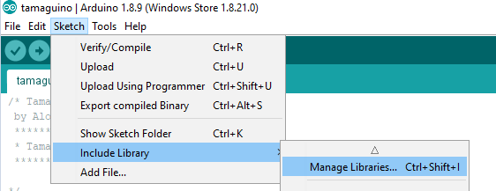

Search for library and select the version 1.1.5 for Adafruit_GFX.h

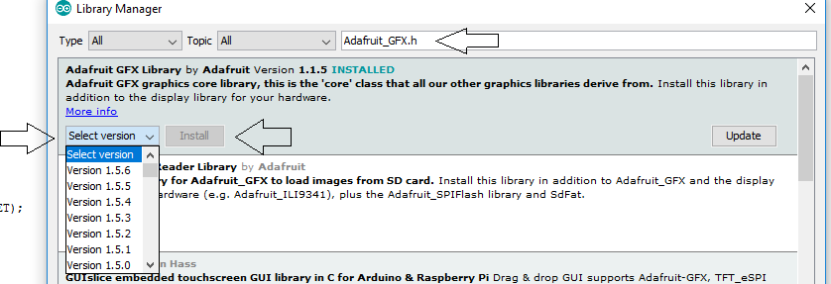

Search for library and select the version 1.2.2 for Adafruit_SSD1306.h

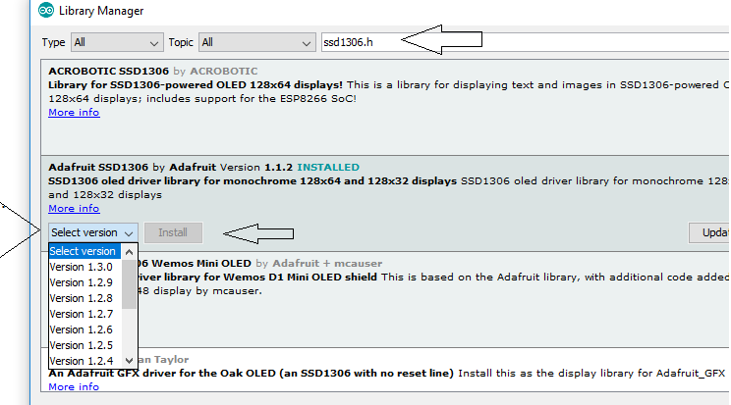

Last step is to modify the library Adafruit_SSD1306 in order to fit the entire screen :

Go document -> Arduino -> library -> Adafruit_SSD1306 -> Adafruit_SSD1306.h

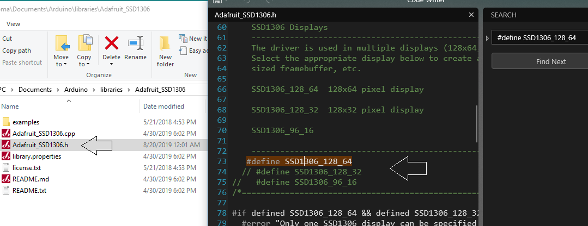

Should now looks like this :

#define SSD1306_128_64   
//#define SSD1306_128_32   
//#define SSD1306_96_16

Instead of :

//#define SSD1306_128_64   
#define SSD1306_128_32   
//#define SSD1306_96_16

**Finally you can upload the code :**

<https://alojzjakob.github.io/Tamaguino/>

Or another version with a save button :

<https://www.diyelectronics.co.za/wiki/#Arduino/Projects/Tamaguino/Tamaguino/>