CASE STUDY & EXECUTIVE REPORT
Evaluation of a Diagnostic Screening Campaign and Integrated Care Pathway (PDTA) for Type 2 Diabetes in a Local Health Authority Cohort (N = 10,000)

PART A: ASSIGNMENT PROMPT FOR STUDENTS (CLASS EXERCISE)
This document outlines a practical evaluation exercise designed for students in the Master of Science program in Health Economics (Course Module: Information Technologies for Health). The exercise requires student teams to act as Health Economists and Data Analysts for a regional Local Health Authority (LHA / ASL) to evaluate a pilot program for Type 2 Diabetes Mellitus.
METHODOLOGICAL DISCLAIMER & EDUCATIONAL CONTEXT
This case study is a simulated educational exercise based on a synthetic cohort of N = 10,000 enrolled citizens. While parameters (prevalence, screening diagnostic accuracy, incidence rates, and multivariable Odds Ratios) are grounded in real-world epidemiological literature, the study protocol—specifically measuring the laboratory Gold Standard across the entire cohort—is a pedagogical mechanism to teach diagnostic validation, record linkage, and administrative misclassification. It does not represent a standard clinical protocol.

Student Objectives & Task Overview
Working with the provided Stata dataset (dataset_health_econ_asl_corretto.dta / .csv), the command guide, and the executable .do script (analisi_health_econ_asl.do), students must reproduce all analytical steps and prepare a brief oral report addressing the following 4 core modules:
- Module 1 (Disease Occurrence & Social Disparities): Analyze the baseline prevalence of diagnosed Type 2 Diabetes extracted from administrative health databases (Exemption 013, Hospital Discharge Cards - SDO, Pharmaceutical Prescriptions - SIAS) across socio-economic deprivation quintiles (SES 1 to SES 5). Test for statistical significance.
- Module 2 (Screening & Target Population): Evaluate the diagnostic accuracy (Sensitivity, Specificity, Positive and Negative Predictive Values) of a new point-of-care rapid capillary blood test compared to the central laboratory Gold Standard (HbA1c/OGTT). Determine the correct target population for screening and analyze how PPV varies across deprivation strata.
- Module 3 (Person-Time Risk & Follow-up): Restrict the cohort to true, confirmed diabetic patients (Gold Standard == 1, N = 1,865) and calculate the person-time incidence rates of acute myocardial infarction (AMI) per 1,000 person-years over a 3-year follow-up, contrasting PDTA-adherent vs. non-adherent patients.
- Module 4 (Multivariable Adjustment & Health Impact): Estimate Cumulative Risks, Risk Ratios (RR), and Risk Differences (RD). Fit a multivariable logistic regression model to estimate the Adjusted Odds Ratio (aOR) of PDTA adherence while controlling for age, sex, and SES deprivation. Calculate the public health impact in terms of avoided AMI events for the LHA.
PART B: FULL EXECUTIVE CASE STUDY REPORT
1. Background & Disease Burden
Type 2 Diabetes Mellitus (T2DM) represents one of the most pressing public health and health economics challenges globally and regionally. Its high prevalence, progressive nature, and severe macrovascular complications—specifically Acute Myocardial Infarction (AMI)—impose significant clinical mortality and financial strain on healthcare budgets through avoidable hospitalizations (DRG costs).
A primary governance challenge lies in the presence of 'undiagnosed diabetes' (the epidemiological iceberg). When LHAs rely exclusively on routine administrative health databases (disease exemptions, inpatient discharge records, pharmaceutical dispensing), they measure administrative prevalence rather than true biological prevalence, leaving a substantial proportion of asymptomatic citizens uncaptured and untreated.
⚠️ STOP AND THINK — DECISION POINT 1: KNOWN VS. REALE PREVALENCE
Why must an LHA distinguish between administrative prevalence and biological prevalence? If we rely solely on routine administrative data (Exemption 013, SDO, SIAS), we capture only patients who have already interacted with the health system. In our cohort (N = 10,000), administrative baseline prevalence is 13.0% (1,295 patients). However, laboratory screening reveals 774 additional undiagnosed cases. Relying solely on administrative records ignores 37.4% of the true diabetic population, preventing timely preventive care.

2. Intervention Rationale & Integrated Care Pathways (PDTA)
To tackle cardiovascular complications, regional health systems implement Disease Management Programs or Integrated Care Pathways (Percorsi Diagnostico-Terapeutici Assistenziali - PDTA) for chronic care. Moving from fragmented care to proactive 'initiative medicine', the PDTA ensures routine multi-professional monitoring: regular HbA1c testing (at least twice yearly), annual microalbuminuria and fundoscopy exams, and sustained multi-drug compliance (antidiabetics, statins, antihypertensives with Medication Possession Ratio MPR ≥ 80%).
3. Specific Pilot Project Objectives
- Objective 1: Quantify undiagnosed diabetes across socioeconomic strata.
- Objective 2: Validate a rapid, decentralized screening test to establish its real-world accuracy and optimal deployment strategy.
- Objective 3: Evaluate the clinical effectiveness of PDTA adherence in preventing 3-year AMI incidence among confirmed diabetics.
- Objective 4: Calculate net health impact (AMI events avoided) to inform Health Technology Assessment (HTA) and LHA resource allocation.
4. Operational Methodology & Information System Record Linkage
The evaluation relies on deterministic Record Linkage across four distinct administrative and clinical health information systems using the patient's unique anonymized tax code (ID):
Information System / Health Database | Extracted Variables & Operational Role in Linkage
Population Registry (Anagrafe Assistiti) | Demographic baseline (Age, Sex, SES Deprivation Index 1-5), active enrollment, and date of death/censoring.
Disease Exemption Registry (Flusso Esenzioni) | Code 013 (Type 2 Diabetes Exemption) to establish baseline administrative diabetes status.
Hospital Discharge Records (Flusso SDO) | ICD-9-CM codes for Diabetes (250.xx) at baseline and primary/secondary AMI events (410.xx) during follow-up.
Outpatient Pharmacy Database (Flusso SIAS/FARM) | ATC A10 prescriptions (oral antidiabetics/insulin) to calculate MPR and PDTA adherence (pdta_adherent = 1 vs 0).
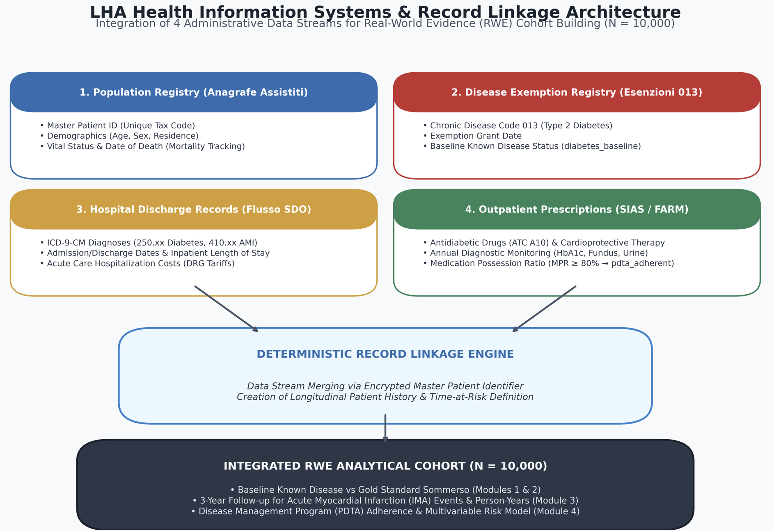

⚠️ STOP AND THINK — DECISION POINT 2: TARGET POPULATION FOR SCREENING
Who should be invited to a diagnostic screening campaign? In routine health management, screening patients who already have a documented diabetes exemption (diabetes_baseline == 1) is an inappropriate use of resources. Screening must target only citizens without prior administrative diagnosis (diabetes_baseline == 0, N = 8,705). In our validation analysis, evaluating the rapid test within this target population yields Sensitivity = 81.5%, Specificity = 88.0%, and PPV = 40.0%.

5. Detailed Analytical Results
Module 1: Occurrence & Socioeconomic Gradient (N = 10,000)
The total enrolled cohort comprises 10,000 citizens. Administrative records identified 1,602 diabetics at baseline (16.0% prevalence). Analyzing prevalence across socioeconomic deprivation quintiles reveals a profound social gradient:
• SES 1 (Least Deprived): 11.3% (223 / 1,968)
…. Omitted….
• SES 5 (Most Deprived): 21.6% (1,427 / 1,821)
A Pearson Chi-square test confirms a highly significant association between socioeconomic deprivation and diabetes prevalence (Chi2 = 97.0, p < 0.001).
Optional: in this hypothetical situation we collected the laboratory test results (Gold standard) for all 10.000 population, try to valuate the accuracy of administrative data compared to gold standard (2.1 Audit of the Existing LHA Administrative Database (Full Cohort N = 10,000)). Comment the result.
Module 2: Screening Validation & Predictive Values (N = 8,398 Target Population)
Among the 8,398 citizens without prior administrative diagnosis, central laboratory testing (Gold Standard) identified 774 true undiagnosed diabetics (8.89% prevalence of undiagnosed disease). Evaluating the point-of-care rapid test against the Gold Standard produces the following 2x2 matrix:
• True Positives (TP) = 709 | False Positives (FP) = 902
• False Negatives (FN) = 164 | True Negatives (TN) = 6,623
Diagnostic Performance Metrics: Sensitivity = 81.21%, Specificity = 88.01%, Overall Accuracy = 87.3%, Positive Predictive Value (PPV) = 44.01%, Negative Predictive Value (NPV) = 97.58%.
Optional: Accuracy formula?
Variation of PPV across Deprivation Strata: In high-deprivation areas (SES 4-5, undiagnosed prevalence = 13.29%), the PPV rises to 50.84%. In low-deprivation areas (SES 1-2, undiagnosed prevalence = 7.93%), the PPV drops to 36.70%. This demonstrates that the predictive yield of a screening test depends directly on underlying pre-test disease probability.
⚠️ STOP AND THINK — DECISION POINT 3: EXPOSURE DEFINITION FOR FOLLOW-UP
Which patients should be included in the 3-year follow-up cohort to evaluate PDTA effectiveness? Only patients with biologically confirmed diabetes (Gold Standard == 1, N = 2,256) are eligible for diabetic care pathways. Including false positives (sane subjects misclassified by rapid test or administrative errors) would dilute the observed effect and introduce severe misclassification bias.

Module 3: Person-Time Risk Rates in Confirmed Diabetics (N = 2,256)
Restricting analysis to the 2,256 confirmed diabetic patients (1,383 baseline known + 873 newly diagnosed), we track incident AMI events over a 3-year follow-up (3,951.75 total person-years):
- • Non-Adherent Group (pdta_adherent == 0, N = 929): 619 AMI events over 1650.98 person-years. Incidence Rate = 374.9 per 1,000 person-years.
- • Adherent Group (pdta_adherent == 1, N = 1,327): 642 AMI events over 2300.77 person-years. Incidence Rate = 279.0 per 1,000 person-years.
- • Incidence Rate Ratio (IRR): 37.492/ 27.903 = 0.74424 (p < 0.0001). The rate of AMI among non-adherent patients is nearly 3/4 that of adherent patients.
⚠️ STOP AND THINK — DECISION POINT 4: PERSON-TIME VS. STATIC CUMULATIVE RISK
Why use person-time incidence rates (stset / ir) instead of simple proportions? Cumulative risk assumes all patients are observed for the exact same duration. Person-time accounting dynamically accommodates censoring, loss to follow-up, and competing risks (e.g., non-AMI death), providing a precise measure of disease occurrence speed.

Module 4: Cumulative Risk, Multivariable Adjustment, and Health Impact
Cumulative 3-Year Risk: Non-adherent = 66.6% (642 / 1327); Adherent = 48.37% (642/ 1327).
• Risk Ratio (RR): 48.37% / 66.6% = 0.726.
• Risk Difference (RD): 36.89% - 58.12% = - 18.2.
• Multivariable Logistic Regression (Adjusted Odds Ratio): Controlling for Age, Sex, and SES Deprivation (i.ses_deprivation) yields an Adjusted Odds Ratio (aOR) = 0.3978 (p < 0.000). Adherence to the PDTA reduces the odds of AMI by 60.2% independent of age, sex, and social status.
⚠️ STOP AND THINK — DECISION POINT 5: RARE DISEASE ASSUMPTION & RR VS. OR DIVERGENCE
Why does the Adjusted Odds Ratio (aOR = 0.3978) differ from the Risk Ratio (RR = 0.726)? The 'Rare Disease Assumption' states that OR approximates RR only when disease risk is low (< 5-10%). Because AMI incidence in this high-risk diabetic cohort is high (31.1% to 68.8%), the OR mathematically exaggerates the relative risk. Analysts must communicate this distinction clearly to decision-makers.

⚠️ STOP AND THINK — DECISION POINT 6: CONFOUNDING BY INDICATION & MULTIVARIABLE ADJUSTMENT
Why is multivariable regression essential in observational data? In non-randomized studies, healthier or more educated patients are more likely to adhere to PDTAs. Without controlling for Age, Sex, and SES, the unadjusted effect might reflect patient self-selection rather than true clinical pathway efficacy. Multivariable adjustment isolates the independent effect of PDTA care.

6. Public Health Impact & LHA Economic Return
Quantifying the population-level health impact across the 881 non-adherent diabetic patients:
Expected Avoided AMI Events = 929 non-adherent patients × 18.2% Risk Difference = 169.0 (169 avoided acute myocardial infarctions over 3 years).
Assuming an average acute AMI hospitalization DRG cost of €5,200 per patient, achieving 100% PDTA adherence would generate direct hospital savings of €879,205 for the LHA, excluding long-term savings from secondary heart failure prevention.
⚠️ STOP AND THINK — DECISION POINT 7: PREVENTED FRACTION EXPOSED (PFE) VS. POPULATION (PFP)
What is the difference between Prevented Fraction in the Exposed (PFE) and in the Population (PFP)? PFE measures clinical efficacy among participants (PFE = 1 - RR = 27.4%). PFP measures overall community impact, which depends directly on program coverage (Pe = 70.0%= 929 /1,327). PFP = Pe × PFE = 19.1%. Increasing pathway enrollment is the primary operational lever to maximize population-level DRG cost reductions.

7. Methodological Limitations & HTA Governance Summary
- 1. Selection Bias: Non-randomized enrollment may leave unmeasured residual confounding (e.g., health literacy, diet, physical activity).
- 2. Information Bias: Administrative databases may contain misclassification in prescription filling (dispensed vs. ingested medication).
- 3. HTA Recommendation: Expand point-of-care rapid screening in high-deprivation districts (SES 4-5) where PPV is highest, and incentivize General Practitioners (MMGs) to maximize PDTA enrollment to capture the €879,205 + hospital cost savings.

