INT307 Web Application Security

Lab 6: Insecure Direct Object References (IDOR) in DVWA

Name: Patrick Damian Ozimede
Program: ICDFA Internship
Date: August 2026

Lab Environment
Attacker machine (Kali Linux): legion@pastor, 192.168.5.139
Target (OWASP BWA VM): 192.168.5.130 (DVWA v1.8)
Note on lab adaptation: DVWA v1.8 does not include a dedicated IDOR module (/vulnerabilities/idor/ returns a 404 Not Found). This is a known gap, as a standalone IDOR page was only added in later DVWA versions. The lab was adapted to use the SQL Injection page (/vulnerabilities/sqli/?id=), whose "id" parameter directly references a database user record with no ownership or authorization check - a textbook IDOR pattern, independent of any SQL injection technique.

Exercise 1: Understanding IDOR

Definition
Insecure Direct Object Reference (IDOR) occurs when an application exposes a direct reference to an internal object - such as a database record, file, or user account - typically via a URL parameter or form field, without verifying that the currently logged-in user is actually authorized to access that specific object.

How IDOR Vulnerabilities Arise
The vulnerability arises because the application trusts the object reference itself (e.g., id=1) as sufficient proof of authorization, rather than checking whether the requesting user has permission to view or modify that particular record. This typically happens when developers implement authentication (proving who a user is) correctly, but skip or under-implement authorization (verifying what that user is allowed to access) at the individual-record level.

Real-World Examples
IDOR has been responsible for real-world breaches, including exposed invoice or document IDs that let any authenticated user view other customers' invoices by changing a number in the URL, social media platforms where changing a numeric user ID in an API request exposed private profile data, and banking or fintech applications where account or transaction IDs could be incremented to view other users' financial records.

Exercise 2: Identify IDOR Vulnerabilities in DVWA
Using the adapted SQL Injection page as the IDOR test target, the User ID field was submitted with a value of 1.
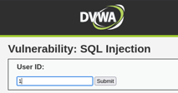

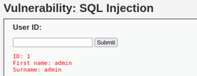

The result returned the logged-in user's own record (ID: 1, First name: admin, Surname: admin) - a legitimate, expected result for an authorized lookup of one's own data.

Reflection
The URL parameter directly references a database record by its numeric ID (?id=1), with no session-based ownership check tying the requested ID to the identity of the logged-in user. This structure is the precondition for an IDOR vulnerability: any change to this parameter will be executed by the server without question.

Exercise 3: Exploit IDOR to Access Unauthorized Data
The id parameter was changed sequentially to access other user records, without any special tooling or injection technique - simply incrementing the value in the URL.
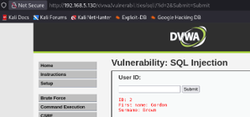

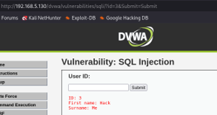

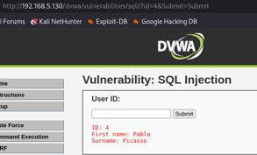

Results
User ID | First Name | Surname
1 | admin | admin
2 | Gordon | Brown
3 | Hack | Me
4 | Pablo | Picasso

Analysis
IDs 1 through 4 all returned distinct, complete user records with no restriction of any kind. No session-to-record ownership validation exists anywhere in the request flow - the application trusts the id parameter alone as sufficient authorization to return data. Because these IDs are small sequential integers, an attacker could trivially script a loop (id=1 through id=1000, for example) to enumerate and exfiltrate the entire user table within seconds, without needing any SQL injection payload at all - this is pure IDOR.

Reflection: Sensitive Data and Risk
The data exposed in this lab was limited to first and last names, but the same flawed access-control pattern, applied to a real-world application, typically extends to far more sensitive fields such as email addresses, phone numbers, order history, financial records, or private messages, depending on what the vulnerable endpoint returns. IDOR is considered a low-effort, high-impact vulnerability class precisely because exploitation requires no special tools or skills beyond changing a number in a URL, making it one of the most commonly found - and most commonly overlooked - issues in real-world web applications.

Exercise 4: Preventing IDOR Vulnerabilities

Mitigation Strategies
1. Access control / authorization checks on every object reference - the core fix. Every request that includes an object identifier must be checked server-side to confirm the currently authenticated user actually owns or is permitted to view that specific record, not just that they are logged in generally.
2. Indirect object references - instead of exposing raw, predictable database primary keys (sequential integers) directly in the URL, map them to random, per-session, non-guessable tokens (such as a UUID). This does not replace proper authorization checks, but removes the ability to simply guess or enumerate adjacent records.
3. Enforce authorization at every layer, not just the UI - many applications hide a "view other users" link in the interface for regular users but forget that the underlying endpoint is still directly reachable via URL manipulation. Authorization must be enforced server-side, on every request, regardless of what the UI displays.
4. Logging and monitoring access attempts - logging every object-access request, including denied ones, allows detection of enumeration patterns, such as one account rapidly requesting sequential IDs, which is a strong signal of an IDOR attack in progress. Rate-limiting and alerting on such patterns adds a detection layer even where a flaw exists.

Reflection: Applying This to DVWA
For the IDOR pattern demonstrated on DVWA's SQL Injection page, the application would need a server-side check comparing the requested id against the logged-in session's own user ID (or an explicit role-based permission check for administrative access to other records) before executing the query at all, rather than processing any id value supplied in the URL unconditionally. In a production application, this is typically implemented as reusable authorization middleware applied consistently across all endpoints that accept object identifiers, rather than relying on individual developers to remember to add the check to each new feature separately.

Conclusion
This lab demonstrated an Insecure Direct Object Reference vulnerability using DVWA's SQL Injection page as a stand-in for a dedicated IDOR module not present in this DVWA version. Simply changing a numeric ID parameter in the URL allowed complete, unauthorized access to every user record in the application's database, with no authentication bypass, injection payload, or specialized tooling required. This lab reinforced that authorization checks must be enforced independently for every object a user requests, at the server level, rather than relying on authentication alone or on the assumption that predictable identifiers will not be manipulated.

