INT307: Web Application Security
Lab 2: XSS Vulnerabilities in DVWA

Student: Damian Ozimede Patrick
GitHub: github.com/damianozimede
Environment: Kali Linux (legion@pastor, 192.168.5.139) - OWASP BWA VM (192.168.5.130)
Date: July 2026

Objective
To identify and exploit Cross-Site Scripting (XSS) vulnerabilities within the Damn Vulnerable Web Application (DVWA), covering Reflected and Stored XSS across Low, Medium, and High security levels, and to document mitigation strategies.

Environment
Item | Value
Attacker machine | Kali Linux - legion@pastor (192.168.5.139)
Target VM | OWASP BWA - 192.168.5.130
Target application | DVWA (Damn Vulnerable Web Application)
DVWA login | admin / admin
Database setup | Performed via /dvwa/setup.php - Create/Reset Database

Note on scope
This DVWA installation does not include a separate "XSS (DOM)" module - only "XSS reflected" and "XSS stored" are present in the application menu. DOM-based XSS testing was therefore not performed, as the vulnerable page does not exist in this environment. Testing proceeded with the two available XSS categories: Reflected and Stored.

Step 1-2: Setup and Identify Vulnerable Input Fields
DVWA was accessed at http://192.168.5.130/dvwa/. The database was initialized via the Setup page (Create / Reset Database), which created the users and guestbook tables successfully. Login was completed using admin/admin.
Exploring the application sidebar identified two relevant vulnerable pages:
- XSS reflected - a single "What's your name?" input field, reflected back into the page immediately upon submission via a GET parameter (name).
- XSS stored - a guestbook form with Name and Message fields, where submitted entries are saved to the database and displayed to all visitors.
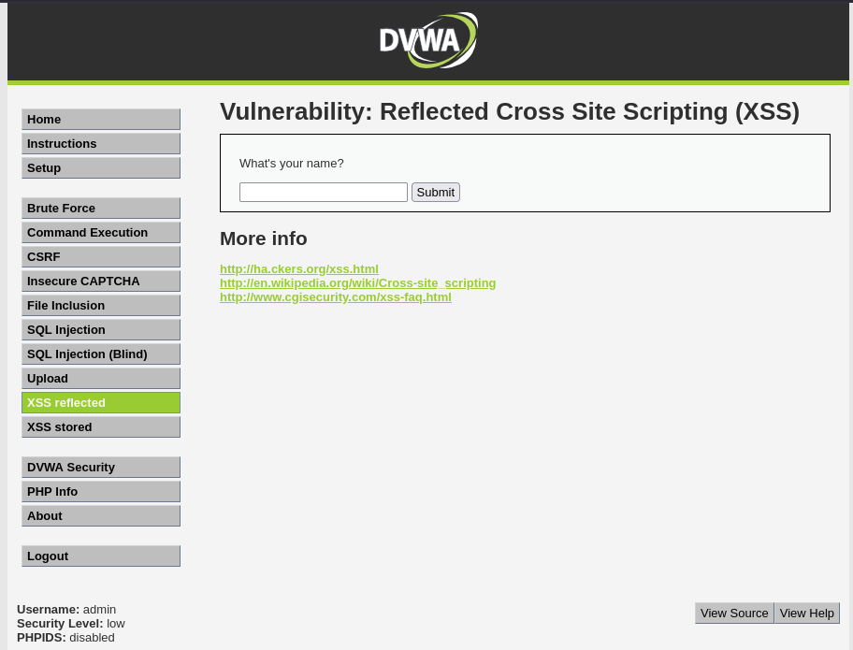

XSS (Reflected) Testing

Low
Payload:
<svg onload=alert('BugBot19 was here')>
Submitted into the "What's your name?" field at Security Level: Low. Page source confirmed the payload was reflected into the HTML completely unescaped, and the browser executed it, producing a JavaScript alert dialog showing "BugBot19 was here".
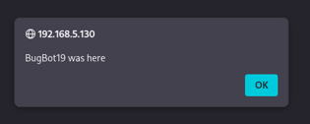

Finding: user input is echoed back into the page without any sanitization or HTML encoding at Low security.

Medium
Initial payload (failed):
<script>alert('BugBot19 was here')</script>
This did not execute; the page displayed the literal text "Hello alert('BugBot19 was here')". Inspecting the page source revealed the filter had removed only the opening <script> tag, leaving the closing </script> tag intact - the signature of a naive, case-sensitive string-replacement filter.
Bypass payload (succeeded):
<ScRipt>alert('BugBot19 was here')</ScRipt>
Since the filter's match is case-sensitive, mixed-case tags are not recognized as <script> and pass through unmodified. This executed successfully, producing the expected alert dialog.
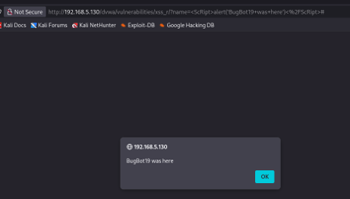

Finding: blacklist-based filtering is fundamentally weak - case variation alone defeats a naive string-match filter. It was also observed that the <svg onload=...> payload used at Low was fully stripped at Medium, suggesting the filter's scope differs by tag type rather than applying uniform sanitization.

High
Payload:
<ScRipt>alert('BugBot19 was here')</ScRipt>
The same case-variation bypass from Medium was tested first at High, and it succeeded immediately without modification, producing the alert dialog.
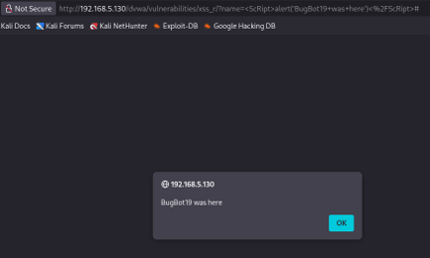

Finding: DVWA's High-level filter for XSS Reflected does not add case-insensitive matching over the Medium-level filter. This highlights a key weakness in blacklist-based defenses: increasing a "security level" label does not guarantee that known bypass techniques are closed - the underlying filtering logic must be reviewed for completeness, not assumed to improve with a difficulty setting.

XSS (Stored) Testing

Low
Payload (Message field):
<script>alert(document.domain)</script>
Submitted with Name: test2 at Security Level: Low. The alert fired immediately upon submission, displaying "192.168.5.130" (the value of document.domain), confirming the script executed with access to page context, not just a static string.
Critically, the payload was also persisted to the guestbook - the entry shows Name: test2 with an empty Message field (the script tag consumed the visible content). This means the malicious script will re-execute for any user who later views this page.

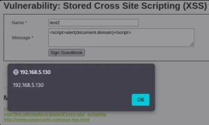
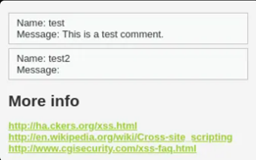

Finding: stored XSS is more severe than reflected XSS - it requires no crafted link or social engineering, and persists as a standing threat to every subsequent visitor to the page.

Medium
Payload (Message field):
<img src=x onerror=alert(document.cookie)>
Submitted with Name: test3 at Security Level: Medium. The payload executed successfully via the onerror event handler - since src="x" is an invalid image path, onerror triggers automatically, executing the injected JavaScript. This bypasses filters that specifically target <script> tags, since no script tag is present at all.
The payload was persisted to the guestbook (Name: test3, empty Message), confirming stored XSS remains exploitable at Medium via non-script-tag vectors.
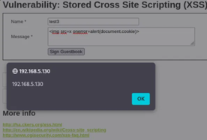
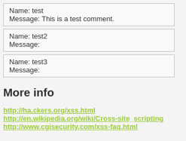

High
Payload attempts:
<body onload=alert('BugBot19')>
<img src=x onerror=alert('BugBot19')>
Both payloads were submitted at Security Level: High (Name: test4, test5). Neither executed - both were rendered as literal text, with angle brackets converted to HTML entities (&lt; and &gt;) before being stored/displayed, e.g. &lt;img src=x onerror=alert('BugBot19')&gt;.
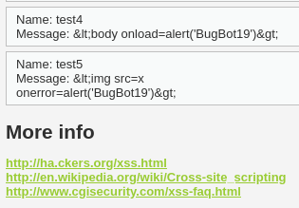

Finding: this is a fundamentally stronger defense than the Low/Medium filters, since it does not rely on blacklisting specific tags or keywords. Instead, it neutralizes any HTML markup by encoding it for safe display, meaning no tag-based XSS payload can execute at this level. This demonstrates the correct mitigation approach: output encoding (contextual escaping) is far more robust than blacklist-based input filtering, which can always be bypassed with tag or case variations, as shown in the Reflected XSS exercises.

Create Your Own Payload
Rather than using only the lab's suggested payloads verbatim, an original bypass was developed for the Reflected XSS page at Medium and High security levels. Initial testing showed the standard payload <script>alert('BugBot19 was here')</script> failed at Medium - inspection of the page source revealed the filter performs a simple, case-sensitive string replacement, removing the literal substring <script> but leaving the closing </script> tag untouched.
Based on this observation, a custom payload using mixed-case tags was developed:
<ScRipt>alert('BugBot19 was here')</ScRipt>
Since the filter's string-match is case-sensitive, this payload is not recognized as <script> and passes through unmodified. It was tested and confirmed successful at both Medium and High security levels, proving that DVWA's XSS Reflected filter relies on a weak, case-sensitive blacklist rather than genuine sanitization - and that the "High" setting does not add case-insensitivity over "Medium."
This demonstrates a general principle in web security testing: understanding why a filter fails (by inspecting source/behavior) is far more effective than blindly trying payloads from a list.

Conclusion and Mitigation Strategies
This lab demonstrated both Reflected and Stored Cross-Site Scripting vulnerabilities in DVWA across Low, Medium, and High security levels. Reflected XSS proved exploitable at all three levels - the Low level applied no filtering at all, while Medium and High relied on a case-sensitive blacklist that was bypassed using mixed-case HTML tags, showing no meaningful improvement between the two settings. Stored XSS followed a similar pattern at Low and Medium, where script tags and event-handler-based payloads (img onerror) executed and persisted in the guestbook database, posing a standing risk to every future visitor. Only at High security level was Stored XSS properly mitigated, via output encoding that converts angle brackets to HTML entities regardless of tag or keyword used.
Key recommendations:
- Apply context-aware output encoding (HTML entity encoding) to all user-supplied data before rendering it in a page - this is effective regardless of which tags or keywords an attacker uses, unlike blacklist filtering.
- Avoid blacklist/keyword-based input filtering as a primary defense; it is trivially bypassed via case variation, alternate tags, or encoding tricks.
- Apply a strict Content Security Policy (CSP) to restrict inline script execution as a defense-in-depth measure.
- Sanitize and validate input on the server side, never relying solely on client-side JavaScript validation.
- Treat all stored user input (e.g. guestbook/comment fields) as untrusted at the point of display, not only at the point of submission.
Ethical note: all testing in this lab was performed against a deliberately vulnerable, isolated training environment (DVWA on the OWASP BWA VM) with no real user data, for educational purposes only.

