INT308: Session Management and Web Security

Lab 1: Session Management Vulnerabilities
Name: Patrick Damian Ozimede
Environment: Kali Linux (legion@pastor, 192.168.5.139) targeting DVWA v1.8 on OWASP BWA VM (192.168.5.130)

Overview
This lab explored session management vulnerabilities in DVWA v1.8, focusing on how insecure session cookie configuration and lack of session regeneration can lead to session fixation and session hijacking attacks. Three exercises were conducted: analysis of session cookie attributes, a session fixation attack via manual cookie manipulation, and a session hijacking demonstration using Burp Suite as an intercepting proxy.

Exercise 1: Analyzing Session Management Practices

Steps Performed
- Logged into DVWA using valid credentials (admin/admin) and used browser DevTools (Storage > Cookies) to inspect the PHPSESSID session cookie and its attributes (HttpOnly, Secure, SameSite).
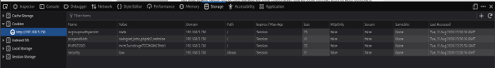

Findings
Attribute | Observed Value
PHPSESSID | mcm3ucsdcvge7553f68t63fnb1
HttpOnly | false
Secure | false
SameSite | None

Reflection
Because HttpOnly is set to false, the PHPSESSID cookie is accessible to client-side JavaScript through document.cookie. This means that if the application has any XSS vulnerability, an attacker could inject a script to steal the session cookie directly and impersonate the logged-in user without ever knowing their password. Similarly, because Secure is set to false, the cookie can be transmitted over plain, unencrypted HTTP, so anyone able to intercept network traffic between the user and the server (e.g. on a shared Wi-Fi network) could capture the session ID and hijack the session. Together, these missing flags mean the session token has no protection against either script-based theft or network-based interception -- the two most common vectors for session hijacking.

Exercise 2: Session Fixation Attack

Steps Performed
- Before authenticating, the PHPSESSID cookie value was manually set to a known, attacker-chosen value (fixedsession12345) via browser DevTools. The application was then logged into (admin/admin) using this same browser session, and the PHPSESSID value was checked again post-login to determine whether the server regenerated it.
- A second, independent browser session (private/incognito window) then presented the same known session ID and attempted to access an authenticated page directly, without submitting any login credentials.
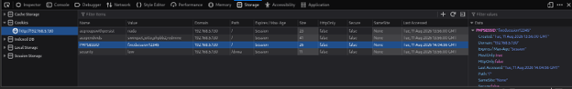
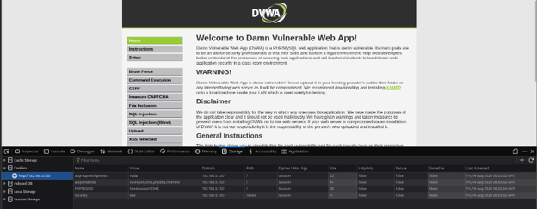

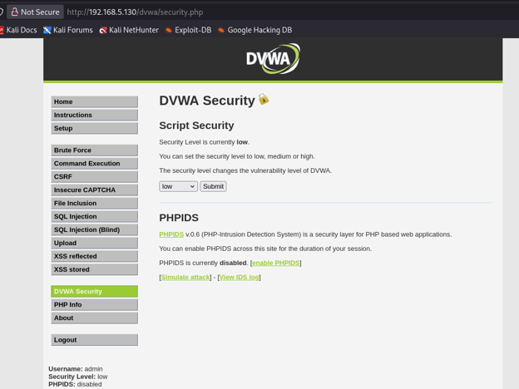

Findings
The PHPSESSID value (fixedsession12345) remained identical before and after login, confirming that DVWA does not regenerate the session identifier upon successful authentication. A second browser session that never submitted any credentials was then able to access the authenticated DVWA security settings page simply by presenting this same session ID.

Reflection
This exercise demonstrated a session fixation vulnerability in DVWA. By manually setting the PHPSESSID cookie to a known value before authenticating, and observing that the same value remained active after login, it was confirmed that the application does not regenerate session identifiers upon successful authentication. This allowed a second browser session, which never submitted any login credentials, to access an authenticated page simply by presenting the same session ID. This confirms that an attacker who can plant a known session ID on a victim's browser (for example, via a crafted link) could hijack that victim's session once they log in, without ever needing to know their password. The core mitigation is to regenerate the session ID immediately after a successful login (e.g. using session_regenerate_id() in PHP), which invalidates any pre-set or attacker-known session values.

Exercise 3: Session Hijacking Using Burp Suite

Steps Performed
- Burp Suite's built-in Chromium browser was used to route traffic through Burp's intercepting proxy. The DVWA login request was captured with Intercept enabled, and the PHPSESSID value in the Cookie header was modified to an arbitrary, attacker-chosen string (hijacktest99999) before forwarding the request to the server.
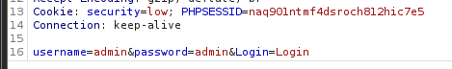

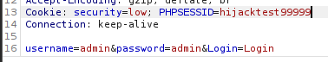

Findings
Despite substituting an arbitrary, attacker-chosen PHPSESSID value mid-request, the server granted full authenticated access to the DVWA dashboard. This confirms DVWA does not bind sessions to any additional validation (such as IP address, user-agent fingerprinting, or a server-side session token check) -- it trusts whatever PHPSESSID value is presented.
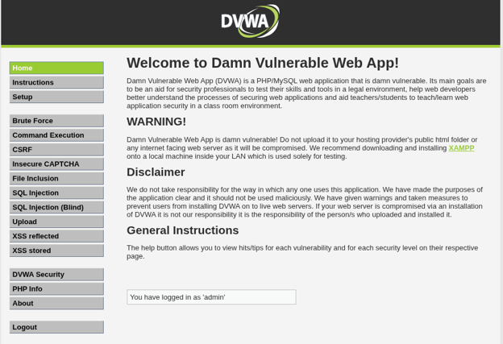

Reflection
Using Burp Suite as an intercepting proxy, the login request was captured and the PHPSESSID cookie value was modified to an arbitrary, attacker-chosen string before forwarding the request. Despite this tampering, the application granted full authenticated access, confirming that DVWA does not validate or bind session IDs to any server-side state beyond the string itself. This demonstrates that session management in this application relies entirely on the secrecy of the session ID with no additional integrity checks (such as IP address binding or user-agent verification). An attacker who intercepts or guesses a valid session ID -- whether via network sniffing, XSS, or a fixation attack as shown in Exercise 2 -- can fully hijack a user's session. Mitigations include regenerating session IDs after login, binding sessions to additional client attributes, enforcing short session timeouts, and always transmitting session cookies over HTTPS with the Secure and HttpOnly flags set.

Additional Insights and Recommendations
- Set the HttpOnly flag on all session cookies to prevent JavaScript access and mitigate XSS-based cookie theft.
- Set the Secure flag to ensure cookies are only transmitted over HTTPS.
- Set SameSite=Strict or Lax to reduce cross-site request exposure.
- Call session_regenerate_id(true) immediately after successful authentication to invalidate any pre-existing or attacker-known session IDs.
- Enforce session binding to additional client attributes (e.g. IP address or user-agent) where feasible, and implement short session timeouts with server-side invalidation on logout.
- Migrate the application to HTTPS to protect session tokens from network-level interception.

Conclusion
This lab confirmed that DVWA v1.8 exhibits multiple session management weaknesses: session cookies lack protective flags (HttpOnly, Secure, SameSite), the application does not regenerate session IDs after login, and it does not bind sessions to any additional client-side validation. Together, these weaknesses make DVWA fully susceptible to session fixation and session hijacking attacks, underscoring the importance of secure session management practices in real-world web applications.

