INT309: Web Technologies and Database Security

Lab 1: Introduction to Web Technologies and Understanding HTTP and HTTPS
Damian Ozimede Patrick

Overview
This report documents the completion of Lab 1, covering the foundational concepts of web technologies, with a focus on the HTTP and HTTPS protocols. The lab explored the structure of a basic web page, the anatomy of HTTP requests and responses using browser developer tools, and the security guarantees provided by HTTPS through certificate inspection and TLS analysis.

Exercise 1: Creating a Simple Web Page
A basic HTML page (index.html) was created, including a header, a paragraph, a placeholder image, and a link to an external resource. Note: the lab's original placeholder image URL (via.placeholder.com) has been discontinued; it was replaced with placehold.co, a functionally equivalent, currently active service.
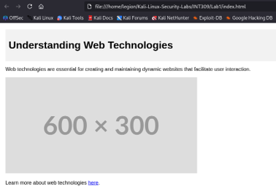

Reflection
This exercise reinforced how HTML uses semantic structure to organize content in a way that's both machine-readable and human-usable. The header element visually and structurally separates introductory content from the body, giving users an immediate sense of what the page is about. Paragraph tags break content into readable chunks rather than one dense block of text, which improves readability. The image tag demonstrates how visual media is embedded and referenced via a src attribute rather than stored inline, meaning a page's appearance depends on external resources being available, a point reinforced firsthand when the lab's original placeholder image URL failed to load because the service had been discontinued, requiring a working alternative to be substituted. Finally, the anchor tag shows how HTML enables navigation between resources, forming the basis of the interconnected web. Together, these elements illustrate that HTML isn't just about displaying text, it's about structuring content in a way that conveys meaning, hierarchy, and relationships to both browsers and users.

Exercise 2: Analyzing HTTP Requests and Responses
The page was first inspected via the file:// protocol (opened directly from disk), and the Network tab in Firefox DevTools was used to examine the request. This showed no headers, since no real HTTP transaction occurs when loading a file locally.

To properly capture an HTTP transaction, a local server was started using "python3 -m http.server 8000" and the page was reloaded at http://127.0.0.1:8000. This produced a genuine request/response cycle, including a 200 OK on first load, a subsequent 304 Not Modified (demonstrating browser cache validation), and a benign 404 for the automatically-requested favicon.ico.



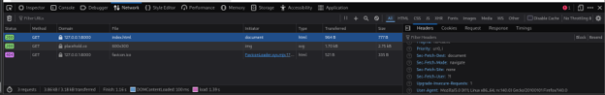

Reflection
This exercise highlighted a distinction that isn't obvious until you see it firsthand: opening a file directly via the file:// protocol is not the same as loading it over HTTP, even though the rendered page looks identical. When index.html was opened locally, the Network tab reported no headers for the request, because no actual HTTP transaction occurred; the browser simply read bytes off disk. To properly observe HTTP behavior, a local server was started and the page reloaded over HTTP. This surfaced a genuine HTTP request/response cycle, complete with a status code, response headers, and caching behavior — including a 304 Not Modified response on the second load, which demonstrated the browser's cache validation mechanism in action. The 404 for favicon.ico was also observed and is benign, expected browser behavior rather than a page defect. Reviewing the Request and Response headers (Content-Type, Content-Length, Date, Server, etc.) reinforced why these matter for security: headers like Content-Type prevent MIME-sniffing attacks when set correctly, Cache-Control governs whether sensitive data might be inappropriately cached, and improperly configured or missing headers (e.g. absent X-Content-Type-Options or Content-Security-Policy) are a common source of web application vulnerabilities. This exercise made clear that understanding the full HTTP request/response cycle — not just the rendered page — is foundational to identifying and mitigating such risks.

Exercise 3: Understanding HTTPS and Its Importance
A secure website (https://www.google.com) was accessed and its network traffic inspected. All 35 observed requests, including POST requests, carried the padlock indicator confirming HTTPS encryption.



The site's certificate was inspected via the padlock icon, showing a certificate for *.google.com issued by Google Trust Services (WR2), chaining to the GTS Root R1 root certificate, valid from 10 Aug 2026 to 2 Nov 2026.
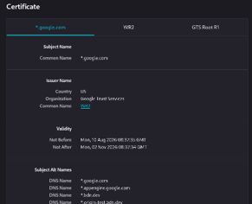

The Page Info Security tab confirmed the connection was secured using TLS 1.3 with the TLS_AES_128_GCM_SHA256 cipher suite.
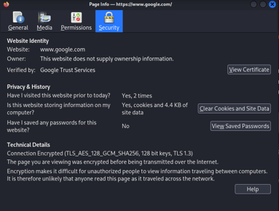

Reflection
This exercise demonstrated concretely what HTTPS provides over plain HTTP. Every request to google.com carried a padlock icon in the Network tab, confirming that all requests observed — including POST requests carrying data — were encrypted in transit. Inspecting the certificate showed a chain of trust: the leaf certificate for *.google.com was issued by Google Trust Services (WR2), which itself chains up to the GTS Root R1 root certificate. This chain is what allows a browser to verify the site's identity without having to trust every server individually — trust is inherited from a small set of root certificate authorities. The certificate's short validity window (roughly three months) reflects a broader industry shift toward short-lived certificates, which reduces the impact of key compromise and encourages automated renewal. The Page Info panel further confirmed the connection was secured using TLS 1.3 with the TLS_AES_128_GCM_SHA256 cipher suite — an authenticated encryption mode that protects both confidentiality and integrity of the data in transit. Together, these findings illustrate why HTTPS is essential: it prevents eavesdropping, protects against man-in-the-middle attacks through certificate validation, and preserves data integrity. By contrast, the HTTP request examined in Exercise 2 had none of these protections — data was transmitted in plaintext, with no verification of server identity and no protection against tampering.

Conclusion
This lab provided hands-on exposure to the foundational mechanics of web communication. Building a simple page reinforced HTML structure and semantics; inspecting HTTP traffic — both locally via file:// and over an actual HTTP server — clarified the real difference between a rendered page and a genuine network transaction, along with headers, status codes, and caching behavior; and analyzing HTTPS traffic to a live production site demonstrated encryption, certificate chains of trust, and modern TLS in practice. Together, these exercises establish the groundwork needed for the more advanced web and database security topics ahead in this course.

